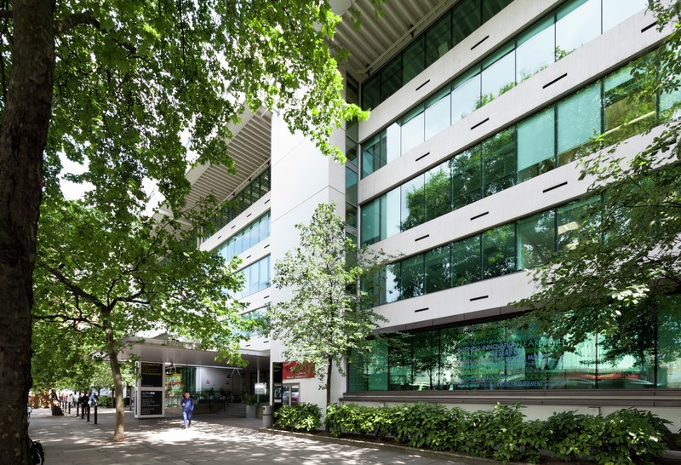
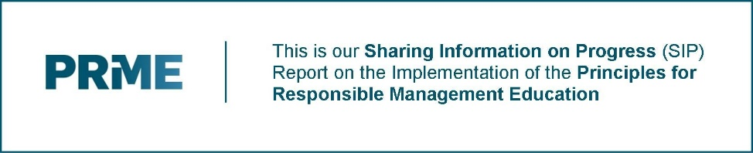
Principles for Responsible Management Education (PRME)
Sharing Information on Progress Report 2017-2019

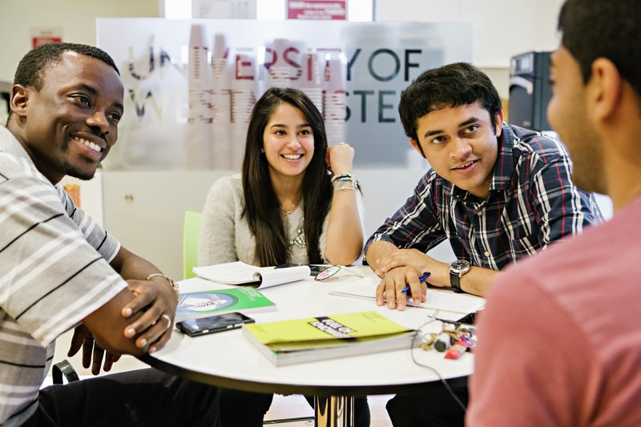
Principles for Responsible Management Education (PRME)
Sharing Information on Progress Report
Contents

Renewal of Our Commitment to PRME 3
PRME 2017 – 2019 Objectives 4

Action Taken on our 2017 – 2019 Objectives Principles 1: Purpose 8
Principle 2: Values 11
Principle 3: Method 12
Principle 4: Research 15
Principle 5: Partnership 16
Principle 6: Dialogue 17

PRME 2019-2021 Objectives 18

Principles for Responsible Management Education (PRME)
Sharing Information on Progress Report
Renewal of Our Commitment to PRME

Westminster Business School is proud to be a signatory of the PRME Principles and a member of the international PRME community. We are committed to ensuring that our students are fully prepared to meet the challenges and opportunities that will confront them in their professional lives and be able to develop successful careers. To achieve this, we recognise that our students need to acquire not only business knowledge but also the values and attributes required to inspire others and transform futures – their own, their organisations and wider society. Therefore, we have identified PRME and the UN Sustainable Development Goals as important components of our Education for Sustainable Development (ESD) strategy.

On behalf of Westminster Business School, I am pleased to reconfirm our commitment to upholding the UN backed Global Compact Principles of Responsible Management Education and our engagement in a continuous process of improvement in the application of the PRME Principles.

In this, our second SIP report, we are happy to share our experiences and outcomes as we have worked hard to integrate the Principles into all areas of our activities. Overall, we have made significant progress especially in the areas of curriculum, culture and operational practice.

However, there is still further work to do. In the last year Westminster Business School has increased in size, gaining College status, in our University structure, and adding the areas of Property and Construction management to our growing portfolio. We have identified ambitious objectives for the next reporting period as we continue embedding PRME Principles into all our activities. We look forward to sharing our successes and experiences with fellow PRME signatories in the future.

Professor Malcolm Kirkup
Pro Vice Chancellor and Head of College,
Westminster Business School
35 Marylebone Road London, NW1 5LS

Principles for Responsible Management Education (PRME)
Sharing Information on Progress Report
PRME Objectives 2017 – 2019

As one of the largest and most experienced providers of business and management education in London, we are distinctive in a number of ways. We are known for our practical and applied teaching, rooted in the University’s 180-year history as the first Polytechnic. Our community of around 5000 students brings together one of the most diverse cultural and international populations of any Business School in the UK. Our programmes enjoy the recognition, endorsement and accreditation of a wide range of national and international professional bodies. We occupy an enviable location in the heart of London, providing our students with access to the very best business and social opportunities that any international city can offer.

In 2017-18 the University of Westminster was restructured into three colleges. One of the Colleges is Westminster Business School. Within our college we have the following four Schools: School of Finance and Accounting, (SFA), School of Management and Marketing (SMM), School of Applied Management (SAM) and School of Organisations, Economics and Society (SOES). Each school is governed by a Head of School. Heads of School sit on the highest governing body of the college, the College Executive Group (CEG).

Under the leadership of our Head of College, Professor Malcolm Kirkup, our mission is to build a Business School that is distinctive, globally-connected, research-engaged, financially strong and a provider of choice for applied and professionally-accredited management education.

Responsible for the delivery of management and business education within the University of Westminster - a leading modern UK university - Westminster Business School offers an extensive portfolio of undergraduate, postgraduate, research and executive education programmes spanning all disciplines in business and management. We are committed to educating graduates for the needs of professional life and have established a reputation for our high quality of teaching and the relevance of our courses to the needs of contemporary business. We are enriching our Masters’ portfolio and will launch a new MSc Sustainable Management and Innovation and an MSc in Social Enterprise. Our final year undergraduate students on the Business Management course are offered a Sustainable Business module.

Westminster Business School has been awarded accreditations from the following professional bodies: Association of Chartered Certified Accountants (ACCA), Chartered Financial Analysts (CFA), Chartered Institute of Personnel and Development (CIPD), Association for Project Management (APM), Association of Project Management Group (APMG), Global Best Practice Solutions (AXELOS), Chartered Institute of Purchasing & Supply (CIPS), Royal Institute of Chartered Surveyors (RICS), Chartered Association of Building (CABE), Chartered Institute of Building (CIOB), Chartered Association of Building Engineers (CABE), Project Management Institute (PMI), Chartered Institute of Marketing (CIM), Chartered Management Institute (CMI), Chartered Institute for Securities & Investment (CISI), Institute of Data and Marketing (IDM), Chartered Institute of Management Accountants (CIMA) and Digital Marketing Institute (DMI). These accreditations, together with the strength of its corporate connections, means that the College ensures a strong professional practice focus supporting our undergraduate and postgraduate provision and builds in work-related learning and assessment that builds intellectual capacity and critical thinking. We are also members of UK Universities Alliances (SAP) which enables students to have a value-added package of additional SAP certifications at a substantial discount through the SAP Alliance Programme. We are also working with the new One Planet Education Network (OPEN) to bring external and professional guidance into our work to embed sustainability across all of our programmes.

Student Experience

We are committed to continually enhancing the students’ experience. Our campus provides high specification teaching and social spaces for students including a state-of-the-art Financial Markets Suite which features Bloomberg terminals and software, a unique Boardroom Lab which provides students with the opportunity to develop their communication skills for business meetings and a new high spec digital lab just launched in September 2019. We also provide an extensive range of extra-curricular activities including guest speakers, workshops, professional placements, internships, voluntary work, as well as European and international mobility.

Principles for Responsible Management Education (PRME)
Sharing Information on Progress Report
PRME Objectives 2017 – 2019

Research

The College hosts three Research Centres that have portfolios of research recognised to be internationally world leading and excellent. These are the Centre for Employment Research, the Centre for the Study of the Production of the Built Environment and the Centre for Digital Business. These Centres attract funding from leading grant awarding bodies such as ESRC, the Leverhulme Trust and the Nuffield Foundation.

Knowledge Exchange

The College has a thriving portfolio of executive education programmes and short courses. We also undertake consultancy for a range of businesses and public sector organisations. Particularly successful short courses include Prince2, Management of Risk, Agile PM, Professional Diploma in Digital Marketing, and a series of APMG-accredited Project Management programmes. Our Leadership and Management short course attracts participants from all over the world. This particular course designates considerable time to discuss ethical dilemmas and sustainability issues with participating leaders. The School also undertakes contract work for organisations such as The Royal Society, the Department for Business Innovation and Skills and the Government Equalities Office. The College is involved in a number of Knowledge Transfer Partnerships (KTPs) as well as research and development projects for business organisations.

The Centre for Employment Research (CER) and the Centre for the Study of the Production of the Built Environment (ProBE) have an excellent record in working with external organisations and bringing research insight and practical proposals to organisations. The College hosts the newly established Development Policy Analysis Research Network, which provides opportunities for collaboration across the University. The Special Interest Group in Entrepreneurship (SIG) invites specialists across our college and supports the development of entrepreneurial initiatives among students.
Principles for Responsible Management Education (PRME)
Sharing Information on Progress Report
PRME Objectives–2017 - 2019
In our last report we set out our PRME objectives

Principles 1: Purpose

  - Ensure that all of the College strategic priorities reflect our commitment to PRME
  - Continued strategic development of competences within the College to ensure that we can instil in our graduates the knowledge, skills and attributes required to be responsible professionals and develop success business and management careers
  - Develop a clear strategy (including KPIs) for the further development of the PRME agenda within the College

Our continued purpose is to transform the prospects of our students by equipping them with the knowledge, skills and mind-set to succeed in management and, through research and knowledge exchange, to positively influence and shape policy and management practice.

Principle 2: Values
Principles for Responsible Management Education (PRME)
Sharing Information on Progress Report
PRME Objectives 2017 – 2019

  - Ensure that the PRME agenda is regarded as a critical element of our programme validations / reviews and quality assurance processes
  - Continue to review curricula to ensure that they cover all aspects of the PRME agenda
  - Enhance our operational processes to promote further behaviours which reflect PRME principles

We view professional education as a partnership, and we encourage all staff and students to be:

- Responsible: Accountable for ourselves and our actions
- Engaged: Actively learning, teaching and working
- Respectful: Considerate of others and their ideas
- Informed: Aware of policies, procedures and developments
- Clear: Thoughtful and constructive communicators
- Prepared: Ready to learn, teach and support one another
- Punctual: Meeting deadlines and being on time
- Lifelong learners: Committed to personal and professional growth

These values inform and support our course validations, the content of the course and module handbook and how we engage with students inside and outside the classrooms.

Principle 3: Method
Principles for Responsible Management Education (PRME)
Sharing Information on Progress Report
PRME Objectives–2017 - 2019

  - Review our current teaching practice and share best practice related to the teaching of responsible management
  - Encourage the adoption of innovative pedagogies designed to facilitate student engagement with responsible management activities

The University of Westminster has signed the UK government Emission Reduction Pledge to reduce our carbon emission by 30% by 2020/21 against a 2009/2010 baseline. Changes such as installing energy efficient LED lighting and to encourage cycling to campus are ongoing. We introduced ‘meat free’ days and reduced meat and dairy consumption at university events in order to reduce our carbon footprint.

Our induction programmes and extra curricula activities invite students to volunteer, raise awareness about and get involved in sustainability and social enterprise initiatives across the University. Events are advertised via newsletters, and our Engage and Blackboard sites. Each school sends specific information to the students about employability events which are bespoke to the needs of the different courses and also enable the development of responsible global citizens. The Careers and Employability service team not only advertise Employer Events but provide information about Mentoring, Teaching and Work placements, Careers Consultation appointments (One-to-One advise), Information Resources, Entrepreneurship Resources, Talent Banks and Mentoring and the Westminster Employability Award.

Emphasis is also placed on how Employability is embedded with the curriculum. Each module handbook has a specific section explicitly indicating the inclusion of employability skills in the module.

Principle 4: Research
Principles for Responsible Management Education (PRME)
Sharing Information on Progress Report
PRME Objectives 2017 – 2019

  - Develop a cluster of research around the pedagogic approaches to responsible management education. This work will seek to identify and evaluate innovative ways of engaging students in responsible management activities
  - Encourage all researchers to consider PRME implications and opportunities associated with their research findings
  - Strengthen the mechanisms to ensure that leading edge research informs our teaching of PRME issues

Teaching and Learning coordinators organise events to discuss innovative teaching and assessment methods. Colleagues are encouraged to conduct action research, observation, and discussion forums to collect rich data from the classrooms. The findings are disseminated through inhouse events and also presentations at national forums such as the British Academy of Management.

Principle 5: Partnership

  - To engage in more collaboration and partnerships with other members PRME members. Examples of activities which we intend to undertake include:
    - Join UK and Ireland Chapter of PRME and participate in events
    - Develop Enactus project opportunities in the UK and overseas
  - Develop relationships with socially and environmentally responsible organisations (corporate, public and NGO) willing to support our initiatives to develop responsible graduates who will help to shape a better future for all

Principle 6: Dialogue

  - To engage further with members of our local community and the wider academic community to reinforce adoption of PRME principles and act as a forum to share knowledge and best practice

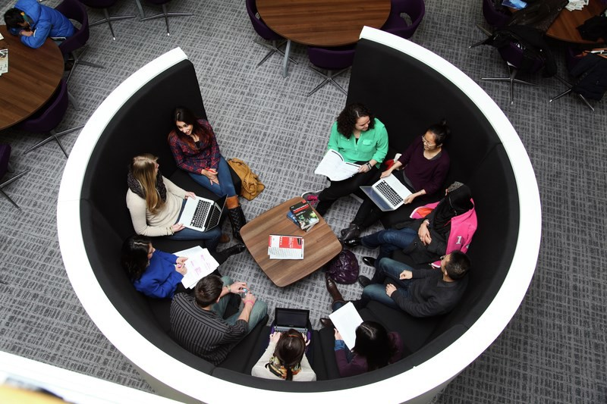

Principles for Responsible Management Education (PRME)
Sharing Information on Progress Report
Principles 1: Purpose
We will develop the capabilities of students to be the future generators of sustainable value for business and society at large and to work for an inclusive and sustainable global economy

Strategic Focus

Our purpose

Our purpose is to transform the prospects of our students by equipping them with the knowledge, skills and mind-set to succeed in management and, through research and knowledge exchange, to positively influence and shape policy and management practice.

Our mission

We are committed to building a Business School that is distinctive, globally-connected, research-engaged and financially strong, and a provider of choice for applied and professionally-accredited management education.

Values

The Westminster Business School values embrace the values of our wider University:

Progressive: We look forward, anticipate what’s changing and embrace the new with energy and

imagination. In all areas of business and management, our programmes are continually adapted to the practical needs of employers and the professions.

Compassionate: We are thoughtful and sensitive, supportive and encouraging, making time to talk,

especially when the pressure is on. As a University community we are inclusive and united, careful to consider what enables each and every one of us to play our part, and our school structure enables and reinforces this.

Responsible: Individually and collectively, we take responsibility for our actions, work to the highest

ethical standards and help each other to do the right thing. We support the Principles of Responsible Management Education (PRME) and encourage our students to embrace the virtue of sustainability in business and enterprise.

A focus on ethical behaviour, sustainability and engagement is central to all our activities. We monitor these values on a daily basis and work towards an organisational culture where ethical behaviour is the norm, where both colleagues and students are mindful of the environmental consequences of individual choices, where recycling is second nature to us all. All our students and staff receive refillable bottles and we aim to minimise the use of plastic bottles on our campuses.

At Westminster Business School, we view professional education as a partnership, and we encourage all staff and students to be:

• Responsible: Accountable for ourselves and our actions

• Engaged: Actively learning, teaching and working

• Respectful: Considerate of others and their ideas

• Informed: Aware of policies, procedures and developments

• Clear: Thoughtful and constructive communicators

• Prepared: Ready to learn, teach and support one another

• Punctual: Meeting deadlines and being on time

• Lifelong learners: Committed to personal and professional growth

Principles for Responsible Management Education (PRME)
Sharing Information on Progress Report
Principles 1: Purpose
We will develop the capabilities of students to be the future generators of sustainable value for business and society at large and to work for an inclusive and sustainable global economy
Principles for Responsible Management Education (PRME)
Sharing Information on Progress Report
Principles 1: Purpose
We will develop the capabilities of students to be the future generators of sustainable value for business and society at large and to work for an inclusive and sustainable global economy

Strategic Priorities

We are a College that plays a leading and unique role in helping students from different backgrounds realise

their full potential. We are a high-performing learning organisation and a community of educational

endeavour where individuals, students and colleagues are able and encouraged to pursue their personal

goals. We are respected as leaders in teaching, research and engagement with industry, employers and the

professions in the development of work-ready graduates for management in a wide range of sectors.

We are making more of a difference than ever before. We are helping more individuals to develop in ways

they value through our learning and teaching activities. We are making a stronger contribution to the

world’s learning and well-being through our research. We are making a bigger difference to organisations

and society through our knowledge exchange endeavours. The recent organisational changes we have

made in the Business School will help facilitate an open, collaborative, accountable, focused and sustainable

organisation built to last.

We have ambitious expectations for both our students and staff. Our portfolio of programmes covers a wide range of disciplines; each providing our students with an intellectually stimulating and distinctive education which prepares them for professional management and business careers.
Our strategic priorities can be summarised as:

  - Demonstrating excellence in all our activities (teaching, research, partnerships and operations)
  - Gaining recognition as a business school of choice for aspiring business students by ensuring that our graduates are confident, independent, highly employable and free thinking; furnished with the technical and analytical skills to understand and resolve the constantly evolving intellectual, professional and business challenges that they will face during their careers

We view our continued association with PRME and the implementation of the PRME principles as key elements in our ability to achieve these strategic priorities.

Achievements

In the last two years we have worked on:

  - Conducting a strategic review of our portfolio of taught courses to ensure that the curricula contains leading edge thinking related to PRME principles and QAA’s Education for Sustainable Development initiatives. This has resulted in development of innovative modules to engage students with the material. Examples of these are described in the Values section of this report
  - Revising our operational practices to embed sustainability and demonstrate to our students the values and attributes that we encourage them to adopt. Working in partnership with the University’s Sustainability Team, extensive modifications to our operational practices have been achieved. Details of specific enhancements are described in the Methods section of this report

Recognition of Achievements
Principles for Responsible Management Education (PRME)
Sharing Information on Progress Report
Principles 1: Purpose
We will develop the capabilities of students to be the future generators of sustainable value for business and society at large and to work for an inclusive and sustainable global economy

People and Planet Award – 50 place ranking improvement

Our continued efforts to improve our environmental and ethical performance were formally acknowledged by our ranking of 49 in the People and Planet league table of 150 universities. We jumped 50 places from our 2015 position and were awarded a 2:1 classification. This places us in the top 7 London based universities.
People and Planet is the UK’s only comprehensive and independent ranking of universities by ethical and environ- mental criteria published by The Guardian.

EcoCampus – Gold Award

After a comprehensive audit, we gained an EcoCampus Gold Award. EcoCampus is the leading Environmental Management System and Award Scheme for the Further and Higher Education Sectors in the UK. This is a major step to achieve our ambition to become ISO 14001 accredited. The EcoCampus scheme offers a flexible approach to gaining standard ISO 14001. In addition to providing tools and guidance, it also offers recognition of progress through awards at each phase.

The Duke of Edinburgh Gold award has been introduced this academic year further supporting the principles of retaining PRME on our courses.

Principles for Responsible Management Education (PRME)
Sharing Information on Progress Report
Principle 2: Values
We will incorporate into our academic activities and curricula the values of global social responsibility as portrayed in international initiatives such as the United Nations Global Compact

Teaching at WBS

Ethical behaviour, sustainability and engagement are the principles underpinning our teaching activities. We adopt a holistic approach to teaching which incorporates a focus on the social, ethical and environmental dimensions of business strategies and operational practices. We believe strongly that the most effective learning occurs when
students are engaged, active learners and this is reflected in our “learning through doing” and “practice based” teaching approaches.

A new MSc in Sustainable Management and Innovation is to be launched in 2020 and the College leads in teaching Sustainable Business to final year students across all our Business Management courses.

We are committed to embedding the following graduate attributes into all our courses and we are committed to preparing all our students for meaningful graduate employment. When they leave Westminster Business School we want them to be:

    - Critical and creative thinkers,
    - Literate and effective communicators,
    - Entrepreneurial
    - Global in outlook and engaged in communities, and
    - Social, ethically and environmentally aware

  - We have worked hard to embed sustainability and social responsibility within every undergraduate and postgraduate taught programme. We are confident that our enhanced programmes provide a distinctive learning experience and significant opportunities for our students to our gain a thorough understanding of the way in which organisations can respond positively to some of the world’s most pressing issues.

Principles for Responsible Management Education (PRME)
Sharing Information on Progress Report
Principle 3: Method
We will create educational frameworks, materials, processes and environments that enable effective learning experiences for responsible leadership
Principles for Responsible Management Education (PRME)
Sharing Information on Progress Report
Principle 2: Values
We will incorporate into our academic activities and curricula the values of global social responsibility as portrayed in international initiatives such as the United Nations Global Compact

Examples of activities that focus on ethics and sustainability

Working with the Busogo Trust in Uganda

PG groups of students from the MBA course went to Uganda in 2018 and 2019 in partnership with the Busogo Trust, a leading Ugandan water and sanitation charity. The students raised half the money for this project and the other half was funded by Westminster Business School. Students piloted education programmes around sanitation and hygiene with school children in Uganda. The success of the business model and the knowledge that the children shared with their families are bringing long-term benefits to the rural communities.

In the School of Organisations, Economics and Society we are building on the success of our projects in Uganda. Currently we are in the process of developing an MSc in Social Enterprise and an MSc in Sustainable Leadership and Innovation. We aim to attract students who intend to become agents for social change and raise awareness of individual and collective responsibilities for responsible business and sustainable individual behaviour. We actively seek opportunities to work in partnership with social enterprises. We aim to gain accreditation from the Carbon Trust for the forthcoming MSc in Sustainable Leadership and Innovation.

Sustainable Supply and Procurement

Sustainable Supply and Procurement is a core module for the MSc Purchasing and Supply Chain Management course. This module focuses on green logistics and its impact on procurement and supply chain management. During this module students are required to actively engage with the challenge of creating a company specific green logistic system which requires them to address a range of sustainability issues that occur in urban areas including: transportation and congestion, clean energy challenges, an ageing population, terrorism and the formulation and delivery of adequate and green Infrastructure able to meet future demands. Students present their solutions to a panel of company representatives.

Skills of the Manager

The Skills of the Manager is a core module on the MA HRM course. Through this module students learn to appreciate how wider cultural and environmental factors affect organisations. They analyse the global and national environment and their impact on the business environment. They also discuss ethical dilemmas and ethical requirements in the workplace.

Extra Curricula Practice Based Opportunities for Students

Our students enjoy a wealth of opportunities of extra curriculum activities provided for all students of the University of Westminster. Participating in these events enable students to develop vital life skills and also interact with students from different disciplines.

As explained in the previous section, we are committed to providing a deep and meaningful coverage of responsible leadership issues within our programmes. However, we realise the importance of providing extra curricula activities. Therefore, we encourage our students to engage strongly with a range of extra curricula opportunities designed to increase their practical understanding of CSR and sustainability issues, increase their confidence and enhance their skills development.

Examples of opportunities include volunteering through Westminster Extra Initiatives, undertaking placements and internships, and working with Westminster NUS on Responsible Futures activities. All of these extra curricula opportunities align explicitly to the PRME principles.

Principles for Responsible Management Education (PRME)
Sharing Information on Progress Report
Principle 3: Method
We will create educational frameworks, materials, processes and environments that enable effective learning experiences for responsible leadership

Westminster Extra Initiative
Each year many of our students devote their time and enthusiasm to support charities and organisations working in
the local community as well as overseas; they counsel, campaign, mentor and teach; they volunteer in schools, work with families and provide vital support to people in crisis.

Placements and Internships
We have a team of professional staff dedicated to securing placement and internship positions for our students. Lasting from a minimum of four weeks to an entire academic year, there has been a significant increase in the number of placements requiring students to focus on sustainable development and CSR issues.

NUS Responsible Futures
We encourage students to become actively involved promoting the NUS Responsible Futures initiative and work with the Westminster Student Union and University staff to ensure that the Student Voice is heard and social responsibility and sustainability is embedded into all of the University’s activities.

Below is a list of some practice-based opportunities currently available for all of our students.

https://www.westminster.ac.uk/current-students/employability-and-career-development/working-and-studying-abroad/types-of-opportunities-and-destinations/westminster-working-cultures

https://www.westminster.ac.uk/current-students/employability-and-career-development/exploring-careers/mentoring

https://www.westminster.ac.uk/current-students/employability-and-career-development/improving-your-employability/student-volunteering-service/benefits-of-volunteering
https://www.youtube.com/watch?v=NsuY3pzKTJ0Westminster.ac.uk/employability

https://engage.westminster.ac.uk/workgroups/graduate-jobs-and-events

westminster.ac.uk/employability-award

https://www.westminster.ac.uk/current-students/employability/improving-your-employability/work-experience-and-placements
https://engage.westminster.ac.uk/students/infopages/detail/98

Principles for Responsible Management Education (PRME)
Sharing Information on Progress Report
Principle 3: Method
We will create educational frameworks, materials, processes and environments that enable effective learning experiences for responsible leadership

Leading by example

We believe that it is important that the faculty demonstrate their commitment to the values underpinning our vision and mission. As part of the University’s Environmental and Sustainability policy, we have implemented a number of initiatives that address the main components of the policy. These include:

  - Promoting energy efficiency across the campus in a variety of ways. Energy consumption is continually assessed and evaluated by the Estates & Facilities Team through reporting mechanisms and campaigns. We are committed to reducing carbon emissions and have set the target to reduce our carbon footprint from buildings by 43% by 2020. We are achieving this through a variety of ways from designing more efficient buildings through BREEAM to engaging people on how best to use them through projects such as Switch Off

- Minimising waste productions far as practical by re-using or recycling waste and regulating the treatment and disposal of residual waste. Paper usage has decreased significantly following the adoption of electronic sub- mission of course works and only providing course materials in electronic formats

- Promoting “green travel” to minimise the impact of transport on the environment by providing a “season ticket loan” scheme and a cycle scheme to facilitate the tax efficient purchase of a bike. Wherever possible all
teaching only takes place on one campus to reduce inter-site travel by both staff and students

- Adoption of a sustainable procurement process that aims to promote environmentally responsible procurement of goods and services and ensure that we operate to the highest standards in terms of: health and safety, data protection, freedom of information, IT acceptable use and security, ethics, equality and diversity.

Principles for Responsible Management Education (PRME)
Sharing Information on Progress Report
Principle 4: Research
We will engage in conceptual and empirical research that advances our understanding about the role, dynamics and impact of corporations in the creation of sustainable social, environmental and economic value

Recently, there has been an increase in the number of research activities undertaken which directly support the PRME agenda particularly in the areas of sustainable economic development; social mobility, inclusion, equality and diversity; employment; and labour relations.

The majority of our research is concentrated in three Research Centres:

  - The Centre for Employment Research (CER)
  - The Centre for the Production of the Built Environment (ProBE)
  - Centre for Digital Business

These centres have established reputations for excellent, internationally world-leading research that attracts funding from leading grant-awarding bodies such as ESRC, the Leverhulme Trust, and the Nuffield Foundation.

In addition to the research centres, there are also three active research groups:

  - IDEaS – Innovation, Design, Entrepreneurship and Strategy Research Group
  - Equality, Diversity and Inclusion Group
  - Entrepreneurship Special Interest Group

Titles of specific research projects are listed below:

  - Further Education: Social Mobility, Skills and Second Chances
  - Managing Conflict and Resolving Disputes
  - Research into Society Diversity
  - An impact analysis of training and skills for the unemployed
  - Locating Poverty in Retirement amongst Women of the Asian Diaspora in Britain
  - Women in the Construction Workforce
  - Development of Equality Framework for Women in Construction Industry
  - Diversity Works for London
  - Influence On-line

Principles for Responsible Management Education (PRME)
Sharing Information on Progress Report
Principle 5: Partnership
We will interact with managers of business corporations to extend our knowledge of their challenges in meeting social and environmental responsibilities and to explore jointly effective approaches to meeting these challenges
Principles for Responsible Management Education (PRME)
Sharing Information on Progress Report
Principle 5: Partnership
We will interact with managers of business corporations to extend our knowledge of their challenges in meeting social and environmental responsibilities and to explore jointly effective approaches to meeting these challenges

A distinguishing feature of Westminster Business School is our deep association with business corporations and professional bodies. We understand the importance of partnerships in enabling us to deliver our mission and
strategic priorities. Strong partnerships enhance our students’ learning experience, underpin our employability initiatives and enable us to deliver on our Education for Sustainable Development agenda.

We have regular contact with our partners and are committed to working with them in ways that are mutually beneficial and socially responsible. We are involved in a variety of knowledge transfer activities, ranging from corporate professional development through to support for SMEs in London to consultancy and thought leadership, especially in finding creative solutions to help businesses tackle sustainability and CSR issues.

Inclusive Futures is a new initiative emphasising our commitment to diversity and equal opportunities. Students are invited to hear from industry experts and recent graduates offering their views on a variety of topics including:

  - Gender Diversity – Why it still matters to employers
  - Working in the UK: What should you know as an international student?
  - LGBTQ+ Workplace Inclusivity
  - How to break into the elite
  - Graduate Recruitment and Entering the World of Work

We regularly organise events where students can talk to employers both face to face and online. These events enable students to understand different types of organisations and make educated choices about graduate employment. Below are a range of companies participating in our events:

Accenture (Online)  Airbus China (Online)  Ascot (Online)  Atkins (Online  BAE Systems (Online)  BDO (Online)  Bird & Bird (Online)  Bloomberg (Online)  Bouygues Energies & Services (Online)  Brandsen & Tourgot Executive (Online)  Charityworks (Online)  Civil Service Fast Stream (Online)  Clifford Chance (Online)  East London Business Alliance (Online)  Frontline (Online)  GlaxoSmithKline (GSK) (Online)  Highered EFMD (Online)  Home Office Digital Internships (Online)  Irwin Mitchell LLP (Online)  ITV (Online)  Leonard Cheshire: Change 100 (Online)  Montgomery (Online) | Nike Inc (Online)  Premier Pathways (Online)  PwC (Online)  Shoosmiths (Online)  THRDS (Online)  Virgin Media (Online)  Afro-Caribbean Insurance Association  Ambition  Archus Limited  BGC Partners  Brands2Life  Change100  Civil Service Fast Stream  Computacenter  Dexters Estate Agents  Docebo UK  East London Business Alliance (ELBA)  FDM Group  Goldman Sachs  Graduates into Health  Heart of London Business Alliance  Hire STEM Women  i-movo | Investment2020  The Chartered Governance Institute  Kurt Geiger  Lidl  Mansion House Consulting  Merkle Inc  Metropolitan Police  Montgomery  National Graduate Development Programme (NGDP)  NetApp  Portland Communications  Santander Consumer  Skills Development Network London - NHS  Sky UK  Step  Student Circus  TechTarget  Transport for London (TfL)  Thrds  Twitter  Utility Warehouse Limited  Willmott Dixon Interiors

Principles for Responsible Management Education (PRME)
Sharing Information on Progress Report
Principle 6: Dialogue
We will facilitate and support dialog and debate among educators, students, business, government, consumers, media, civil society organisations and other interested groups and stakeholders on critical issues related to global social responsibility and sustainability

Responsible Management Seminar Series

The College runs regular seminars on a range of topics associated with responsible management. The seminars provide a forum for dialogue between the business community and academics. They also stimulate ongoing discussions about the contemporary challenges and issues facing organisations and members of the wider society.

BUIRA Seminar Series

The Central London British Universities Industrial Relations Association (BUIRA) monthly seminar series is also organised and hosted by the College and led by Professor Linda Clarke. These attract a lively mix of people from a range of different disciplines and organisations, including from universities, trade unions and employer associations, with prominent international and national speakers. In addition, the College hosts the BUIRA IR History Study Group seminar series, held 3-4 times a year and co-organised by Professor Clarke, including currently seminars planned on particular historical aspects of the automobile industry and of public sector management.

Westminster Business School Research Seminar Series

These events take place in our Schools and they are led by the Schools’ Research Directors. The seminars provide a forum for the discussion and dissemination of research findings. the events are attended by academics and researchers from both Westminster Business School and other academic and research organisations. Post-graduate students are also encouraged to attend.

Principles for Responsible Management Education (PRME)
Sharing Information on Progress Report
PRME Objectives 2019 – 2021

Over the next 18-month period, we want to build on the progress made during current reporting period and achieve further integration of the PRME Principles into all areas of our activities. In particular, we want to focus on the following objectives:

Principles 1: Purpose

  - Ensure that all of the College strategic priorities reflect our commitment to PRME
  - Continued strategic development of competences within each of our four Schools to ensure that we can instil in our graduates the knowledge, skills and attributes required to be responsible professionals and develop success business and management careers
  - Develop a clear strategy (including KPIs) for the further development of the PRME agenda within each School

Principle 2: Values

  - Ensure that the PRME agenda is regarded as a critical element of the programme validations / reviews and quality assurance processes
  - Continue to review curricula to ensure that they cover all aspects of the PRME agenda
  - Enhance our operational processes to promote further behaviours which reflect PRME principles

Principle 3: Method

  - Review our current teaching practice and share best practice related to the teaching of responsible management
  - Encourage the adoption of innovative pedagogies designed to facilitate student engagement with responsible management activities

Principle 4: Research

  - Develop a cluster of research around the pedagogic approaches to responsible management education. This work will seek to identify and evaluate innovative ways of engaging students in responsible management activities
  - Encourage all researchers to consider PRME implications and opportunities associated with their research findings
  - Strengthen the mechanisms to ensure that leading edge research informs our teaching of PRME issues

Principle 5: Partnership

  - To engage in more collaboration and partnerships with other members PRME members. Examples of activities which we intend to undertake include:
    - Join UK and Ireland Chapter of PRME and participate in events
    - Develop Enactus project opportunities in the UK and overseas
  - Develop relationships with socially and environmentally responsible organisations willing to support our initiatives to develop responsible graduates who will help to shape a better future for all
  - Support and develop collaborative projects with Industry and pursue multidisciplinary projects to tackle the issues relating to ethics, CRS and sustainability.

Principles for Responsible Management Education (PRME)
Sharing Information on Progress Report
PRME Objectives 2019 – 2021

Principle 6: Dialogue

  - To engage further with members of our local community and the wider academic community to reinforce adoption of PRME principles and act as a forum to share knowledge and best practice

- Overall we have mapped over 65% of education objectives with the 17 sustainability development goals.

