Swansea University School of Management

United Nations Principles of Responsible Management Education:
Sharing Information on Progress Report 2022

Contents

Section | Page
Letter of Commitment | 3
Statement from the UNPRME Implementation Group | 4
Section One: About the School of Management
Institutional Context | 5
UNPRME Implementation | 7
Section Two: The Current Situation  Principles One and Two: The School Strategic Purpose and Vision  Principle Three: Method  Principle Four: Research  Principle Five: Partnerships and Collaboration  Principle Six: Dialogue  Principle Seven: Organisational Practice | 10  10  14  16  19  21  23
Section Three: Future Objectives | 25
Appendices  - Sustainability and Ethics Modules | 28
- Ethics and Sustainability Survey | 29
- Research Articles related to Sustainability, Ethics, Climate and Social Benefit | 31

Letter of Commitment from the Pro Vice Chancellor and Executive Dean of the Faculty of Humanities & Social Sciences

It is my pleasure to introduce Swansea University School of Management’s first Sharing Information on Progress report for the United Nations Principles of Responsible Management Education initiative (UN PRME). We are a university that has been making rapid progress with our sustainability agenda in our research, our curriculum and our operations. In our Strategic Plan we outlined our commitment to aligning our work to the Sustainable Development Goals and made our commitment to being a carbon-zero university by 2035.

The School of Management here at Swansea University has responsible management education at its heart. The work of the School is aligned with our institutional commitments to make a difference, be socially responsible and have a global outlook. Through teaching, research and partnership with business across the Swansea region and beyond we drive forwards sustainable development and sustainable business.

I am delighted to confirm our commitment to the continued support of UN PRME.

Professor Elwen Evans QC.

Statement from Dr Simon Brooks, Chair of the UNPRME Implementation Group
With the launch of our new School of Management Strategy 2021-27 we have re-vitalised our commitment to UNPRME. We are proud of the strength of our commitment to sustainability and ethics which is evident in this report and the work of our School community.
As a School we have made deep and lasting progress relating sustainability to our five areas of core business, these being teaching, research, enterprise, the student experience, and our civic mission. A number of drivers have contributed to this. For example, reflecting on our experience of the pandemic has allowed us to consider how and what we do. In particular we have made some major enhancements to our portfolio of programmes, embedded sustainability and ethics teaching in our approach to business school accreditation, continued to grow our research profile in this area and expanded our collaborative and partnership working.
The following are highlights of some recent developments, which are expanded upon through this document.
- Our School strategy prioritises sustainability as part of our core purpose.
- Our new MSc Management (Sustainable Business) programme launches in September 2022 and our new MSc Sustainable Finance programme in September 2023.
- We have placed sustainable and ethical education at the heart of our application for AACSB accreditation.
- We are building on existing research and teaching strengths to create a ‘community of interest’ based on the UN sustainable development goals.
- We are successfully delivering our flagship Circular Economies and Innovation Communities programme
- Our pioneering work on the leadership and management of health and care continues to develop through our collaborations with the Bevan Commission, the Government funded Intensive Learning Academy and with private sector partners such as Pfizer.
Moving forward we are using our UN PRME Sharing Information on Progress report as a driver of organisational change and a demonstration of our commitment to being a leading sustainable business school.

Dr Simon B. Brooks, on behalf of the UN PRME Implementation Group.
July 2022.
Section One: About Swansea University School of Management
The School of Management sits at the heart of Swansea University’s impressive Bay Campus which opened in 2015 on reclaimed industrial land, adjacent to the beach in Swansea bay. The School is home to over 150 faculty and professional services staff and 3500 students. World-class facilities provide students with access to an outstanding learning environment which they helped co-create. Facilities include an impressive communal atrium, lecture theatres, teaching rooms, meeting rooms, computer laboratories, a broadcast standard media suite, and a professional learners MBA suite.
The School contains a broad range of subject groups, these being accounting and finance; strategy, operations and analytics; marketing and tourism; people and organisations and entrepreneurship and innovation. We also work closely with colleagues in the economics department, sharing expert teaching, specialist modules and collaborating on research.
We have an excellent track record of producing some of the country’s most successful graduates. This focus on employability, teamed with our vibrant forward-thinking faculty, state-of-the-art facilities and close links with industry, makes the School a truly unique place to study.
The University published its Strategic Vision and Purpose in 2020. This marks the start of the second 100 years of Swansea University, and as such the Strategic Vision and Purpose contains four commitment, these being ‘A Global Outlook’, ‘Social Responsibility’, ‘Making a Difference’ and ‘Striving for Excellence’. These commitments provide a supportive institutional context for The School of Management to pursue the principles of responsible management education.
More broadly, the university’s location in Wales means that our organisational purpose is influenced by the Wellbeing of Future Generations Act (2015) which commits the Welsh Government to a series of principles based on the United Nations Sustainable Development Goals. This act informs the priorities of many of the public sector bodies with which the School partners and interacts.
In 2021-22 The School of Management implemented its own strategic review and has prioritised sustainability as a key theme contributing to our core purpose. This is detailed in Section Two under ‘Purpose and Vision’.

The Institutional Context: Swansea University
Our report on progress covers the School of Management’s work to embed and promote responsible management education. However, the School of Management sits in the wider university context.

The university overall has strong environmental and sustainable credentials and is closely aligned with both PRME and the Sustainable Development Goals. Some of our achievements are listed below.

Times Higher Education Impact Rankings 2022

This international ranking assessed more than 1,400 universities internationally across the breadth of university activity from research stewardship, teaching, sustainability metrics, policies, outreach and partnership work and aims to capture universities’ impact on society. In 2022 Swansea has performed very well, ranking in the top 200 overall (101-200th) and within the top 20 for three SDGs showing our commitment to a sustainable future. The university was assessed against 11 of the 17 SDGs and came in the top 100 out of 1400 institutions for eight of these.

People and Planet Green League
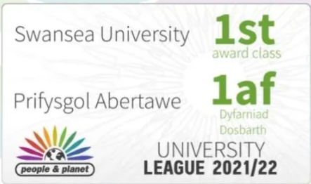
The university has been a strong performer in the People and Planet University League for many years. We are currently ranked in the top ten institutions and play a crucial sustainable development role in the region, the UK and globally.
Further information can be found here
https://peopleandplanet.org/university-league/2021/u263/swansea-university

University Sustainability Strategy

Our Sustainability and Climate Emergency Strategy (2021-2025) is aligned with the University's Strategic Vision and Purpose and sets out how we operationalise our Sustainability Policy, and commits us to actions across four key themes: The Climate Emergency, Our Natural Environment, Our Working Environment and Our Travel. The University also contributes to other key sustainable development goals: Wellbeing and Human Health, Wellbeing of Future Generations and the United Nations Sustainable Development Goals, working collaboratively with our research community to achieve a better and more sustainable future for all.

Climate Emergency and Net Zero

In 2019, we signed the 2019 Global Universities and Colleges Climate Letter, declaring a climate emergency and recognising the need for a drastic societal shift to combat the growing threat of climate change. In 2021 we committed to our new Sustainability and Climate Emergency Strategy. In the strategy we committed to achieving zero scope 1 and 2 carbon emissions by 2035. We also committed to reducing our scope 3 emissions by 50% by 2035. Our plan to achieve net zero can be found in our Carbon Management plan and sustainability strategy above.

The University is committed to sustainable and active travel and was Wales’ first Gold Standard Cycle Friendly Employer and works closely with local partners to enhance and promote cycling. As a part of this commitment the university introduced Swansea’s Santander Cycle Hire Scheme.

The University is home to numerous centres of excellence in research into renewable and sustainable technology and practices. In 2021 the SPECIFIC programme won the Queen’s Anniversary Prize for its work revolutionising applications for renewable energy.

Staffing and Culture

Swansea University aims to provide a working and learning environment, which is free from discrimination and enables staff and students to fulfil their personal potential. We welcome and celebrate the diversity our staff and students bring to the University, encouraging us to think differently and act differently.

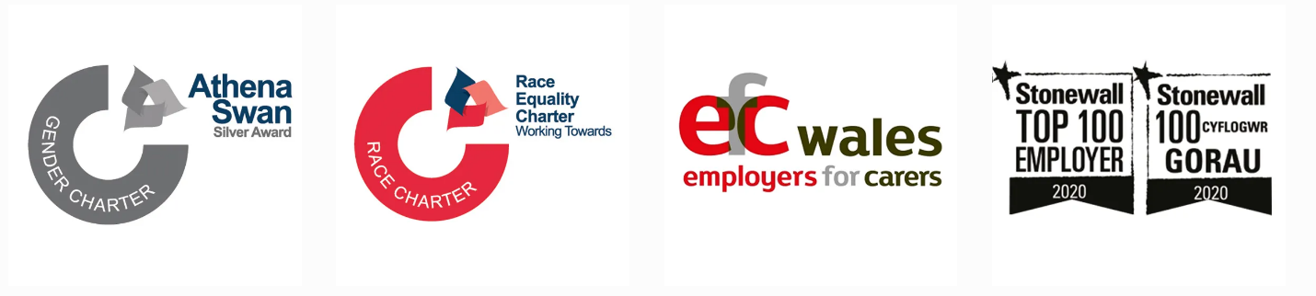

The University is an Athena SWAN Silver Award Winning institution and has been a member of the Athena SWAN Charter since 2008. The charter recognises the advancement of gender equality through representation, progression and success for all. The Charter is based on ten key principles, and through our commitment to it, we embed these principles within our policies, practices, action plans and culture.

Swansea University is a proud member of the Race Equality Charter (REC). Being a member of REC provides us with a framework, to help us identify and self-reflect on organisational and cultural barriers that might affect minority ethnic staff and students. From this (and our other Equality, Diversity & Inclusion measures), we develop initiatives and solutions for positive change across the University.

We are proud members of the Stonewall Workplace Equality Index (WEI), which provides us with a definitive benchmarking tool to measure our progress on lesbian, gay, bi and trans inclusion in the workplace. In 2022 Swansea University has increased its ranking from 47th to 26th, which is our highest ranking to date in the league table of UK employers. We are delighted that we have also increased our rankings in participating Education Sector entrants from 6th to 5th. We have achieved a Gold standard award, which recognises that we have embedded LGBT+ equality into our core areas of work at the highest level.

The School Implementation of UNPRME
The School of Management has established a UN PRME Implementation Group to support the development and implementation of our SIP.
The membership of the group is given below, although this is developing to include more colleagues as the PRME activities become more strategically embedded.
Dr Simon Brooks | Chair, Associate Professor of Strategy. Academic Lead.
Phil Brophy | Professional Services Lead and Secretary.
Professor Katrina Pritchard | Professor, People and Organisations.
David Bolton | Programme Director undergraduate programmes.
Dr Emily Bacon | Lecturer, Circular Economy Innovation Communities.
Dr Paul Davies | MBA Programme Director.
Dr Victoria Seller | Research Officer, Sustainability.
Dr Laurie Hughes | Senior Lecturer, Strategic Operations.
Dr Fiona Jordan | Lecturer, Tourism.
Dr Fern Davies | Senior Lecturer, Strategy and Corporate Responsibility.
Tracey Williams | Associate Professor, Accounting.
Hannah Johns | Careers Consultant.
Will Fleming | Senior Lecturer, Marketing.

There are five linked core areas of activity that the School will use to structure its implementation of the six principles of UN PRME. These are: research, learning and teaching, enterprise and innovation, student experience and civic mission. These correspond to the ‘five pillars’ of the university strategy.
These five core areas are briefly introduced here and will form key aspects of our situation analysis and our future objectives, which are themselves structured around the UN PRME principles.
Research
The research strategy has pledged to focus on climate change, as well as other areas covered by the SDGs, such as income inequality, wellbeing and justice. Existing activity will continue to be supported so that developments in learning and teaching can be truly ‘research led’ in the following areas:
- Circular economy.
- Sustainable finance and reporting.
- Small business social responsibility.
- Corporate sustainability strategies.
- Environmental standards.
Collaborations will be explored internally and externally to position the School within the wider University landscape reflecting the way strategic priorities inform each other.
Learning and Teaching
New masters’ level modules have been approved in the fields of both sustainability management and corporate social responsibility. This will lead to the creation of a specific MSc pathway in sustainable management. The progress of this pathway will be assessed periodically with a view to creating a full programme in sustainable management if demand is sufficient.
We also plan to embed sustainability in undergraduate programmes. Level four (year one) has recently undergone review with levels five and six entering review in 2022. We will also be adding a new MSc in Sustainable Finance. This is discussed below under Principle Three.
Enterprise and Innovation
There is a strong philosophy and clear mission for enterprise and innovation (E&I) in the School, grounded in the fact that Swansea University was founded by industry, for industry. This means that E&I is central to many of our collaborative activities.
Collaboration is a key driver of the development of new modules and programmes, additional research opportunities, our civic mission, and the student experience as we pursue our strategic priority of being a sustainable school of management.
The School is a component of a wider ecosystem comprising a range of internal and external stakeholders. We will proactively seek collaboration at four levels:
- Across subject groups within the School.
- With other Schools within the faculty.
- Across the University.
- With external stakeholders.
Enterprise and innovation acts as a link between organisational practice and both research and learning and teaching. Our enterprise activities include supporting development of major regional and national collaborations with government and industry, supporting a vibrant network of industry partners, adding value to the School and our stakeholders.
Student Experience
A holistic approach to the student experience is taken by professional services staff and faculty working collaboratively. Clearly learning and teaching as a core activity also plays a major part in the student experience.
We have an academic lead on ‘Student Engagement’ as well as a range of professional support colleagues, who have worked toward the construction of a ‘Student Engagement Strategy’ structured around six principles published in 2019-20. Highly experienced student support colleagues contribute to the student experience from the beginning of the student journey, from organising open days, and clearing visit days, through to pre-arrival communications and supporting student induction and ‘welcome week’.
The physical learning environment has also been partly designed by and co-created with the student body.

Civic Mission
Our civic mission activities are built on our strengths in enterprise education, which is in turn linked to our strong research impact initiatives.
For example, we have worked with Swansea City Council and other local authorities to stimulate social and economic development in the region. Colleagues in the fields of enterprise and innovation produced underpinning research and formed an integral part of the team that succeeded in securing the City Region City Deal. The school also contributes to a range of projects related to key societal challenges such as climate change, digitization, wellbeing and the need for advanced manufacturing.

Section Two: The Current Situation
As this is the first Sharing Information on Progress report we are submitting we do not have formal actions from a previous report.
This section therefore presents an analysis of the current situation structured around the seven principles.

A note on terminology: In the university strategy, it refers to five ‘pillars’ of the strategy. As noted above, these are research, learning and teaching, enterprise, student experience and civic mission. In the school strategy we have aligned with these but use the term ‘core areas of activity’ to describe what we focus on. Where we are looking forward to the future from 2022, we refer to ‘six priorities’ which feed into our core purpose.

Principles One and Two: The School Strategic Purpose and Vision.

Purpose

We have grouped principles one (purpose) and two (values) together because we see our overall strategic purpose as being intimately connected to the values that underpin it. As is explained below, we align with the purpose and vision represented by the university’s five pillars, as well as the values represented by the four commitments.

The mission statement for the School is as follows:

“Our School is an integrated, collaborative community of professionals, engaging in research-led scholarship, education and innovation to share value with all our stakeholders. With our students we co-create an experience that equips them to become socially and environmentally aware global citizens. The School is committed to supporting the civic and cultural mission of the University in Wales and globally, aligning our work to the sustainable development goals.”

As can be seen, there are clear statements on sharing value with our stakeholders as well as the awareness we seek to engender in our learners. We also commit to aligning our core business with the UN sustainable development goals and the Wellbeing of Future Generations Act (2015) in Wales.

Figure 1: Swansea University Commitments and Pillars
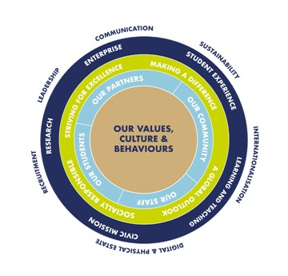
In 2021, the School undertook a consultative process of strategy formulation, guided by the four commitments embedded in the university strategic purpose.

The resulting School strategy for 2021 to 2027 is designed to build on prior achievements to continue to improve our response to the grand challenges facing society. We do this by articulating our vision and organisational purpose through our clear mission statement. We will focus on five core areas of activity, corresponding to the five pillars of the university strategy and informed by the four university commitments.

We believe that our four commitments, articulated through our five core areas of activity offer strong support for the integration of the Principles of Responsible Management Education into our strategy.

The School of Management is committing to aligning with the United Nations Sustainable Development Goals (UN SDGs) and will play a key part in moving the University to being ‘carbon-zero’ by 2035, as set out in the University Strategic Vision and Purpose.

In addition to the UN SDGs, the School is impacted by the policy context in Wales, specifically the Wellbeing of Future Generations Act (2015). We therefore interpret sustainability broadly to include all aspects of the SDGs rather than solely ecological and environmental considerations.

Having introduced the mission statement and our current strategic context, the diagram below presents the six priorities that the school has identified looking forward. These are mutually dependent to varying degrees and taken together could be said to describe our core purpose.

Figure 2: School of Management 6 Priorities

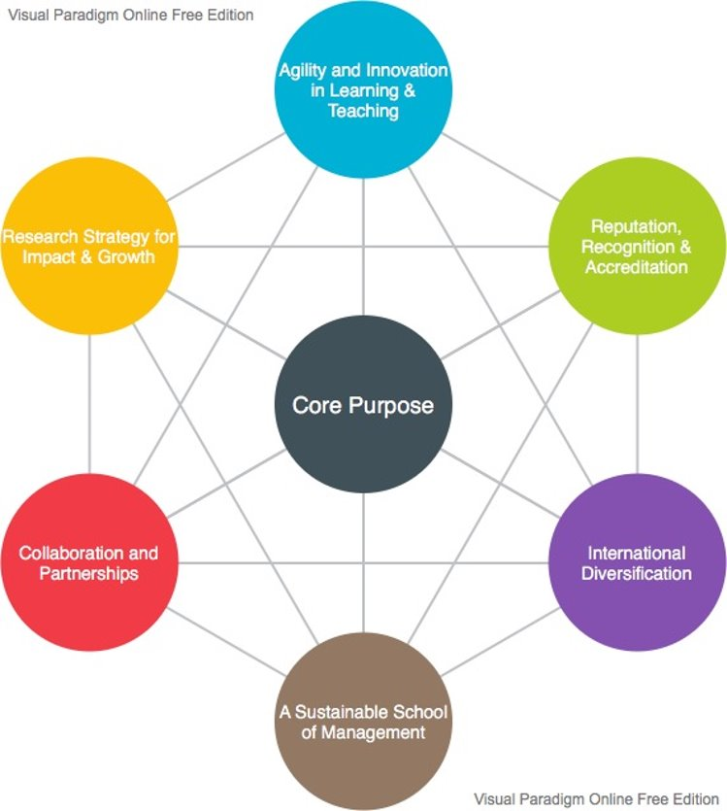

Our Values

Four Commitments

The values that underpin our five core strategic activities are articulated through the four commitments established by the University strategy. These are as follows:

Commitment One: | Social responsibility
Commitment Two: | Striving for excellence
Commitment Three: | Making a difference
Commitment Four: | Maintaining a global outlook

These four commitments inform all five areas of core business as articulated in our School Strategy. The commitments match those set out in the University strategy and therefore integrates the school into the wider strategic context of the values of the University.

Equality and Diversity

The School is committed to promoting gender equality and our policies are closely linked with wider university initiatives.

Swansea University has been a member of the Athena Swan Charter since 2008, and we are pleased to be one of only 20 universities in the UK to currently hold the Silver Institutional Award. We have achieved three departmental silver awards and seven departmental bronze awards.

The university is also committed to a Strategic Equality Plan (2020-24) which adopts an outcome approach to systematically embed equality into all aspects of the strategic direction of the University.

We are also committed to public engagement through, for example, our support for International Women’s Day. In 2021 we supported a series of events and keynotes speakers including sports personalities, industry leads and workshops presenting around the theme #choosetochallenge.

Swansea University has a number of policies aimed at reducing inequalities. These include the agile working policy and flexible working policy which supports employee’s performance and productivity whilst maintaining a positive work-life balance. Other policies include Family Friendly - Swansea University and Childcare - Swansea University.

Additionally, our Equality Annual Report contains information regarding staff and student demographic as well as an update in our Strategic Equality Action Plan.

At Swansea we oppose and challenge homophobia, biphobia, and transphobia, seeking to create a positive and inclusive environment that allows our LGBT+ colleagues and students to be respected in their identity and expression. We support all LGBT+ people within our community and are proud of the work we do as we continue to promote diversity, inclusivity and equality. We have established staff networks for working carers, LGBT+ colleagues and LGBT+ allies, Black, Asian and Ethnic Minority colleagues and disabled colleagues. In 2019, Swansea University became the first Welsh higher education institution to join the Employers for Carers (EFC) membership.

Principle Three: Method
We will use the new school strategy (2021 to 2027) as a framework to guide our tactical and operational approaches to integrating responsible management education. Under ‘Principle Three’ we focus on ‘Learning and Teaching’ and ‘The Student Experience’.
Learning and Teaching
New masters’ level modules have been designed in the fields of both sustainability management and corporate social responsibility, and it is anticipated that these will be approved within the first six months of the period covered by this SIP. This will lead to the creation of a specific MSc pathway in sustainable management. The progress of this pathway will be assessed periodically with a view to creating a full programme in sustainable management. We also plan to embed sustainability in undergraduate programmes beginning with a current review of years two and three.
At masters’ level, our recently validated MBA is designed to critically evaluate the impact and purpose of organisations. The initial module (which attracts double the credits of other modules) is entitled ‘Exploring Organisational Purpose’. This examines the history of organisational governance and management, leading to an exploration of the increasing commonality between corporate responsibility, stakeholder theory and organisational strategy.
BSc Business Management is our largest undergraduate programme, attracting approximately 400 students per annum. Years two and three (levels five and six) of the programme are being restructured with sustainability, equality and diversity, and employability being three of the five cross-programme themes around which future modules will be structured. The audit of existing modules for these themes began in May 2022.
Methodologically the established structures and processes around module and programme review will be augmented by a specific audit of the extent of sustainability related teaching which will then be updated annually.
Climate Emergency Education
The School and University will be rolling out a programme of climate emergency education to all students. We will be piloting and evaluating this training in the School of Management. The training is based on the materials and approach developed by the Carbon Literacy Project, EAUC and Manchester Metropolitan University. The training aims to give students an awareness of the climate emergency impacts of everyday activities, and the ability and motivation to reduce emissions, on an individual, community and organisational basis. This is supplemented by a wider programme looking to embed climate emergency education in programmes across the School and Institution.

Modules

Below are some of our existing exemplar modules in sustainability, ethics and corporate social responsibility. Our existing modules which explicitly link to the Sustainable Development goals are listed in Appendix 3 below.

Sustainable Tourism |  |  |  | Corporate Governance and Ethics
This module identifies the core principles of sustainable development and examines how they can be put into practice with the aim of making various tourism types and destinations more sustainable. |  | 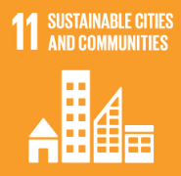 |  | Values, ethics and governance are essential skills for finance professionals. It is important for all those with aspirations to a career in accounting or finance to understand what it means to work and act professionally and ethically in the workplace. |  | 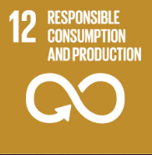
Sustainability and Environmental Management |  |  |  | Corporate Social Responsibility
The course studies the drivers and opportunities for businesses to improve their environmental performance. A broad range of environmental management issues are examined, both from the viewpoint of the current status and future development, and these are illustrated using appropriate case histories. |  |  |  | This module provides an overview of the concept of Corporate Social Responsibility (CSR) and the challenges and opportunities associate with managing CSR in a global context. |  | 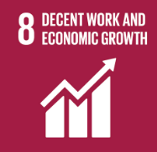
MSc Sustainable Finance

Launching in 2023 our new MSc in Sustainable Finance will bring together our teaching and research excellence in Sustainable Finance. The programme is set against the Paris Climate Agreement of 2015 which sets out a global framework to avoid climate change by limiting global warming to below 2°C. To achieve this the finance industry will need to mobilise funds sufficient to secure the required investment on a massive scale.

Sustainable finance is defined as investment decisions that account for the environmental, social, and governance (ESG) factors of an economic activity or project. Investing in businesses and projects with sustainable ESG practices is already on the rise, as is demand for finance professionals with expertise in this rapidly growing field. For sustainable financing to work it requires investors to have reliable information to base their decisions on. This is being met by new international reporting standards that require companies to account for and report on their sustainability. This programme will provide students with an awareness of the main issues relating to the global transition to net-zero greenhouse gas emissions as well as equipping them for employment in the fields of sustainability reporting and sustainable investing.

The Student Experience
Our School of Management student experience is central to our success and is a result of a holistic approach by professional services colleagues and academic faculty working together.
The disruption caused by the COVID-19 pandemic accelerated a trend that has seen the importance of student support from professional services colleagues move to the foreground of the student experience. This includes pastoral support, well-being, careers support and informational technology support.
We have an academic lead on ‘Student Engagement’ as well as a range of professional support colleagues, who have worked toward the construction of a ‘Student Engagement Strategy’ published in 2020.
Key elements of this strategy are:
- Excellent student support networks available to students.
- Co-creation of the student learning environment.
- A strong sense of community.
- An embedded employability ethos.
- Excellence in the provision of learning and teaching.
We want our students to think of themselves as professionals who will make the world a better place. Whether that is through setting up a new business, working on a social enterprise, volunteering in the community or adding value to an organisation. Our programmes encourage our students to think differently and pursue social as well as economic value.
We enable students to co-create their experience with us. For example, despite the School building being newly built in 2015, student feedback told us they needed more communal space and study space. We worked with students to give them a strong voice in the redesign of our reception area, a student common room and the creation of a variety of innovative communal and study spaces on all floors of the building.
Student support in the School of Management has been an area of strength. Highly experienced student support colleagues contribute to the student experience from the beginning of the student journey, from organising open days, and clearing visit days, through to pre-arrival communications and supporting student induction and ‘welcome week’. Support professionals also link students through to the ‘student voice’ structure (student representatives), as well as to student community activities like societies and student events.
The School has a large team of employability professionals who support students through careers advice and the provision of placement opportunities. They engage with students through a plethora of activities including; webinars, employer-led events, ‘business in the bay’ competitions, mock interviews, employability fairs and the provision of an ‘employability module’. The team also works with academic staff to ensure employability skills are embedded throughout taught programmes, as well as linking with our E&I academics.
We are proud of the difference our support teams make to the student experience at all points of their journey and this is recognised by the students.

Principle Four: Research
The research strategy has pledged to focus on climate change, as well as other areas covered by the SDGs, such as income inequality, wellbeing and justice. Please see Appendix Three for selected publications related to the sustainable development goals.
Existing activity will continue to be supported so that developments in learning and teaching can be truly ‘research led’ in the following areas:
- Circular economy.
- Sustainable finance and reporting.
- Small business social responsibility.
- Corporate sustainability strategies.
- Environmental standards.
Collaborations are being established internally and externally to position the School within the wider University landscape.
The existing research centres are listed at the end of this section. However, a new ‘community of interest’ is being established in the summer of 2022 to act as a focal point for colleagues interested in research, scholarship and teaching in the area of sustainability. This will deliberately seek to link research to learning and teaching and will remain an open community.
The research strategy of the school, and the research centres are guided by the research priorities of the university. These are set out below. Those that align most closely to UN PRME are in bold.

- sustainable futures and the environment
- health innovation
- digital futures
- justice and equality
- smart manufacturing
- culture, communication
- heritage, steel innovation.

While the School expects to collaborate on aspects of all of these University priority areas, some will necessarily attract more focus, based on our capabilities and available expertise. The areas in bold type above are those aligned with UN PRME where the school has existing or developing research expertise.
From 2021, the School has been part of a wider faculty, made up of the School of Social Sciences, the School of Culture and Communication and the Hillary Rodham-Clinton School of Law. This opens opportunities for collaborative activities, expanding our research scope.
Alongside the established research at the School, recent developments in our strategic environment have led to the emergence of four overarching themes that several of the School’s subject groups have developed interest in from both a research and a learning and teaching perspective. These themes are:
- Firstly, sustainability and responses to the climate crisis. This is aligned to the University priorities and commitments, as well as several emerging themes in the School.
- Secondly, a related interest is emerging in questioning ‘business as usual’. This is from a broadly critical perspective and draws on existing interests in ethical and responsible business.
- Thirdly, the future of work and employment is an increasingly significant area of research, encompassing remote working, precarity of employment and flexible working, among other themes.
- Finally, there is a broad interest in, and an awareness of, the importance of digital futures and data analytics. There are ethical elements such as digital inclusion, which relates to aspects of individual and societal wellbeing

Existing Research Centres

The following research centres support and drive the research agenda of the School.

Centre for Health and Environmental Research and Innovation (CHEMRI) | Centre for People and Organisation (C4PO) | Centre for Research in Macroeconomics and Macro-Finance (CREMMF) | Centre for Visitor Economy Research (CVER)
Emerging Markets Research Centre (EMARC) | Hawkes Centre for Empirical Finance | Swansea Innovation LAB | Welsh Economy Labour Markets Evaluation Research Centre (WELMERC)

Research Case Study

Sustainable Tourism in National Parks
This project with Pembrokeshire Coast National Park Authority will involve the identification and implementation of more effective tourism planning, development and management strategies. There will be significant impact on the development of tourism and event planning in the context of climate change and the dangers of ‘over-tourism’.
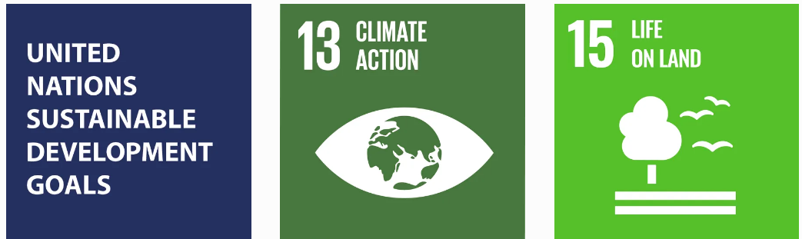

Selected Research Publications (please see Appendix Three for the full list)
Output Title | Authors | Journal
Women's Mountaineering Tourism: an empirical investigation of its theoretical constraint and benefit dimensions | Tiffany Low | Sustainable Tourism Development: Issues, Challenges and Debates
Sustainability and legitimacy theory: The case of sustainable social and environmental practices of SMEs | Mohamed Elmagrhi, | Business Strategy and the Environment
The social benefits of kaizen initiatives in healthcare: an empirical study | Nicholas Rich | International Journal of Operations & Production Management
Forty Years of Climate and Land-Cover Change and its Effects on Tourism Resources in Kilimanjaro National Park | Sarah Nicholls, | Tourism Planning & Development
Bridging the gap between circular economy and climate change mitigation policies through eco-innovations and Quintuple Helix Model | Paul Jones | Technological Forecasting and Social Change
Sustainable consumption from the consumer’s perspective: Antecedents of solar innovation adoption | Yogesh Dwivedi | Resources, Conservation and Recycling

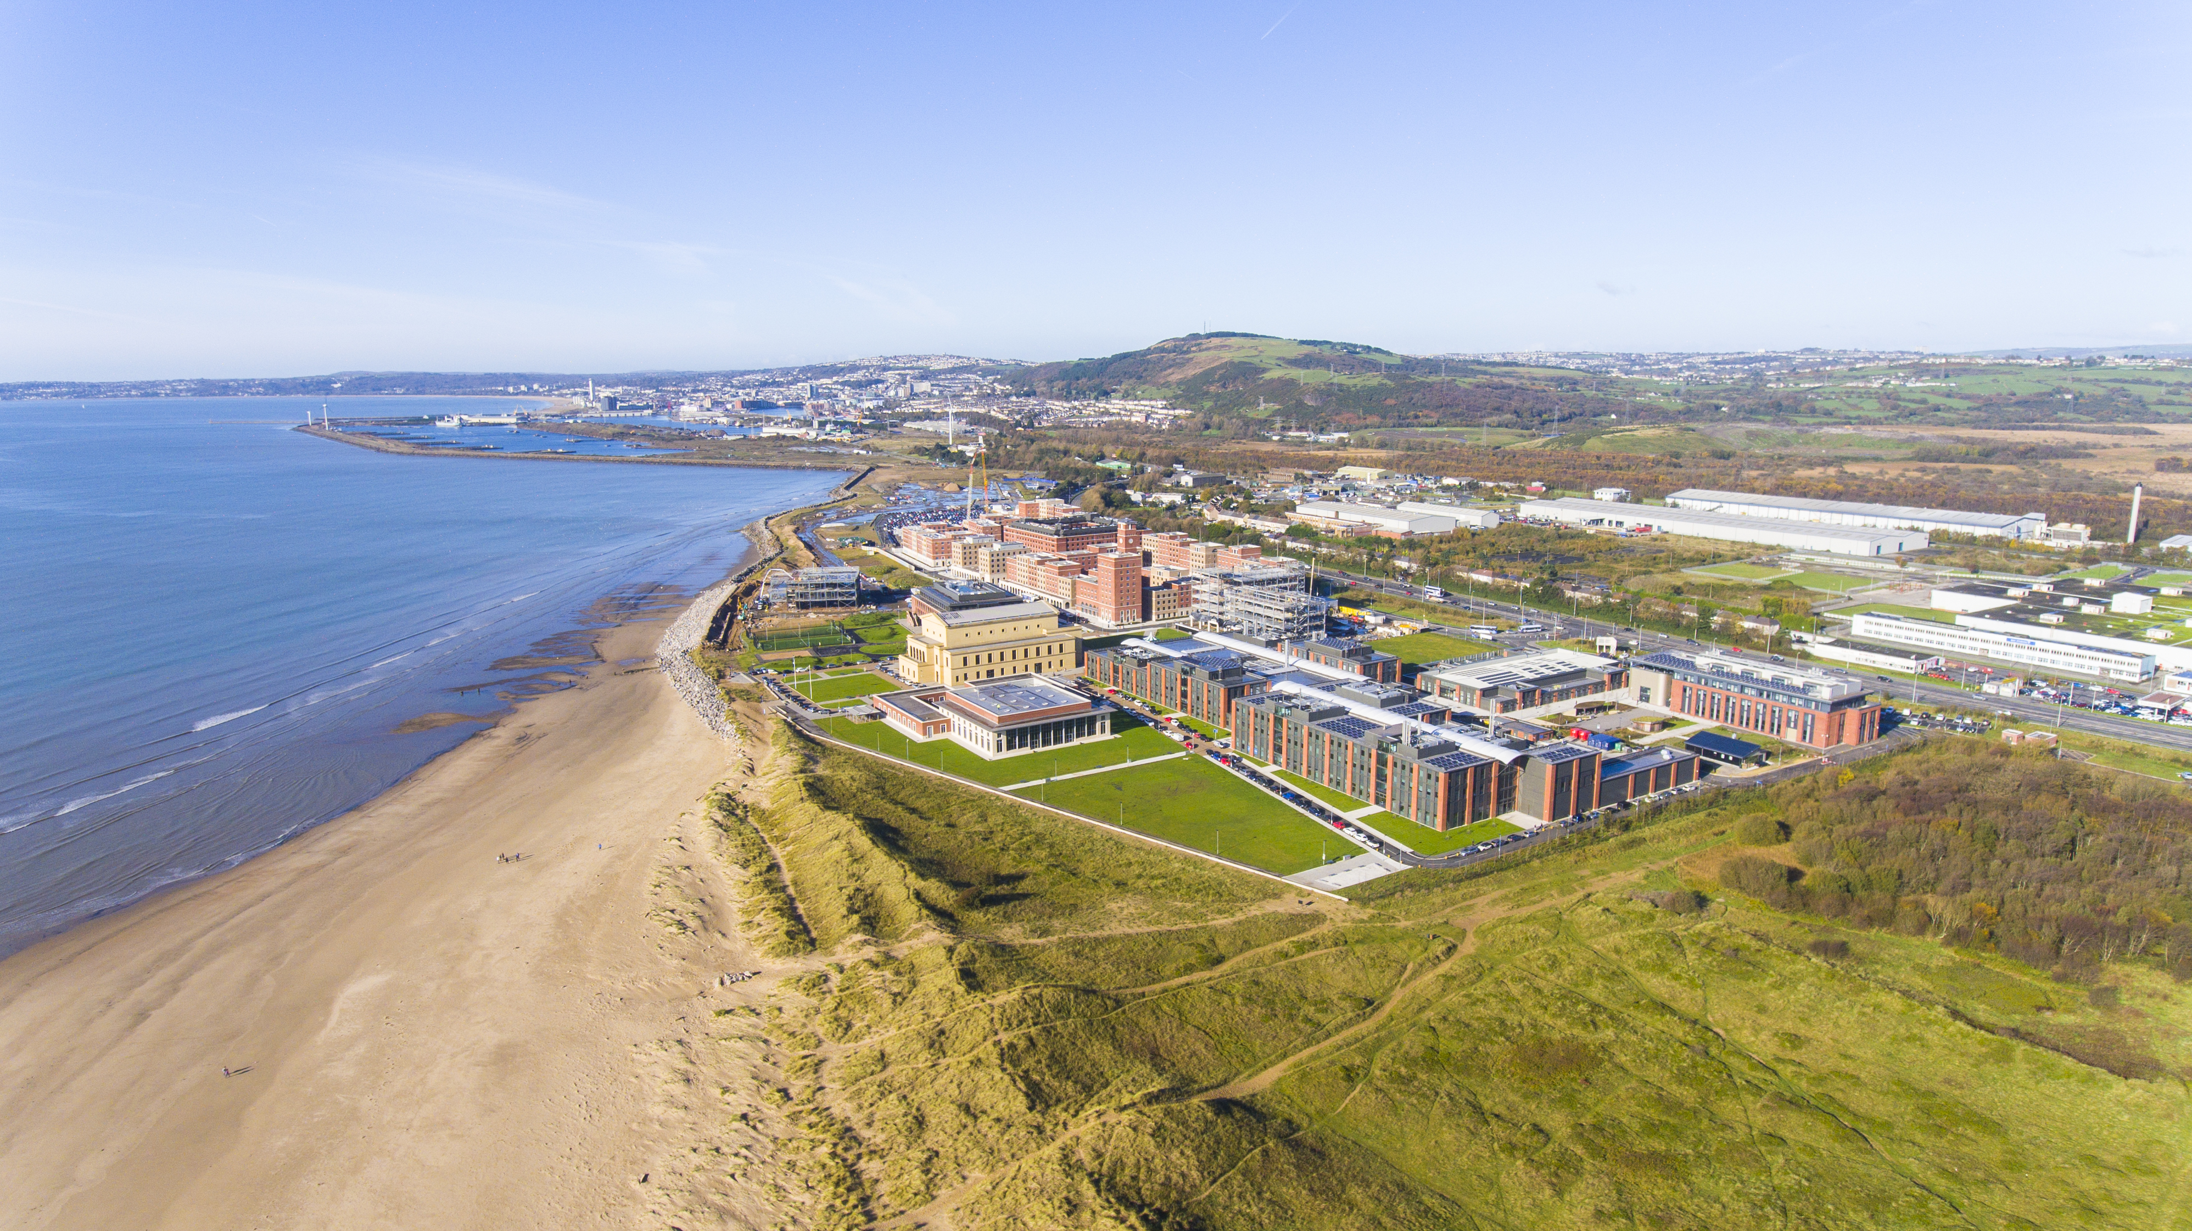
Principle Five: Partnerships and Collaboration

The School of Management has a number of strategic partnerships which enhance what we do and how we work. This aspect of the school’s activity also links closely with the UN PRME ‘Dialogue’ principle.

We have very strong partnerships with the health and wellbeing sectors in particular through the Bevan Commission who are based in the school. We also closely collaborate with the Welsh Government and other bodies through the two Intensive Learning Academies (ILAs) for Value-Based Health and Care and for Innovation in Health and Social Care.

The ILAs have been able to provide access to education on innovation in healthcare through short-course executive education, as well as at master’s level and the Doctor of Business Administration.

We additionally support AGORIP which works to commercialise ideas and innovation from across Wales, and the Circular Economy Innovation Communities (CEIC).

Examples of our partnership projects are:

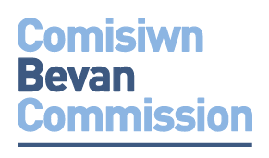 |  | Based in the School of Management, the Bevan Commission is Wales leading health and care think tank. Established in 2008 to observe, interpret, analyse, scrutinise, advise and comment on health-related matters in Wales. Its role now is to provide independent, authoritative advice to the Welsh Government and leaders across NHS Wales, the UK and internationally. The Commission translates its thinking into practice through a number of different means, including the innovation programmes such as the ‘Bevan Exemplars’ programme which supports staff to develop their own innovations.  https://www.bevancommission.org/
A School of Management initiative, the Circular Economy Innovation Communities (CEIC) project provides public sector organisations in the Cardiff Capital and Swansea Bay regions with the knowledge, skills, experience and ideal environment to collaboratively identify and solve common challenges through solutions that are resource-efficient, resilient and low-carbon by design.

CEIC deliver a 10 month programme with stakeholder engagement, workshops, site visits, action learning, peer learning and support, expert master-class support and implementation support. CEIC works with business and the public sector
https://ceicwales.org.uk/
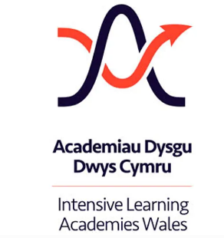 | The school hosts two Welsh Government supported Intensive Learning Academies which support innovation, from the incremental to transformative across Health & Social Care. Involving public, private and third sectors through a case-based learning and practice approach, drawing upon front-line activities of groups such as the NHS Innovation Leads through to international knowledge and expertise of international partners and networks.  The Value-Based Health and Care Academy is aimed at Leaders and Senior Managers with an interest in developing knowledge and insight in how to develop and engage with Value-Based Health and Care (VBHC) systems and services https://www.swansea.ac.uk/som/vbhc-academy/  The All-Wales Intensive Learning Academy for Innovation in Health and Social Care has been developed to deliver a world-class learning, research and teaching base that will equip leaders with the confidence, skills and capability to realise innovation in health & care and wellbeing.  https://www.swansea.ac.uk/som/innovation-academy/
AgorIP works across all sectors from business, to academic and to the NHS to help realise the potential of ideas, product or research. Our team of experts help take “IP” to the marketplace and help make it a commercial success. The project works across three main themes that relate to the UN SDGs:

- Equal opportunities, gender mainstreaming and the Welsh Language – reducing injustice and promoting social cohesion, while providing opportunities to increase prosperity and address imbalances in earnings in Wales.
- Sustainable development – ensuring projects meet social, economic and environmental objectives simultaneously. Preserving, protecting and improving the environment, providing a high quality, attractive place for people to live and work in Wales.
- Tackling poverty and social exclusion – helping those most in need and preventing future generations from experiencing poverty. The commitments focus on actions to create sustainable employment and progression opportunities and will help people to access those opportunities
https://www.agorip.com/

Principle Six: Dialogue

The School of Management has developed a wide range of external partnerships through which dialogue on the sustainable development goals is either taking place or will be developed. However, internal dialogue is also key to promoting the SDGs and UN PRME. Key stakeholders for internal dialogue include students, academic colleagues, professional service colleagues and the wider university.

The creation and maintenance of fruitful dialogue with stakeholders is central to the development of our commitment to UN PRME. The following examples illustrate the approaches we are taking at strategic and operational levels.

The School Strategy Process

The process of strategic framework formulation is inextricably linked to its successful implementation. The school strategy 2021-27 has been created through a series of staff and stakeholder consultations and guided by the five pillars and four commitments of the university ‘Strategic Vision and Purpose’.

This means the school strategy was created through dialogue, within the broad parameters of the university vision. That dialogue thoroughly embraced the four commitments to social responsibility, making a difference, taking a global perspective and striving for excellence.

Sustainability emerged as a key priority for the school, and this was defined broadly to match the UN SDGs and the premises of the Welsh ‘Wellbeing of Future Generations Act’ (2015). As can be seen under ‘Purpose and Values’ above, commitment to the UN SDGs is built into our mission statement.

This would arguably not have happened as effectively without a dialogic approach to strategy formulation. Dissemination of the school’s strategic priorities is now taking place to internal and external stakeholders.

School Colleague Involvement in UN PRME

The strategy formulation process above provided the opportunity to discuss becoming a participating member of PRME, and then this became part of the conversation in terms of implementing the school strategy.
UN PRME was also discussed at all-school staff meetings and email communications were used to set up an implementation group that began to meet regularly online to focus on the production of this report.
The implementation group includes an excellent spread of academic staff of different levels of experience and seniority, as well as professional services colleagues who have in some cases taken on leading roles in the process. The group contains the programme director of the MBA, drawing on recent experience of responsible programme design, as well as the programme directors of our large BSc in Business Management, and the Doctor of Business Administration. There is also a blend of research active and teaching-focused colleagues, as well as those involved in outward-facing enterprise and innovation roles.
Moving forward in 2022, the next stage is to establish leadership roles for aspects of the implementation of UN PRME principles, as well as creating a multi-disciplinary ‘community of interest’. This community is deliberately not being characterised as a nascent research centre because we want it to be inclusive of those focusing on learning and teaching as well as research and innovation. It should also be open to non-academic colleagues because the UN SDGs represent issues that affect the operation of our institution as well as informing teaching, research and innovation.
This community plans to invite guest speakers on a broad range of sustainability-related topics, as well as providing opportunities for colleagues to show-case their own research or teaching practice.
Programme Redesign

The process of undergraduate programme restructuring will include sustainability, equality and diversity among five cross-cutting themes. This is being communicated to all stakeholders involved in consultation on programme design, including students, module leaders, senior colleagues and external stakeholders such as professional bodies. The imperative to embed the UN SDGs into as many aspects of our learning and teaching as possible is also being communicated as part of this consultative process.
Ethics and Sustainability Questionnaire

In 2021-22 we began to use an ethics and sustainability questionnaire to measure the impact of our education on learners understanding of ethics and sustainability in business. This is designed not only to garner information from our students but also to stimulate debate in the student body about these issues.

During the programme redesign described above, students will be overtly engaged on the topic of sustainability, and the part that it should play in new modules and assessments. For example, larger assessments spanning several modules are being considered, and the key themes underpinning the programme, including sustainability, will potentially be written into the assessment requirements.

External Collaborations

The range of partnerships and collaborations in which the school engages has been displayed through examples in the previous section. All of these offer the opportunity to promote the school and university’s commitment to responsibility and sustainability.
This happens overtly through initiatives such as CEIC, but it is also implicit in much of the other work, especially in those programmes and collaborations designed to make a difference in the sphere of health and care, such as the Bevan Commission and the Intensive Learning Academies.
There are other examples of the school promoting its reputation for sustainability (defined broadly) through various activities.
For example, we have worked with Swansea City Council and other local authorities to stimulate social and economic development in the region. Colleagues in the fields of enterprise and innovation produced underpinning research and formed an integral part of the team that succeeded in securing the City Region City Deal, projected to create over 9,000 jobs and result in £1.8 billion of investment. These endeavours continue as we contribute to a range of projects related to key societal challenges such as climate change, digitization, wellbeing and the need for advanced manufacturing.
During the pandemic, School colleagues have worked with Neath Port Talbot Council on a project involving 63 schools, designed to use digital and social media marketing to improve attendance and achievement in the 11 to 18 age range.
School of Management colleagues have also led the Local Area Coordination (LAC) project, which is based around local community coordinators working on community cohesion with individuals and local businesses. The underpinning research has led to all of Swansea City being covered by local area coordinators, with the School providing initial funding for a coordinator in the early years of the project.
We recognise moving forward that active membership of UN PRME offers the opportunity to more explicitly communicate our commitment to the SDGs and to stimulate debate among our stakeholders.

Principle Seven: Organisational Practice
The organisational practice of the school refers to structures, policies and processes that cut across all areas of our core business in the school strategy. This means this section links to, and overlaps with, research, learning, partnerships and collaboration, for example.
Operationally, the School is aligned with the University sustainability policy and will contribute to its four priorities: the climate emergency, our working environment, our natural environment and our travel. University. We will develop sustainability policies on staff travel, such as to conferences and recruitment visits. We are also considering how we address the environmental impact of the travelling undertaken by international students themselves.
Inevitably our structures, policies and processes are also integrated with the wider institutional practices at faculty and (more obviously) at university level. Much of what follows is therefore informed by this context.
Equality and Diversity
As set out under the section on our values, we have a number of policies in place to promote equality and diversity. These are established at a university level, but the School of Management plays a full part in supporting these policies.
Learning and Teaching
Our large business management undergraduate programme is going through a process of redesign with the structure and the policies guiding the programme being reconfigured to integrate sustainability, defined broadly through the UN SDGs, as a cross-cutting foundational theme.
Research
While many of the existing research centres have strong elements which focus on themes relating to the UN SDGs (please see Appendix # for a list of outputs), we are establishing a ‘Community of Interest’ based on sustainability across the school. This will not only provide many of the support features of a formal centre but will also admit a wider constituency to cover scholarship, learning and operational matters.
Climate Action Plan
The university declared a Climate Emergency in 2019 signing the Global Universities and Colleges Climate letter. We followed this up by responding to this emergency in our operations, teaching, research, meaning Civic Mission is now a core commitment of the University’s Strategic Vision and Purpose.
The University carbon emissions have reduced by 9,276 tonnes of carbon dioxide equivalent (CO2e) since then. We have also reduced building, utility and fleet, scope 1 and 2 carbon emissions by 2,432 tonnes of CO2e since baselining, against a backdrop of a growing teaching space. Additionally, we have increased solar PV capacity from 50KW to 490KW with 2,670,052 kWh of renewable energy generated since 2015/16, avoiding 376 tonnes of CO2e and saving £330,000 of imported grid electricity. We have also seen a 16% drop in CO2e from electricity consumption since 2015/16, which is on target for zero carbon by 2035
Our innovative ‘Active Buildings’ are generating, storing and releasing their own energy. Electricity supply for our Active Classroom building is generated by a steel roof with integrated solar cells and are capable of storing enough energy to power the building for two days.

Economic impact
There are a number of examples of the school making a positive economic impact to the region.
Entrepreneurship leadership has led to the establishment of ‘Agor IP’. This is a £20 million initiative, initially funded until 2023, which investigates and supports the commercialisation of ideas and products by providing support for intellectual property development. This project has also made a difference internally by helping raise the contribution from intellectual property to the University to circa £500,000.
Colleagues in the school produced underpinning research and formed an integral part of the team that succeeded in securing the City Region City Deal. These endeavours continue as we contribute to a range of projects related to key societal challenges such as climate change, digitization, wellbeing, and the need for advanced manufacturing.

Section Three: Future Objectives
This section is approached in tabulated format to clearly present our objectives and how we will monitor them.
Principle | Objectives (next 24 Months) | Measures and outcomes
One and Two: Purpose and Values | - Disseminate and embed strategic priorities across the school.  - Communicate to key institutional and external stakeholders.  - Embedded sustainability and UNPRME into our new School Strategy  - Audit the extent of UN SDG related research and teaching going forward. | - Sustainability and UNPRME embedded in draft strategy (2021-22) as a strategic priority.  - Production of a continuous audit document.
Three: Method | - Use of a sustainability and ethics questionnaire to measure the impact of our education on learners’ understanding.  - Repeat questionnaire to measure improvement in sustainable education.  - Deliver CEIC programme.  - Launch new MSc Management (Sustainable Business) programme  - Launch new MSc Sustainable Finance programme  - Embed UNPRME in UG and PG programmes by September 2023.  - Create shareable set of SDG related case studies and teaching materials.  - Re-design BSc Business Management Levels 2 and 3 curriculum to embed sustainability as a cross-cutting theme.  - New Master of Business Administration Programme designed to encourage a critical approach to organisational purpose.  - Pilot and Evaluate Climate Emergency Education for students on undergraduate programme in School | - Results collected and analysed January 2022.  - Improved responses and response rates for survey  - Deliver CEIC training to all sectors. Two cohorts per annum.  - Recruit students for Sept 2022  - Approve and recruit students for September 2023  - Curriculum Audit for SDGs by Dec 2022  - Creation of online knowledge repository of cases and materials.  - Re-designed curriculum improved by 2024  - The MBA has recruited three cohorts of students. Its ‘Exploring Organisational Purpose’ module has been adopted into other executive education offerings in healthcare and innovation. Increase recruitment in line with school planning.  - Complete pilot and evaluation. Plan for full school roll-out.
Four: Research | - Support the creation of research outputs relating to the sustainable development goals and grow the number of research publications from 2021 baseline of 18 over last 2 years  - Expand the number of DBA and PhD students studying topics related to the UN sustainable development goals.  - Establish a school-based ‘Community of Interest’ for researchers and scholars based on the UN sustainable development goals. | - Target 40 over 2022 and 2023.  - 6+ per year.  - Number of staff and breadth of disciplines. Engagement with existing research centres.
Five: Partnership | - Continue CEIC leadership programme working with local government and public sector.  - Deliver Intensive Learning Academy programme on Value Based Health and Care and Innovation and Transformation. Working with the NHS and and Care Council for Wales.  - The AgorIP project will continue to support open IP across the Health and Public Sector in Wales.  - Continue to support and deliver the work of the Bevan Commission | - Further 3 cohorts start and 5 full cohorts to complete the programme  - Recruit cohorts of MSc students in 2022 and 2023  - Continued growth of investment in the cross cutting themes and registering of patents.  - 8 Innovation Programmes  - 4+ Bevan Events  - Support 100+ innovations
Six: Dialogue | - Repeat sustainability and ethics questionnaire annually.  - Follow questionnaire with focus groups on sustainable business education. | - 65% understand how to act ethically  - 70% understand how to act sustainably  - Minimum of one focus group per year per programme on the sustainable development goals.
Seven: Organisational Practice | - Maintain Athena SWAN Silver  - Establish baseline benchmarks for staff and student travel | - Annual monitoring of progress against Athena Swan.

Appendix 1: Sustainability and Ethics-related Modules
Module | Level | Programmes | Subject(s) | SDGs
Creating Sustainable Value | M | MBA | Sustainability, Ethics | 8, 9, 10, 12
Corporate Governance and Ethics | UG | BSc Accounting and Finance | Ethics, governance, standards | 8, 10, 12, 16
Social Aspects of Organisations | UG | BSc Business Management | Social consequences of business | 8, 12
Corporate Social Responsibility | UG | BSc Business Management | Globalisation, Sustainability, Development | 8, 12
Sustainable Tourism | UG | BSc International Tourism Management | Environmental impact, sustainability, community | 8, 10, 11, 12
Sustainability and Environmental Management. | UG, level 6 M | BSc Business Management  MSc Management | Sustainability, Environmental Management, Climate Change | 6, 8, 9, 12, 15
Tourism and Society | UG, Level 4 | BSc International Tourism Management | Economic, social, environmental impact of tourism, globalisation | 8, 10, 11, 12
Leading with Integrity | M | MBA | Ethics, Diversity, Inclusivity | 12, 16
Exploring Organisational Purpose | M | MBA | Globalisation, uncertainty, value | 12, 16
Artificial Intelligence – Principles and Concepts | M | MSc Management | Ethics, societal impacts | 8, 12,
Marketing Ethics | UG | BSc Business Management, BSc Marketing | Ethics, | 12, 16
Business Ethics | UG | BSc Business Management | Ethics | 12, 16
International Corporate Governance and Ethics | M | MSc Finance programmes | Governance, ethics, standards | 12, 16
Current Issues in Economics | UG | BSc Economics | Environmental Economics | 3, 5, 7, 12
Environmental and Resource Economics | UG | BSc Economics | Environmental Economics, Climate Change, Sustainability | 7, 12, 13
Energy Economics | M | MSc Economics | Renewable Energy | 7, 12, 13
Development Economics | M | MSc Economics | Sustainable Development, Environment | 1, 2, 8, 9, 10,
Prudent Health and Care | M | MSc Advanced Health Care Management | Good Health and Wellbeing | 3
Value-Based Health and Care | M | MSc Advanced Health Care Management | Good Health and Wellbeing | 3
Complex Health and Care, People and Systems | M | MSc Advanced Health Care Management | Good Health and Wellbeing | 3
Appendix 2: Ethics and Sustainability Survey: Summary of Responses
- Method and Response Rates
An email link was sent to students twice and Programme Directors also added announcements or sent emails to students asking them to complete the survey. There were a total of 128 responses to the survey with 76 fully complete responses. Percentages are calculated on the complete responses only but all comments are included.
- Discussion of Results
This is the first time that the School has run a survey of this type to attempt to measure student engagement with and understanding of climate change, sustainability and ethical behaviour in relation to their studies. The low response rate is disappointing and limits the ability to drill down to more detailed levels in the responses.
2.1 Quantitative Responses
The intention is to use this first set of results as a benchmark to build improvement upon. As such this gives us a good starting point to enhance provision.
Table 1: Percentage Agree All Students
Climate Change
Q9. As a result of my studies I understand how to consider climate change in relation to my expected field of work
Q8. Climate change is important to the industry or subject I have learnt about
Q7. I have learnt about climate change in my programme of study
Sustainability
Q6. As a result of my studies I understand how to act sustainably in relation to my expected field of work
Q5. Sustainability is important to the industry or subject I have learnt about
Q4. I have learnt about sustainability in my programme of study
Ethical behaviour
Q3. As a result of my studies I understand how to behave ethically in relation to my expected field of work
Q2. Ethical behaviour is important to the industry or subject i have learnt about
Q1. I have learnt about ethical behaviour in my programme of study

Table 1 shows the percentage of students who agreed with each of the statements. Generally there is lower agreement with the statements relating to climate change, then with ethical behaviour and then with sustainability. This is probably a good reflection of the coverage of these areas within programmes of study.
In all areas students are more likely agree that the subject is important to their subject or industry than to say that either they have learnt about it or they understand how to act or behave in relation to this area.
Given the importance of Ethical Behaviour to our subjects it is perhaps surprising that only 62% of students say they have learnt about ethical behaviour in their programme of study. However, this is likely to relate in part to the timing of the survey. It was timed to be as late in the year while avoiding the core NSS and other survey period. However, this means that some students have only covered half their modules for that year. In addition students in the first year of their studies are unlikely to have covered this area in detail.
In relation to Sustainability we see the highest number of students agreeing that they understand how to act sustainably in relation to their expected field of work as a result of their studies at 66%.
Climate change comes out strongly as an area where there is potential to enhance students engagement with and understanding of how this relates to their studies. Only 38% of students agreeing that they had learnt about this in relation to their studies. Again this is likely to reflect that this is taught at higher levels in Level 5 and Level 6 modules in management and economics. This is probably as this is an area which the sector, industry and professional bodies are only beginning to grapple with how to embed this within their practices.
2.2 Qualitative Responses
We have reviewed the full set of qualitative responses which will be useful for the School and individual Programme Directors to enhance their content. There are three questions which ask Please identify the most useful thing you have learnt in relation to ethical behaviour/sustainability/climate change and how this was useful to you. There is a further question which asks, In relation to ethical behaviour, sustainability and climate change how can we improve what we do across the Faculty of Humanities and Social Sciences? There were a number of positive comments about ethics such as “The ethics within accounting and finance and the effects that working unethically can have on the wider world. This was useful to me in understanding the importance of accounting standards.” and “I learned that just because something (can) be ignored or accepted legally, I should still consider whether it is ethical or not.” There were a small number of comments relating to ethics not being covered on the course.
In relation to how we can improve there are a number of responses along the lines of “Implement these themes into core modules so all students have exposure to them” and “All courses should have at least some parts including these topics and how they relate to their subject and their personal life.” This will be important in addressing the targets set in relation to Assurance of Learning plans below.
- Assurance of Learning Plans and Target Setting
The survey was introduced to gather feedback from students in relation to their engagement with climate change, ethical behaviour and sustainability in their studies. On reviewing the responses it is proposed to use overall rather than programme level responses to set targets due to the low response rates for programmes and levels of study. We will aim to improve response rates to allow more detailed analysis in future years. Targets are as follows
 | % Agree 2021-22 | Target 2022-23
As a result of my studies I understand how to consider ethics  in relation to my expected field of work | 59% | 65%
As a result of my studies I understand how to act sustainably in relation to my expected field of work | 66% | 70%

- Next Steps

- The targets identified above have been introduced to Assurance of Learning plans for each programme.
- Programme Directors and teaching teams will consider the results and review any further actions required
- The survey will be repeated on an annual basis to measure intended improvements
- We will implement measures to improve response rates in future year

Appendix 3: Table of Selected Research Articles related to Environmental, Sustainability, Climate and Social Benefit.
Type | Output Title | Authors | Date First Appeared Online | Date of Publication Year | Journal | Publisher
Conference contribution | Women's Mountaineering Tourism: an empirical investigation of its theoretical constraint and benefit dimensions | Tiffany Low, |  | 2017 | Sustainable Tourism Development: Issues, Challenges and Debates | Sustainable Tourism Development: Issues, Challenges and Debates
Journal article | The social benefits of kaizen initiatives in healthcare: an empirical study | Nicholas Rich, | 05/02/2018 | 2018 | International Journal of Operations & Production Management | Emerald
Journal article | Women’s mountaineering: accessing participation benefits through constraint negotiation strategies | Tiffany Low, | 14/05/2020 | 2020 | Leisure Studies | Informa UK Limited
Journal article | Mobile services use and citizen satisfaction in government: integrating social benefits and uses and gratifications theory | Yogesh Dwivedi, | 14/05/2021 | 2021 | Information Technology & People | Emerald
Chapter in book | Social Entrepreneurship: Policies and Practice in Malaysia | Robert Bowen, |  | 0 | Entrepreneurial activity in Malaysia: a country level perspective
Journal article | Sustainability and legitimacy theory: The case of sustainable social and environmental practices of SMEs | Mohamed Elmagrhi, |  | 0 | Business Strategy and the Environment
Journal article | Immigrants’ socio-economic achievements and cultural diversity | Annie Tubadji, | 07/08/2017 | 2017 | International Journal of Manpower | Emerald
Journal article | Well-Being and the Social Environment of Work: A Systematic Review of Intervention Studies | Cigdem Gedikli, | 16/08/2017 | 2017 | International Journal of Environmental Research and Public Health
Journal article | For reflexivity as an epistemic criterion of ontological coherence and virtuous social theorizing | Christoforos Bouzanis, | 14/09/2017 | 2017 | History of the Human Sciences
Research report for external body | Gender and unemployment. Analysis of Understanding Society: the UK Household Longitudinal Survey. Technical report and appendices | Cigdem Gedikli, | 31/10/2017 | 2017
Journal article | Discrimination, Social Capital, and Financial Constraints: The Case of Viet Nam | Sasha Talavera, | 06/11/2017 | 2017 | World Development
Conference contribution | We're happy to help: exploring the socio-economic impact of voluntourism on local residents in Cusco, Peru | Tiffany Low, |  | 2017 | International Conference on tourism, ethics and global citizenship: connecting the dots | International Conference on tourism, ethics and global citizenship: connecting the dots
Chapter in book | From Cultures of Resistance to the New Social Movements | Elaine Forde, |  | 2017 | Self-build Homes: Social discourse, experience, directions | UCL Press
Journal article | Female Autonomy, Social Norms and Intimate Partner Violence against Women in Turkey | Okan Yilmaz, | 26/12/2017 | 2018 | The Journal of Development Studies | Routledge
Journal article | The social benefits of kaizen initiatives in healthcare: an empirical study | Nicholas Rich, | 05/02/2018 | 2018 | International Journal of Operations & Production Management | Emerald
Journal article | “Technology enabled Health” – Insights from twitter analytics with a socio-technical perspective | Gareth Davies, | 25/07/2018 | 2018 | International Journal of Information Management
Journal article | Social enterprises operating in the South Wales valleys: a Delphi study of persistent tensions | Paul Jones, | 11/12/2018 | 2018 | Social Enterprise Journal | Emerald Publishing Ltd
Chapter in book | Subsistence Entrepreneurship: The Role of Collaborative Innovation, Sustainability and Social Goals | Paul Jones, | 05/04/2019 | 2019 | Subsistence Entrepreneurship | Springer
Journal article | Towards an Ethical and Trustworthy Social Commerce Community for Brand Value Co-creation: A trust-Commitment Perspective | Nick Hajli, | 22/05/2019 | 2019 | Journal of Business Ethics
Working paper | Reaction Asymmetries to Social Responsibility Index Recomposition: A Matching Portfolio Approach | Wanling Qiu, | 02/12/2019 | 2019
Journal article | General managerial skills and corporate social responsibility | Xicheng Liu, | 05/11/2019 | 2020 | Journal of Empirical Finance | Elsevier BV
Chapter in book | Return on Investment in Social Media Marketing: Literature Review and Suggestions for Future Research | Yogesh Dwivedi, | 12/11/2019 | 2020 | Digital and Social Media Marketing | Springer International Publishing
Journal article | Consumers’ value co-creation in sharing economy: The role of social support, consumers’ ethical perceptions and relationship quality | Nick Hajli, | 19/11/2019 | 2020 | Technological Forecasting and Social Change
Journal article | The effect of institutional investors’ distraction on firms’ corporate social responsibility engagement: evidence from China | Paul Jones, | 12/05/2020 | 2020 | Review of Managerial Science | Springer Science and Business Media LLC
Journal article | The Role of Childhood Participation in Cultural Activities in the Promotion of Pro-Social Behaviours in Later Life | Brian Garrod, | 17/07/2020 | 2020 | Sustainability | MDPI AG
Journal article | Public perceptions and experiences of social distancing and social isolation during the COVID-19 pandemic: a UK-based focus group study | Simon Williams, Kim Dienes, | 20/07/2020 | 2020 | BMJ Open | BMJ
Chapter in book | Social tourism in later life | Jocelyn Finniear, | 01/09/2020 | 2020 | Handbook of Social Tourism | Edward Elgar Publishing
Journal article | Social entrepreneurship orientation: Drivers of success for start-ups and established industrial firms | Paul Jones, | 07/07/2020 | 2021 | Industrial Marketing Management | Elsevier BV
Journal article | Do foreign institutional investors drive corporate social responsibility? Evidence from listed firms in China | Zhe Li, | 21/07/2020 | 2021 | Journal of Business Finance & Accounting | Wiley
Journal article | On the intellectual structure and influence of tourism social science research | Yogesh Dwivedi, | 23/01/2021 | 2021 | Annals of Tourism Research | Elsevier BV
Edited book | Universities and Entrepreneurship: Meeting the Educational and Social Challenges | Paul Jones, | 10/02/2021 | 2021 | Universities and Entrepreneurship: Meeting the Educational and Social Challenges | Emerald Publishing Limited
Chapter in book | Universities and Entrepreneurship: Meeting the Educational and Social Challenges | Paul Jones, | 15/02/2021 | 2021 | Universities and Entrepreneurship: Meeting the Educational and Social Challenges | Emerald Publishing Limited
Journal article | Mobile services use and citizen satisfaction in government: integrating social benefits and uses and gratifications theory | Yogesh Dwivedi, | 14/05/2021 | 2021 | Information Technology & People | Emerald
Journal article | Forty Years of Climate and Land-Cover Change and its Effects on Tourism Resources in Kilimanjaro National Park | Sarah Nicholls, | 22/01/2019 | 2019 | Tourism Planning & Development | Informa UK Limited
Journal article | Bridging the gap between circular economy and climate change mitigation policies through eco-innovations and Quintuple Helix Model | Paul Jones, | 20/08/2020 | 2020 | Technological Forecasting and Social Change | Elsevier BV
Journal article | Examining antecedents of consumers’ pro-environmental behaviours: TPB extended with materialism and innovativeness | Yogesh Dwivedi, | 31/01/2020 | 0 | Journal of Business Research | Elsevier BV
Journal article | Sustainability and legitimacy theory: The case of sustainable social and environmental practices of SMEs | Mohamed Elmagrhi, |  | 0 | Business Strategy and the Environment
Journal article | Appraising the influence of pro-environmental self-identity on sustainable consumption buying and curtailment in emerging markets: Evidence from China and Poland | Anita Zhao, | 06/10/2017 | 2018 | Journal of Business Research | Elsevier
Journal article | Game of Regional Environmental Policy: Europe and US | Ilias Asproudis, | 15/03/2018 | 2018 | Journal of Industry, Competition and Trade
Journal article | A study of environmental policies and regulations, governance structures, and environmental performance: The role of female directors | Mohamed Elmagrhi, | 06/11/2018 | 2019 | Business Strategy and the Environment | Wiley
Journal article | Impacts of environmental disturbances on housing prices: A review of the hedonic pricing literature | Sarah Nicholls, | 03/06/2019 | 2019 | Journal of Environmental Management
Conference contribution | Rural Wales a Space for Environmental Entrepreneurship | Robert Bowen, |  | 2019 | ISBE 2019
Website content | Free public transport is great news for the environment but it's no silver bullet | Ansgar Wohlschlegel, |  | 2019 |  | The Conversation
Journal article | Environmental Technological Choice in a Cournot-Bertrand Model | Ilias Asproudis, | 22/04/2020 | 2020 | Journal of Industry, Competition and Trade | Springer Science and Business Media LLC
Journal article | Impact of governance structures on environmental disclosures in the Middle East and Africa | Mohamed Elmagrhi, | 11/05/2020 | 2020 | Corporate Governance: The International Journal of Business in Society | Emerald
Journal article | Environmental management practices and financial performance using data envelopment analysis in Japan: The mediating role of environmental performance | Mohamed Elmagrhi, | 04/12/2020 | 2020 | Business Strategy and the Environment | Wiley
Journal article | Environmental performance, sustainability, governance and financial performance: Evidence from heavily polluting industries in China | Mohamed Elmagrhi, | 09/02/2021 | 2021 | Business Strategy and the Environment | Wiley
Chapter in book | Role of Smart Cities in Creating Sustainable Cities and Communities: A Systematic Literature Review | Yogesh Dwivedi, | 19/05/2019 | 0 | ICT Unbounded, Social Impact of Bright ICT Adoption | IFIP WG 8.6 International Conference on Transfer and Diffusion of IT
Journal article | Embedding Sustainability into the Tourism Planning Process: Evidence from Michigan | Sarah Nicholls, | 28/02/2021 | 0 | International Journal of Sustainable Development and Planning
Journal article | Sustainability and legitimacy theory: The case of sustainable social and environmental practices of SMEs | Mohamed Elmagrhi, |  | 0 | Business Strategy and the Environment
Journal article | Managing Corporate Sustainability with a Paradoxical Lens: Lessons from Strategic Agility | Simon Brooks, | 29/05/2017 | 2017 | Journal of Business Ethics
Chapter in book | Guidelines for Maintaining Sustainable Entrepreneurial Centres | Paul Jones, | 31/12/2017 | 2017 | Entrepreneurship Centres | Palgrave Macmillan
Journal article | Appraising the influence of pro-environmental self-identity on sustainable consumption buying and curtailment in emerging markets: Evidence from China and Poland | Anita Zhao, | 06/10/2017 | 2018 | Journal of Business Research | Elsevier
Journal article | Tourism & sustainable development | Carl Cater, | 10/07/2018 | 2018 | Journal on tourism & sustainability
Journal article | Enablers to implement sustainable initiatives in agri-food supply chains | Yogesh Dwivedi, Nripendra Rana, Nicholas Rich, | 18/07/2018 | 2018 | International Journal of Production Economics
Journal article | Boundary crossing ahead: perspectives of entrepreneurship by sustainability educators in higher education | Paul Jones, | 31/10/2018 | 2018 | Journal of Small Business & Entrepreneurship | Routledge Taylor & Francis
Chapter in book | Entrepreneurship and the Sustainable Development Goals | Paul Jones, | 31/10/2018 | 2018 | Entrepreneurship and the Sustainable Development Goals | Emerald Publishing Ltd
Edited book | Entrepreneurship and the Sustainable Development Goals | Paul Jones, | 31/10/2018 | 2018 |  | Emerald Publishing Ltd
Edited book | Sustainable Entrepreneurship: The Role of Collaboration in the Global Economy | Paul Jones, | 04/04/2019 | 2019 |  | Springer
Chapter in book | Subsistence Entrepreneurship: The Role of Collaborative Innovation, Sustainability and Social Goals | Paul Jones, | 05/04/2019 | 2019 | Subsistence Entrepreneurship | Springer
Conference contribution | Students exploring power and privilege in engineering design for sustainable community development | Patricia Xavier, Catherine Groves, Gabrielle Orbaek White, | 13/12/2019 | 2019 | The proceedings of the 7th Annual Conference of the UK and Ireland Engineering Education Research Network
Journal article | The inherent tensions within sustainable supply chains: a case study from Bangladesh | Yogesh Dwivedi, Laurie Hughes, Hatice Kizgin, | 29/12/2019 | 2019 | Production Planning & Control | Informa UK Limited
Journal article | Sustainable consumption from the consumer’s perspective: Antecedents of solar innovation adoption | Yogesh Dwivedi, | 29/09/2019 | 2020 | Resources, Conservation and Recycling
Journal article | Sustainable supply chain for disaster management: structural dynamics and disruptive risks | Yogesh Dwivedi, | 09/07/2020 | 2020 | Annals of Operations Research | Springer Science and Business Media LLC
Journal article | Application of industry 4.0 technologies in SMEs for ethical and sustainable operations: Analysis of challenges | Yogesh Dwivedi, | 08/09/2020 | 2020 | Journal of Cleaner Production | Elsevier BV
Conference contribution | Critical reflection as a pathway for students to identify and challenge structures of power in engineering for sustainable development | Catherine Groves, |  | 2020
Journal article | Role of institutional pressures and resources in the adoption of big data analytics powered artificial intelligence, sustainable manufacturing practices and circular economy capabilities | Yogesh Dwivedi, | 01/11/2020 | 2021 | Technological Forecasting and Social Change | Elsevier BV
Journal article | Moving from service to sustainable services: a healthcare case study | Sharon Williams, | 01/01/2021 | 2021 | International Journal of Productivity and Performance Management | Emerald
Journal article | Lockdown and sustainability: An effective model of information and communication technology | Yogesh Dwivedi, Nripendra Rana, | 05/01/2021 | 2021 | Technological Forecasting and Social Change | Elsevier BV
Journal article | Critiquing a Utopian idea of Sustainable Consumption: A Post-Capitalism Perspective | Anita Zhao, | 08/01/2021 | 2021 | Journal of Macromarketing | SAGE Publications
Journal article | Environmental performance, sustainability, governance and financial performance: Evidence from heavily polluting industries in China | Mohamed Elmagrhi, | 09/02/2021 | 2021 | Business Strategy and the Environment | Wiley
Journal article | Planning for sustainable tourism development in Wales: an analysis of destination management plans | Kate Organ, Sarah Nichols, Beth Cummings, | 26/02/2021 | 2021 | Welsh Economic Review | Cardiff University Press

