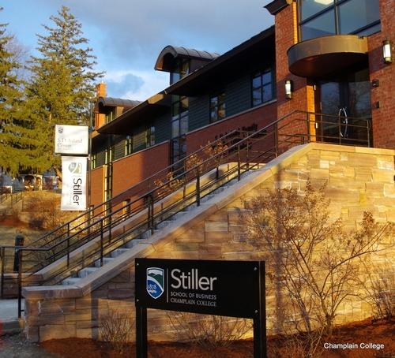
2017 Sharing Information on Progress (SIP) Report Update on the Implementation of the Principles of Responsible Management Education.

Champlain College | 246 South Willard St. | Burlington, VT 05402

The Robert P. Stiller School of Business | Champlain College
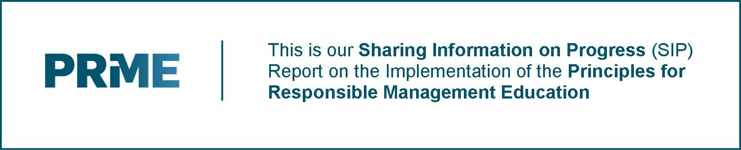
STATEMENT OF RENEWED COMMITMENT
The Robert P. Stiller School of Business at Champlain College is pleased to submit our updated Sharing Information on Progress Report. Our mission statement is: “To prepare innovative business professionals who will use their integrity, expertise, and entrepreneurial spirit to create positive change in their workplaces, their communities, and the world.” This statement continues to provide a guiding aim for our faculty and students alike to keep a constant eye toward how to use business as a force to create positive change for all stakeholders in society. As such, our values and efforts continue to be closely aligned with the principles of responsible management education. Herein, we highlight our efforts and successes over the past 24 months, and we reaffirm our commitment to PRME. The rest of our report is structured as follows:
- Overview of The Stiller School of Business
- Updated Information on PRME Implementation at The Stiller School
- Specific Achievements Around the PRME Principles.
We look forward to continually working to integrate the spirit of PRME into our work in the years ahead.
Dr. Scott Baker, Dean, Robert P. Stiller School of Business, Champlain College

I. STILLER SCHOOL OVERVIEW
Continuing its 137-year-old tradition of agility and relevance, the Robert P. Stiller School of Business (SSB) at Champlain College offers an experiential, outcome-oriented business education with outstanding degree programs in the most sought after business arenas. In 2012, the Division of Business was renamed The Robert P. Stiller School of Business in recognition of the transformational gift made by the Stiller Family to enhance business education and continue to build its Appreciative Inquiry (AI) educational offerings. The innovative educational leadership of the Stiller School was exemplified by development of the first academic center devoted to Appreciative Inquiry in the country in 2014, The David L. Cooperrider Center for Appreciative Inquiry.
The mission statement of the Stiller School continues to be: “To prepare innovative business professionals who will use their integrity, expertise, and entrepreneurial spirit to create positive change in their workplaces, their communities, and the world.” Echoing this drive to create a better world for future generations, the mission statement of our new Cooperrider Center for AI is: “To educate leaders to be the best in the world at seeing the best for the world in order to discover and design positive institutions, organizations and communities that elevate, magnify and bring our highest human strengths to the practice of positive organizational development and change.” With these two driving calls to positive action, it is no coincidence that the curricula taught in all programs of the SSB are infused with all major principles that form the bedrock of what could be called “Responsible Management Education”.
The SSB continues to enjoy a geographic advantage for implementing PRME in that, here in Vermont, we have an unusually high concentration of business leaders who have been at the forefront of socially and environmentally responsible management practices. These on-the-ground business world pioneers “walk the walk” when it comes to implementing the essence of PRME in the day-to-day running of their companies.
Companies with distinctive social and environmental missions like Ben & Jerry’s Ice Cream, Rhino Foods, Keurig Green Mountain, NRG, and Seventh Generation are quite literally in our neighborhood, and as such, our faculty has ready and frequent access to the expertise and practical knowledge of senior executives who run these companies.
We also benefit from our location because Vermont, as a state, is well known for its natural beauty and is a tourist destination, which attracts visitors from all over the world. This in turn has fostered a long tradition and culture of environmental stewardship within both the government and the private sectors. Companies in Vermont “sign on” to the operating mantra of doing business in not just environmentally compatible, but also in socially responsible ways.
The SSB programs continue to incorporate a rich and practical blend of core business competencies, numerous study abroad options, international internship opportunities, frequent and meaningful interactions with business executives from local and regional companies, and several courses which include “live client” projects in which students teams work on real-life company initiatives, many of which are in the areas of social and environmental responsibility.
Further, SSB undergraduate freshmen students experience our unique “upside down” curriculum in which they are immediately immersed in courses, which include all the major functional areas of business, with a significant component of Business Ethics taught in their very first semester.
All these factors coalesce into a rich and fertile environment for the teaching and practice of PRME.

II. UPDATED INFORMATION ON PRME IMPLEMENTATION AT THE STILLER SCHOOL
Responsible management education is a theme that continues to be woven into almost every facet of SSB program offerings and co-curricular activities. Starting with the intentional and carefully selected language embodied in our Mission Statement, running through the school-wide competencies we equip our students with, and continuing on through our curricula in every program offering, the twin themes of social / environmental responsibility and ethical management practices are evident throughout the Stiller School.
We teach Responsible Management practices in a variety of ways on a daily basis. The major ways in which we ensure that students learn the essence and the details of Responsible Management practices include:
- The SSB Mission Statement - Our Mission Statement says that “The Stiller School of Business develops the strengths, integrity, expertise and entrepreneurial mindset of aspiring and innovative professionals to create positive change in their lives, workplaces, communities, and the world.”

Our Mission Statement is included in every syllabus so that students are well aware of it, and so that it can serve as a touchstone for both students and faculty in every course that is taught. As mentioned earlier, the language was selected with much deliberation, and the words “integrity” and “positive change” were intentionally included to guide our actions towards imparting an education that is centered around responsible management practices.

- SSB Competencies - Among the many important core competencies that we ensure are covered in SSB program and course offerings, three in particular deserve a mention when it comes to illustrating how we accomplish the goal of teaching our students responsible management practices. These are:

The Corporate Citizen – Participate in community-based projects that make a difference in the civic life of our communities and reflect on the ethical and societal implications of such activities for corporations.

The Global Citizen – Diagnose communication issues and evaluate business environments in multicultural and multinational case settings and propose appropriate solutions.

The Emotionally Intelligent Professional – Develop a personal code of values and ethics that includes, among other things, a commitment to understanding themselves and others.

The above competencies are embedded in many course and program offerings within the SSB, and all students are required to take courses, which specifically teach them these competencies. The competencies are also made visually evident in our hallway wall mural (pictured below) as a clear reminder to students of the importance of these competencies as they are going to and from classes every day.

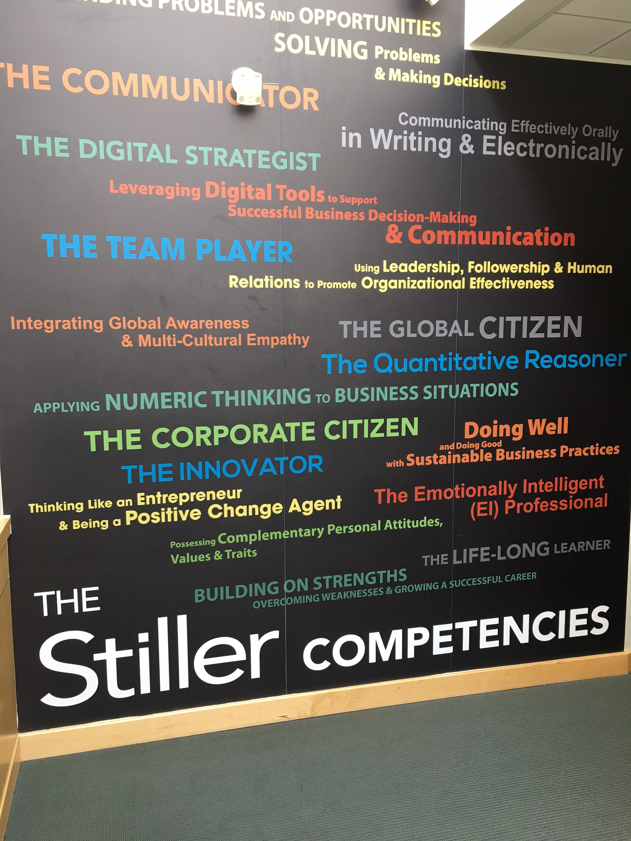
A required course on Social and Environmental Responsibility – All SSB students in every major are still required to take our stand-alone dedicated course called “Corporate Social Responsibility”. This is a 3-credit course is exclusively designed to impart comprehensive education on societal and environmental issues that real-world business must deal with. It teaches students real-world stakeholder management issues faced by business executives and how best to make responsible management decisions in dealing with these issues. Along with in-depth study of responsible stakeholder management practices in a globalized business world, students work on two “live client” projects, both with the central theme of implementing Responsible Management practices from both a societal and an environmental perspective.

- The SSB Professionalism Pledge Project – In order to emphasize the importance of professional and ethical behavior, beginning in Fall 2014, we designed and implemented a two-level professionalism pledge project inspired by work of the Oath Project (http://theoathproject.org/). An SSB customized pledge of professional and ethical behavior is taken by students both at the first-year level when they begin their educational journey, and then at the Senior level right before they embark on their professional work careers.

Freshmen students are encouraged to understand and sign a pledge of professionalism and ethical behavior as it pertains to their college careers as students, and Senior students are given a different pledge to sign which speaks to their commitment to professional and ethical behavior in their immediate and future business careers.

- Coverage of Business Ethics and Professionalism across a variety of SSB Courses – We continue our commitment to PRME by including “Business Ethics” and “Professional Codes of Conduct” modules and assignments in a number of courses throughout our program offerings. For example, courses in the areas of Accounting, Finance, Management Information Systems, Marketing, and Human Resource Management include classroom and homework assignments / readings / and discussion on a variety of issues and current event topics that relate to business ethics, social responsibility, and professional conduct.

This deliberate strategy of multiple points of contact with the underlying tenets of PRME serves to remind and reinforce in the minds of students the importance of considering all business decisions through the lens of responsible management practice - regardless of the specific functional area in which the decision is being made.

The following section of the report contains the most recent developments and activities related to PRME that we have undertaken at the SSB over the past two years.

The Positive Education Summit hosted by the SSB’s Cooperrider Center

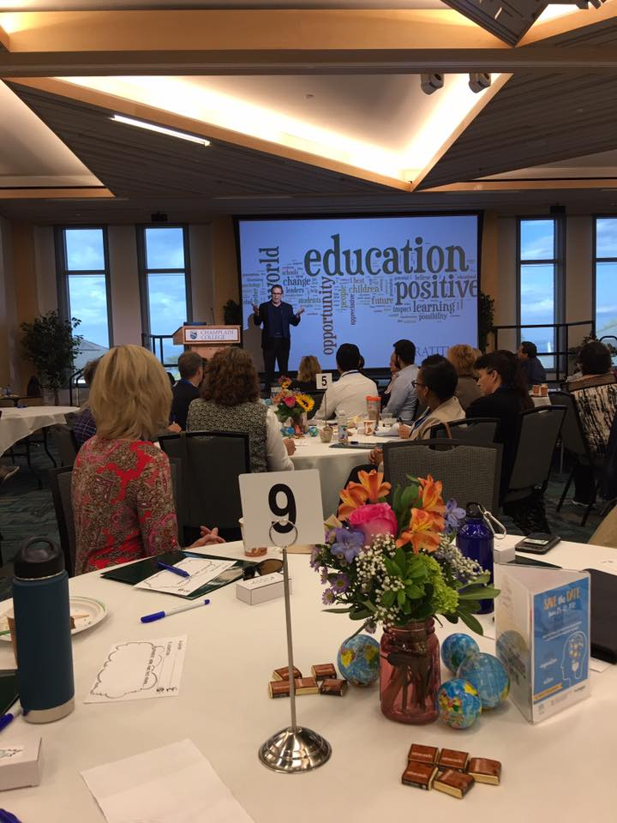
One of the major new initiatives that the Stiller School has engaged in to bring to life the PRME principles since our last report on progress is our work to launch an initiative to accelerate positive education around the globe. This work truly aligns with UN Global Goal #4, “ensuring inclusive and equitable quality education and promote lifelong learning opportunities for all.”
Champlain College received a $1 million gift from the Stiller Family Foundation in 2016 to support our Stiller School of Business’ Cooperrider Center to plan and convene a Positive Education Summit that will use Appreciative Inquiry (AI) to accelerate positive education from early childhood on up. This has led to the Cooperrider Center partnering with IPEN, a leading global network dedicated to the advancement of positive education around the globe. Together, our Stiller School’s Cooperrider Center and IPEN will hold a World Positive Education Accelerator June 25-28, 2018 in Fort Worth, Texas. More than 1,200 participants from nearly two dozen countries are expected to attend IPEN's Second Festival of Positive Education and Appreciative Inquiry Summit. The goal of the 2018 meeting will be to design a plan to strengthen and advance positive education globally.
In September 2017, Champlain hosted the World Positive Education Accelerator's Steering Committee. The event brought together more than 105 members from 18 countries-including students from the Stiller School and our Education programs, with teachers, psychologists, higher education faculty, headmasters, researchers, CEOs, consultants, and philanthropists-to Burlington to begin work on the 2018 summit.

The Steering Committee worked collaboratively over 2 days to design next June's accelerator event by:
- Identifying critical stakeholders and stakeholder groups that represent the whole system (students, educators, and school leadership spanning early education to higher education; parents; counselors; nutritionists; health and mental health experts; local and federal governments, think tanks, and policy makers; marginalized groups; businesses and nonprofits; associations; and foundations)
- Planning how to engage these stakeholders
- Establishing the overarching specific theme of the summit
- Determining necessary summit content, and
- Structuring catalytic conference processes such that stakeholders generate innovative, powerful and actionable ideas.
This work truly brings to life many of the PRME principles including helping our students connect with a higher sense of purpose, developing new educational frameworks that enable effective learning, and engaging in global partnerships that help bring the UN Global goals into practice.
You can read more about this work at: http://ipen-festival.com/

The Entrepreneurship For Good (E4G) Summer Program

Our inaugural Entrepreneurship for Good summer program was hosted by the Cooperrider Center and the Stiller School of Business in June/July of 2017. This experiential learning program is grounded in the belief that doing social and environmental good is also good business. While conventional business thinking measures performance primarily in terms of profit alone, social entrepreneurs also take into account a positive return to society. This program is built on the most current research and best practices in entrepreneurism, innovation, sustainability and strength-based organizational development.
Right from the start, students rolled up their sleeves and dove into interactive exercises (including going sailing together!) designed to create a collaborative group dynamic and build effective teams. Each project team worked to develop a unique business concept designed to create a positive social change or to provide benefit to a disadvantaged population. Students were encouraged to focus on an issue or community need that is of personal importance to them. Throughout the week, Entrepreneurship for Good participants visited a variety of socially minded companies in the area including: City Market, Ben & Jerry’s, Sun Common, Keurig Green Mountain Coffee, Good News Garage, Old Spokes Home, VT Bicycle Recycling, American Flatbread, Big Heavy World, and Mamava. They also received individual coaching from outstanding business leaders, bringing additional ideas and perspective to the students' thinking. On the last day of the program, the teams presented their business and marketing plans to a panel of successful entrepreneurs for feedback and suggestions.

The Stiller Women in Business Program

We initiated the Stiller Women in Business program which provides a regular forum for our students to exchange ideas, to network, to provide support for business initiatives, and to address gender and equity issues that arise in the workplace.

We believe our initiatives such as the Stiller Women in Business program help in operationalizing our ongoing commitment to promote responsible management education and to promote social responsibility in business.

In terms of implementing PRME into our regular curriculum, here are the most recent examples of SSB courses that embed ethics, social responsibility, and responsible management practices as part of the coursework:

- The Entrepreneurship Capstone – Six class sessions focus on Ethics where students read cases and a book on ethics prior to class sessions and discuss ethics during class. Further, some of the team projects in this course relate to the principles of social responsibility and environmental issues.
- The Business of Entrepreneurship – This course includes a 4-week team based project on a socially-conscious entrepreneurial venture.
- Design Thinking – This course includes a module on ethics in design thinking and it weaves social responsibility themes throughout the course by teaching design thinking through the lens of human-centered design and designing for social good.
- Talent Planning and Acquisition – This course includes a segment on the role of the Human Resources team in guiding and supporting sustainability and ethics within organizations and it also recognizes the strategic role of human resources management as the closest link to the “people” stakeholder group in the Triple Bottom Line.
- Problem Analysis and Decision Making – A segment in this course deals with so-called “wicked problem” that include large-scale societal problems like global warming, the opioid crisis and human trafficking. Students working on “wicked problem” assignments identify the problem, its causes, consequences and the stakeholders affected. During the semester, students return to this theme and consider how businesses can uncover opportunities to address these problems.
- Designing Innovative Organizations – Part of this course is the requirement that students read the entire book called “Firms of Endearment” and work on assignments based on the book, which is a study of organizations that are deemed the most responsible to all stakeholders including the environment.
- Business Policy & Strategic Management – Students in this course review CSR principles, the Balanced Scorecard, UN initiatives, and then do a case study of a for-profit business that is socially and environmentally driven.
- Managerial Accounting and Cost Accounting – In both these courses students start the semester with a discussion and assignments about the 5 standards of ethical conduct for accountants with an emphasis that the 5 standards really apply to any profession. The 5 standards taught are competency, confidentiality, integrity, credibility, and the resolution of ethical conflicts.
- Marketing Capstone – This course requires graduating seniors to do an in-depth focus on professional ethics. Students study the American Marketing Association (AMA) and the Data and Marketing Association (DMA) codes of professional ethics and they are required to develop their own professional values statement. Additionally, they explore Utilitarian, Deontological and Virtue ethical frameworks, and apply these frameworks to current marketing issues.
- Accounting Capstone – In this course, the students are required to become certified as ethical leaders through the Ethical Leadership Certification Program (https://www.studentcpt.org/ethical-leadership-certification-program/), and the students do a presentation at an annual Ethics Continuing Process Education (CPE) seminar offering discounted CPE to local CPAs to maintain their licensure. Additionally, the course includes numerous ethics case studies as part of the student experience.
- Federal Taxes II – A significant part of this course examines tax policy and tax practices of organizations and individuals through the lens of ethics, social responsibility and social equity.
- Auditing – The topic of organizational ethics as they relate to financial reporting is a major component of this course, and students regularly discuss ethical issues that arise in the accounting profession from the public accounting point of view as well as from the clients’ perspective.
- The Volunteer Income Tax Assistance (VITA) Program – To support the SSB’s commitment to social responsibility, our accounting students volunteer their time each year (each student is required to work 40 hours at the VITA site between February 1 and April 15 each year) to prepare free income tax returns for the elderly and low income population in our local community. Although VITA is a community-wide effort, our SSB students make up the majority of the volunteer base.

III. SPECIFIC ACHIEVEMENTS AROUND PRME PRINCIPLES
We continue to implement the six “Principles” of PRME in our body of work as manifested in our program and course offerings.

Principle 1 | Purpose - “We will develop the capabilities of students to be future generators of sustainable value for business and society at large and to work for an inclusive and sustainable global economy.”

Creating sustainable value in business, and its beneficial ripple effects in society at large, is a thread that is at the foundation of our curricular and co-curricular activities. All subject areas that are taught in our undergraduate courses examine issues, problems, and opportunities facing business through the lens of creating lasting value, and we require our students to take into consideration both short-term and long-term ramifications of the solutions and proposals they make to address such issues and problems.
For example, in our International Business courses, we draw heavily upon company case studies so that our students can combine theory with actual practice in shaping their understanding of the topics. One of the more controversial topics in this field is “Outsourcing and Offshoring” of US business to countries outside the US.
Students are challenged to analyze and think about such topics in a holistic manner. The case analyses and recommendations provided by the students, both written and oral, require them to answer whether what they are proposing will create sustainable value for the company in question and what the impacts might be for the global economy.
Typically, in such courses, students work a case study in a team setting, and they are expected to demonstrate teamwork, sophisticated analysis, and critical thinking skills, which can be applied to the business world.
To further the goal of developing the capabilities of our students to work towards creating an inclusive and sustainable global economy we have, for the past three years, very successfully created the following international Internship program for all our students:

The Freeman Foundation China Internship Program
Through a grant from The Freeman Foundation, we have created an ongoing internship program, which allows our students to work in Shanghai for two months each summer with a number of Chinese and other international companies.
Students who are selected for the program are immersed in the following experiences which help foster a deeper understanding of the workings of the global economy:
- Intensive Mandarin language training, which equips the students with linguistic and cultural skills that they can immediately apply in their internships
- Practical work assignments in Chinese companies and other global companies operating in Shanghai. The types of work assignments our students have engaged in over the past 3 years have honed their skills in the areas of creating durable beneficial market impacts and contributing to the actual development of a sustainable global economy.
- Learning to work in a cross-cultural environment. The companies in which the students work represent a cross-section of players in the global economy. For example, students in this program have successfully completed internships in Chinese, French, American, and French companies who have been operating in Shanghai for a number of years
- Developing contacts and relationships with ex-patriate businesspeople from numerous countries who are working in Shanghai.
These kinds of practical work experiences we provide for our students not only develop their capabilities to create value in a global economy, but they also light the spark of creativity and sensitize them to understand, empathize with and work in cross-cultural global environments.

Principle 2 │ VALUES - “We will incorporate into our academic activities and curricula the values of global social responsibility as portrayed in international initiatives such as the United Nations Global Compact.”
Our commitment to inculcate the values of global social responsibility is manifested in a number of our courses, beginning with our dedicated course on “Corporate Social Responsibility” (CSR) which is a required course for all SSB students, regardless of which program or major they pursue.
The CSR course blends theory and practice into a powerful educational experience for the students. Broad topic areas, which are explicated further in the next section of this report, that students delve deeply into include:
- Globalization of Business and Cultures - Students study and understand contemporary issues and drivers of globalization and its impact on cultures and societies around the world
- The Growing Power and Responsibilities of Global Business - Students analyze the scale and reach of global companies and understand the tremendous power and influence of such companies on the lives of people across the globe
- The STAKEHOLDER VIEW of Management - The CSR course devotes a lot of class content and time to truly developing in the minds of our students the need and the means of managing a business in a way that balances and optimizes the competing needs of ALL stakeholders in any business
- Environmental Stewardship as a Management Imperative - We also devote a substantial amount of the course to address the growing problem of environmental degradation and help our students develop the capability to assess the role that business can play to improve its practices and thereby help alleviate the situation
- Personal Lifestyle Assessment, Choices, and Responsibility - A part of the CSR course teaches the students that the first step in addressing environmental responsibility begins with each person assessing his or her own lifestyle choices and the impact of those on the environment. Each student calculates his/her carbon footprint to raise awareness of their daily impact on the planet, and this sparks some reflection on possible changes that can be made by them in order to help the environment, albeit on a small and individual level.
Apart from our dedicated CSR course, we also impart the values and tenets of global social responsibility in several of our other courses which provides students multiple points of contact with what we at the SSB consider an extremely important business imperative.
For example, global societal topics such as “The Digital Divide” are thoroughly addressed in our Management Information Systems course which is also a required course for all SSB students. Students are made aware of the developmental impact of the digital divide all over the world and they work on cases to propose solutions which would help bridge this divide.
In our financial courses, such as Investment Management, students spend a significant amount of class time working on the Chartered Financial Analyst (CFA) Institute-designed Ethics modules. The SSB Finance courses are recognized by the CFA Institute and they require us to incorporate Ethics education as an integral part of the students’ education in the area of Finance.
Co-curricular activities we undertake also incorporate significant social responsibility elements. For example, for the past two years, incoming freshmen students are introduced on their first day, during Orientation, to real-life companies, which have substantial Social and Environmental Missions. This fall, for example, groups of students spent the better part of Orientation day on-site at local companies like Seventh Generation, ReSource, Onion River Cooperative, etc. - all of whom emphasize their commitment to doing business in socially and environmentally responsible ways.
This deliberate “Orientation Day” activity immediately sends the message of social and environmental responsibility of business to incoming SSB students starting with “Day One” of their programs.

PRINCIPLE 3 │ METHOD - “We will create educational frameworks, materials, processes, and environments that enable effective learning experiences for responsible leadership.”
The five major topic areas of Globalization of Business and Cultures, the Growing Power of Business and its Responsibilities, the Stakeholder View of Management, Environmental Stewardship as a Management Imperative, and Personal Lifestyle Assessment, Choices and Responsibility that are covered in depth in the CSR course are implemented in a framework of experiential learning which combines the following major learning modules:
- “Live Client” projects
- Detailed study of the theory and practice of responsible leadership
- Stakeholder Analysis Exercises based on real-life Case Studies
- Classroom Debates on CSR and Environmental Issues
- Guest Speakers - Input from real-world practitioners of responsible management through our “Guest Speaker” series each semester.
These elements of the CSR course are explained in further detail below:
- Live Client Projects - Every student in the CSR course participates in two Live Client projects which have as their ultimate goal the creation of a product or service that explicitly and directly helps the client to fulfill their societal and/or environmental responsibility missions.

For example, students have conceived and crafted projects as diverse as designing alternative energy solutions (solar and wind power) for Champlain College itself, reducing electricity consumption by the College by designing a system to use geo-thermal energy, helping Seventh Generation Corporation develop a Cause-Related Marketing Campaign for their re-usable Bobble product, creating a product promotion campaign that would simultaneously boost sales and benefit the cause of “Breast Cancer Prevention and Treatment” on behalf of Green Mountain Coffee Roasters (now called Keurig Green Mountain), as well as projects with more immediate impact for fellow students like developing a “Campus Bike Share” program which would benefit students who don’t have a car and would also reduce emissions in and around the campus area.

- Theory Applied to Practice in the Classroom - All major topics and concepts covered in the CSR course are taught with immediate application of the concepts to real-world case studies as well as to current events.

For example, we feature a module in the course called “Headline Discussions” in which students bring “hot-off-the-press” articles to do with responsible management to class. Each student is responsible for bringing at least one article of current CSR events happening in companies, and he or she leads the classroom discussion on the event while tying into the discussion the relevant CSR concepts and theories that they have learned in class. The effect this has on the “sponsoring” students is quite remarkable in the sense that, in most cases, they become impassioned champions of the social or environmental issue that underscores the article they have chosen to bring into the classroom for discussion.

- Stakeholder Analysis Exercises - Each semester students participate in teams to dissect the issues facing ALL stakeholder groups in a real-life company Case Study.

Students in this classroom action learning activity first meet with others in their own stakeholder group….for example, all “employees” in the class meet as a group to discuss issues and concerns common to all of them, all “investors” meet as a group to go through a similar exercise, etc.

After they have agreed on their respective group’s issues and priorities, the class is re-shuffled into new groupings in which each group has a representative from each major stakeholder group. The discussion then enters the second phase in which issues are examined and prioritized based on the concerns and recommendations of each individual stakeholder group, with the ultimate goal of coming to a resolution that takes into consideration as many viewpoints as possible.

This exercise equips the students with an understanding of the importance of responsible management practices which try as best as possible to create outcomes that benefit as many stakeholder groups as possible.

- Classroom Debates on CSR and Environmental Issues - Each semester students in the CSR course also take part in debates on a variety of issues facing real-life companies on different social and environmental fronts.

These debates are designed to “keep it real” in the sense that any proposal made by either side is required to have an “implementation” component which needs to demonstrate how the idea can be implemented by the company in question, and what the potential cost/benefit tradeoff is based on their proposal.

- Guest Speaker Series - Each semester the students in the course experience at least one Guest Speaker (a practitioner of responsible management) from the “real world” of business.

These learning encounters inform the students’ overall comprehension of responsible management practice from an “in-the-trenches” perspective.

Our experience has been that in each of these sessions, the Q & A portion far exceeds the talk itself. Students are very engaged in these sessions in attempting to link what they have learned in class to what the real-world practitioner has experienced in his or her company.
This educational framework extends beyond the CSR course into a number of other SSB business courses all of which tend to emphasize the blending of theory with actual practice in the business world.
Augmenting this educational framework is our heavy emphasis on Internships, which are required across all the programs offered in the SSB. Internships, especially those that are within companies with explicit Social/Environmental Missions like Ben & Jerry’s Ice Cream, Keurig Green Mountain, etc. are yet another way in which SSB students actively learn the practices of responsible management.

PRINCIPLE 4 │ RESEARCH - “We will engage in conceptual and empirical research that advances our understanding about the role, dynamics, and impact of corporations in the creation of sustainable social, environmental and economic value.”

Our faculty continues to engage in a variety of academic work to advance the conceptual field of socially responsible business. Such work keeps our faculty connected to the research and theory evolutions happening, as well as contributing to the wider academic conversations happening around PRME-related issues. Examples of some of the recent work of our faculty includes:
- Dr. Lindsey Godwin was a guest editor for a 2014 special issue on positive organizational ethics for the Journal of Business Ethics. Her introductory article for the issue helped further frame the concept of positive organizational ethics in the field:
  - Sekerka, Leslie, Godwin, Lindsey & Comer, Debra. (2014). “Positive Organizational Ethics: Cultivating and Sustaining Moral Performance.” Journal of Business Ethics, 119(4), p. 435-444.

- Dr. Godwin also co-authored an article that examined the concept of moral curiosity in the workplace:
  - Sekerka, Leslie, Godwin, Lindsey & Charnigo, R. (2014). “Motivating Managers to Develop Moral Curiosity.” Journal of Management Development, 33(7), p.709-722.
- Dr. Godwin and Professor Nicole Morris co-authored a chapter on embedded sustainability:
  - Godwin, Lindsey & Morris, Nicole. (2013). Embedded Sustainability: Creating Ethical Habits through personal engagement. In Ethics Training in Action, Leslie Sekerka (Ed.), Information Age Publishing, 121-138.

Three of our faculty members, Tom Myers, Pat Patel and Nicole Morris, are currently pursuing doctorates, and much of their work focuses on strength-based approaches to management aligned with PRME.

PRINCIPLE 5 │ PARTNERSHIP - “We will interact with managers of business corporations to extend our knowledge of their challenges in meeting social and environmental responsibilities and to explore jointly effective approaches to meeting these challenges.”

SSB students, faculty and administrators have frequent and ongoing learning encounters with managers of a variety of Vermont-based as well as other North East region companies. Among the business corporations with whom we regularly partner on a variety of projects are:
- Seventh Generation Corporation
- Ben & Jerry’s Ice Cream / Unilever Corporation
- Keurig Green Mountain Corporation
- MyWebGrocer Inc.
- Vermont Businesses for Social Responsibility (VBSR)
- Burton Snowboards Company
Student learning encounters with these and other businesses happen with regularity as a result of faculty who invite business managers into the classroom as part of their “Guest Speaker” initiatives, courses that embed Live Client projects in which real company issues and problems are worked on by students, as well as field trips to local companies in which students spend a day inside the companies studying the products, processes, and issues that the host company managers share with the students during the field trip.
Students have, through our local business partnerships, worked on projects with companies like ReSource Inc., which is a Burlington-based company that “upcycles” electronics, appliances, furniture and household fixtures. Part of the social mission embraced by ReSource Inc. is to reduce waste by accepting used but working products which local businesses and residents would otherwise dispose of as trash, and to refurbish these products for re-sale at a highly reduced price point for low-income segments of the population. A portion of the products that are repaired and refurbished by the company are donated to local organizations that serve the poor.
We have ongoing partnerships with Seventh Generation Corporation, Keurig Green Mountain, Ben & Jerry’s Ice Cream, Burton Snowboards, and with a local business association called Vermont Businesses for Social Responsibility (VBSR).
As mentioned earlier, a number of our courses tap into this network of partnerships to provide mutual benefit for both our students and for the partner companies we work with.
Through these kinds of projects and learning opportunities, students learn how to balance the needs of business with those of society and the environment.
SSB administrators work closely with a “Leadership Council” which is comprised of members from the local business community. The goal is to keep abreast of the current issues and challenges facing business and to incorporate the evolving needs of the business world into our curricula and various co-curricular activities.

PRINCIPLE 6 | DIALOGUE - “We will facilitate and support dialogue and debate among educators, business, government, consumers, media, civil society organizations and other interested groups and stakeholders on critical issues related to global social responsibility and sustainability.”
The SSB has long been committed to creating ongoing opportunities for dialogue in the community. To this end, we are home to a number of forums and events which regularly promote dialogue between our students/faculty/staff and local and regional organizations in the areas of business, government, media, and other relevant stakeholder groups.
For example, the SSB along with the larger Champlain College community hosts a number of student-led clubs and forums which create events in which speakers from the world of business, government, media and other stakeholder groups come to campus and engage with our students, faculty and staff. The on-campus clubs and forums that are most directly connected with the SSB include:
- The Finance Club
- The Accounting Club
- The International Business Club, and
- Build Your Own Business (BYOBiz)
Each of the above mentioned organizations hosts speakers from the business world who are most connected with their respective fields, and this encourages ongoing dialogue between our campus community and them. The International Business Club has raised over $8500 to lend to entrepreneurs in developing countries through Kiva.
Of particular note for ongoing dialogue on global social responsibility and sustainability is the BYOBiz department which works very closely with the SSB. BYOBiz hosts a regular forum on campus called “Speaking From Experience (SFE)” for speakers from business and other relevant stakeholder groups.
The SFE series of speakers truly promotes dialogue between especially the business community and our faculty, students, and staff, on all manner of contemporary issues at play in the business world. Many of the speakers who have come to campus represent companies with strong Social and Environmental Missions.
For example, one of the founders of Stonyfield Yogurt Company of New Hampshire was a featured guest at an SFE event. Speaking to a standing-room-only crowd on campus, he engaged our students in a spirited dialogue on how every company can find ways to make incremental improvements in its processes which would benefit the environment and reduce its carbon footprint.
He substantiated his proposition to the students by citing the example of his own company, Stonyfield Yogurt, and how they harnessed waste material from their dairy cows to generate a substantial amount of renewable energy which now powers a significant part of their yogurt-making facilities.
Encounters such as these really motivate the students and catalyze their thinking along the lines of social and environmental responsibility.
The above examples are just a few of the many ways in which the SSB facilitates and encourages dialogue between our campus community and businesses and a variety of other relevant stakeholder groups.
In conclusion, the multiple initiatives and learning modalities explained in the preceding pages of this report demonstrate the SSB’s ongoing and firm commitment to integrate corporate social and environmental responsibility education into all our program offerings using the Principles of Responsible Management Education (PRME) as a guiding framework for this purpose.

Report compiled by: Pat Patel, Assistant Professor of Business (ppatel@champlain.edu) & Dr. Lindsey Godwin, Associate Professor of Management (godwin@champlain.edu) with input from the Business Faculty.

