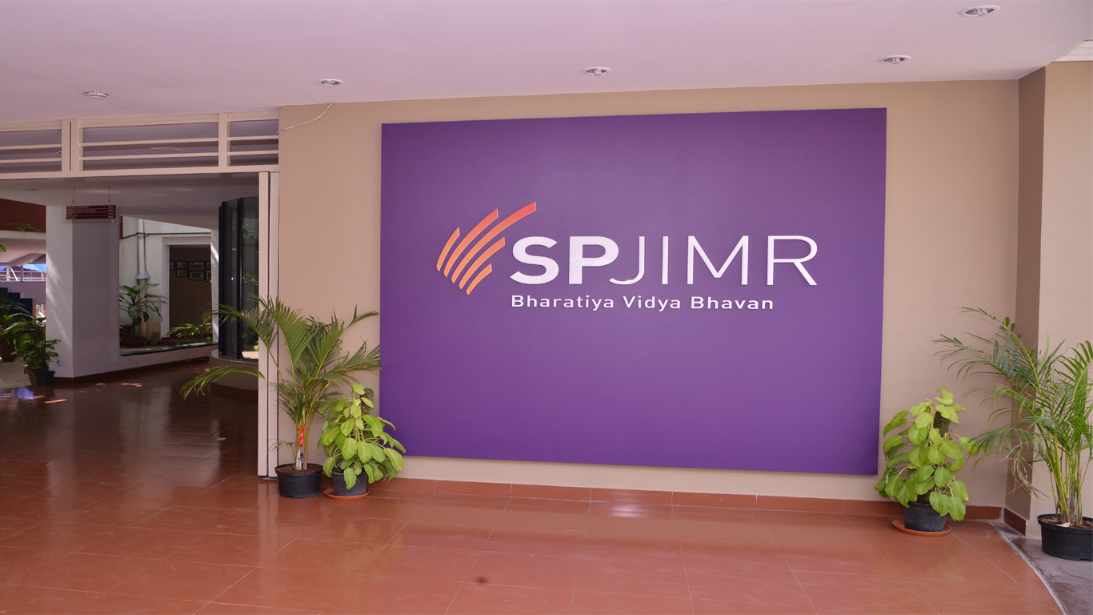

Table of Contents
Chapters Name |  | Sr. no
Renewal of PRME Commitment |  | 2
Sharing Information on Progress (SIP) Report
Principle 1. Purpose |  | 3
Principle 2. Values |  | 4-5
Our Guiding Philosophy
Principle 3. Method |  | 5-20
Abhyudaya Programs |  | 5-9
Center For Development Of Corporate Citizenship(C-DoCC) |  | 10-12
Principle 4.Research |  | 13-20
Principle 5.Partnership(C-DoCC with Corporates, Public Sectors & Universities )  - TATA Social Internship  - Social Impact Awards  - International Exchange Programs (Academic Partnership) |  | 20-24
 |  | 20-21
 |  | 21-22
 |  | 23-24
Principle 6. Dialogue |  | 22-26
Classroom Learning on Social Responsibility (C-DoCC)
- Sustainability and Distributive Justice Course
- Enhancing Growth Through Social Responsibility

 |  | 24-27
 |  | 28
SPJIMR DoCC Partners |  | 29
SPJIMR DoCC at a Glance |  | 29

Renewal of PRME Commitment
Our continuing endeavor over the past few years has been to evolve as a management institute that can be a model for Indian Business Schools and is also world class, not only in terms of material modernity of infrastructure but also in terms of contextual relevance by way of its contribution to the society’s growth and value based development.
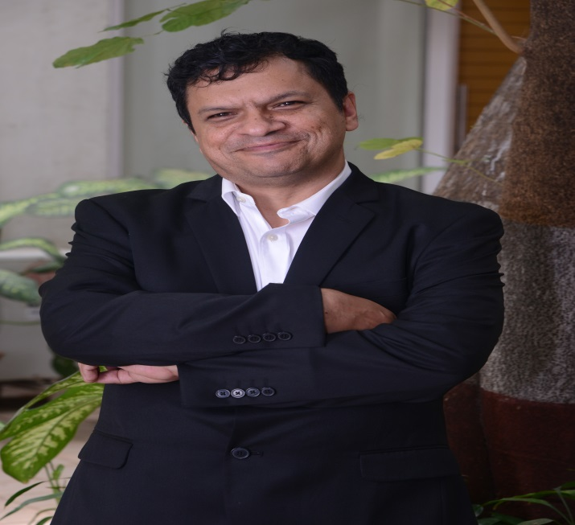
It has been a matter of satisfaction that our relentless commitment to “Influencing Practice” and “Value–Based Growth” has resulted in higher national rankings, global a ccreditations and recognitions, committed alumni and continuous support. We have conceptualized a well – defined Leadership Development Program to influence attitudes of participants and strengthen social, moral and ethical dimensions of their personality.
Bharatiya Vidya Bhavan’s S.P Jain Institute of Management & Research expressed its commitment to the Principles for Responsible Management on November 2, 2012. Today we reiterate that we are fully and continuously committed to the Principles for Responsible Management Education.
This report is a statement on the activities which our institution has undertaken and are in sync with the Principles for Responsible Management Education.
Dr. Ranjan Banerjee Dean, SPJIMR

Principle 1.Purpose: We will develop the capabilities of participants to be future generators of sustainable value for business and society at large and to work for an inclusive and sustainable global economy

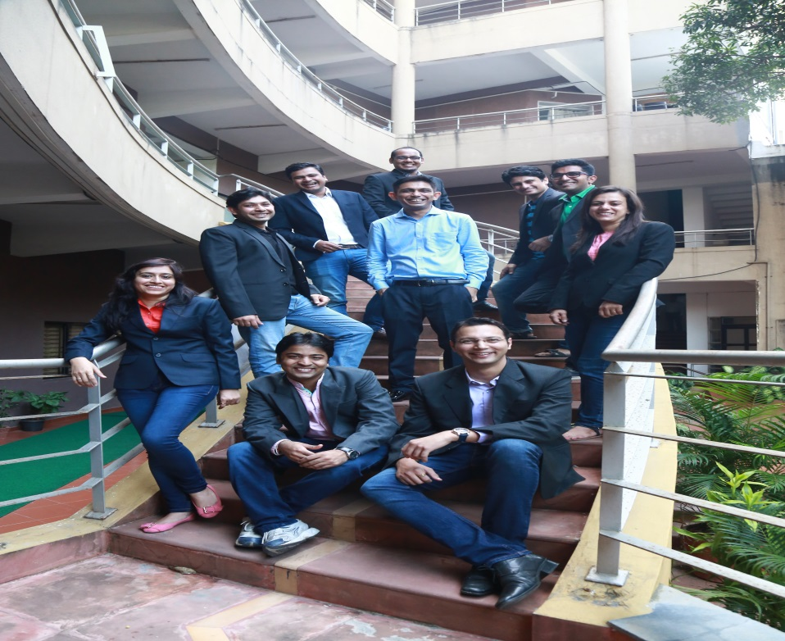
We recognize our twin roles – as a responsible member of Bharatiya Vidya Bhavan and as a responsive member of Indian society at large – and look at ourselves in a wider context as a ‘Beyond MBA’ institution. We aspire to be a globally recognized institute with concurrent presence in socially relevant segments of Indian society.
We emphasize ‘Influencing practice’ and ‘Promoting Value- Based Growth’, which remain the guiding philosophy for planning and execution in all that we do.
In all our endeavors, we emphasize (i) attitudes and skills as much as knowledge, (ii) indigenous learner-centric pedagogy, and (iii) global best practices. Our attempt is to synthesize the apparent contradictions between western efficiency and eastern ethos, and competition and collaboration. We believe this could be a global model one day.
As a self – reliant institution, we seek operational freedom and encourage an entrepreneurial, agile and flexible organizational culture working on a collaborative pursuit of innovative solutions.
SPJIMR community strives to realize the objectives of the institution through self – accountability, professional discipline and hard work.

Principle 2.Values: We will incorporate into our academic activities and curricula the values of global social responsibility as portrayed in international initiatives such as the United Nations Global Compact.
OUR GUIDING PHILOSOPHY
The Philosophical pillars upon which rests the edifice of our educational pedagogy and development are
-Influencing Practice
-Promoting value-based growth.

Influencing Practice:
The initiatives and innovations at SPJIMR aim to influence industry practices and therefore enable us to be a participant in re-shaping the nation. The learning imbibed through a flexible and versatile curriculum develops in the participants not only a capacity for analysis and judgment, but also an innate ability to relate to social problems and then draw upon their own resources for understanding and action

Promoting value-based growth:
SPJIMR propounds that individuals need to build the right blend between concern for their own welfare and social good. Thus the Institute encourages development of a co-operative outlook that recognizes the value of sharing and mutual respect. This is emphasized in the curriculum through practical experiential learning as well as by example.

The other principles, which guide working are-

Social relevance and responsiveness – SPJIMR seeks to incorporate strategies for innovative business practices and social value through the integration of corporate social responsibility programs.

Co-operation and Collaboration- The advent of globalization has brought about an increased collaboration for heightened social, economic and environmental benefit. Through collaborative effort, it is possible to optimize the use of limited resources leading to more appropriate and relevant business practices. SPJIMR strongly advocates collaborative efforts for achieving higher than normal returns on investments.

Networking- As a management institute, SPJIMR encourages its functioning within a wider social and cultural environment with an emphasis on critical socio-economic processes that are shaping business today. SPJIMR endeavors to amalgamate these diverse perceptions and demands in order to generate a more relevant and significant management education for India and in this respect, it attempts to be seen as a major trendsetter in management education. Believing itself to be a part of a larger effort, SPJIMR encourages learning by imbibing from:

- The best and latest global business practices.
- Globally recognized institutes from across the world.
- The efforts of Indian business in their quest for growth, productivity and quality.
- Ideologies of talented individuals who are ecologically conscious.
- Western efficiency and eastern ethos.

SPJIMR believes in building bridges to the future through synergistic effort along with the industry to which it feels accountable and answerable and hence serves with a deep commitment.

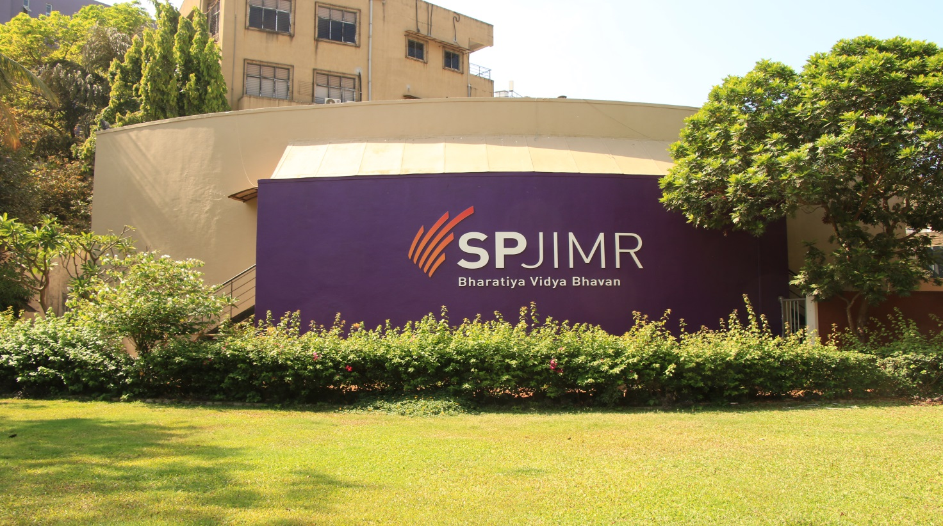

Principle 3 Method: We will create educational frameworks, materials, processes and environments that enable effective learning experiences for responsible leadership.
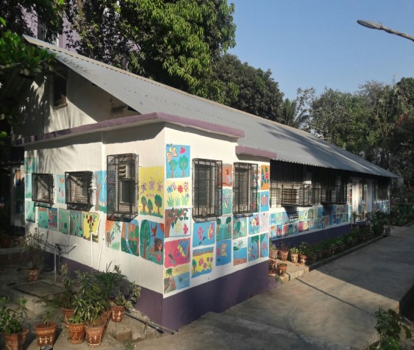
ABHYUDAYA PROGRAM
Abhyudaya is 1.5 credit course offered during the first year of MBA at SPJIMR. It is a compulsory year-long mentorship course through which first year MBA participants mentor bright, underprivileged children from neighbouring schools. We call the children Sitaras, which means “Stars”.

Currently Abhyudaya works with 500+ participants from low income families in K-West Ward of Mumbai. The children join Abhyudaya as Pre-Sitaras in Standard 6, and become Sitaras in Standard 7. They remain with the program until they graduate college and get jobs.

Apart from the home-based mentoring done by the MBA participants, the Sitaras receive intensive academic and extra-curricular inputs from trained teachers at Abhyudaya for their all-round development. The Abhyudaya team assists them with college admissions as well as placement in jobs.

Activity Update

For the academic year 2016-17, there have been many activities at Abhyudaya.

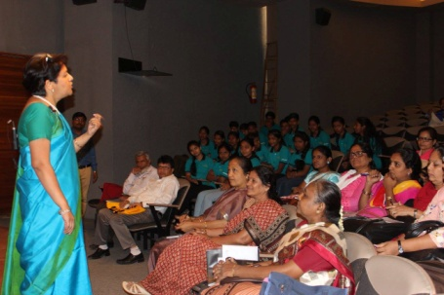
Influencing the teaching community

In February 2016, we invited school principals from around 40 schools in the K-west ward to visit us. These schools have children from various slum localities in Jogeshwari, Andheri, Versova, Juhu, & Vile Parle. Our Sitaras come from these schools. We spoke about the Abhyudaya program and our goals for social change. We introduced the principals to some outstanding Sitaras. We received excellent feedback from the school principals after the meeting. Many were inspired by the stories they heard. They were amazed to meet the Sitaras and see what outstanding citizens and role models the Sitaras had become. Many principals told us that we have now convinced them, that it is possible for them to make a huge impact in the lives of participants if they provide the right inputs. It is a source of great joy that we are able to influence and inspire the school leadership community around us.
Prof. Deepa Krishnan addressing the group

Mentoring by MBA participants
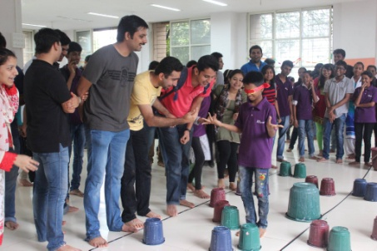
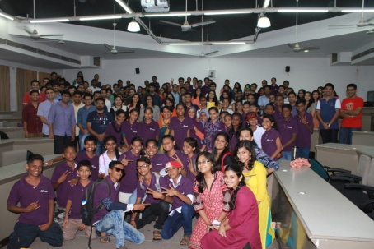
The new MBA batch joined in June 2016. There was a “Hastantaran” (hand-over) event, where the previous batch handed over the mentoring to the new batch. After being introduced to their Sitaras, an ice-breaker activity was conducted where mentor-mentee pairs painted pots with traditional Warli designs. It was followed by games, music and dancing.
Ice breaking game
Hastantaran

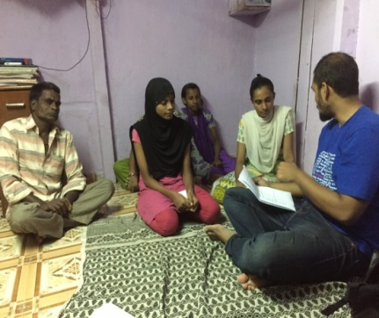
Home visit

After this, the mentoring home visits began. The MBA participants wrote Mentoring Plans, based on which they conducted their mentoring visits. Each participant did 12 home visits. There was a prefixed schedule for each home visit. The mentors reflected upon their learning experiences by writing Diaries. There were smaller Cohort meetings of 12-14 MBA participants, in which they discussed their home visits.

Livelihood Program for Sitara Parents

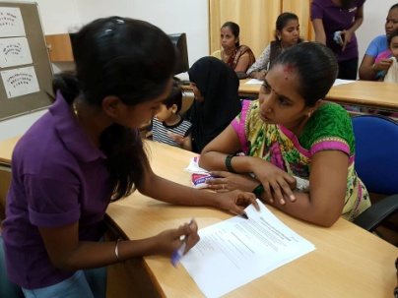
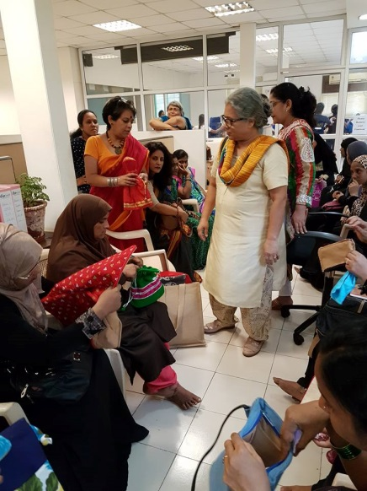
In May 2017, we launched an initiative to help the families of our Sitaras find ways to augment their incomes. By increasing the family's economic well-being, we can ensure better quality of life for our Sitaras. It also ensures that our Sitaras don't get trapped into discontinuing their education due to straitened financial circumstances. As part of the Livelihood Program, we collected information on the skills / capabilities of the families, as well as the sort of employment they were looking for. Our MBA participants are collating the information, and then we will match this with training and employment opportunities available in the market. Since many of the parents cannot read or write, our senior Sitaras helped them to fill out the forms. We were proud of how well our Sitaras conducted this exercise. Subsequent to the data collection, we have formed a group of Sitara mothers who are interested in tailoring, and have started a program to make bags and pouches. This idea originated during the Ethnography Project presentations by the MBA participants.

Research Paper

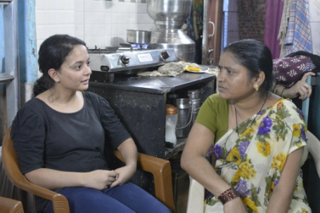
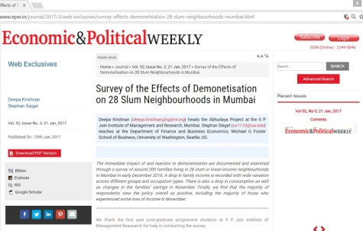
In Nov 2016, the government of India announced a demonetization program, where currency notes of 1000 and 500 were withdrawn from the market. Our MBA participants conducted a survey of the Sitara household, so see how demonetization had impacted them. The results were published in a research paper by Prof. Deepa Krishnan, along with Dr. Stephan Siegel of the University of Washington, Foster School of Business. The paper was also presented at CAFRAL, the research wing of the Reserve Bank of India (our central bank). The findings were reported widely in the press and was the top trending story in the Economic Times.

Participation in Conferences
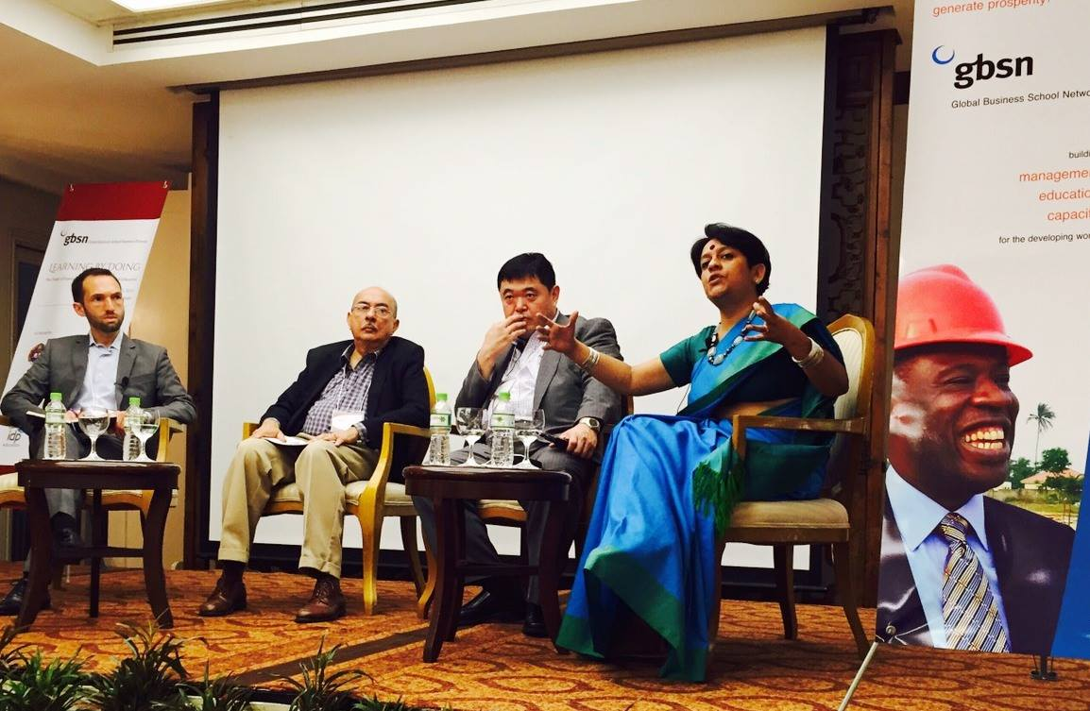 | In August 2016, Prof. Deepa Krishnan travelled to Cambodia to speak at the Experiential Learning Models in Management Education –Global Business School Network.  She explained the Abhyudaya and DoCC model to an audience of 60 people from 10 countries which included deans and professors, as well as industry participants.

In December 2016, Prof. Deepa Krishnan spoke about Abhyudaya at the Maidan Summit in Mumbai. The theme was “Converging Education and Livelihood Spaces through scalable innovations”.  Hosted by Magic Bus India Foundation, Tata Institute of Social Sciences and the University of Mumbai. The audience of over 500 people came from education and non-profit sector from India and abroad. | 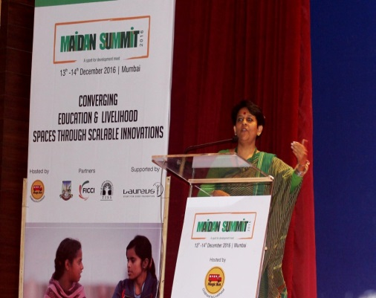

Impact Assessment Surveys

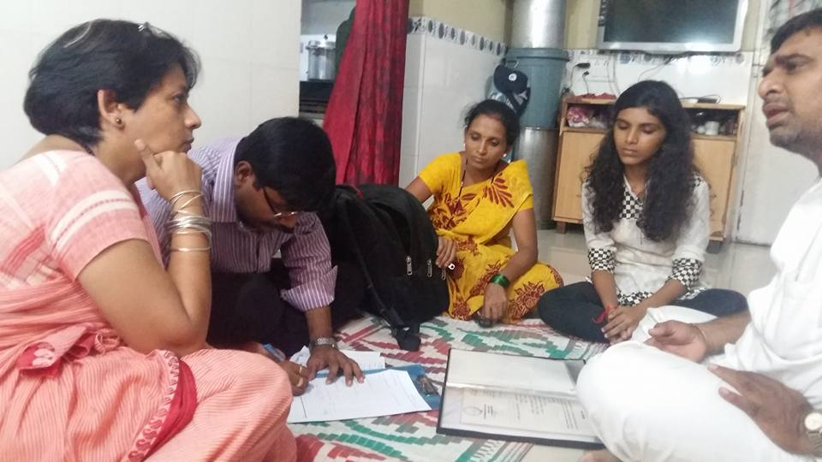 | Three surveys were conducted in 2016 and in 2017 to assess the impact of Abhyudaya:  - Self-Assessment by MBA participants (impact on Self, impact on Sitara, impact on Community)  - Survey of Std X Sitaras (impact on Self, impact on PGP 1 participant)  - Survey of parents of Std X Sitaras (impact on Sitara)

The feedback was very positive and suggestions have gone into improving the design of the course.

Visits by foreign universities
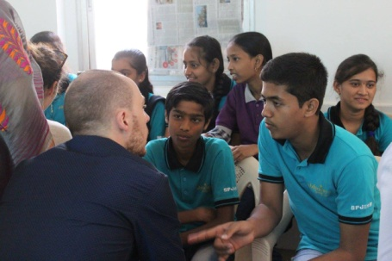
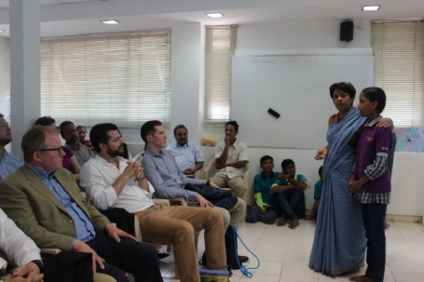
In April 2016, participants from HWZ University in Switzerland visited Abhyudaya and were introduced to the mentoring model of education. There were group interactions to allow our Sitaras to learn about life in Switzerland, and for them to learn about India.

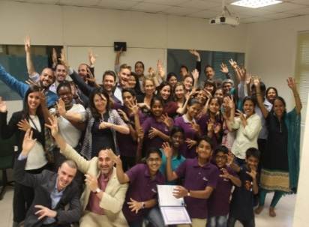
In Jan 2017, participants from University of St Thomas, Minnesota visited Abhyudaya. Prof. Deepa Krishnan gave a lecture about population and slum growth in Mumbai and the challenges in the education system. Our Sitaras asked the visitors many questions about their life.

Placement program for Sitaras

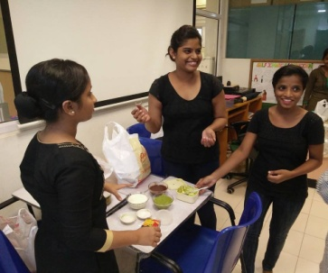
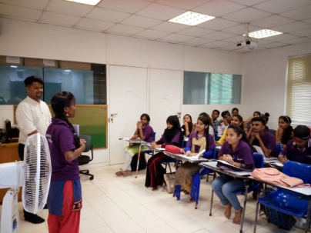
Through a tie-up with the Kotak Education Foundation, our Sitaras are now part of a formal placement program which kicked off in June 2017. They are currently receiving 2 months of training and then will be sent for job interviews. The jobs are in retail, hospitality, and banking/finance, both in front office and back-office. For Sitaras who want part-time jobs, retail and hospitality jobs are available. The 2 month daily training is being conducted at the Abhyudaya centre by skilled resource persons from Kotak Foundation. It includes training in etiquette, dressing, computer skills, spoken English skills and how to handle oneself in an interview. We were really happy when on the very first day, the instructor gave us positive feedback about the Sitaras! The instructor appreciated the enthusiasm and smartness of the Sitaras and felt that placement would not be difficult. Apart from the Sitaras, there are also 8 Sitara siblings who we have enrolled in Unnati. Helping the siblings is part of our Sitara Family Livelihoods initiative.

Ethnographic Study of Slum and Identification of Business Ideas

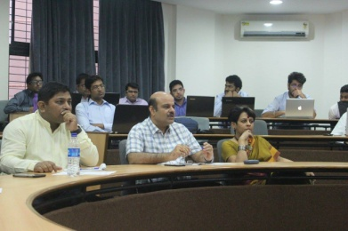
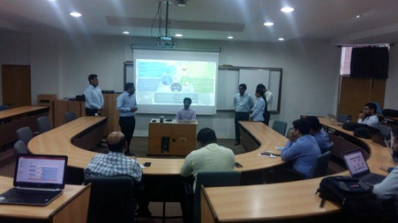
Ethnography is the study of a community from within, over a period of time; and not just as a one-time observation. During the course of their home visits, our MBA participants studied a typical household - the different types of house constructions, sizes, number of people, constraints, water/electricity supply, storage spaces in the house, etc. Then they went on to understand the health and hygiene aspects of a slum neighbourhood, and listed problems and challenges which they saw. Our MBA participants also studied the retail landscape of a slum; they studied the various types of shops, the stocking patterns, the purchase patterns, etc. They were divided into teams came up with business ideas for the Base of the Pyramid. These business ideas were presented to a panel of 12 SPJIMR Alumni for evaluation. One of the business ideas identified through this exercise was then taken up by Abhyudaya for implementation (creation of a craft business involving the mothers of the Sitaras).

CENTRE FOR DEVELOPMENT OF CORPORATE CITIZENSHIP(C-DoCC)
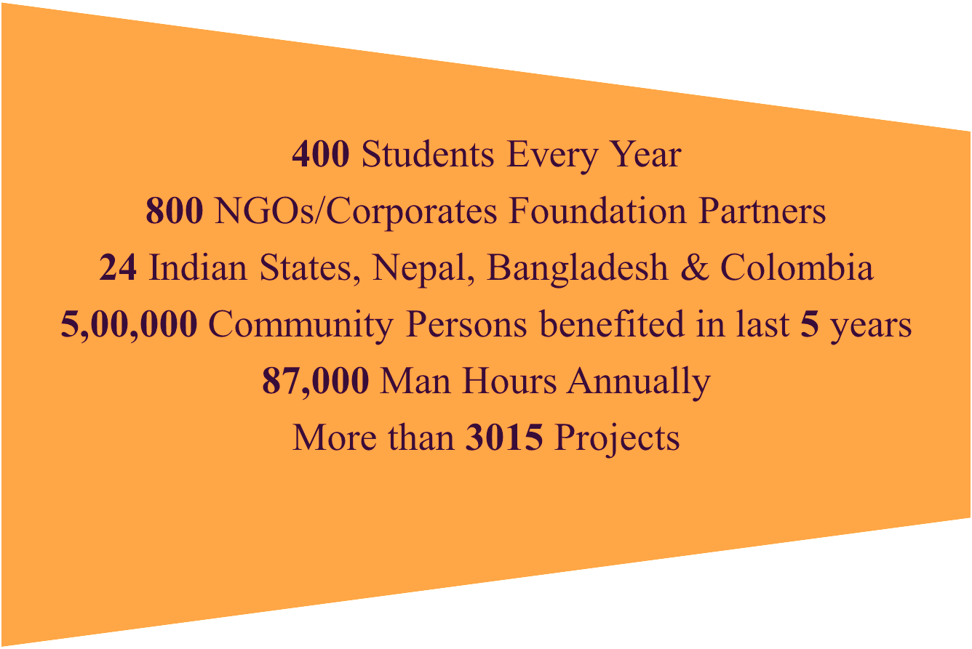
AN OVERVIEW
SPJIMR’s significant research study in 1989 for ASSOCHAM on accelerating the pace of socio-economic development of India’s vast rural society led to the introduction of social projects in place of conventional summer projects for MBA participants. This culminated in the formation of a full-fledged Centre for Development of Corporate Citizenship (C-DoCC). By initiating a C-DoCC, we have reached out to the social sector and started social projects with NGOs in various parts of the country.
C-DoCC was formally established in 2001, with the vision to accelerate the pace of socio economic development in India through collaboration and networking. DoCC is a mandatory integrated module of the management curriculum and is a 3 credit course. The distinctive feature of this pedagogic innovation was that these objectives were to be achieved by experiential learning and through unique “Non-Classroom Learning” pedagogy. It is encouraging to see that our pioneering concept, DoCC is now practiced by institutions both in India and abroad.
The course begins with theoretical inputs, workshops by eminent leaders, followed by visits to places where exemplary social work is carried out and culminating into a 5 weeks social project with NGOs spread across the country.
Objectives of DoCC
- To demonstrate to the participants (alumni, current and prospective) the universality of management principles and their applications to the social sector
- To empower the participants to deal with unstructured environment and make decisions
- To provide capacity development programs for development sector including government and NGOs
- To develop amongst the participants sensitivity to the underprivileged constituents of the society
- To consult for Monitoring, Evaluation and Impact Assessment study for various development programs/projects
- To conduct action field research and develop case, research paper along with other publications.

AWARDS (Last 5 years)

PERIOD | EVENT | AWARD | LOCATION
2017 | HULT Clinton International Competition | National Winner | New Delhi
2016 | SPJIMR - PRME (UN Global Compact) | Champion | USA
2015 | Rural Marketing Association Award | Winners | New Delhi
2014 | Rural Marketing Association Award | Winners | New Delhi
2012 | Rural Marketing Association Award | Winners | New Delhi
2012 | Team MBA | Winners | USA

UN Sustainable Goals
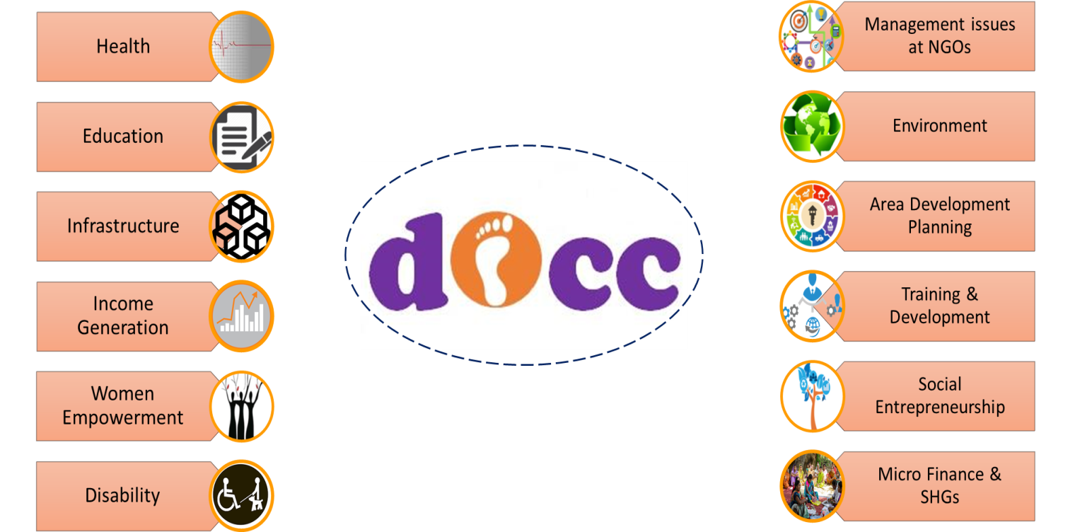

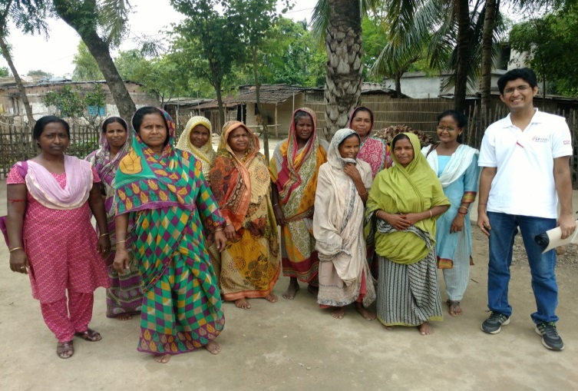
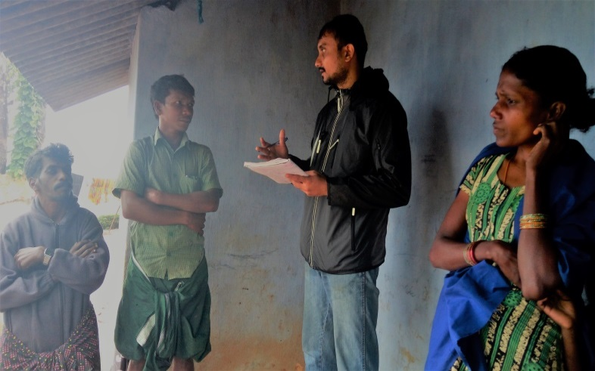
SPJIMR DoCC Interns in Rural India:
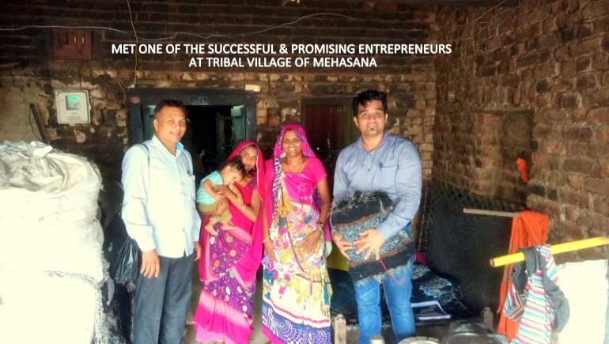
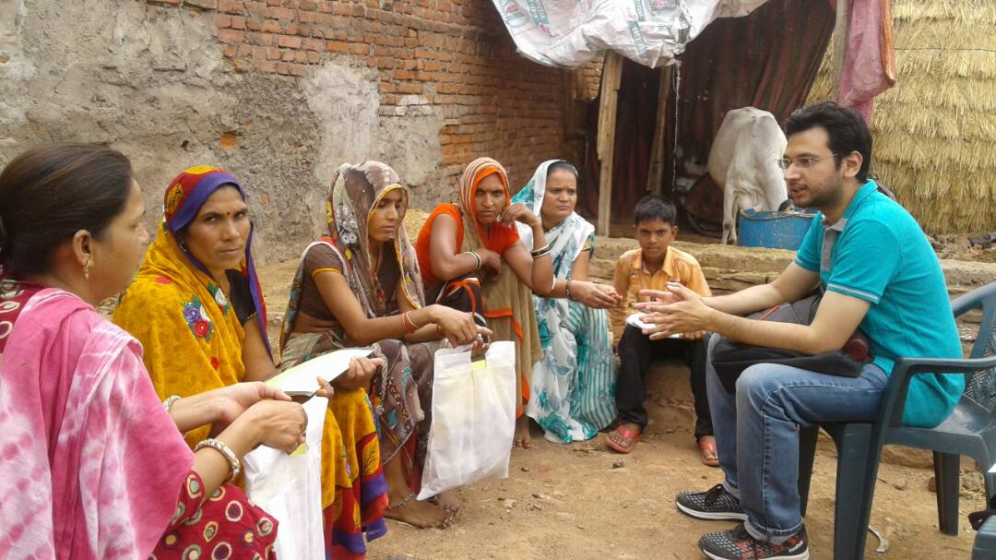
At Murshidabad: Sustainable Options for Uplifting Livelihoods (SOUL) project

At Nilgiri: Tribal organic tea cultivation and construction of processing unit – Marketing Strategy and Branding

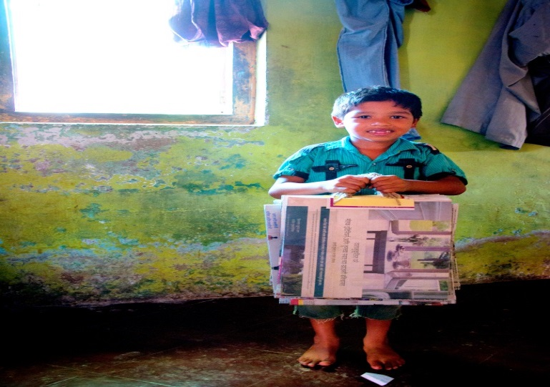
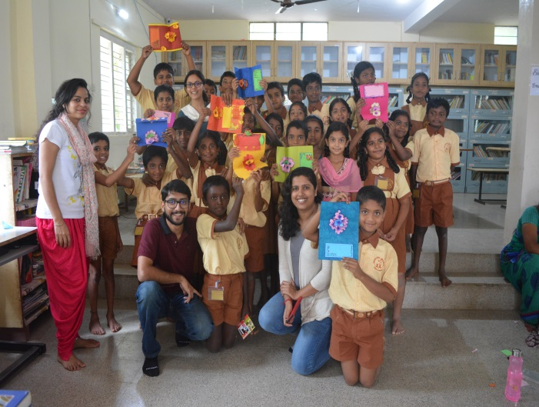
At Gwalior: Impact Assessment of VAMA’s Microfinance Programs
At Ahmedabad: Study development process of highly & moderately successful entrepreneurs
At Roha: Impact assessment of Newspaper Paper bag project
At Bangalore: Costing model for Participant Accommodation Facility

Principle 4.Research: We will engage in conceptual and empirical research that advances our understanding about the role, dynamics and impact of corporations in the creation of sustainable social, environmental and economic value.
S. P. Jain Institute of Management & Research
Summary of Publications for the year 2015 and 2015 in keeping with the spirit of the PRME principles
Srl. | Type of Publication | Faculty Name along with co-author/s | Topic / Title | Publishers / Presentation Details | Status | Date
1 | Conference Paper & Proceedings | Rajiv Agarwal, Arya Kumar and Keith D'Souza | Successors in Indian Business Families: A Demographic Sample Study. | Journal of Applied Management and Investments 4(4), 2015, pp 201-208. | International | April 4, 2015
2 | Newspaper Article | R. K. Pattnaik (Co-Author: Tulsi Jayakumar) | Lending rate cuts hold key to monetary policy | The Free Press Journal, 08 April 2015, Page: 15 | National | April 8, 2015
3 | Newspaper Article | Tulsi Jayakumar | Asset prices - a policy blind spot | Business Line, 08 April 2015, Page: 8 | National | April 8, 2015
4 | Magazine Blog | Mr. Shreenivas Kunte | Winning vs. Losing (Blog) | Financial Kaleidoscope - an online as well as print magazine from NSDL (nation's largest securities depository) https://nsdl.co.in/downloadables/March2015.pdf ( Page 4) | National | April 20, 2015
5 | Conference Paper & Proceedings | Ravindra Dey and Keith C. D'Souza | Leadership Styles of Leader Role Models of Gen Y Prospective Managers Studying in B-Schools | Paper presented at the 8th Doctoral Thesis Conference, IBS, Hyderabad, April 23, 2015. | National | April 23, 2015
6 | Journal Paper | Ajit Prasad (Co-Author: Rajiv Agarwal) | The Oxymoron that is ‘Business Ethics’ | Journal of Management Research (FMS Delhi); Volume 15, No. 1, pp 13-22, Jan - Mar 2015 | National | May 4, 2015
7 | Working Paper | Srivatsan Lakshminarayanan | The idea of ‘emerging’ India – Unraveling the institution | Working Paper Presented at "Whither Emergence" 2015 Ephemera conference at the National Centre for Contemporary Arts (NCCA), Moscow | International | May 6, 2015
8 | Newspaper Article | Dr. R. K. Pattnaik | Don't rush the PDMA | Indian Express; Page: 13; May 12, 2015 | National | May 12, 2015
9 | Newspaper Article | R. K. Pattnaik (Co-Author: Tulsi Jayakumar) | State budgets should concentrate on social-sector expenditure | The Free Press Journal, 18 May 2015, Page: 15 | National | May 18, 2015
10 | Journal Paper | Agarwal Rajiv., Kumar Arya, Keith D’Souza | A Study Of The Factors Influencing Successors’ Choices In Indian Family-Managed Businesses | Journal of Applied Management and Investments, 4(3), 128-136 | International | May, 2015
11 | Newspaper Article | R. K. Pattnaik (Co-Author: Harsh Mohan) | Gold monetization scheme: Holdings from temple, trusts should be free from all taxes | The Free Press Journal, 1st June 2015, Page: 15 | National | June 1, 2015
12 | Newspaper Article | R. K. Pattnaik (Co-Author: Tulsi Jayakumar) | Rate cut front loaded; eyes now on data for clarity | The Free Press Journal, June 3, 2015, Page: 14 | National | June 3, 2015
13 | Journal Paper | Dr. Tulsi Jayakumar | India-SAARC Trade In Recovering Markets: An Augmented Trade Model | SMART Journal of Business Management Studies; Vol-11, No.2, July-December 2015; Also chosen for the Best Paper Award Award 2015 by the Journal. | International | June 24, 2015
14 | Magazine Article | Dr. R. K. Pattnaik (Co-Author: Ms. Samarpita Banerjee) | Labour Reforms in India: An Assessment | MEDC's Economic Digest 'The Roadmap for the Future of Maharashtra's Economy', Vol. XLIV No. 08, June 2015 | National | June, 2015
15 | Case Study | Dr. Tulsi Jayakumar (Co-Author: Dr. Indu Niranjan) | Strides Arcolab Limited's Dividend Pay-Out Decision | Ivey Publishing; Case - 9B15N011 | International | July 22, 2015
16 | Spread Sheet | Dr. Tulsi Jayakumar (Co-Author: Dr. Indu Niranjan) | Strides Arcolab Limited’S Dividend Payout Decision | Ivey Publishing; Spreadsheet - 7B15N011 | International | July 22, 2015
17 | Teaching Note | Dr. Tulsi Jayakumar (Co-Author: Dr. Indu Niranjan) | Strides Arcolab Limited's Dividend Pay-Out Decision | Ivey Publishing; Teaching Note - 8B15N011 | International | July 22, 2015
18 | Case Study | Dr. Rakhi Thakur | Hindustan Unilever Limited: Missed Call Mobile Marketing in Rural India (A) | Ivey Publishing; Case - 9B15A037 | International | July 24, 2015
19 | Case Study | Dr. Rakhi Thakur | Hindustan Unilever Limited: Mobile Marketing in Rural India - Kan Khajura Tesan (B) | Ivey Publishing; Case - 9B15A038 | International | July 24, 2015
20 | Teaching Note | Dr. Rakhi Thakur | Hindustan Unilever Limited: Mobile Marketing in Rural India - (A) and (B) | Ivey Publishing; Teaching Note - 8B15A037 | International | July 24, 2015
21 | Conference Paper & Proceedings | Dr. Uma Narian (Co-Author: Mr. Suresh Mhatre) | Uber: A Case of Service Fiduciary | 6th AHFE 2015: International Conference on Human Side of Service Engineering, HSSE 2015, Las Vegas, USA | International | July 26 to 30, 2015
22 | Conference Paper & Proceedings | Mr. Suresh Mhatre (Co-Author: Dr. Uma Narain) | Bollywood: Entertainment as opiate of the Masses | 6th AHFE 2015: International Conference on Human Side of Service Engineering, HSSE 2015, Las Vegas, USA | International | July 26 to 30, 2015
23 | Journal Paper | Dr. Vanita Bhoola | Impact of Project Success Factors in Managing Software Projects in India: An Empirical Analysis | Business Perspectives and Research 3(2) 1–17; SAGE Publications; sagepub.in/home.nav; DOI: 10.1177/2278533715578555  http://bpr.sagepub.com | National | July, 2015
24 | Journal Paper | Dr. Raja Roy Choudhury (Co-Author: Sayed Suhel Mohd Salim) | Development of the Customer Sentiment Index: Measuring Customers' Attitudes | International Journal of Multidisciplinary Consortium; Vol 2, Iss 1, March 2015; ISSN 2349-073X | International | July, 2015
25 | Journal Paper | Dr. Raja Roy Choudhury (Co-Author: Sayed Suhel Mohd Salim) | How Social Media Business Analytics Enhances Customer Care and Loyalty | International Journal of Social Science, Journalism & Mass Communication; Paper ID: 030813; Vol 2, Iss 1, 2015; Pg No. 39-63; ISSN (Online): 2394-2932 | International | July, 2015
26 | Magazine Article | Dr. R. K. Pattnaik | Some Reflections on The Gold Monetisation Scheme | MEDC's Economic Digest 'The Roadmap for the Future of Maharashtra's Economy', Vol. XLIV No. 09, July 2015 | National | July, 2015
27 | Journal Paper | Sapna Taneja , Dr. Ravikesh Srivastava and N. Ravichandran | Consequences of Performance Appraisal Justice Perception: A Study of Indian Banks | The IUP Journal of Organizational Behavior, Vol. XIV, No. 3, July 2015, pp. 33-57,ISSN: 0972-687X; IUP Publications, Social Science Research Network elibrary | National | July, 2015
28 | Journal Paper | Rakhi Thakur | Community Marketing: Serving the Base of the Economic Pyramid Sustainably | Journal of Business Strategy; Strategy, Vol. 36 Iss 4 pp. 40 - 47 | International | August, 2015
29 | Review of Manuscript | Dr. Tulsi Jayakumar | Manuscript ID CR-05-2015-0041 entitled "FDI-Induced R&D Spillovers on Innovation: Evidence from Indian Manufacturing Sector" | Competitiveness Review- ABDC Journal. | International | August, 2015
30 | Conference Paper & Proceedings | R. K. Pattnaik | Ensuring Public Debt Sustainability Through Expenditure Bench Marks | 10th Annual International Conference on Public Policy and Management, organized by Centre for Public Policy (CPP), held at IIM(B), Aug 3 to 5, 2015 | National | August 4, 2015
31 | Newspaper Article | R. K. Pattnaik (Co-Author: Tulsi Jayakumar) | Rajan links more easing to lower bank rates, monsoon, inflation | The Free Press Journal, August 5, 2015, Page: 21 | National | August 5, 2015
32 | Magazine Article | R. Jayaraman | The Quality Revolution in India | Autumn Issue of Magister Operandi: Bi-annual Operations magazine by Opera, The Operations and Supply Chain club of the Shailesh J. Mehta School of Management (SJMSoM), IIT Bombay. | National | August, 2015
33 | Journal Paper | Stephan Alex Almeida (Co-Author: Dr. Raja Roy Choudhury) | An Overview of Resarch in Hospitality Education | The Social Onlooker, International Journal of Social Cience, Journalism & Mass Communication; Paper Id: 030814; Page No. 64-82; Vol 2, Iss 1, 2015; ISSN (Online): 2394-2932 | International | August, 2015
34 | Journal Paper | Stephan Alex Almeida (Co-Author: Dr. Raja Roy Choudhury) | Customer Satisfaction and Behavior in Hospitality & Tourism | International Journal of Multidisciplinary Consortium; Vol 2, Iss 3, 2015; ISSN 2349-073X | International | August, 2015
35 | Magazine Article | Dr. Raja Roy Choudhury | Branding & Marketing in the SME World | Maharashtra Chamber Patrika (MACCIA); August 2015; Vol XXXXVI No. 5; Page 20 & 26 | National | August, 2015
36 | Book | Dr. Raja Roy Choudhury | Sports Psychology | Himalaya Publishing House; Pages 200; ISBN: 978-93-5202-829-0 | National | August, 2015
37 | Newspaper Article | Dr. R.K.Pattnaik (Co-Author: Dr. Tulsi Jayakumar) | RBI Annual Report: Govt needs to front-load divestment plans | The Free Press Journal; Aug 31, 2015; Page: 19 | National | August 31, 2015
38 | Newspaper Article | Dr. Tulsi Jayakumar | WTO's Shadow on India's Solar Industry | Business Line, Sept 11, 2015 | National | September 11, 2015
39 | Conference Paper & Proceedings | Prof. P. Prabhakaran & Mr. Abir Roy (PGEMP Participant) | Optimizing Working Capital And Reducing Cycle Time Using Concept Of Theory Of Constraints | Presentation at the IPMA World Congress 2015 in Panama; Sept 28 to 30, 2015 | International | September 28, 2015
40 | Magazine Article | Dr. R. K. Pattnaik | Monsoon 2015 - Assessment of the Macro Economic Impact | MEDC's Economic Digest 'The Roadmap for the Future of Maharashtra's Economy', Vol. XLIV No. 11, September 2015 | National | September 30, 2015
41 | Newspaper Article | Dr. R.K.Pattnaik (Co-Author: Dr. Tulsi Jayakumar) | Will RBI's Accommodative policy stance be effective? | The Free Press Journal; Sept 30, 2015; Page: 1 | National | September 30, 2015
42 | Book Chapter | Dr. Tulsi Jayakumar | Turning the Wheel of Corporate Social Responsibility: Towards Integrating Corporate Social Innovation with the Corporate Social Responsibility Agenda | Book: Revolutionsing Corporate Social Responsibility. Towards a Sustainable Tomorrow; Hard-cover • 2015; Pages: 358; ISBN: 9789332701816; INR 1195; Eds : R.K. Singh, Shulagna Sarkar, Punam Singh  Publisher: Academic Foundation  Type: Book Chapter (Chapter 8)  http://academicfoundation.org/index.php?route=product/product&product_id=571 | International | October, 2015
43 | Conference Paper & Proceedings | Dr. Pallavi Mody | Ease of Doing Business-Contemporary Issues, Challenges and Future Scope | Ease of Doing Business-Contemporary Issues, Challenges and Future Scope' International Conference by Centre for Financial Services Gujarat Technological University; ISBN 978-93-5254-009-9 | International | October 9 & 10, 2015
44 | Book | Prof. Abbasali Gabula | Conversations…. Dr. M. L. Shrikant | SPJIMR Publication (ISBN: 978-81-922719-6-5) | SPJIMR | October 28, 2015
45 | Conference Paper & Proceedings | Dr. K. G. Karmakar | Genocide: Intolerance, Terror and Extinction | International Conference on "Religion, State and Society in South Asia: A Historical Perspective" organised by Pubjab University, Patiala. | International | Accepted
46 | Conference Paper & Proceedings | Dr. K. G. Karmakar | Colonial Rule and its Effects on India's Rural Economy | Journal of South Asian Studies; Vol 3, No 3 (2015); ISSN: 2307-4000 (Online), 2308-7846 (Print) | International | Printed in Oct 2015, Issued
47 | Conference Paper & Proceedings | Dr. K. G. Karmakar | Risk mitigation in Agriculture | Background Research Paper for 10th Biennial conference Agrocorp - 2015 | International | Nov 3 & 4, 2015
48 | Conference Paper & Proceedings | Dr. K. G. Karmakar | Agricultural Value Chain for Smallholder Farmers: Concepts and Systems | NABARD - IFPRI National Seminar for Agri Value Chains; Nov 29 & 30, 2015 | National | Nov 29 & 30, 2015
49 | Book Review | Dr. K. G. Karmakar | Agricultual Crisis in India - The Way Out | Indian Journal of Agricultural Economics | National | November, 2015
50 | Conference Paper & Proceedings | Dr. Tulsi Jayakumar | Transitioning from philanthropy to corporate sustainability | Paper Id – ICRBS-244; International Conference on Research and Sustainable Business, Indian Institute of Technology, Roorkee, Department of Management Studies | International | December 4 to 6, 2015
51 | Conference Paper & Proceedings | Dr. Rakhi Thakur (Co-Author: Prabir Jana) | Understanding the Drivers of Information Sharing In Global Apparel Supply Chain | XIX Annual Conference of the Society of Operations Management (SOM); IIM Calcuta; December 11 to 13, 2015 | International | December 11 to 13, 2015
52 | Conference Paper & Proceedings | Sajeev A. George | Operational performance, service quality and financial performance: A Study of the Indian Airline Industry | 19th Annual International Conference of the Society of Operations Management, IIM (C); Dec 11 to 13, 2015 | International | December 11, 2015
53 | Conference Paper & Proceedings | Dr. R. K. Pattnaik | Fiscal Sustainability and Fiscal Legislation in India | Economic Growth in India and USA - Fifth International Conference on Economic and Business Issues organized by Indian Journal of Economics and Business at Kolkata; Dec 19 & 20, 2015 | International | December 19 & 20, 2015
54 | Journal Paper | Anshul Verma & Prashant Dev Yadav | Exploring the Dimensions of Women Empowerment among Microfinance Beneficiaries in India: An Empirical Study in Delhi-NCR | Journal of Applied Management and Investments, ISSN 2225-3467; Vol. 4, Issue 4, December 2015 | International | Dec, 2015
55 | Conference Paper & Proceedings | Dr. Pallavi Mody | Make In India- Campaign for Inclusive Growth: Initiatives and Challenges | “International Conference on Make in India Campaign for Inclusive Growth Initiatives and Challenges Sub Theme – Policy Reforms”, Aligarh Muslim University, Aligarh (India) on 4th and 5th January 2016 | International | January 4 & 5, 2016
56 | Journal Paper | Rajiv Agarwal, Arya Kumar an Keith D'Souza | Issues in Career Choices Of Successors In Family Businesses: Perspective From Literature Review | Journal of Applied Management and Investments 5(1), 2016, pp 1-19. | International | January 5, 2016
57 | Newspaper Article | Dr. Tulsi Jayakumar | Evening out the odds | Hindu Business Line; Jan 5, 2016 | National | January 5, 2016
58 | Journal Paper | Dr. Tulsi Jayakumar | Social Capital Creation in Indian Rural Cooperatives in the era of Globalisation | SMART Journal of Business Management Studies, Vol 12, No.1, January-June 2016 issue | International | January 2016
59 | Journal Paper | Dr. R.K.Pattnaik (Co-Author: Dr. Anshul Verma) | Rule-Based Fiscal Policy in India: An Assessment | BULMIM Journal of Management and Research; Year 2016, Volume-1, Issue-1 (January-June); Online ISSN : 2455-3298; DOI:10.5958/2455-3298.2016.00003.9 | National | January, 2016
60 | Case Study | Dr. Tulsi Jayakumar | Agarwal Packers and Movers: Competing for "Moving" Experiences | Ivey Publishing; Case - 9B16M008; Featured by the Case Centre in June 2016 | International | January 28, 2016
61 | Teaching Note | Dr. Tulsi Jayakumar | Agarwal Packers and Movers: Competing for "Moving" Experiences | Ivey Publishing; TN - 8B16M008 | International | January 28, 2016
62 | Book Chapter | Keith C. D'Souza, Ravindra Dey and Sheba Mathew | OD Values in Family Owned Business in India. | In T.V. Rao and Anil Khandelwal (eds.): HRD, OD, and Institution Building: Essays in Memory of Udai Pareek. New Delhi: Sage, 2016. | International | January, 2016
63 | Newspaper Article | Dr. Renuka Kamath | Segmenting online consumers | Businessline; February 2, 2016 | National | February 2, 2016
64 | Newspaper Article | Tulsi Jayakumar & R.K. Pattnaik | Policy Review: A Case of Stable and Sustainable Growth? | Free Press Journal; Feb 2, 2016 | National | February 2, 2016
65 | Journal Paper | Dr. Anjali Malik (Co-Author: Rajeev Kumra -  IIM – Lucknow, Smitha Girija - IILM Institute for Higher Education) | Gaming Dependency Among Indian Adolescents: A Phenomenological Study | International Journal of Indian Culture and Business Management, Vol. 12, No. 3, 2016; Page 361 to 375; ISSN online: 1753-0814;  ISSN print: 1753-0806 | International | February 3, 2016
66 | Newspaper Article | Dr. Tulsi Jayakumar (Co-Author: Dr. R. K. Pattnaik) | Revival of Pvt Investment key to higher growth: RBI | The Free Press Journal; Date: 03 Feb 2016; Page: 21 | National | February 3, 2016
67 | Journal Paper | Dr. Tulsi Jayakumar | Sholay 3D: Recreating Magic? | South Asian Journal of Management (SAJM); Vol. 22.4, Oct-Dec. 2015 | International | February 3, 2016
68 | Conference Paper & Proceedings | Dr. K. G. Karmakar (Co-Author: Ms. Anuradha Karmakar) | Reviving India's Decaying Rural Economy | International Conference on Rural Development; XIDAS Campus, Jabalpur; Feb 4 & 5, 2016 | International | February 4, 2016
69 | Web Portal Article | Dr. Tulsi Jayakumar | There’s No Such Thing as a Free Lunch! | eSS Current Affairs: Union Budget 2016-17; eSocialSciences is a pan-Asia social sciences portal (www.esocialsciences.org); http://www.esocialsciences.org/Articles/showArticle.aspx?qs=+30QEbn3Sin1XnvhkfnzXVMpYu7w83gG7XAQhjbRJx5JvXK7N5iWCi/2rwY2lAl+phQ1CY+DOv5cF1/XqQnAiw== | International | February 11, 2016
70 | Conference Paper & Proceedings | Arunima Haldar, Sagari Dey | Empirical study on the predictive power of bankruptcy models: Evidence from Indian companies | 12th International Research Conference on Quality, Innovation & Knowledge Management - Monash University, Australia | International | Feb, 2016
71 | Conference Paper & Proceedings | Arunima Haldar, Rashmi Dyondi | Role of Market Knowledge in Aiding Long Term Sustainability of Film Studies: Evidence from Hindi film industry in Mumbai | 12th International Research Conference on Quality, Innovation & Knowledge Management - Monash University, Australia | International | Feb, 2016
72 | Journal Paper | R. Jayaraman | An empirical approach to inventory cost reduction | International Journal of Research in Commerce , IT and Management, Volume 6 , Issue 2 , February 2016 . pp 27-39; ISSN 2231-5756 | International | Feb, 2016
73 | Journal Paper | R. Jayaraman | Why Should the Corporate Sector Embrace CSR? | The International Journal of  Business & Management (ISSN 2321–8916); Vol 4 Issue 2 | International | Feb, 2016
74 | Journal Paper | Ajit Prasad (Co-Author: Lekha Warrier) | Mr. Porter and the New World of Increasing Returns to Scale | Journal of Management Research; Vol 16, No1 (2016); Pages 3 - 15; Published: 2016-03-01 | International | Dec - Jan 2016
75 | Magazine Article | Dr. Ranjan Banerjee | Now and Then: A perspective | Business India; December 21, 2015 | Ntl | December 21, 2015
76 | Magazine Article | Dr. Ranjan Banerjee | Why People Spend The Way They Do | BusinessWorld; November 16, 2015 | Ntl | November 16, 2015
77 | Magazine Article | Dr. Ranjan Banerjee | Why Research  Matters? | Forbes India Marquee . A Special Marketing Presentation In Association With Skilltree  Knowledge Consortium And Great Place To Study Research Institute March 2016 | International | March, 2016

Principle 5. Partnership: We will interact with managers of business corporations to extend our knowledge of their challenges in meeting social and environmental responsibilities and to explore jointly effective approaches to meeting these challenges.

TATA Social Internship meets SPJIMR / DoCC 2016

The TATA Social Internship (TSI) is a unique two month experiential corporate sustainability internship offered to undergraduate and postgraduate participants from the world’s leading universities who come to India to intern in one of the TATA Companies’ ongoing Corporate Sustainability (CS) Projects. This is very much in line with SPJIMR’s DoCC Project Initiative for PGDM & PGPM participants wherein they embark on a two month sojourn with NGOs thereby acting as agents for inclusive business development in the social sector.

This year Centre for DoCC, SPJIMR in association with Tata’s TATA Social Internship (TSI) organised the program ‘Building Bridges across Boundaries VI’ on 2nd September, 2016 at SPJIMR. The agenda of the program was to give TSI interns and SPJIMR participants an opportunity to share their social internship projects with the eminent panel. This year 15 TSI interns came from University of Cambridge, London School of Economics (LSE) University of California, Davis and 3 SPJIMR participants presented their DoCC projects. The projects were from different sectors such as Healthcare, Education & Skill Development, International Migration, Rural Development and Entrepreneurship.

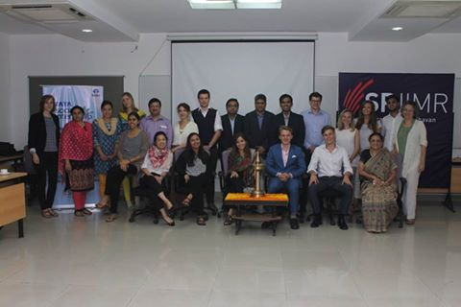
Building Bridges across Boundaries VI

The esteemed panel members included Ms. Shernavaz Colah (TSI Coordinator- Group Corporate Communication), Mr.Colin Wells (Deputy Head of Mission, British Deputy High Commission), Mr Atul Aggarwal( Sr.VP – Corporate Affairs, Tata Services) and from SPJIMR the members were, Dr Nirja Mattoo ( Chairperson C-DOCC), Dr. K.G. Karmakar, Prof. M.S.Rao, Prof. Jiban Mukhopadhayay, Prof. Bindu Kulkarni, and Prof. Jagdish Rattanani.

The program was concluded by a valedictory speech by Dr. Nirja Mattoo.

Cummins DoCC Social Impact Awards (8th SIA)
SPJIMR’s DoCC in collaboration with Cummins India Ltd. celebrated its 8th Social Impact Awards on November 30th, 2016. DoCC which stands for Development of Corporate Citizenship runs rural internship programs under which all participants intern with non-profits for six weeks before they work go for corporate internships. This is a part of the evaluation of the participants and is done to sensitise them to the realities of India. The projects so generated are then evaluated and the top five of these are honoured at the Social Impact Awards every year.

The program commenced with a speech by the Dean, Dr. Ranjan Banerjee who emphasised the need for exposure to rural India in order to understand India in totality and how just by exposure one can start changing things.

The five NGOs invited for the award this year were:
- “Snehalaya” from Ahmednagar Maharashtra
- “GRAMA” from Chitradurga,
Dr. Ranjan Banerjee
- “Rural Healthcare Foundation” from Kolkata, West Bengal
- “SAWERA” from Amritsar, Punjab
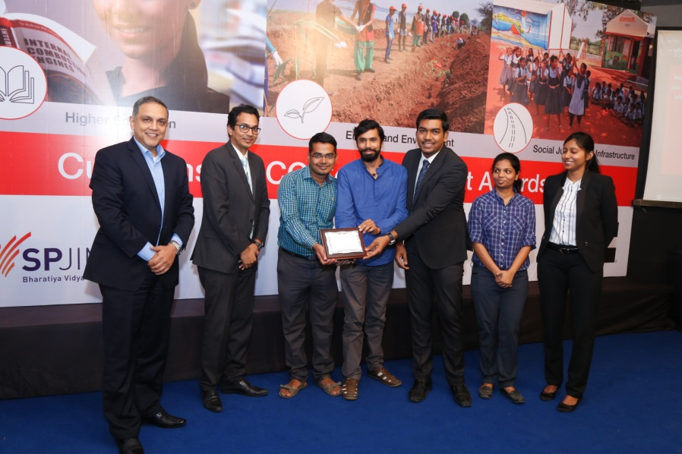
- “EcoAd” from Pune Maharashtra.
The top award was won by Eco-Ad which incidentally also received an order from the sponsor of the awards Cummins for innovative high-strength paper bags to replace thin plastic bags. The second award went to GRAMA and the third to Rural Healthcare Foundation.
After an enthralling session by the participants, the audience was mesmerised by the performance by participants of St. Catherine’s Home. The performance received a standing ovation and uplifted the mood of every one present.
Winning Team EcoAd Receiving SIA 2016

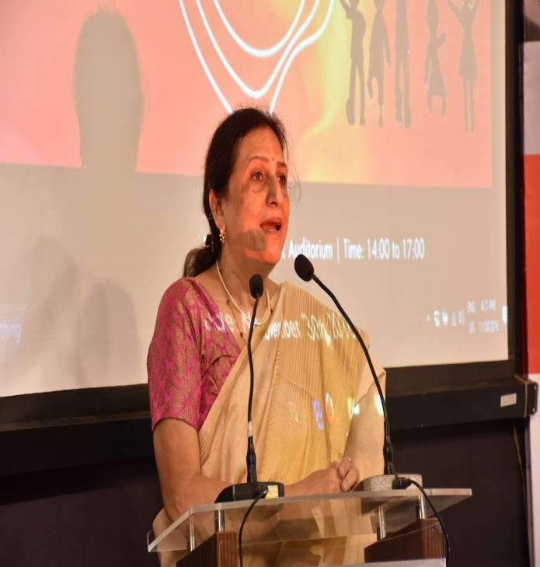
To end the ceremony, Dr. Nirja Mattoo, Chairperson – DoCC remarked that, “Management is universal. It just cannot be applied to the corporate sector, but also the social sector. When I came to SPJIMR, this DoCC was a small initiative. Our former dean, Late Dr. M. L. Shrikant had this dream of sensitising the participants to ground realities of larger India and to give them an exposure to rural India. That is the area where management is really important.”
The ceremony really opened the eyes of the participants and made them understand what they are expected to do in the rural internships and what are the standards set by their seniors. The interaction of the participants with the NGO’s and the seniors showed the enthusiasm and the impact generated by the event.
Dr. Nirja Mattoo

INTERNATIONAL EXCHANGE PROGRAMS (Academic Partnership):

SPJIMR has collaborations with foreign universities for case writing and participant learning in areas of development and responsible management. Some of the Universities with whom we partner are National University of Singapore, University of Paris-Dauphine, France and Darden School of Business, University of Virginia, University of St. Thomas – Minnesota.

National University of Singapore (NUS)

In the last few years Development of Corporate Citizenship (DoCC) at SPJIMR and National University of Singapore have partnered through University Scholars Program (USP) wherein participants from NUS work with social organisations for a period of 7 weeks. During the immersion, the participants are oriented to social issues and use their expertise to provide solutions to some of them.
The participants had an enriching experience and worked with great enthusiasm. In spite of there being differences in terms of climate, food habits and culture, the participants adapted easily in the environment. The NGOs were extremely supportive and made them feel a part of them. The immersion program not only enabled them to do societal work, but also changed their mindset.
C-DoCC Project Presentation by Participant from National University of Singapore

University of St. Thomas – Minnesota (1 Week Immersion Program)
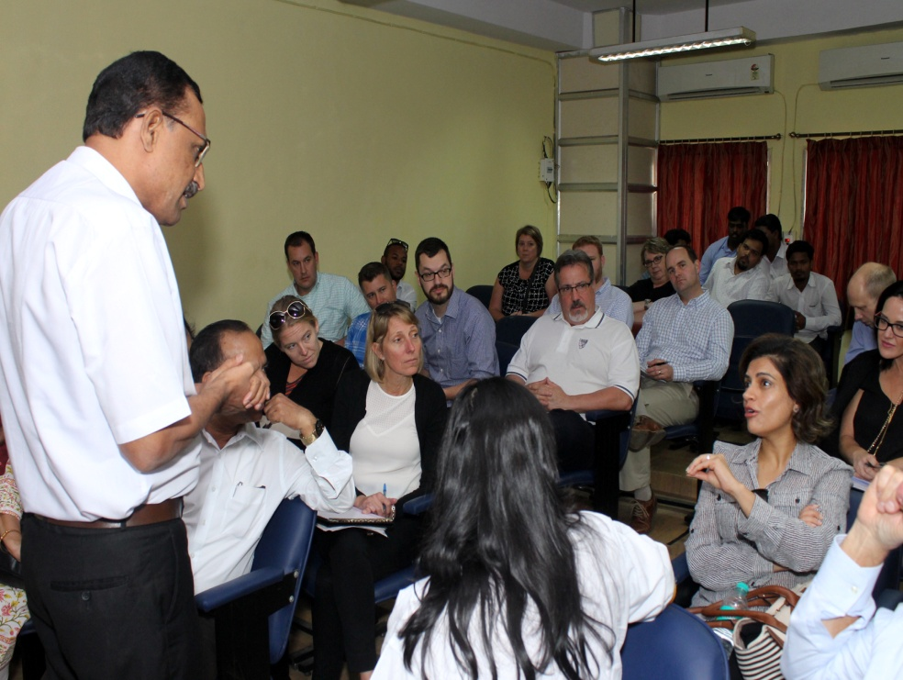
20 Executive MBA participants from Opus College of Business-University of St. Thomas, Minnesota visited S. P. Jain Institute of Management & Research (SPJIMR), Mumbai for 1 week as part of their immersion program. They visited Nair hospital to understand the structure of public health system in India and Maharashtra, visited Dharavi, Aisa’s largest slum. The participants also visited BMC (Brihanmumbai Municipal Council) vegetable waste recycling unit in Dharavi. They also visited the slums of Khar to understand the Supplementary Nutrition program under the Government’s Integrated Child Development Services (ICDS) Scheme. The ICDS Scheme is one of the flagship programs of the GoI and aims to improve the nutritional and health status of children in the age group of 0-6 years, pregnant women, lactating mothers and adolescent girls (out of school).
Volunteers in Discussion with Dr. Suryavanshi at Nair hospital
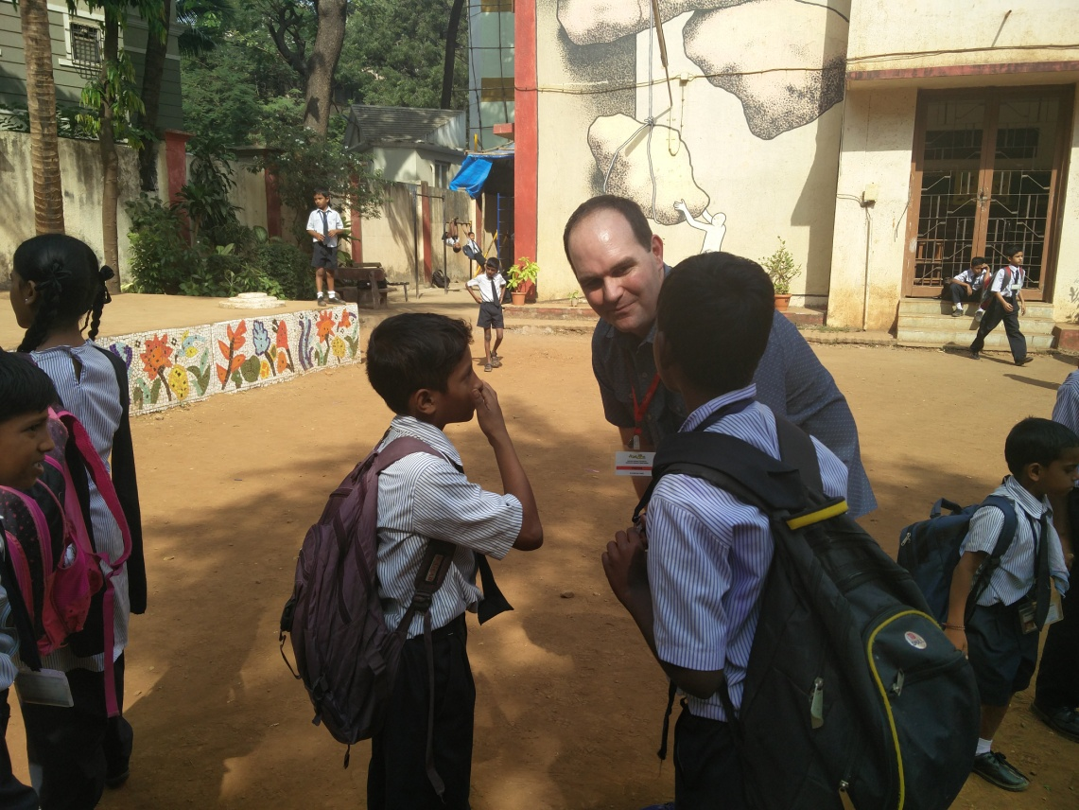
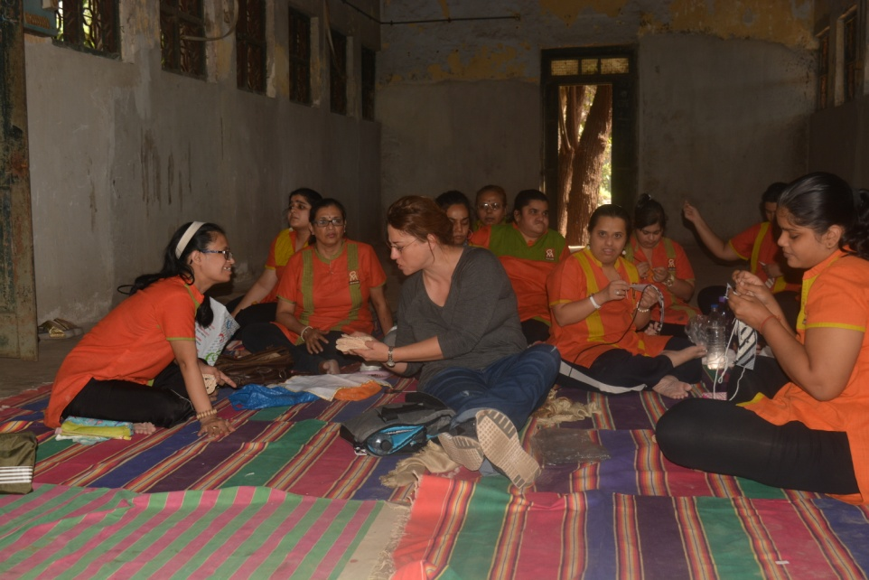
Two set of participant groups from the Executive MBA program of Opus College of Business-University of St. Thomas, Minnesota spend their day volunteering with Assema Charitable Trust and OM Creation Trust.
Volunteer Interacting with School Participants of PCMC, Aseema Charitable Trust
Volunteer in action at Om Creations with the group

Principle 6: Dialogue: We will facilitate and support dialogue and debate among educators, participants, business, government, media, civil society organizations and other interested groups and stakeholders on critical issues related to global responsibility and sustainability.

Classroom Learning on Social Responsibility

- Sustainability and Distributive Justice Course (PGDM)
This course is designed to present practical skills for participants in the area of integrating sustainability into business practices, operational procedures, policies, research and development through a series of interactions with experts. Sustainability in the context of equality of opportunity, outcomes, economic rewards, justice and human rights would be covered.
The course also aims at introducing the concept of distributive justice from the perspective of human rights and gender. With examples of discrimination and hence a need for empowerment of marginalized, it is essential for managers to understand the perspective and appreciate the interventions executed to address these issues. These motivational sessions will equip and prepare the participants to handle varied situations effectively.

This year the theme was Base of the pyramid (BoP):
The BoP protocol is a co-venturing process that integrates the principles of mutual value and co-creation”. By mutual value, it is meant that at each stage of the process, not simply the new business, value is for all partners in terms important to each. The “co-“component of “co-creation” captures the need for the company to work in equal partnership with BoP communities to nurture and grow into a sustainable business.
Course Overview:
In an attempt to cover the major and broad level concepts with relevant illustrations, this course would be imparted through a pedagogy of extraordinary work done by ordinary persons, and learning through their journey of hardship.
The (BoP) theme will revolve around the following topics which will also include a Seminar.
- Gender Empowerment
- Sustainable Development
- Human Rights Justice
- Marginalized sector

This course has strategic partners providing us with content and with platforms for discussion. These networks will provide the course with an extensive and diverse portfolio of problems, challenges & solutions.

Session Details

Session 1: Gender Empowerment (Lecture by Mr. Arunachalam Murugunantham)

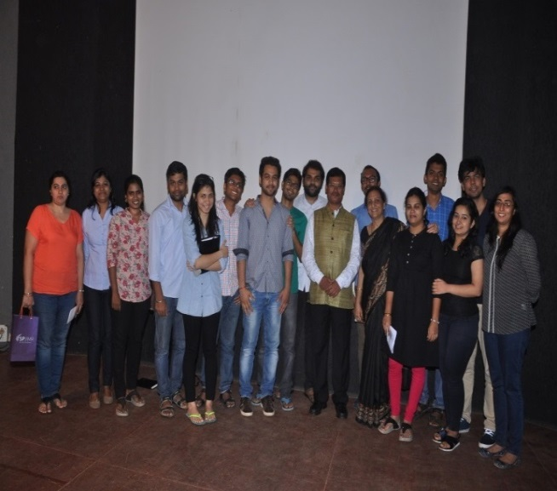
Mr.Muruganantham is a social entrepreneur from Coimbatore in Tamil Nadu, India. He is the inventor of a low-cost sanitary pad making machine and has innovated grass-roots mechanisms for generating awareness about traditional unhygienic practices around menstruation in rural India. He is social entrepreneur, innovator and the leader who brought to the public eye the issues related to unhygienic practices around menstruation in rural India.

The dession covered the followings:
A) Social Marketing
Mr. Muruganatham with Dr. Nirja Mattoo & DoCC Committee members
B) Trial & Error
C) Problem vs Solution
D) Retail vs Detail

Session 2: Sustainable Development
Lecture by Dr. Harish Hande
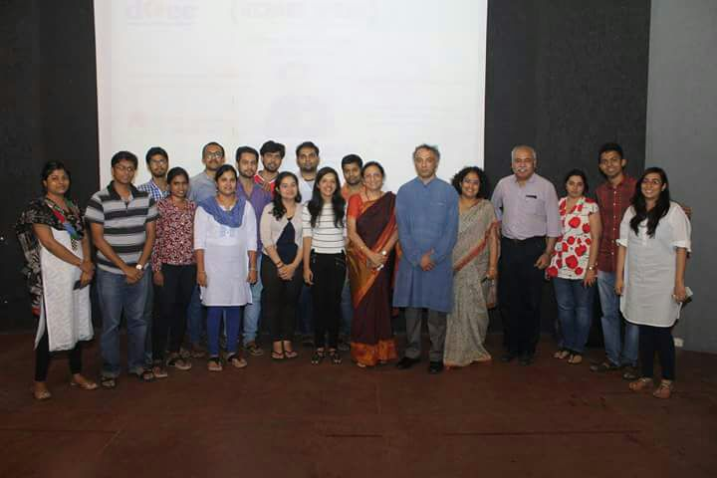
Dr. Hande is an Indian social entrepreneur, who co-founded SELCO India which is a social enterprise, to eradicate poverty by promoting sustainable technologies in rural India. SELCO India is a social enterprise that provides sustainable energy services to the poor in India. Dr. Hande is embellished with qualifications ranging from an undergraduate degree at IIT; Kharagpur to a PhD. in Energy Engineering at the University of Massachusetts Lowell .He was awarded with the Ramon Magsaysay Award for 2011 for "his pragmatic efforts to put solar power technology in the hands of the poor, through his social enterprise SELCO India.
Dr. Hande with Dr. Nirja Mattoo & DoCC Committee members
The following had been covered:
A) Ecosystem
B) Affordable Energy Solutions
C) Outreach /Impact
D) Research & Development

Session 3 - 5: Human Rights Justice

Lecture & Technical Session by Mr. Viraf Mehta & Mr. Rana Alok Singh

Human Rights establish a culture where human rights are understood and respected and thereby ensure democracy, social justice and tolerance. The relationship between business practices and international human rights standards is a significant area of human rights which has relatively recently been acknowledged following an increase in the number of private enterprises on a global scale. The Guiding Principles on Business and Human Rights: Implementing the United Nations are “Protect, Respect and Remedy” Framework. The topics covered as followed:

A) Transition of CSR/Human Rights
B) United Nations Guiding Principles (UNGP) – Reporting Framework
C) United Nations Extreme Poverty & Human Rights
D) Business & Human Rights
E) Supply Chain – Human Rights
F) Human Rights – Due Diligence Framework

Session 6 - 8: Marginalized sector

Inclusion of Differently Abled Persons/ Social Innovation

Panel Discussion on Inclusiveness Makes Business Sense
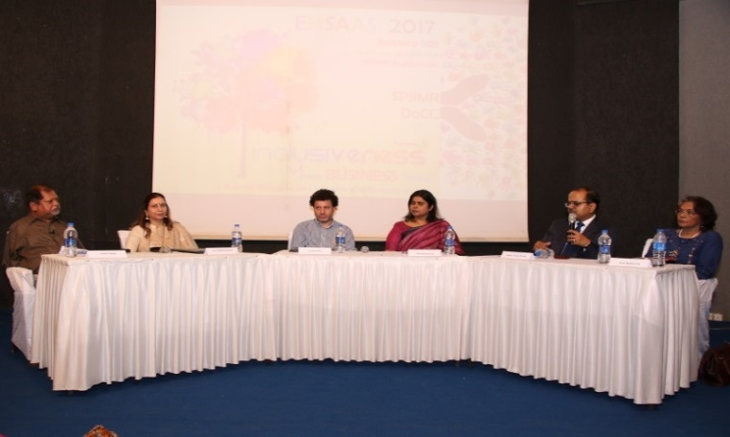
There are some 600 million people with disabilities worldwide, or 10% of the world population, with 400 million of them estimated to live in the Asia and Pacific region. People with disabilities are poor because they are denied access and opportunities most basic to human development—education, income, and self-esteem. However, people with disabilities have the capacity to become productive citizens and contribute to national development. The core values for the employability criteria are:
Panel Discussion

1. Wealth creation is important for society as a whole not just for individuals
2. Character & integrity are as important as capability
3. UN Sustainable Goal number 10 - Reduced Inequalities to be incorporated

Objectives of the Panel Discussions -

1. To assess gaps in skill development for the differently abled persons in India in order to boost their employability and income generation capacity, ultimately moving toward a more inclusive society.

2. To assess & create the employability options for the differently abled persons with the core values

3. Academia as a catalyst - to mentor, advice & promote talent of differently abled persons from inclusive education to accessibility

4. How corporate sector can create an enabling environment to integrate differently abled persons in the workforce?

5. The role of government in creating & designing a social inclusion program for differently abled persons. What are the government policies?

The Panel members comprised of experts from diverse backgrounds such as:

1. Corporate sector
2. Social Entrepreneur
3. NGO
4. Academia
5. Government Sector
6. Training & Development

- ENHANCING SOCIAL RESPONSIBILITY (ESR) – COURSE (PGEMP)

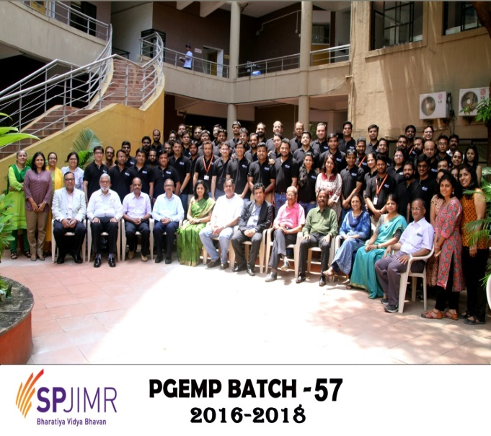
The emerging business challenges require corporations to create a reservoir of versatile executives with a strong base of functional knowledge along with general management perspective. SPJIMR’s uniquely designed Post Graduate Executive Management Program (PGEMP) is designed for this purpose.

One of the courses designed for the PGEMP participants is the Enhancing Social Responsibility (ESR) Course. The ESR course is a 1.0 credit course conducted by the faculty of the C-DoCC Department.

The course on Enhancing Social Responsibility (ESR) is designed to understand different aspects of business growth on the basis of values and social responsibility. The objective of this course is to introduce a conceptual framework for CSR with an approach of strategic and sustainable development models.

Course Objectives

The specific objectives and dimensions of the course are as follows,

- To demonstrate a strong business case for CSR and that business performance and social responsibility can complement one another (doing well while doing good, makes good business sense)
- To acquaint the participants with the Government’s mandate on CSR, issues relating to the companies Act, 2013 that came into effect on 1st April 2014 replacing the 57 year old Companies Act 1956.
- To provide knowhow on the practices of CSR which influence responsibility and responsive business decision making.
- To position and select appropriate models for companies to gain sustainable competitive advantage with an integration of CSR in the company’s goal
- To showcase the commendable services rendered by the social organizations to the society and environment and how companies can partner with their CSR activities.

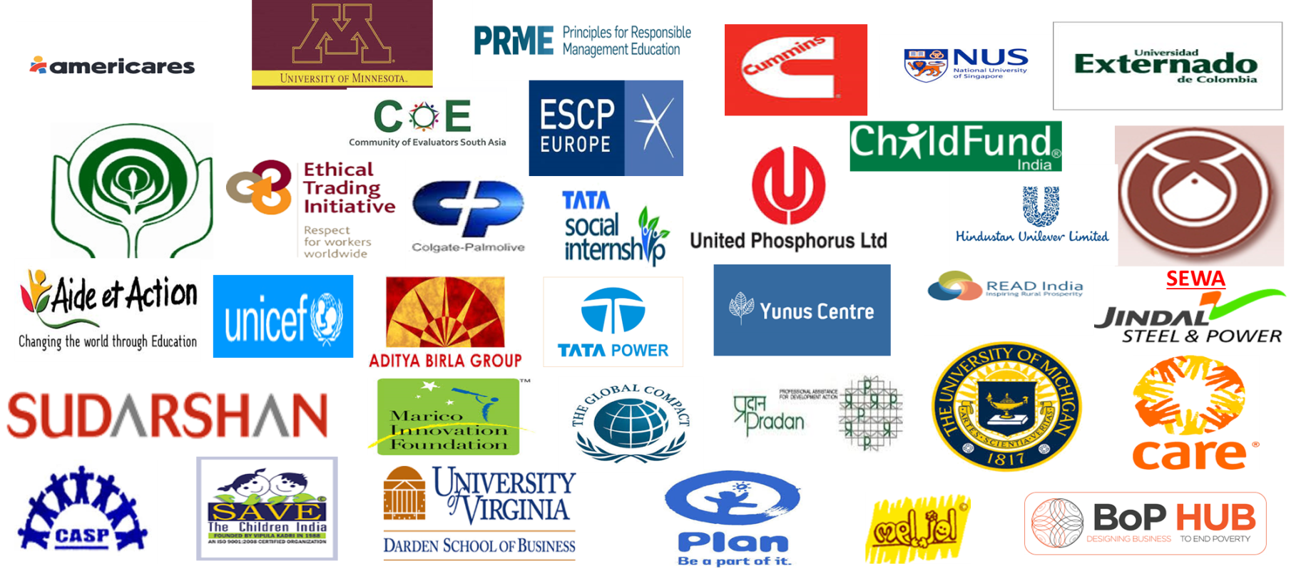
SPJIMR DoCC Partners:

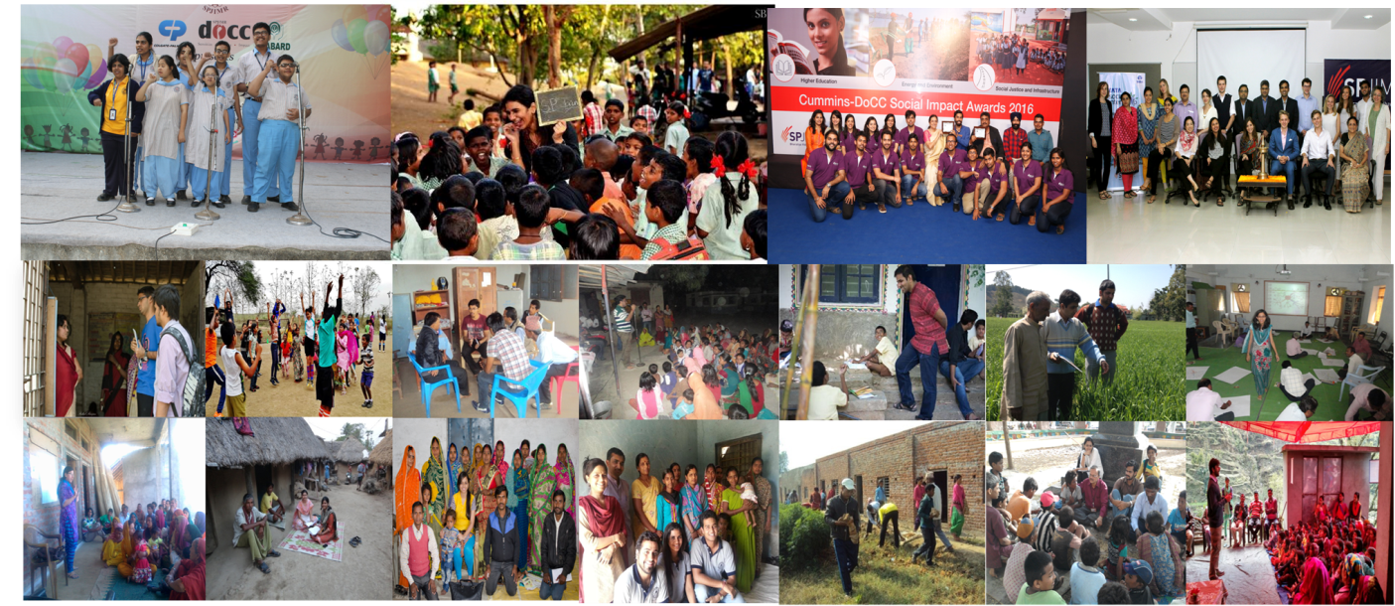
SPJIMR DoCC at a Glance:

