CSR Activity at Dr. Bhim Rao Ambedkar School : Establishment of Library
Purpose:
To upgrade the standard of education in government schools in Ghaziabad
Values:
Upgradation of society by imparting education
Provide the underprivileged with resources that will help them become independent
IPM has been vibrant and responsive to changing social and business environment.
IPM has society's engine for knowledge creation.
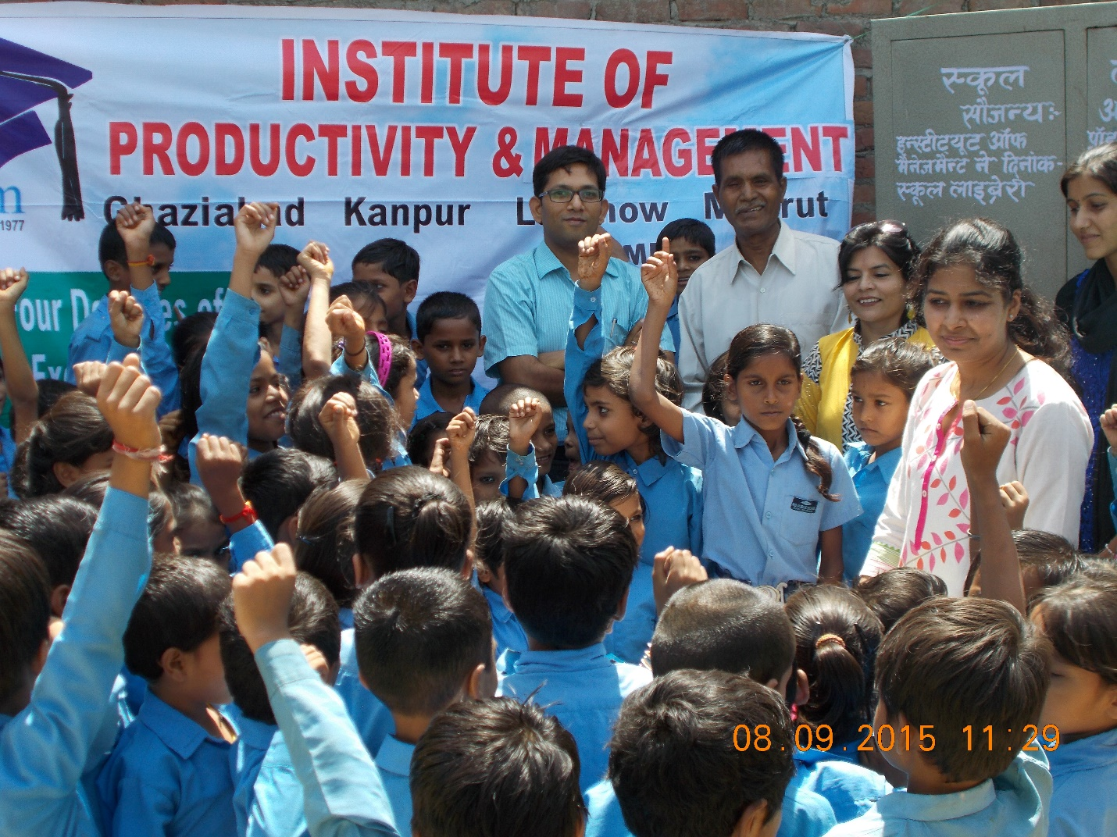
Method:
Institute of Productivity and Management conducted its CSR activity in Dr. Bhimrao Ambedkar Institute, Duhai, Ghaziabad, India on 8th September, 2015 and established the library for students. The faculty of IPM told the students about the importance of reading. The establishment of library brought great joy to the faculty and students at the school and they promised to make the most out of it. It incorporates books on myriad subjects like English, hindi, science, social science, maths, general knowledge, etc.
Outcomes:
The students have become interested in reading and studying
The mental capability of students has improved
Key objectives for the next 24-month period with regard to the implementation of the Principle(s):
More books will be donated on continuous basis for benefitting students from economically weaker strata of society

