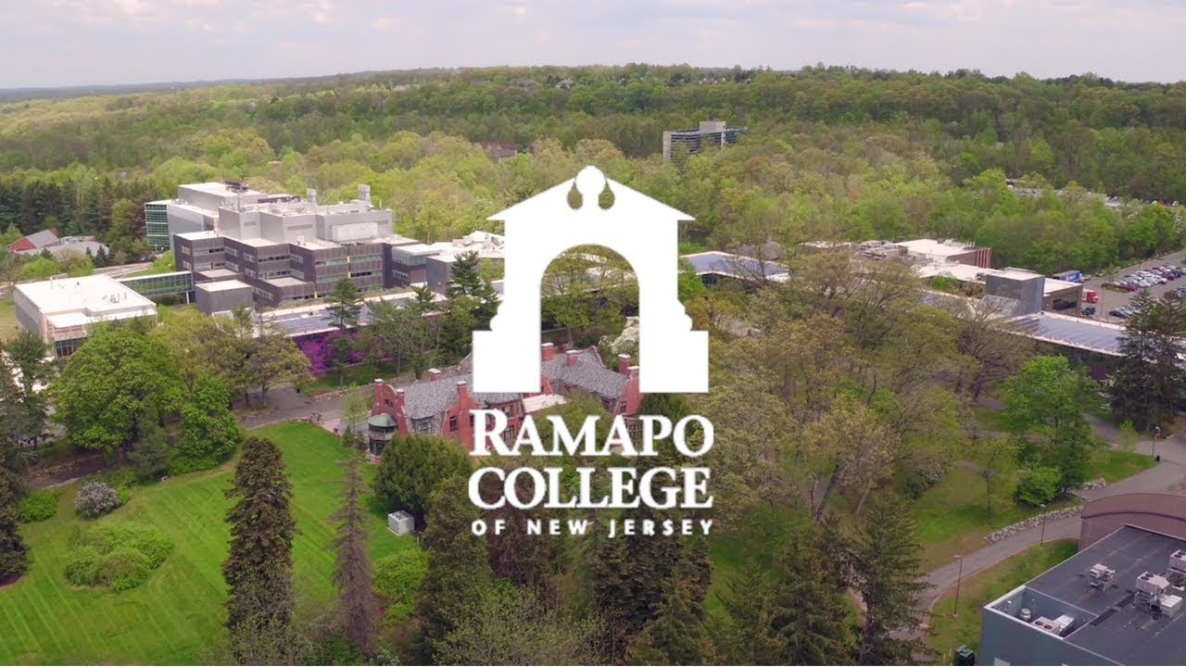

Sharing Information on Progress for PRME
July, 2019

At the Anisfield School of Business
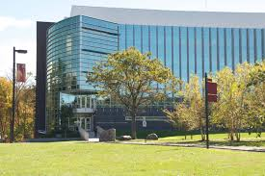

Message from the Dean
In 2017, the Anisfield School of Business was delighted to codify our mission-driven adherence to diversity, integrity, social responsibility, global awareness, and continuous improvement by becoming a signatory to Principles of Responsible Management Education (PRME).

This report constitutes our first communication on Sharing Information on Progress (SIP), although action on social responsibility has been baked into our DNA from the founding of our sustainability-committed host institution, Ramapo College, in 1969.

Given our long history of sustainable action, we have devoted our first two years of PRME membership to taking stock of where we are at the outset of this newest leg of our social responsibility journey. We present this report as a baseline for our future PRME endeavors. The report summarizes the results of three studies we have undertaken to assess our current baseline commitment to the PRME. We share our progress to date on 1) our faculty’s baseline stated adherence to the PRME at the beginning of our signatory status, 2) our faculty’s baseline research at the intersection of business and societal challenges (one measure of our starting point on Principle 4), and 3) our faculty’s inclusion of the content of the United Nation’s 2030 Sustainable Development Goals in our syllabi (one measure of our starting point on Principle 3).

The baseline activity we report provides a snapshot of our readiness for our PRME journey. A planned visioning session for Fall 2019 will provide our targets for the next few years and a gap analysis will follow.

We are grateful for this self-assessment opportunity. We would like to use the occasion of the submission of this report to reiterate the Anisfield School of Business’s commitment to the PRME. We continue to be energized by its promise to build a better world through business.
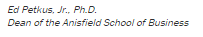

The Mission of Ramapo College of New Jersey
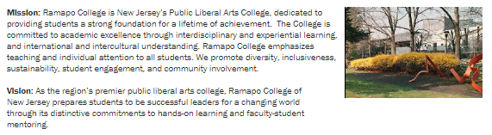
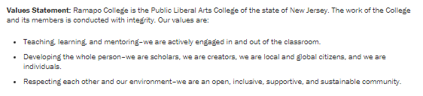

The Mission of the Anisfield School of Business
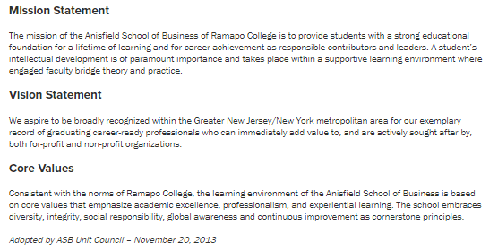

Ramapo College Sustainability Approach

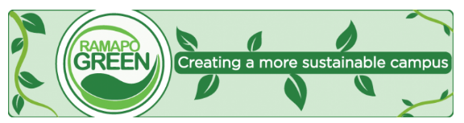

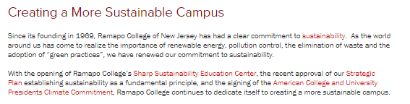

PRME at the Anisfield School of Business
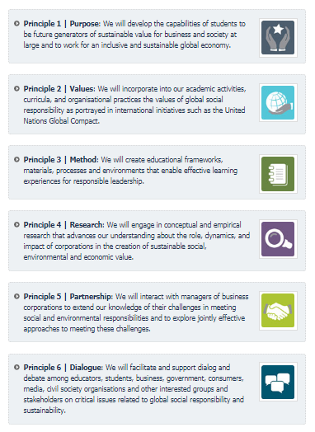
In the Fall of 2018, the Ramapo ASB PRME team created and executed a survey of our faculty to provide a baseline measure of support for the PRME principles. We devised a 23 question survey to determine faculty member adherence to the six principles of PRME in their undergraduate core (where faculty autonomous pedagogical design decisions are limited), undergraduate elective and graduate classes, as well as in their research and practice, where applicable. With an N of 58 (42 full-time faculty and an additional 16 adjunct faculty) we received back 34 usable responses for a response rate of 58.6%. Adherence to/agreement in practice with each of the principles given different teaching, research, and practice contexts was measured on a scale of 1 to 4 (plus 0 for not applicable) with 1 = to no extent; 2 = to a small extent; 3 = to some extent; and 4 = to a large extent

Full results are presented in Table 1 but highlights include:
• Over 23 questions, 6 Principles, PRME is reflected in practice an average of 2.15 (between “some” and “large”) extent at Anisfield School of Business
•Most Reflected in Practice: Methods in Individual Faculty’s Undergraduate Elective Courses (2.55)
•Least Reflected in Practice: Individual Faculty Partnerships (1.83)
•PRME Values is reflected slightly more in MBA teaching than Undergraduate
•PRME Purpose and Method are reflected slightly more in Undergraduate than MBA teaching

Table 1:
Question about PRME practice | Average Faculty Response (1-4 scale)
Q1: To what extent do required major courses reflect PURPOSE? | 2.24
Q2: To what extent do elective major courses reflect PURPOSE? | 2.33
Q3:To what extent do graduate courses reflect PURPOSE? | 2.29
Q4: To what extent does undergrad program reflect PURPOSE? | 2.31
Q5: To what extent does graduate program reflect PURPOSE? | 2.30
Q6: To what extent do required major courses reflect VALUES? | 2.03
Q7: To what extent do elective major courses reflect VALUES? | 2.04
Q8:To what extent do graduate courses reflect VALUES? | 2.18
Q9: To what extent does undergrad program reflect VALUES? | 2.19
Q10: To what extent does graduate program reflect VALUES? | 2.24
Q11: To what extent do required major courses reflect METHOD? | 2.47
Q12: To what extent do elective major courses reflect METHOD? | 2.55
Q13: To what extent do graduate courses reflect METHOD? | 2.29
Q14: To what extent does undergrad program reflect METHOD? | 2.39
Q15: To what extent does graduate program reflect METHOD? | 2.32
Q16: To what extent does your research reflect RESEARCH? | 1.93
Q17: To what extent does school’s research reflect RESEARCH? | 2.11
Q18: To what extent does your practice reflect PARTNERSHIP? | 1.83
Q19: To what extent does school’s practice reflect PARTNERSHIP? | 2.00
Q20: To what extent does your practice reflect DIALOG? | 2.00
Q21: To what extent does school’s practice reflect DIALOG? | 2.22

As another measure of our starting point on Principle 4, In the Fall of 2018, the Anisfield School of Business PRME team collected data on reported “Faculty Research Interests” from the School’s website: (https://www.ramapo.edu/asb/):

Findings Include:

•42 Full-Time Faculty
•45.2% Female
•45.2% Non-white (US Census Definitions)
•9 Accounting 6 Economics
•5 Finance 3 International Business
•4 Information Tech Mgmt 11 Management
•4 Marketing

45.2 list Social/Ethical Issues as Research Focus

Sample recent publications centering business with social issues include:

Crawford, C. (2017). The Earned Income Tax Credit on its 40th Anniversary-The Most Successful Anti-Poverty Program in the United States? Journal of Leadership, Accountability and Ethics, 14 (1).

Redd, T.C., Hutchins, T.D. and Giuliano, D. (2015) The World Guide to Sustainable Business:A country-by-country analysis of responsible business and social entrepreneurship, “Costa Rica.” In W.G. Visser (Ed.); Green Leaf Publishing, (4): 62-68.

McCrea, E. A., & Torres-Baumgarten, G. (2017). GRAINS FOR GOOD: Choosing Between Two Business Models. Journal of Business Ethics Education, 14, 331-344.

For our final baseline data collection effort we reviewed every Anisfield School of Business syllabus for Fall of 2018, coding for presence of social impact, looking specifically for mentions of the 2030 United Nations Sustainability Goals. Initial results follow in Table 2:
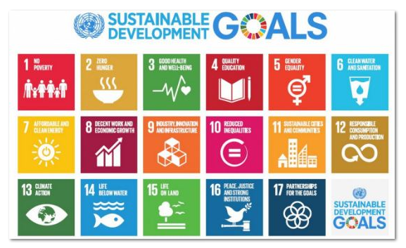

Table #2 Faculty inclusion of the content of SDG in course syllabi
Sustainability Development Goals | Proportion of Syllabi with specific SDG elements
1. No Poverty | 3.06%
2. Hunger, Food Security, Nutrition, Sustainable Agriculture | 4.08%
3. Good health and Well-being | 19.39%
4.Education | 2.04%
5. Gender Equality | 26.53%
6. Clean Water Sanitation | 3.06%
7. Affordable sustainable energy | 0.00%
8. Decent Work Economic Growth | 29.59%
9. Infrastructure, Innovation, Industry | 20.41%
10. Reduced Inequalities | 7.14%
11, Sustainable Communities | 4.08%
12. Sustainable consumption and production | 5.10%
13. Combat Climate Change | 9.18%
14. Life Below Water | 0.00%
15. Life on land | 0.00%
16. Peace, justice, strong institutions | 72.45%
17. Partnership for Goals | 0.00%

Our three baseline studies highlight our commitment to the PRME principles given:

- Almost half of the faculty publishing research in the area of business and social impact
- Support for PRME principles somewhere between some and large extent of the time
- At least some evidence for almost all of the specifically included in syllabi.

Finally, for this first iteration of our SIP, we would be remiss if we neglected to report on the Anisfield School of Business’s highly successful June 2019 hosting of:

Future Research and Action

With our baseline of attitude and execution established, our next steps will include, for our next SIP, a determination of our PRME targets through visioning and planning in 2019-2020, and then a gap analysis and avenues for closing the loop in 2020-2021. A specific action timeline for the next 24 months follows:

Fall 2019: faculty brainstorming sessions to determine vision for PRME activity in next 24 months
Early Spring 2020: action plan developed based on gap analysis
Late Spring 2020-early Fall 2020: implementation
Spring 2021: outcomes assessment; identification of loop-closing activities

