**School of Business**

Slippery Rock University of Pennsylvania

United Nations Principles for Responsible Management Education (PRME)

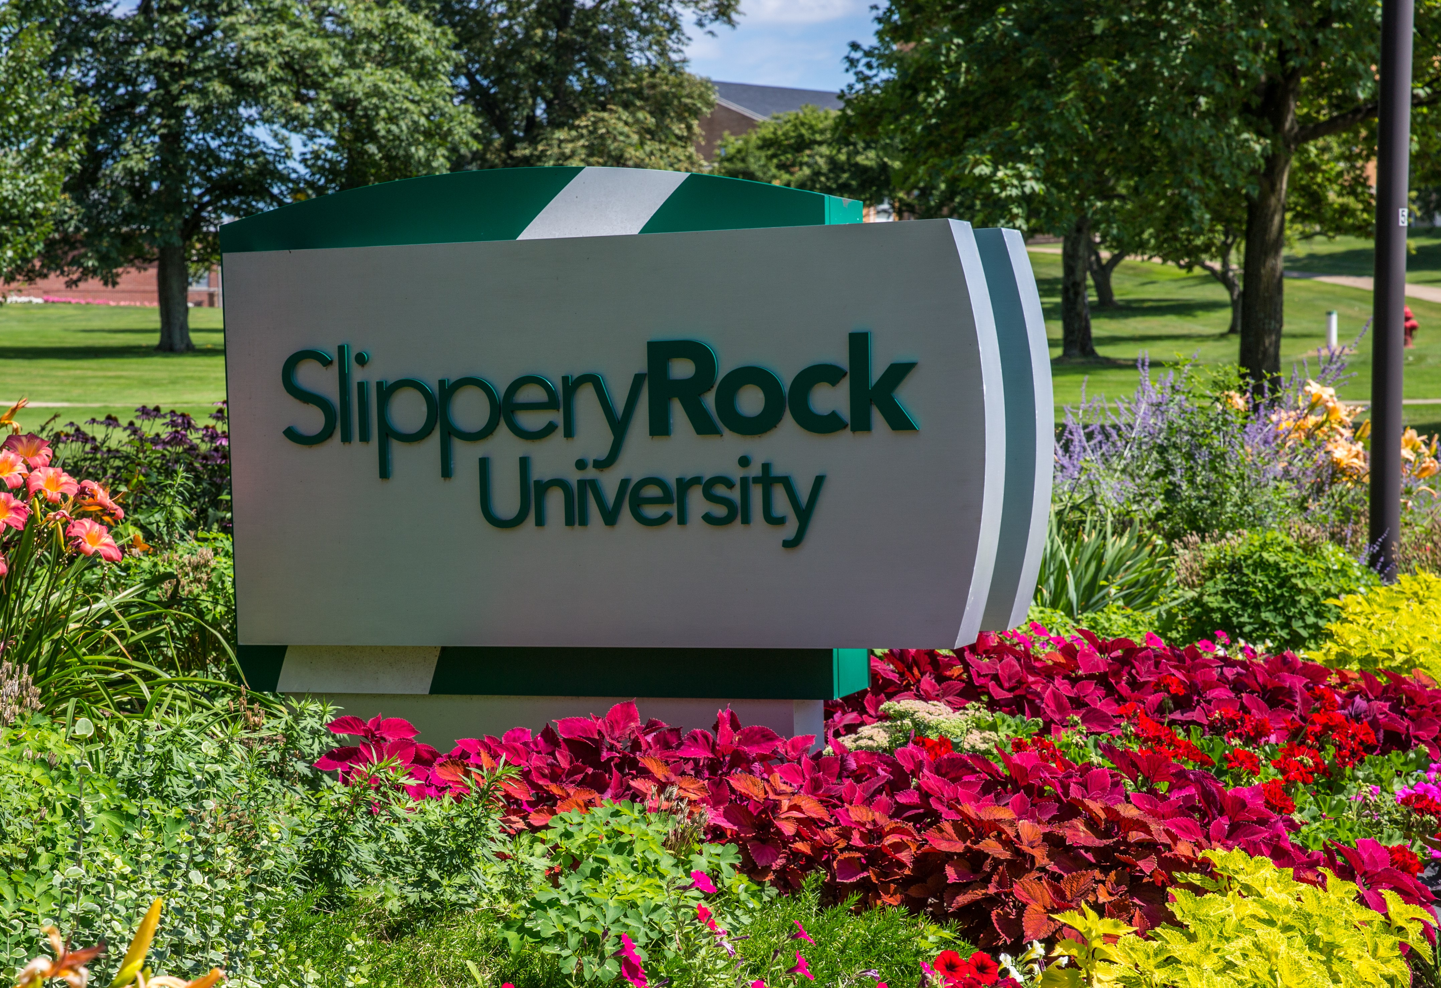

Sharing Information on Progress (SIP)

2018 PRME Report





Letter from Dr. Shao

Dean of the College of Business

May 2018

Dear PRME Members,

It is my distinct honor to inform you that the School of Business at Slippery Rock University of Pennsylvania is the first of the fourteen higher education institutions (HEIs) in the Pennsylvania State System of Higher Education to become a signatory institution in the United Nations Principle for Responsible Management Education (PRME) program. Since Slippery Rock University has a long history of incorporating sustainability practices into its culture and operational processes, it makes sense that the School of Business should undertake this initiative to educated future business leaders about the importance of responsible leadership.

As an active member of AACSB International, we are constantly working to “continuously improve” our business programs as we pursue AACSB accreditation. We are always thinking about ways to cultivate engagement, hasten innovation, and strengthen the impact of the educational experience we provide our students. Being a member of PRME provides important structure for us to improve our programs and to incorporate responsible management practices into our curriculum.

By consulting the principles established by PRME, we are better able pursue our ultimate goal of developing business leaders who are able to meet the growing challenges faced by businesses and society at large. Our School of Business has had a tradition of embracing the core principles of PRME in both our business curriculum and program offerings. One program we are particularly proud of is our Sustainable Enterprise Accelerator (SEA), which helps foster close cooperation between student entrepreneurs and businesses to create environmental friendly, sustainable business practices.

The fundamental goals of the School of Business are to promote responsible management business education and corporate sustainability. Welcome to the Rock!

Sincerely,



Dr. Lawrence Shao

Dean, College of Business

**Sharing of Information on Progress Report**

**Academic Years 2016-2018**

**Table of Contents**

Letter from Lawrence Shao, Dean of the College of Business 2

Introduction 4

Principle 1 – Purpose 6

Principle 2 – Values 9

Principle 3 – Method 16

Principle 4 – Research 21

Principle 5 – Partnerships 27

Principle 6 – Dialogue 31

Members of the PRME Task Force who collaborated on this report include: Frances Amatucci, Diane Galbraith (Chair), Jeffery Forrest, Yi Li, Sunita Mondal, Pavani Tallapally, and Liang Xu. We gratefully acknowledge the cooperation and valuable input from the faculty and staff of the School of Business at Slippery Rock University.

**Primary Contact:**

Dr. Diane D. Galbraith

Professor, and Internship Coordinator

School of Business

Slippery Rock University of Pennsylvania

313 H Eisenberg

Slippery Rock, PA 16057

Tel: (724) 738-4918

E-mail: [diane.galbraith@sru.edu](mailto:diane.galbraith@sru.edu)

**INTRODUCTION**

Slippery Rock University (SRU) is one of the fourteen institutions of higher education in the [Pennsylvania State System of Higher Education](http://www.passhe.edu/) (the State System). It is a four-year, public, coeducational, comprehensive university offering a broad array of undergraduate and select graduate programs to more than 8,500 students. Located in western Pennsylvania, the 660-acre campus is less than an hour north of Pittsburgh, Pennsylvania (USA). The University just celebrated its 125th anniversary and has a long tradition of embracing values that are consistent with the six PRME principles.

*SRU Mission*

The fundamental educational mission of Slippery Rock University (SRU) is to transform the intellectual, social, physical, and leadership capacities of students in order to prepare them for life and career success. Complementary missions are to engage in scholarly activity and professional service.

SRU is committed to serving a diverse student body and empowering anyone regionally, nationally, and internationally who can benefit from its programs and lifelong learning opportunities. Thereby SRU addresses the educationally-related economic, health, environmental, social, cultural, and recreational needs of the communities served by the university.

In pursuit of SRU's educational purpose, talented faculty and staff provide creative integrated curricula and experiences that are connected to the world in which graduates will work and live. Students are taught using powerful and engaging pedagogies in appropriate learning spaces employing state-of-the-art technology. They study in an open, caring, nurturing, and friendly environment, and live in a safe community with access to high-quality student services. SRU strives to be a best-value institution with an affordable cost and substantial student financial support. <http://www.sru.edu/about/mission-and-vision>

*SRU Vision*

Slippery Rock University will excel as a caring community of lifelong learners connecting with the world.

*SRU Strategic Goals are:*

1. Increase enrollment while enhancing student quality and diversity.
2. Offer a quality, flexible, agile and integrated curriculum and co-curriculum to develop the intellectual, social, physical and leadership capacities of students.
3. Fuel learning with powerful pedagogies and transformational experiences in and out of the classroom.
4. Maintain an unwavering focus on success for all students.
5. Provide a supportive campus experience through quality housing, dining, recreation, health, safety and administrative services, and a caring community.
6. Attract, retain and develop highly qualified and diverse faculty, staff and administrators.
7. Increase financial resources, enhance physical facilities, employ cost-effective technology and use sustainable processes and procedures.
8. Engage alumni and friends in the life of the university.
9. Support external communities through programming and expertise <http://www.sru.edu/about/strategic-planning>

According to the Interim President’s Year in Perspective report in 2017, progress towards these goals is substantial. He is dedicated to these goals and the continuation of the five-year trends related to student access and success, enrollments and increased diversity, graduation rates and employment, faculty success, numbers of faculty, record number of new programs, rising teaching evaluations and grant income, institutional success, etc. The university’s new tagline, “Experience the Difference”, reflects the importance of student engagement, student success and transformational experiences.

In the past few years, SRU has accumulated a long list of awards and special recognition. In 2016, and for the past six out of seven years, it has been recognized as one of the nation’s Best Places to Work for” by the Chronicle of Higher Education. Other accolades include: “One of the 25 Best Public Schools in the North” (U.S. News and World Report); “One of The Best Universities in The Northeast” (The Princeton Review); “One of the Top 150 Best Public Colleges in America” (American Business Journal); and “One of the Top 353 Green Colleges in America (The Princeton Review). In the PASSHE Financial Risk Analysis: SRU ranks 2nd most secure. • USN&WR rank: rose to #23 in Regional Universities in the North.

The College of Business is one of four Colleges within the University and the School of Business (SBUS) is one of five departments within the College of Business. In the fall of 2015 there were approximately 913 full-time and part-time undergraduate students and 27 graduate students enrolled in SBUS. The following degree programs in the School of Business have been accredited by the Association of Collegiate Business Schools and Programs (ACBSP) since 2012: BSBA Accounting, BSBA Marketing, BSBA Management, BSBA Finance, BSBA Economics. Candidates for ACBSP accreditation are the BS Information Systems, BS Health Care Administration and Management (HCAM) and the Masters in Business Administration (MBA). The School of Business is pursuing candidacy for AACSB accreditation.

*College of Business Mission Statement:*

<http://www.sru.edu/academics/colleges-and-departments/cob>

The mission of the College of Business is to offer academic programs that provide opportunities for the personal and professional development of a diverse population, and to prepare individuals for careers in the public and private sectors, as well as for graduate education. These programs are intended to foster the knowledge and skills that are needed in a globally interdependent and technologically sophisticated marketplace.   
  
The primary emphasis lies with our commitment to students. Learning occurs in an applied environment that enhances individual student development through working relationships with a community of scholars dedicated to teaching excellence, scholarship, and service.

*School of Business Mission Statement approved by the faculty in April 26, 2016.*

The School of Business at Slippery Rock University is committed to preparing students in the region, nationally and internationally in developing competencies for success in their professional careers and personal lives. Both undergraduate and graduate academic programs are student-centered with high levels of engagement with faculty, other students and the community. We strive to ensure our students are principle-centered, including global citizenship, diversity and ethical values. Student learning is enhanced through faculty scholarly activities. The School of Business serves as a catalyst for economic development through outreach and partnerships with external stakeholders.

*SBUS Vision Statement:*

We will provide transformative educational experiences that equip students to be lifelong learners who engage the world as knowledgeable, responsible and productive citizens.

*School of Business Core Values*:

Collaboration, Social Responsibility, Engagement, Quality, Respectful, caring community, Innovation

*SBUS Strategic Goals* (See Appendix 1 for Hierarchy of Strategic Goals):

1. **Curriculum**: SBUS is committed to providing high quality curriculum designed to make students ‘career ready’. We emphasize excellence in teaching incorporating high impact practices to facilitate student engagement.
2. **Recruitment, Retention and Graduation**: SBUS faculty and staff in conjunction with the University administration are highly engaged in the recruitment and retention of quality and diverse students.
3. **Qualified Faculty**: SBUS strives to recruit and retain academically qualitied, experienced and diverse faculty and staff.
4. **Scholarship**: SBUS faculty conduct scholarship that enhances student learning.
5. **Partnerships**: SBUS is engaged with faculty, students, its advisory board, University staff and other external stakeholders.
6. **Global Citizenship**: SBUS strives to develop principle-centered students who are responsible global citizens.

The School of Business became a signatory institution in PRME in the spring of 2014 when the former dean approved the proposal presented by member of the faculty. Subsequently, the business faculty voted to support this initiative and we began our journey in the fall of 2014. In the fall of 2015, the new dean, Lawrence Shao, pledged his support for SBUS’s PRME participation. During the past four years, we continue to make progress toward integrating PRME principles into our business climate and curriculum.

In the past two years, SBUS has made significant progress regarding its strategic planning process. As noted above, we have finalized our mission statement, and developed a vision, core values, and strategic goals. We are incorporating PRME principles into the strategic planning process as noted by the addition of a strategic goal related to ‘principle centered students who are responsible global citizens.

PRINCIPLE 1 – PURPOSE

We will develop the capabilities of students to be future generators of sustainable value for business and society at large and to work for an inclusive and sustainable global economy.

**SLIPPERY ROCK UNIVERSITY**

As stated earlier, SRU has a long tradition of embracing core values that are consistent with PRME principles. In 1990, the Robert A. Macoskey Center for Sustainable Systems Education and Research was founded. The Pennsylvania Climate Action Plan detailing what the state will undertake to reduce greenhouse gas emissions was completed in 2009. SRU’s former President, Robert Smith, was the first signatory in The State System to commit the University to net climate neutrality. SRU has been a member of the Association for the Advancement of Sustainability in Higher Education (AASHE) since 2009. The SRU Office of Sustainability collects information and coordinates University sustainability initiatives including Earth Day celebrations and the Energy Action Pledge. <http://www.sru.edu/about/sustainability> The President’s Commission on Sustainability is comprised of a cross-section of representatives from the SRU community to advise the President on sustainability initiatives, strategies and policies.

 Taking full advantage of its membership, SRU received the Silver rating in its recent submission to Sustainability Tracking Assessment & Rating System (STARS) for its sustainability curriculum and initiatives. SRU has consistently been rated as one of Princeton Review’s ‘Green Colleges’. The University has reduced its GHG emissions by 22 percent from 2005 to 2014 and is committed to achieving carbon neutrality by 2037.

**The Robert A. Macoskey Center at SRU:** The Robert A. Macoskey Center for Sustainable Systems Education and Research (RAMC) was created in 1990 to promote sustainability at SRU and in the local community. The Center is located on 83 acres of the University campus and enacts its mission in three ways: education about sustainability, physical demonstration of sustainable technologies and systems, and supporting sustainability-focused academic initiatives and research. The Harmony House is a newly renovated facility certified LEED-Silver for existing buildings: operation and maintenance and serves as a classroom and public meeting space.

**Sustainable Enterprise Accelerator:** In 2010, the Sustainable Enterprise Accelerator (SEA) was created from an Entrepreneurial Leadership grant from The State System. The main objective of the SEA is to have student entrepreneurs and established businesses work together to create a world of sustainable businesses. For students, the SEA offers an opportunity to pitch ideas in a competition to receive a cash prize in the annual "Rock the Boat" Elevator Pitch Competition.

**Weather and Air Quality Observatory:** The PA Departmental of Environmental Protection has partnered with Slippery Rock University to operate a weather and air quality observatory (WAQO) on the Slippery Rock University campus. This observatory produces environmental data that is publicly available to the Slippery Rock community and serves as an excellent resource for both teaching and research toward better air quality.

In addition to environmental ecology, there are many University initiatives that address social justice and promote diversity throughout the academic year. Some of them include:

* Office of Diversity and Equal Opportunity
* Office of Global Engagement
* President’s Commission on Women
* President’s Commission on Gender Identity and Sexual Orientation
* President’s Commission on Race and Ethnic Diversity
* President’s Commission on Disabilities
* APSCUF Committee on Social Justice
* APSCUF Gender Issues Committee
* Women’s Solar Center (Business)
* SRU Women’s Center
* SGA Committee on Social Justice

On July 16, 2016, Slippery Rock University became an institutional member in the Ph.D. Project ([www.phdproject.org](http://www.phdproject.org) ) demonstrating a strong commitment to diversifying the faculty, staff and student populations by encouraging minorities to become part of the SRU community.

**SCHOOL OF BUSINESS**

*School of Business Mission Statement:*

The School of Business at Slippery Rock University is committed to preparing students to be career-ready by developing competencies for success in their professional and personal lives. Our graduates are emerging leaders regionally, nationally, and internationally. Both undergraduate and graduate academic programs are student-centered with high levels of engagement. We strive to ensure our students are principle-centered and responsible global citizens. Student learning is enhanced through faculty scholarly activities. The School of Business serves as a catalyst for regional economic development through outreach and partnerships with external stakeholders.

In the pursuit of AACSB accreditation and the continuation of progress related to PRME principles, SBUS has hired nine new faculty members since the 2016 SIP report. The PRME task force continues to be active with increased participation from newly-hired faculty. Although most academic institutions are facing additional financial challenges, our administration continues to support our PRME efforts.

PRME task force members will continue to consider travel for chapter and international PRME meetings supported by SRU. Dr. Frances Amatucci attended the 2017 10th Annual PRME Meeting in New York City and attended the Working Group meeting on Gender Equality. Initially, administration approved an annual $300 contribution to PRME Secretariat for administrative support. This amount was subsequently increased to $400 in 2016 with continued annual support.

Dr. Frances Amatucci continues to serve as the facilitator for the PRME Working Group on Gender Equality Resource Repository for Finance. With the research assistance provided by a MBA student, resources (case studies, academic journal articles, text books, best practices, websites, etc.) related to gender equality and finance are being collected and uploaded to the website for public availability. <http://prmegenderequalityworkinggroup.unprme.wikispaces.net/Resource+Repository>

*Resource Database for Faculty*: A resource database by discipline was created for faculty to assist in further revising their course content to incorporate issues related to the sustainable development goals.

*Student- Led Activities and Organizations*: Student organizations such as Alpha Kappa Psi, the Society for the Advancement of Management (SAM), American Marketing Association, Enactus, the Sustainable Enterprise Accelerator, Future Health Care Leaders, Finance and Economics Club, and APICs provide opportunities for discussing sustainability topics. Women’s Solar Center was developed in the spring of 2016 by students as an educational and networking group to address gender-related issues in business.

*Integrated Sustainability Research and Student Participation:* There are many examples of faculty-student research related to sustainability and corporate citizenship, as well as the sustainable development goals. They are described in detail later in the report.

**2018-2020 Principle 1 Goals:**



* Continuously assisting faculties in obtaining information about best practices in curriculum development related to sustainability through the resource repository
* Encouraging faculties to integrate sustainability across various business functional areas.

PRINCIPLE 2 – VALUES

We will incorporate into our academic activities and curricula the values of global social responsibility, as portrayed in international initiatives such as the United Nations Global Compact.

Slippery Rock University is committed to being at the forefront of preparing the next generation of thinkers, innovators and entrepreneurs to help the world meet its profound environmental challenges. We are also focused on meeting the sustainability goals set forth in our [Climate Action Plan](http://www.sru.edu/Documents/about/sustainability/climate_action_plan.pdf). This serves as our road map to achieving carbon neutrality by the year 2037, in keeping with the [President's Climate Commitment and our long term Strategic Plan, Trend Five: "The world is reaching a point of diminishing returns regarding resource utilization".](http://www.sru.edu/Documents/about/sustainability/00000%20Trend%20Five%20Update%2011-08-2017.pdf)

We are proud of our achievements to date, which include:

* Consistently making the**Sierra Club's Top 100 Cool Schools**list, the **Princeton Review's Guide to Green Colleges,**and ranking in the top 100 schools in the**University of Indonesia's International Green Metric Survey**
* Being the first 4-year college in Pennsylvania to be named a**Green Ribbon School**by the U.S. Department of Education
* **Reducing our net GHG Emissions by approximately 30% since 2005**
* Achieving the **Silver Rating**by the Association for the Advancement of Sustainability in Higher Education (AASHE) - see our latest [AASHE STARS report](https://stars.aashe.org/institutions/slippery-rock-university-pa/report/) for a complete description of all our sustainability initiatives and curricula.
* Regularly exceeding our **EPA Green Power Partnership** minimum green power purchasing requirement.
* Many of the methods we're using to reduce our greenhouse gas emissions and to prepare our students to be good stewards of our environment are summarized in the topic areas shown below, which also include reports on our progress in each area and additional resources relevant to that topic. For link see: <http://www.sru.edu/about/sustainability>
* Slippery Rock University has also been named a 2018-19 national “College of Distinction,” a Pennsylvania “College of Distinction” and a public “College of Distinction” by collegesfdistinction.com. The University earned similar distinctions in 2017-18. <http://www.sru.edu/news/062618a>

**2018 Governor's Award for Environmental Excellence**

Slippery Rock University is among 23 "innovative and impassioned" organizations selected by Pennsylvania's Department of Environmental Protection to receive the prestigious 2018 Governor's Award for Environmental Excellence.

Paul Scanlon

SRU Director of Sustainability

SRU was selected for its Healthy Planet, Healthy People Environmental Summer Camp and Community Project Incubator that helps high school teachers and students create environmental stewardship projects. The University hosted the camp for students and educators that included classroom instruction, leadership training and immersive field experience.

In partnership with the EPA, the camp provided $1,700 in seed money for participating school districts to kick start their community projects. Thirteen projects were completed in eight counties, providing the potential to raise environmental awareness among 2 million Pennsylvanians.

"This main benefit of this program was in creating a ripple effect of environmental awareness, education and stewardship action in the students' local communities," said Paul Scanlon, SRU director of sustainability. "In addition to providing students with the tools necessary to carry out local stewardship projects, their teachers benefited from the experience, friends and families attending the wrap-up session at the end of camp became more aware of local environmental issues and solutions, and their local communities are benefiting from the educational value of the stewardship projects carried out in their communities."

The Governor's Awards for Environmental Excellence are awarded each year by the DEP and highlight the best in environmental innovation and expertise throughout the state. The awards provide statewide recognition to businesses and organizations involved in a cross-section of environmental initiatives from cleaning up watersheds, saving energy, eliminating pollution, reducing waste and more. <http://www.sru.edu/news/042018b>

**SRU recognized in Business Officer magazine for ‘Powering Forward’**

Four Slippery Rock University administrators co-authored a case-study article about the SRU’s approach to deferred maintenance and energy savings that was published in Business Officer, the magazine of the National Association of College and University Business Officers in May 2018.

Slippery Rock University is often recognized as one of the nation's leading universities for sustainability by making decisions that are friendly for the environment and the institution's budget. Now, business officers from colleges and universities from around the country are learning about SRU's secrets to success.

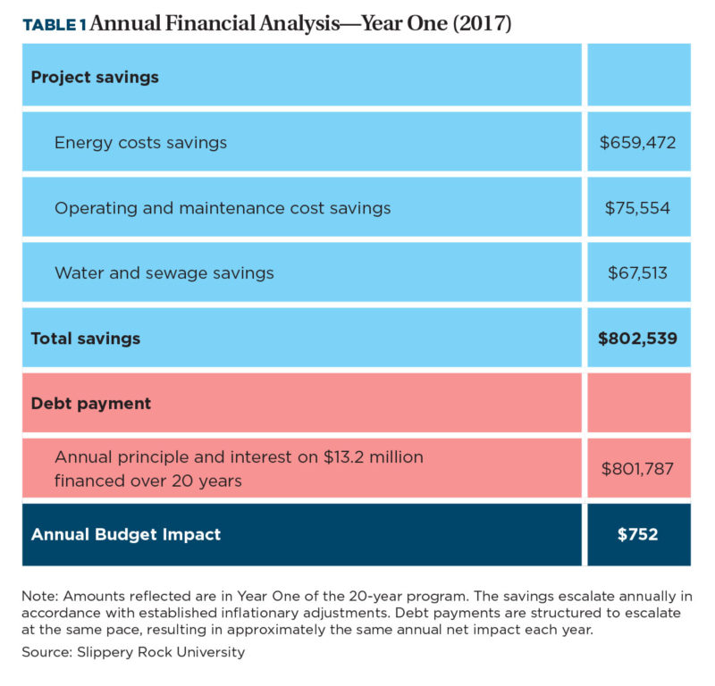Business Officer magazine, the official publication from the National Association of College and University Business Officers, recently published a case-study article detailing how SRU advanced its sustainability efforts while supporting deferred maintenance. Business Officer reaches nearly 45,000 readers at 2,325 unique organizations.

"Business Officer is the best source for people in our profession to share ideas," said Molly Mercer, associate vice president for finance. "We appreciate the University being recognized and the standing that this provides to our work; and we also hope that our colleagues can benefit from the best practices that we used."

What made SRU's approach so unique, according to Albert, was the collaboration between several departments on campus, namely facilities and finance, and how it achieved a "win-win" to address both deferred maintenance and energy savings

<https://businessofficermagazine.org/features/powering-forward/>

**Sustainability Grant**

Two Slippery Rock University professors received a $29,010 grant from ASIANetwork to conduct a sustainability study that will benchmark outcomes from rapid modernization initiatives in China by accounting for economic, environmental and social influences. John Golden, assistant professor of business, and Li Pu, associate professor of communication, wrote the successful proposal, "The Development and Benchmarking of Contemporary Sustainability Indicators for Rural Ethnic Chinese Villages: A Case Study of the Social, Economic, and Ecological Issues of Two Gelao Villages Near Chongqing Municipality." Golden and Pu will travel to China this summer to conduct research with four students: Aisha Aldubayan, a junior communication major from Old Forge; Thomas Fabian, a junior communication major from Burton, Ohio; Marshall Tuten, dual major in modern languages and cultures and economics from Butler; and Marlee Theil, a junior environmental geoscience major from Aliquippa. ASIANetwork is a group of more than 170 North American colleges, which strives to encourage the study of Asian countries and cultures, enable students and faculty to experience those cultures first hand and foster collaboration among institutions. The group plans to present their findings at the 2019 ASIANetwork Conference and the SRU Undergraduate Student Research Symposium.

For link see: <http://www.sru.edu/news/good-news-022218>

**Curriculum Development**

Slippery Rock University has been progressive in terms of adopting a curriculum that addresses sustainability concepts and processes. The Robert A. Macoskey Center, McKeever Environmental Learning Center, Sustainable Enterprise Accelerator, and the Weather and Air Quality Observatory all offer non-credit educational programs related to environmental protection. There are many programs and courses which either are devoted entirely to sustainability or have sustainability content. The Certificate in Sustainability is an interdisciplinary certificate that provides foundations in sustainability that diverse student groups may not be introduced to in their degree programs. The Hospitality, Event Management and Tourism (HEMT) department offers three courses in sustainability: HEMT114 Sustainability in the Hospitality Industry; HEMT210 Ecotourism; and HEMT314 Sustainable Planning for Tourism.

According to the SRU 2016 AASHE STARS Report, 22 undergraduate courses and 2 graduate sustainability courses are offered and 28 undergraduate and 2 graduate courses have sustainability content. A list of approximately 35 SRU sustainability courses offered in 2016-2017 can be found at:

A list of SRU Courses that have sustainability content (excluding SBUS) at

<http://www.sru.edu/about/sustainability/programs-organizations-and-resources> .

In an effort to benchmark the coverage of sustainability topics within the business program, the 2016 UN Sustainable Development Goals were utilized to map sustainability coverage across the core business curriculum. The business faculty was surveyed as to which development goals were covered in various courses, and at what level. The levels chosen were text chapter (T), module within a chapter (M), a topic box within the text (TB), current events discussion (C), and/or as part of a graded assignment (A). Not all of the core courses had coverage reported. The results for those that did report coverage of at least one topic are found in Table 1 below. All of the topics were covered in at least one of the core courses and many were covered in significant detail. Table 2 lists business courses that cover significant amounts of sustainability in their content.

**Table 1. 2016 UN Sustainable Development Goals and SBUS Core Curriculum**

|  |  |  |  |  |  |  |  |  |  |
| --- | --- | --- | --- | --- | --- | --- | --- | --- | --- |
|  | A210 | A340 | B303 | B458 | E201 | E202 | M320 | M351 | Mk330 |
| No Poverty |  |  | M,TB,A |  | T,M,C,A | T,M,C |  | M | C |
| Zero Hunger |  |  | M,C |  |  | TB |  |  | C |
| Good Health and  Well-Being | M,T,C,A |  | M,TB | M | M,C,A | T |  |  | C |
| Quality Education | C,A |  | M |  | M,C | M |  | C | C |
| Gender Equality |  |  |  | C | TB | M,C |  | M | C |
| Clean Water and  Sanitation |  |  | C |  |  | M,C |  |  | C |
| Affordable and  Clean Energy |  |  | M,TB,C |  | M |  |  |  | C |
| Decent Work and  Economic Growth | M,T,C,A |  | T,C,A |  | T,M,C,A |  | M | M,C | TB |
| Industry, Innovation  and Infrastructure | M,T,C,A |  | T,C,A | C | T,M,A | T,M,A | M | C | M,TB,C |
| Reduced Inequalities |  |  | M,C |  | T,C | T,C |  | M,C |  |
| Sustainable Cities  and Communities |  |  |  |  |  | M,C |  |  | C |
| Responsible  Consumption and Production | C,A |  | TB,C | T,M |  | M,C | M |  | M,C |
| Climate Action |  |  | M |  |  | M,C |  |  | C |
| Life Below Water |  |  | M,TB,C |  |  | C |  |  | C |
| Life on Land |  |  | M,TB,C | T |  | C |  |  | C |
| Peace, Justice, and  Strong Institutions | C, A | T | T,M,C,A |  | T,M,C,A | T,M,C |  | T,M,C | C |
| Partnerships for the Goals | C, A |  | M,C | T |  | M |  |  |  |

|  |  |
| --- | --- |
| T – Text Chapter  M – Module within a Chapter  TB – Topic Box  C – Current Events  A – Assignment | A210 – Managerial Accounting; A340 – Legal Env. of Business;  B303 – Issues in Global Business; B458 Business Capstone;  E201 – Macroeconomics; E202 – Microeconomics;  M320 – Operations Management; M351 – Organizational Behavior;  Mk330 – Principles of Marketing |

**Table 2. 2017-2018 Sustainability Courses Taught with the School of Business\***

|  |  |  |  |
| --- | --- | --- | --- |
| Course ID | Title | Depart. | Description |
| Econ 315 | Economics of  Sustainable Development | SBUS | Economic causes and effects of pollution are discussed along with the issue of sustainable economic development. Government policy with respect to the environment and renewable energy is surveyed. The connection between sustainability and the core functions of business for profit are presented. |
| BUSA 370 | Sustainable Entrepreneurship  and Innovation | SBUS | This integrative course introduces students to issues related to sustainable new venture creation and the design of sustainable business models, industry/market analysis, resource acquisition and disposition, assessing a venture’s financial strength, and ethical/legal issues. Students learn the entrepreneurial process while acknowledging multiple stakeholders and addressing social, economic, and environmental concerns. |
| BUSA  459 | Sustainable Business Consulting | SBUS | In this course student teams engage in field=based consulting to analyze actual problem situations involving sustainability for regional businesses. |

**2017 – 2018 Sustainability-Related Courses Taught\***

|  |  |  |  |
| --- | --- | --- | --- |
| Course ID | Title | Depart. | Description |
| BUSA 105 | Economics of Social Issues | SBUS | An introductory course intended to provide an understanding of how our economic system works. A framework of building blocks from macro, micro and international economics is developed to enable students to comprehend the differences among alternative solutions and to understand the implications of policy issues. This includes addressing the environment, policies to protect the environment, and the tradeoffs society face. |
| BUSA 303 | Issues in Global Business | SBUS | This course focuses on fundamental issues in the modern global business environment. The topics covered include comparisons of different economies with respect political economy, culture, and standard of living. The role of international trade in economic development is also discussed. Finally, principled decision making on the part of multinational firms, which includes sustainability issues, is covered in detail. |
| MGMT 456 | Management and Society | SBUS | This course engages students in exploring the social, ethical, environmental, economic, and political/legal restraints on organizational decision-making that managers face. Students develop critical thinking, communication, and management skills necessary to be effective in a global business setting where multiple stakeholder interests must be addressed. |

**Cultural Diversity**

SBUS students are exposed to values associated with cultural diversity and social justice in many ways through the curriculum. In the SRULiberal Studies core curriculum that all University students must complete, the Human Institutions and Interpersonal Relationships goal states that the student will:

Identify and evaluate issues and problems within human institutions and interpersonal relationships using ethical criteria.

Demonstrate how ethical criteria can be used to foster cooperation and promote respect for diversity.

Evaluate social, emotional, cognitive, and/or biological aspects of personal development within human institutions and interpersonal relationships and explain how these affect human beliefs and behavior in everyday life.

* Analyze and evaluate how globally diverse contexts affect beliefs and behaviors of individuals, groups, organizations, and human institutions and how these contexts influence civic engagement.

Students are also required to take two non-US courses in the Global Community area that will:

* Describe how values, attitudes and beliefs affect the ability of people to relate to that which is different
* Evaluate general theories, models, arguments or perspectives that explain contemporary or historical relationships among social, political, economic or environmental systems
* Communicate an understanding of how language or culture affect one’s perception of the world

The Office of Global Engagement offers a variety of programs from week-long spring break seminars to a traditional academic year abroad. It organizes international exchange opportunities for faculty, staff and students. During recent spring breaks, an average of 22 students per trip, participated in SBUS trips including Costa Rica, Greece, Barcelona, and Italy.

**HCAM 420 International Health Care Systems:** Twenty-one students toured Greece**, s**upervised by Dr. David Jordan. Some of the historical cities and sites included Corinthos, Knossos, Chania Town, Heraklon, Rethymnon Hospital, etc.

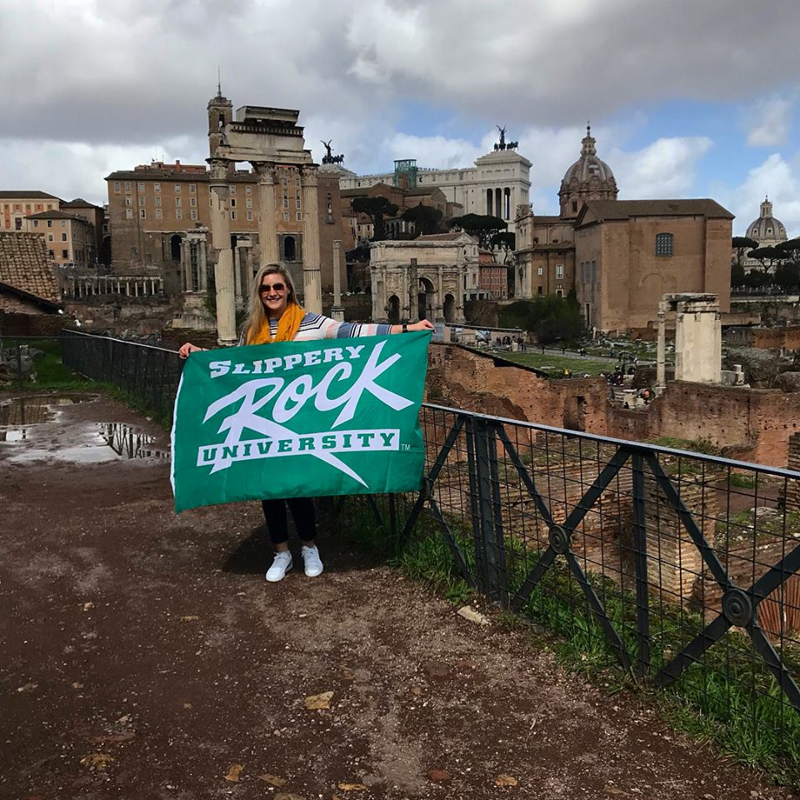**MKTG335: Retail Management and Hospitality Event Management and Tourism majors**: Dr. Bruce Orvis, traveled with Dr. Bruce Boliver and a total of 40 students to Florence, Venice, Pisa, Siena, La Spezia and Rome for a study abroad course in Italy. Tours included the Murano Glass company, a winery, the Vatican, Pantheon, the Leaning Tower of Pisa, St. Peter’s Cathedral, etc. Dr. Orvis has chaperoned 11 consecutive trips abroad during Spring breaks including approximately 250 students.

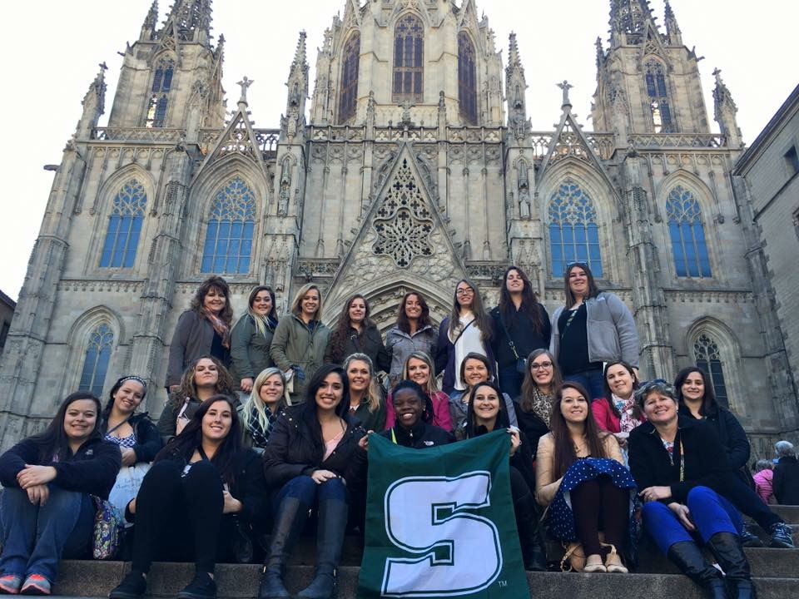**MGMT454 Management Seminar/ACCT411 Auditing Theory**: Under the supervision of Drs. Diane Galbraith and Melanie Anderson, 23 students visited Barcelona, Spain. During the visit students participated in many cultural activities and tours including Montserrat Abbey, the Caixa Bank, Montjuic, Sagrada Familla, Picasso Museum, Barcelona University, Park Guell and other Gaudi buildings. They also experienced a Flamenco show, soccer game and wine tasting at Castellroig.

**2018-2020 Principle 2 Goals:**



* To make progress on incorporating sustainable development goals and practices into the curriculum
* To increase curriculum content related to gender, ethnic, cultural diversity and international experience.

PRINCIPLE 3 – METHOD

We will create educational frameworks, materials, processes and environments that enable effective learning experiences for responsible leadership.

**Sustainable Enterprise Accelerator (SEA)**

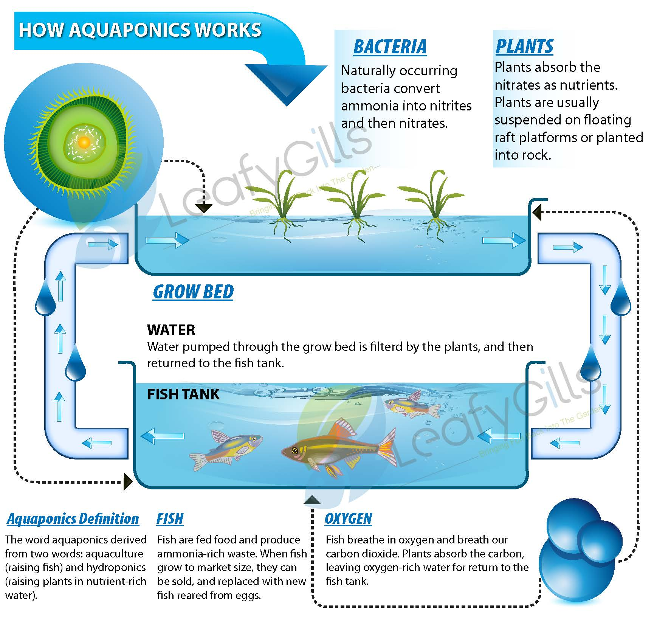Sustainable Enterprise Accelerator (SEA) is a resource for students and entrepreneurs who wish to start or grow a business with sustainability in mind. The organization provides guidance in transforming promising ideas into thorough business plans and early stage businesses. For those operating an established business, the SEA identifies different areas for improvement. The SEA assists in developing competencies for students seeking green jobs. The SEA has worked with students as they create new opportunities with local companies such as Fastenal, North Country Brewing Company, The Harmony Inn, and the Big Rail Brewing Company. Faculty, staff, and student interns are able to create hands-on experience with these projects. The “Food for Profit” series is a two-day workshop partnered with Pennsylvania Association for Sustainable Agriculture (PASA) to include guest speakers who provided attendees with information about how to apply for a license to cook and sell food from one’s home, food production guidelines and marketing strategies to sell homemade products. The SEA organizes the PASSHE Business Plan Competition every year. In addition, the SEA serves as project mentoring space for SRU MBA students and interns.

The Managing Director of the SEA is Dr. John Golden.

Several of the projects the SEA has undertaken, or plans to undertake, are described below.

Other SEA Projects

1. **SEA Aquaponics**: The Aquaponics Project involves the construction of an aquaponics system in Lukaya, Uganda. The project is expected to benefit residential students by extending the local growing season, providing students with incentives and tools for engaging in empirical research, and establishing a market for innovative sustainable agricultural systems in the future. The Aquaponics Project is the product of ongoing collaboration and communication efforts between professionals, Slippery Rock community members, Slippery Rock University students and faculty, Uganda Martyrs University and S.E.A. ambassadors. Professor Joseph SSekandi from Uganda Martyrs University visited SRU in May 2017 as a visiting scholar. The two universities are now exploring a MOU for partnering in other areas as well.
2. **ImPress Digital Badges**: A digital badge is a validated indicator of accomplishment, skill, quality, or interest that can be earned in many learning environments" (hastac.org). The badges are designed to allow users to accumulate visual proof of their abilities that they acquired in a variety of learning environments over a lifetime. One potential use of digital badges is to show potential employers the skills and accomplishments of the user while providing them with actual examples of their proficiencies that have been vetted by professionals from that particular field. The SEA has built a platform to issue the badges and is planning its beta launch. By way of update, ImPress Digital Badges has been accepted in to the Clinton Global Initiative University and was represented at the conference in October 2017.
3. **Doux Dalliance:** Doux Dalliance works with farmers in Trinidad to ensure that they are properly compensated by sharing profits made in the United States and elsewhere. The goal for this undertaking is to encourage the economic development of the Trinitario cocoa industry. We aim to increase the number of farmers participating in the Montserrat Cocoa Co Operative Society. Currently the Co-op has 48 large and small farmers. We would like to see that number increase over the next two years. Opening the United States’ market to the farms in Trinidad will create many opportunities for growth. Doux Dalliance is already doing business with the Montserrat Co-Op which gives access to a multitude of different farmers. One farmer has agreed to lower product prices and split the profits in the future with Doux Dalliance. This project will open new supply chain for cocoa from Trinidad. No such supply chain currently exists. Doux Dalliance has been accepted in to the Clinton Global Initiative University and was represented at the conference in October 2017.
4. **SEA Wilderness Project:** The SEA Wilderness Project aims to be able to bring a wilderness experience to those who are unable to get out and enjoy the wilderness themselves. This project aims to provide a service that brings both mental and physical health benefits, and could potentially be used for more. The main health benefit this project aims to provide is ecotherapy, the applied practice of the emergent field of ecopsychology, which refers to healing and growth nurtured by healthy interaction with the earth.

This project plans to provide this service with the use of virtual reality. With the technology that even the average person can own and operate in today's society, we can create the feeling of being practically anywhere through these virtual reality simulations. With the combination of 360 degree pictures and videos along with virtual reality head-mounted displays, we hope to be able to bring a wilderness experience to those who can no longer get out into the wild. The goal is to be able to experience the benefits that nature can have on the mind and body. The SEA Wilderness Project has been accepted in to the Clinton Global Initiative University and was represented at its conference in October 2017.

1. **SEA Lobo Wolves:**  This team is helping the Dr. McCleery Education Center educate people about Dr. Edward Heber McCleery’s work with conserving the buffalo wolf species, species conservation in general, and the importance of wildlife predators. The team will achieve this through traveling educational presentations and in the future with the Education center in Kane, Pennsylvania. The team will tackle the global issue of species conservation. In recent years, more species have been put on the endangered species list. We aim to use the Dr’s work saving the buffalo wolf species, by raising the last remaining buffalo wolves on a protected preservation as an example to inspire other to learn more and get involved in species conservation. SEA Lobo Wolves has been accepted in to the Clinton Global Initiative University and was represented at its conference in October 2017.
2. **Idea Lab**: an open forum for aspiring entrepreneurs to pitch their ideas. The mission of the Idea Lab is to assist entrepreneurs in transforming their bright ideas into profitable business ventures. We can provide a wide range of services including guidance, resources and idea incubation for startup businesses. Our strategy is focused on the success of startup businesses through combining sustainability with innovative business strategies and critical problem solutions. We believe utilizing sustainability and innovation can promote dynamic opportunities that contribute to the growth of a startup business and mitigate challenges, making business ventures not only profitable, but environmentally, economically, and socially responsible.
3. **SEA Commercial Kitchen**: Kitchen development project for local farmers and food entrepreneurs to get product to market more efficiently.

Some Events and Programs

1. Slow Food: Slow Food USA is part of the global Slow Food network of over 100,000 members in more than 150 countries. Through a vast volunteer network of local chapters, youth and food communities, it links the pleasures of the table with a commitment to protect the community, culture, knowledge and environment that make this pleasure possible. Sea operates local chapter.
2. Rock the Boat: SRU Elevator Pitch Competition (cash prizes to student winners)
3. Penn State College of Agriculture joint workshops
4. Pennsylvania Association for Sustainable Agriculture joint workshops.
5. PASSHE Statewide Student Business Plan Competition: In 2017, SEA student Dan Spiker was a state finalist.
6. Clinton Global Initiative University: 4 SEA teams were selected to present at CGI U at Northeastern University in Boston, MA, from October 13-15, 2017.
7. Earth Week 2017 events, films and speakers.
8. In addition, the SEA serves as project mentoring space for 5 SRU MBA students and their projects.

**BUSA459: Sustainable Business Consulting**

Typically scheduled for every spring, BUSA459 is a course that adopts the Small Business Institute® program and process for field-based student consulting projects. <http://www.smallbusinessinstitute.org> Student teams are able to apply theories related to entrepreneurship, sustainability and small business management into practice with hands on projects with local businesses. Through BUSA459 over the past seven years, 164 SBUS students have participated in approximately twenty-five business consulting projects involving start-ups, for-profit and not-for-profit organizations. Clients included North Country Brewing, the Butler County YMCA, Philsons Farms, National Grind Coffee & Tea, D&D Drafting, the Butler County Transit Authority, Friends of Bantam Jeep Association and the Butler County Community Development Corporation. Clients are typically sourced through the SBUS Business Advisory Council and the Butler County Chamber of Commerce. The primary faculty mentor is Dr. Frances Amatucci.

**Enactus**

This organization of students works to make a difference in the community while developing the skills to become socially responsible business leaders. The Enactus group has been taking time to reorganize and refocus their efforts on workforce readiness, as well as assisting local entrepreneurs. The SRU Enactus team was awarded a small grant funded by Wal-Mart to assist with their workforce readiness projects. The organization worked with the local Dress for Success chapter to guide students on professional dress, and to collect donations for the Dress for Success organization to distribute to local residents seeking employment. The faculty adviser for Enactus is Dr. Melanie Anderson.

**AMA (American Marketing Association)**

The SRU chapter of AMA has been focusing a lot on professional development this year. Speakers have come from Northwestern Mutual and Industry Weapon to speak to the members. Members have also come together to work on case studies for both the AMA International Colligate Conference and a Regional Case Competition. Some of the members have also gone to AMA’s Pittsburgh Professional chapter networking events. This chapter has also done work to give back to the community. A loose change competition was held on campus to raise money for a donation to the Mission Stay Scholarship. This year the group also held a bake sale to help raise money for the Butler Humane Society. This chapter also volunteered for the Annual E-waste Event here in Slippery Rock this Spring. The faculty adviser for the AMA chapter is Dr. Jeananne Nicholls.

**MGMT454: Management Seminar**

MGMT454 is the capstone course for management majors. This course is involved in high impact practices through service learning with external stakeholders. Students work collaboratively in a semester-long project to assist community members and small business owners solve operational issues, market their respective business, create a social media presence, etc. Organizations include: working with the *Pittsburgh Passion*, a women’s American football league located in Pittsburgh, Pennsylvania, owned by Teresa Conn and former Pittsburgh Steeler Franco Harris., In addition to the Pittsburgh Passion, the class has worked with Valley Points,YMCA to update their strategic plan, pricing model, marketing presence,  *Café Kolache* a locally owned shop that sells Czechoslovakian pastries and *Kellner Stair and Rail*, a local family owned business and other small proprietors. Each semester the owners visit the class and present their company’s current challenges with the expectation that the students will conduct research and analysis, and present their recommendations in a presentation at the end of the semester. This course helps students to get out of their comfort zone and have a real-life learning experience comparable to situations they will face when they enter the workforce. The faculty instructor for this course is Dr. Diane Galbraith.

**CareBreaks**

SRU CareBreaks are community service experiences held over Fall, Winter, and Spring Break that gives students the opportunity to travel in need across the United States and the world. Within the last twelve years, over one thousand SRU students, faculty, and staff have spent over 200,000 hours in 26 U.S. cities and 7 countries as they tutor children, build low-income housing, assisting the homeless and the hungry, protecting the environment, and creating Slippery Rock University’s international reputation as a place where students develop strong ethics of service.

**Alpha Kappa Psi**

The oldest and largest professional co-ed business fraternity, Alpha Kappa Psi develops principled business leaders by adhering to their lifetime values: brotherhood, knowledge, integrity, service, and unity. With over eighty collegiate members, the Iota Upsilon chapter has won numerous awards including being awarded the Chapter of the Year distinction by the national office for four successive years; 2014-2017. Bringing in professional speakers and alumni, Alpha Kappa Psi fosters connections between both students and professionals to help them lead a successful life. The faculty advisers for Alpha Kappa Psi are Dr. Bruce Orvis and Dr. Don Mong.

**Delta Mu Delta**

Delta Mu Delta (DMD) is a business honor society that recognizes and encourages academic excellence of students at qualifying colleges and universities to create a DMD community that fosters the well-being of its individual members and the business community through life-time membership.

The invitation to join DMD is extended to SRU Junior and Senior Business Administration Majors who have completed a sufficient number of courses in the top 20% of their respective classes (minimum GPA of 3.50). The induction ceremony was held on April 7, 2018 where several new members were inducted. The members have participated in various events including the etiquette luncheon at the Business Advisory Council meeting, networking events and panel discussions. Dr. Sunita Mondal and Dr. Diane Galbraith are the faculty advisors.

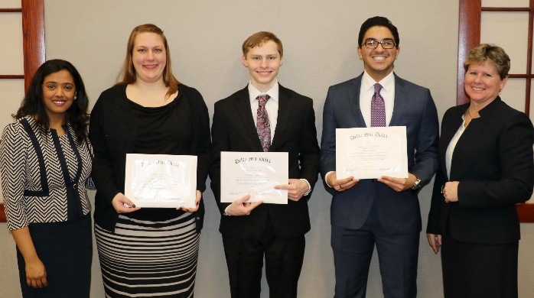

**Women’s Solar Center**

 Through a University grant in 2016, the Women’s Solar Center was created. This student-led organization seeks to close the gap between genders engaging all stakeholders: students, alumnae, faculty, business women and the community. In the spring of 2016 and 2017, student officers and advisors attended a conference at Penn State University entitled: ‘Powerful Women - Paving the Way’. Solar sponsors a number of events each year, like Dress for Success and a stress seminar by award-winning author, Diana Fletcher. This venture needs a full-time employee and/or a Graduate Assistant that can continue the momentum for this valuable addition to the College of Business and the SRU community.

**2018-2020 Principle 3 Goals:**



* Continue and publicize SEA initiatives
* Implement the Aquaponics Project
* Increase student engagement in University and SBUS activities

PRINCIPLE 4 – RESEARCH

We will engage in conceptual and empirical research that advances our understanding about the role, dynamics, and impact of corporations in the creation of sustainable social, environmental and economic value.

The following table provides a list of faculty publications related to the seventeen sustainable development goals (SDGs) developed by the United Nations.

|  |  |
| --- | --- |
| **School of Business Faculty Publications** | |
| **2012-2017** | |
| **Author(s)** | **Citation** |
| Amatucci, F., et al. (2017) | An Interdisciplinary Framework to Deconstruct Second Generation Gender Bias and Why it Matters in Women's Entrepreneurship, Chapter in Women's Entrepreneurship: Going Beyond the Gender-Neutral Approach, Gower Publishing: United Kingdom |
| Amatucci, F., et al. (2016) | Using a Multiple Method And Mixed Mode Approach to Examine Women Entrepreneur Negotiating Styles, Intl Journal of Gender and Entrepreneurship, Vol 8, No. 1 |
| Amatucci, F. (2016) | Women Business Angels: Theory and Practice, Handbook of Research on Venture Capital, Vol. 3 |
| Amatucci, F. (2016) | Still a Man's World? Second Generation Gender Bias in Negotiating for External Equity Term Sheets, Proceedings of the U.S. Association for Small Business & Entrepreneurship |
| Amatucci, F. & McKinney, M. (2014) | Sustainability and the Business Plan, Proceedings of the Small Business Institute Annual Conference |
| Amatucci, F. (2012) | Book Review *Womenpreneurs* by Dorothy Perrin Moore, Journal of Small Business Strategy. |
| Amatiucci, F. & Camillus, J. (2012) | Alcoa Russia, Proceedings of the North American Case Research Association, Boston, MA. |
| Amatucci, F. & Grimm, R. (2013) | Effectuation: An Alternative Approach for Developing Sustainability Architecture in Small Businesses, Journal of Small Business Strategy, Vol. 23, No. 1 |
| Anderson, M. (2017) | Customers’ Indecisiveness: A Pricing Strategy Approach, Pennsylvania Economic Review, Vol. 24, No. 2, pp. 46 – 64. |
| Anderson, M. (2017) | Mylan's Epi-cal Breach at the Top, Journal of Business Cases and Application. Vol (18) 1-11 |
| Anderson, M. (2017) | Case Study - Koss Corporation, Corporate Governance, Internal Controls, and Ethics: What went wrong?, Institute of Management Accounts Educational Case Journal, Vol. 6, Iss. 1. |
| Anderson, M. | WorldCom: A Tale of Two Professionals - Betty Vinson and Cynthia Cooper, Strategic Finance, Carl Menconi Case Writing Completion Winner, PP 44-51 |
| Anderson, M. (2013) | Building Accounting Students' Communication Skills with the Three R's: Writing, charting, and Ratio analysis, Management Accounting Quarterly, Vol. 14, No. 4, pp. 32-43 |
| Anderson, M. (2014) | Twitter effectiveness in motivating business students, Journal of the Northeastern Association of Business, Economics and Technology, pp. 7-14 |
| Anderson, M. (2014) | Cosmopolitans of Locals: Who will lead the next generation of Community Colleges?, Community College Journal of Research and Practice, Vol. 38, Iss. 12, pp 1168-1179 |
| Anderson, M. (2015) | The Financial Fitness of Pennsylvania Volunteer Fire Companies?, Center for Rural Pennsylvania, Publication Pending |
| Buttermore, J., Culp, D. & Baker, E. (2014) | Providing Affordable Access to Higher Education Through Year Round Operation: A Case Study in Public Higher Education, College & University Journal, Vol. 89, Iss. 4 |
| Forrest, J., Ying, Y., Gong, Z. W. (2017) | Currency Wars: Offense and Defense through Systemic Thinking, Contemporary Systems Thinking of Business and Economics Series, Springer Nature, New York, ISBN: 978-3-319-67764-4 |
| Forrest, J., Ying, Y. (2015) | Capital Account Liberation: Methods and Applications, CRC Press, 422 pgs (ISBN: 978-1-4987-1226-2 |
| Forrest, J. Lixin, T. (2014) | Investment and Employment Opportunities in China, CRC Press, 482 pgs (ISBN: 978-1-4822-5207-1 |
| Forrest, J. (2014) | A Systems Perspective on Financial Systems, CRC Press, 570 pgs (ISBN-10: 13802628X, ISBN-13: 978-1138026285) |
| Forrest, J. (2013) | A Systems Perspective on Cognition and Mathematics, CRC Press, 416 +xxv pgs (ISBN: 978-1-13-800016-2) |
| Forrest, J, et al. (2012) | Systems Science: Methodological Approaches, CRC Press (ISBN-10: 1439895511, ISBN-13: 978-1439895511) |
| Forrest, J. et al. (2012) | Uncertain Fuzzy Preference Relations & Their Applications, Springer:, (ISBN-10: 3642284477, ISBN-13: 978-3642284472) Ebook: 978-3-642-28448-9 |
| Forrest, J., et al. (2015) | Two consensus models based on the minimum cost and maximum return regarding either all individuals or one individual, European Journal of Operational Research, vol. 240, no. 1, pp 183-192 |
| Forrest, J. et al. (2014) | Meteorological Disaster Risk Analysis and Assessment: On Basis of Grey Systems Theory, Journal of Natural Hazards (Springer Journal), vol. 71, no. 2, pp. 995-1239 |
| Forrest, J. et al. (2012) | Effects of income, price and interest rate on the consumption of Chinese urban areas, as analyzed using static and dynamic panel data model, Journal of Mathematical Statistics and Management, to appear |
| Forrest, J., et al. (2012) | A brief introduction to grey systems theory, Grey Systems: Theory and Applications, Vol. 2, no. 2 |
| Forrest, J., Zhao, H. (2012) | Theory, modeling and empirical analysis on the demand of foreign reserves, Systems Engineering: Theory and Practice, vol. 30, no. 3, pp. 52-59 |
| Galbraith, D. (2017) | The MBA Factor: A Study of Progression. Archives of Business Research. Vol (5) 2, 135-146 |
| Galbraith, D. (2017) | Mylan's Epi-cal Breach at the Top, Journal of Business Cases and Application. Vol (18) 1-11 |
| Galbraith, D. (2012) | Global Leadership Styles: Comparative Analysis of American and Turkish  University Students, International Journal of Humanities and Social Sciences, Vol (2) 2, pp 177-187 |
| Galbraith, D. (2015) | Leadership and Communication, Leadership Essentials: Indispensable Practices for the Serving Leader, pp 55-68 |
| Galbraith, D. & Mondal, S. (2014) | Comparing the Academic Success of Community College Transfer Students vs Traditional Four Year Students, International Journal of Academic Research in Economics and Management Sciences, Vol. 3, Iss. 6, pp 184-200 |
| Galbraith, D. & Mondal, S. (2016) | University Business Students: A Destination Study, International Journal of Strategic Management, Vol. 16, No. 1 |
| Galbraith, D. & Webb, F. (2013) | Teams That Work: Preparing Student Teams for the Workplace. *American Journal of Business Education*. Vol. (6) 2, 223-234. |
| Galbraith, D. & Lubinski, S. (2012) | Academic Integrity: Implications for Human Resource Management, Business Research Yearbook: Business and Global Social Responsibility, Vol. XIX (1), pp. 295-302 |
| Golden, John (2017) | Steepest Optimal Policies for Regulating Capital Flows and Exchange Rates, Currency Wars: Offense and Defense through Systemic Thinking (Contemporary Systems Thinking_ 1st Ed. 2018 Edition, Springer Publishing |
| Gonul, F. (2012) | Estimation of Promotional Strategies for Newer vs Older Drugs based on Physician Prescribing Data, International Journal of Pharmaceutical and Healthcare Marketing, Vol. 6, Iss. 1, pp 39-54 |
| Gonul, F. (2012) | Determinants of elapsed time to switch between auctions: Findings from a hazard function model with unobserved heterogeneity, Journal of Research in Interactive Marketing, Vol. 6, Iss. 2, pp 96-109 |
| Gonul, F. & Solano, R. (2013) | Innovative Teaching: An Empirical Study of Computer-Aided Instruction in Quantitative Business Courses, Journal of Statistics Education, 21 |
| Jallow, Abdou (2017) | Integrated Change and Knowledge Management (ICKM) Approach for Energy Efficient Building Retrofits, International Journal of Knowledge Management |
| Jallow, Abdou (2017) | An Enterprise Architecture Framework for Electronic Requirements Information Management, International Journal of Information Management, Vol. 37 (5), pp. 455-472 |
| Jallow, Abdou (2014) | An Empirical Study of the Complexities of Requirements Management in Construction Supply Chain, Engineering, Construction and Architectural Management, Vol. 21 (5), pp. 505-531 |
| Jirasakuldech, B. & Emekter, R. (2012) | Nonlinear Dynamics and Chaos Behaviors in the REIT Industry: A Pre and Post 1993 Comparison, Journal of Real Estate Portfolio Management, Vol. 18, pp. 57-77 |
| Jirasakuldech, B., et al. (2012) | Bubbles in Commodity Markets: An Application of Duration Dependence Test, Applied Financial Economics, 22: 581-596 |
| Jirasakuldech, B. (2012) | Foreign Investor's Trading Behavior in Response to Crises: Evidence from Thailand, Journal of Empirical Finance |
| Jirasakuldech, B., et al. (2015) | Evaluation Credit Risk and Loan Performance in Online Peer-to-Peer (P2P) Lending, Applied Economics Journal, Vol. 47, No. 1, pp 54-70 |
| Jirasakuldech, B. & Emekter, R. (2015) | Foreign Investor's Trading Behavior in Response to Crises: Evidence from Thailand, International Research Journal of Applied Finance, Vol. VI |
| Jirasakuldech, B. et al. (2015) | Do Residual Earnings Price Ratios Explain Cross-Sectional Variations in Stock Returns?, Managerial Finance, 41(7), pp. 692-713 |

|  |  |
| --- | --- |
| Jirasakuldech, B. (2017) | The Impact of Bonus Depreciation on Capital Spending, Advances in Taxation |
| Jirasakuldech, B. & Emekter, R. | A Study of Nonlinear Dynamics in Equity Market Index: Evidence from Turkey, Business and Economics Research Journal |
| Jordan, D. (2016) | Paul Argenti - Corporate Responsibility (Contributed), Sage Publications |
| Jordan, D. (2016) | Corporate Responsibility (Reviewed), Corporate Responsibility, 1st Ed., Sage Publications |
| Jordan, D. (2016) | Consumer Directed Health Plans and the Association between Medical Savings Accounts and Plan Choice, Journal of the Northeastern Association of Business, Economics and Technology (JNABET) |
| Jordan, D. & Cotter, J. (2015) | Employee Earnings' Association with Consumer Directed Health Plan Choice, Re-Evaluated, Journal of Healthcare Management (HJM) |
| Jordan, D. et al. (2015) | Key Influencer Analysis of Employee Choice Between Consumer Directed and Managed Care Health Plans, Journal of the Northeastern Association of Business, Economics and Technology |
| Jordan, D. (2015) | Consumer Directed Health Plans and the Association between Medical Savings Accounts and Plan Choice, J of the NE Assn of Business, Econ & Tech (JNABET), Proceedings, State College, PA |
| Jordan, D. (2015) | A Key Influencer Analysis of Health Insurance Choice, Association of Marketing and Healthcare Research, pp. 60-66, Journal of Computing Sciences in Colleges (31:1) |
| Jordan, D. (2017) | Key Influencer Analysis of Employee Choice Between Consumer Directed and Managed Care Health Plans, Journal of the Northeastern Association of Business, Economics and Technology |
| Jordan, D. (2017) | Factors Associated with Health Savings Account Funding, Pennsylvania Economic Review |
| Larson, S. (2015) | Introducing Data Mining Concepts Using Microsoft Excel's Table Analysis Tools, Journal of Computing Sciences in Colleges (31:1) |
| Larson, S. (2015) | The Cyber Security Fair: An Effective Method for Training Users to Improve Their Cyber Security Behaviors, Information Security Education Journal (2:1) |
| Larson, S. (2014) | The Gene Levi (Teaching Tip), Gene 536 (2014), p. 223 DOI: 10.1016 |
| Larson, S. (2014) | Analysis of a second hand Google Mini search appliance, Journal of Digital  Forensic Science and Law, (8:4), pp. 7-24 |
| Larson, S. and Yamatoto, J. (2013) | Flipping the College Spreadsheet Skills Classroom: Initial Empirical Results, Journal of Emerging Trends in Computing and Information Sciences (4:10) p. 751 |
| Larson, S. (2013) | System Analysis and the Design of a Web-Centric Information System, CUR Quarterly on the Web, (34:2) |
| Li, Yi (2016) | Binary Data, Hierarchy of Attributes, and Multidimensional Deprivation, Journal of Economic Inequality, DOI:10.1007/S10888-016-9336-4 |
| McCarthy, Larry (2017) | Employment, Wages and Labor Market Dynamics in Pennsylvania: A Resource for Local Government, Pennsylvania Economic Review, Vol. No. Pp. |
| McCarthy, Larry (2017) | Sales Associates’ Compensation: A Game Theoretic Approach, Pennsylvania Economic Review, Vol. 24, No. 1, pp. 28 – 43. |
| Mondal, S. & Culp. (2017) | Academic Performance in Online versus Hybrid Classes in Basic Economics and Statistics Courses, Journal of Applied Business and Economics, Vol 19 (3) |
| Mondal, S. (2017) | The MBA Factor: A Study of Progression. Archives of Business Research. Vol (5) 2, 135-146 |
| Mondal, S. & Tannery, F. (2016) | College Academic Performance and External Assessment: Has the Relationship Changed? Journal of Higher Education Theory and Practice, Vol. 17(2) |
| Mondal, S. (2014) | Regional Supplier Associations as the Producer of Transitional Public Goods in Latin America and the Caribbean Utility Markets, International Journal of Economics, Vol. 1, No. 4, pp. 58-69 |
| Mondal, S. & Solano, R. (2012) | Social networks and internet based audience response systems in the classroom, Pennsylvania Economic Review, Vol. 19, No. 1 |
| Mong, D. (2012) | Introductory Legal Instructors Can Learn From Joseph Wharton and Albert Bolles, Atlantic Law Journal, Vol. 14 |
| Mong, D. (2013) | Lessons About Cash and Manager Priorities, American Journal of Business Education, Vol. 6, No. 3 |
| Nicholls, J. (2017) | Prior Satisfaction as Reasons for and Against Generosity Decisions: a Behavioral Reasoning Exploration, Marketing Management Journal, Vol. 26 Iss. 2, pp 86-100 |
| Nicholls, J. (2017) | Economic Security under Disturbances of Foreign Capital, Advances in Systems Science and Applications, {S.1.}, v. 17, n. 2, p. 14-28, |
| Nicholls, J. & Schimmel, K. (2012) | Match/Mismatch of the College Business Student Service-Learning Experiences: Drivers of Perceived Attitude Change, Satisfaction, and Future Volunteer Intentions, Journal of Higher Education Theory and Practice, Vol. 12 (6), pp. 91-99 |
| Nicholls, J. & Schimmel, K. (2013) | Cyber-Bullying in the Workplace, Bullying in the Workplace: Symptoms, Causes and Remedies, Rutledge p. 574 |
| Nicholls, J. et al. (2013) | Attitude toward the Website Scale Development in Professional Sports: A Research Note, Sport, Business, Management: An International Journal, Iss. 3, Iss. 2, pp. 118-126 |
| Nicholls, J. et al. (2013) | Promoting Social Entrepreneurship: Harnessing Experiential Learning with Technology Transfer to Create Knowledge Based Opportunities, Journal of Applied Business Research, Vol. 29, Iss. 2, pp. 597-606 |
| Nicholls, J. et al. (2013) | Integrating Ethics, Sustainability and Corporate Social Responsibility in the Undergraduate/Graduate Business School Marketing Curriculum, Journal of Marketing Education, Vol. 35, Iss. 2, pp 129-140 |
| Nicholls, J. et al. | Ethics, CSR, and Sustainability Education in AACSB Undergraduate and Graduate Marketing Curricula: A Benchmark Study, Journal of Marketing Education |
| Schimmel, K. et al. (2014) | Dynamic transaction environment and market efficiency of electronic marketplaces, International Journal of Electronic Business |
| Scott, Edward (2017) | Inclusion Strategies: The Effect of Blacks' Perspective-Taking in White-Dominated Spaces, Proceedings of the 77th Annual Meeting of the Academy of Management |
| Solano, R. (2017) | Identifying Automatic Vehicle Location (AVL) Data Completeness Issues in a Rural Transit Authority System, Asian Journal of Empirical Research, Vol. 7 (1) |
| Solano, R. (2012) | Using Social Networks and Internet Based Audience Response Systems in the Classroom, Pennsylvania Economic Review, Vol. 19, No. 1 |
| Tallapally, P. et al. (2012) | Improving the Correct Classification Rates in Bond Rating Studies, International Journal of Business, Accounting & Finance |
| Tallapally, P. et al. (2012) | Data Differences - XBRL v Compustat, AABRI J of Technology Research 3 |
| Valencia, J. et al. (2012) | Empirical Evidence Regarding the Relationship between the Computerized Classroom and Student Performance in Introductory Accounting, The Accounting Educators' Journal, Vol. 22, pp. 1-23 |
| Valentine, David (2017) | Etudes for Parallel Programming Using the Traveling Salesman, The Journal for Computing in Small Colleges, Vol. 32 (6), pp 152-164 |
| Wajda, T. (2013) | At Nash Equilibrium When New Market Competitions Appear? Kybernetes, Vol. 46 (2), pp. 256-271 |
| Wajda, T. et al. (2013) | Exploring Consumer Animosity Levels and Product Choice: Might Price Make a Difference? Journal of Consumer Marketing, 30 (1) |
| Wajda, T. & Peng, C. (2014) | Luxury Brands in Emerging Markets: A Case Study on China's Markets, Advances in International Marketing, Vol. 25, pp 287-305 |
| Xu, Liang (2015) | Application of Discrete-Event Simulation to Capacity Planning at a Commercial Airport, Computational Logistics (vol. 9335, pp. 719-733, |

In addition to these faculty publications, SBUS faculty delivered approximately 83 presentations on topics related to the seventeen sustainable development goals. Twenty grants (seven external and thirteen internal) were awarded for research related to the sustainable development goals. Drs. Roger Solano and Sunita Mondal received a 2015 Research Mini Grant from the Center for Rural Pennsylvania’s 2015 Research Mini Grant for the project, *“Analysis of 2012 Census of Ag Data”*. Dr. Melanie Anderson received a research grant from the Center for Rural Pennsylvania for her project entitled, “Pennsylvania Volunteer Fire Companies - Financial Fitness”. In 2015, Dr. Solano also received a Faculty/Student Research Grant for his project, “Improving the Timetables of the Local Transit System”. In 2017, John Golden received a grant from Center for Community Resources for the Internal Revenue Service VITA program.

**2018-2020 Principle 4 Goals:**



* Encourage scholarly activities related to the sustainable development goals
* Continue to emphasize need for financial support for research from administration
* Promote to SBUS faculty opportunities for research related to sustainable development goals

PRINCIPLE 5 – PARTNERSHIP

We will interact with managers of business corporations to extend our knowledge of their challenges in meeting social and environmental responsibilities and to explore jointly effective approaches to meeting these challenges.

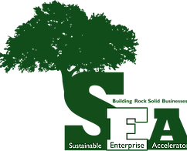A Rock Solid education begins with a comprehensive learning experience, inspired by passionate faculty members and guided by caring support services. The university’s new tagline, “Experience the Difference” is inextricably connected to the stakeholders and the community in which it serves.

“Experience the Difference”, the university’s tagline gives the promise that SRU will deliver a unique Rock Solid education. The difference is not only within the classroom, but also outside the classroom. The current students, faculties, staffs, alumni, organizations, business partners, all

the stakeholders and the community SRU serves interact and form an integral body of the Rock Solid education.

* **SEA Internships**

The SEA internship program allows students to put skills and knowledge to the test by serving a variety of regional clients. It is a team-oriented environment, and students are encouraged to collaborate and delegate with fellow interns. Furthermore, an internship with the SEA provides extensive networking opportunities and a real chance to improve the face of business with sustainable objectives. Through the SEA internship program, students serve the regional clients and help to solve a variety of cases. It’s a great opportunity for the students to link what they have learned in the classroom to real-life problems as well as work and collaborate as a team. SEA also provides the interns networking opportunities and help them start building careers in the sustainable business area.

* **SEA Partnerships**

The SEA maintains active files on 57 clients. The clients are student entrepreneurs, regional entrepreneurs and existing businesses. For effective implementation of its various projects, the SEA has partnered with numerous individuals and institutions including: various clients who provide service learning opportunities for students, North Country Brewing, the Clinton Global Initiative, Penn State University, Pennsylvania Association for Sustainable Agriculture (PASA), the Butler County Chamber of Commerce, the Robert A. Macoskey Center and Mr. David Stoner.

* **Partnership with the Office of Career Education and Development at SRU**

For better assisting students preparing and starting their careers in the business industry upon their graduation, School of Business has partnered with the Office of Career Education and Development at SRU. Students are encouraged to work on the resumes and interview skills, establish their online professional profiles with the team and attend the job fairs, internship fairs organized by the office. Dr. John Rindy also does guest lectures during the semester and gives lectures to business students on etiquette professional manners during the business week.

* **Partnership with the Internal Revenue Service**

Slippery Rock University’s School of Business, in conjunction with the federal Internal Revenue Services’ Volunteer Income Tax Assistance (VITA) program, offers free, federal income tax preparation services to individuals and families earning approximately $54,000 or less annually. VITA interns are IRS trained and certified prior to preparing taxes. The School of Business at SRU has partnered with the Butler County Center for Community Resources for the past 8 years. Our students and volunteers have helped almost 12,500 returns in amount of over $16.5 million for the community. In 2018, 29 interns and 5 volunteers have been trained and helped 2,185 filings which result in over $2.8 million tax returns. The tax preparation service is being funded by grants from the IRS and United Way of Butler County in collaboration with SRU volunteer students. The primary contact for this program is Jean Bowen, Program Specialist and VITA Coordinator with Center for Community Resources, Inc. The faculty advisor for the School of Business is Theresa Phipps.

* 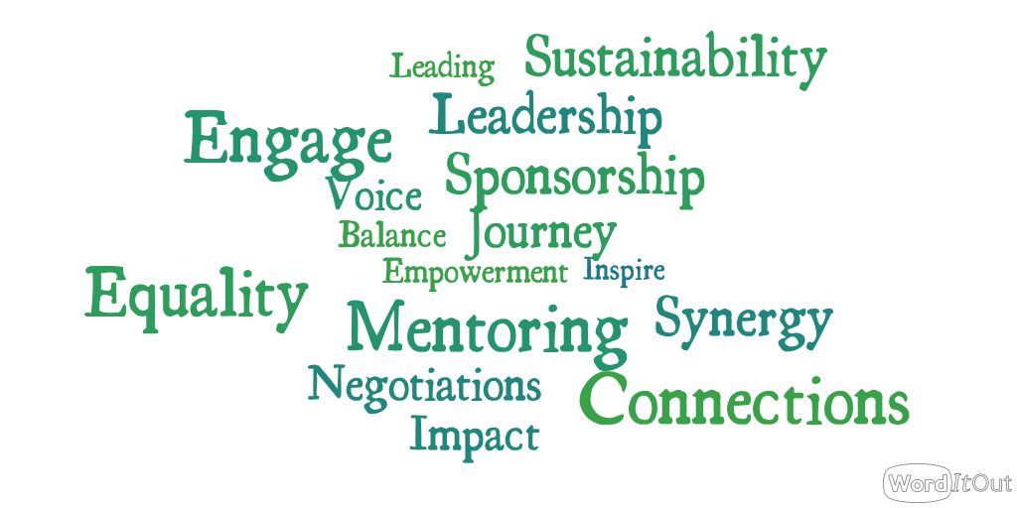**Partnership with Business Women**

**Women’s Solar Center**:

Enlightening, Empowering, and Igniting Women in Business

We will continue to seek partnerships with a variety of Women’s organizations like the SRU President’s Commission on the Status of Women, Women’s Center, Gender Studies, as well as many other organizations. Plans are underway to participate in the Women’s Entrepreneurship Week organized by Montclair State University. Plans are also being made to collaborate with the Women’s Business Center at Chatham University.

* **Partnership with the Business Community**

The Business Advisory Council (BAC) has been one of the most important partnerships. The alliance with our Business Advisory Council allows School of Business to gather feedback from our external stakeholders, revise our curriculum satisfying the market needs and better equip our students in the job market upon their graduation. The School of Business week is held every year, and our Business Advisory Council meets on campus and interacts with students and faculty through a variety of activities, including mock interviews, resume building, guest lectures, etiquette meals, etc. In 2018, the School of Business week was from April 2nd to April 6th, 2018. About 20 business professionals attended the BAC meeting and interacted with about 30 students from the School of Business at the etiquette lunch. In addition, some of our business partners are recruiters at their respective companies (for example, from Allegheny Health Network and UPMC), and have worked with SRU applicants to place them in various positions.

* Partnerships with the local and regional Chambers of Commerce. Specifically, we have a partnership with the Pittsburgh North Regional Chamber of Commerce, whereby many faculty members belong and students are afforded a free membership. SRU, School of Business also partner in various community events plus Dr. Diane Galbraith participated in an internship presentation with 4 other area universities to inform the Chamber members of the definition, the process, the benefits, the challenges, the evaluation, etc. associated with hosting interns.
* Our business partners help our students to understand the real world and the challenges in the companies as well as their respective industries at both micro and macro levels. In the past few years, SBUS students have had guest lecturers from PPG Industries, Inc., Fastenal, Allegheny Health Network, UPMC, Tidbit Creative, Rivers Casino, US Steel, Mercer County State Bank, Northwestern Mutual, etc. For example, in Dr. Jeananne Nicholl’s classes, speakers from PPG and Fastenal have taught classes and/or spoken about the challenges facing their businesses and respective industries at both the micro and macro level. In addition, they have also financially sponsored American Marketing Association (AMA) (one of SBUS students’ organizations) in 2017, to help create a pipeline of prospective interns and employees.
* **Partnership through Internships**

Students in the School of Business can take internships with local, regional, national or international organizations. Each major has an option for an internship as an elective that include up to 12 credit or 480 hours. An average of 15 – 25 students take internships each semester.

Students and their respective organizations understand the value of the internship as they can be mutually beneficial. Through the partnership with local and national businesses and organizations, the students are exposed to how the organizations operate and can apply what they have learned in college to solve business problems from the real world. The interns are mentored and evaluated by the supervisor and received a final written evaluation report. The positive interactions between our internship partners, students and faculties sometimes can lead to formal job offers to School of Business students directly. Dr. Diane Galbraith is the faculty coordinator for the SBUS internship program.

* **Partnerships through Service Learning**

As described earlier, many SBUS courses include semester-long projects whereby the students work as consultants with external stakeholders to solve business problems. These assignments are great opportunities for real-world experience, while assisting the respective organizations.

In some courses in the SBUS curriculum, the students have the opportunity to serve as consultants to assist existing business organizations in solving their business problems. Such project assignments are a win-win for both our students and the business organizations. For example, the organizations include Central Blood Bank of Pennsylvania, Boy Scouts of America, Butler Eagle Newspaper, Convict Choppers, Eat N’ Park Incorporated, National Marrow Donor Foundation, etc. One of the most recent large-scale projects in Dr. Theresa Wajda’s class is “Flaunt Your Fleece” energy project that partnered with SRU-Energy Conservation Committee. In Dr. Diane Galbraith’s class, students work with Valley Points YMCA to evaluate their strategy, pricing structure, and membership and the Pittsburgh Passion for game-day events and a prospective new league.

* **Business of Humanity Project ®** <http://boh.pitt.edu>

The Business of Humanity Project**®** was created in 2007 as a collaboration between the Katz Graduate School of Business and the Swanson School of engineering at the University of Pittsburgh. The objective was to demonstrate the link between incorporating elements of ‘humanity’ into the strategic decision-making process. Since then the project has amassed dozens of videos, case studies, media articles, etc. that illustrate this point. Other universities partnering with the Business of Humanity Project® include Indiana University of Pennsylvania, Edinboro University, Robert Morris University, and Carnegie Mellon University.

Dr. Frances Amatucci is the faculty leader from SBUS that partnered with the Business of Humanity Project®. In 2017, Business of Humanity® held the first New Venture Competition. Two teams from Dr. Frances Amatucci’s Sustainable Entrepreneurship class made it to the final round. Eventually, one team earned third place in the competition. <http://boh.pitt.edu/new-venture-competition>

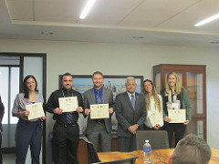 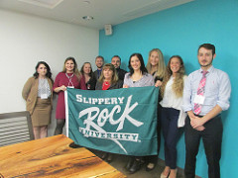

* **Students Clubs and Organizations**

In the School of Business, we also have the roundtable with student clubs and organizations participated, including: Alpha Kappa Psi, American Marketing Association, Society for the Advancement of Management, Finance & Economics Club, Future Healthcare Leaders, Rock Solid Investment Club and Student Accounting Society.

**2018- 2020 Principle 5 Goals:**



* Continue to increase and leverage partnerships within the university and

with external stakeholders

* Search for additional community partners to further the

PRME initiatives

PRINCIPLE 6 - DIALOGUE

We will facilitate and support dialogue and debate among educators, business, government, consumers, media, civil society organizations and other interested groups and stakeholders on critical issues related to global social responsibility and sustainability.

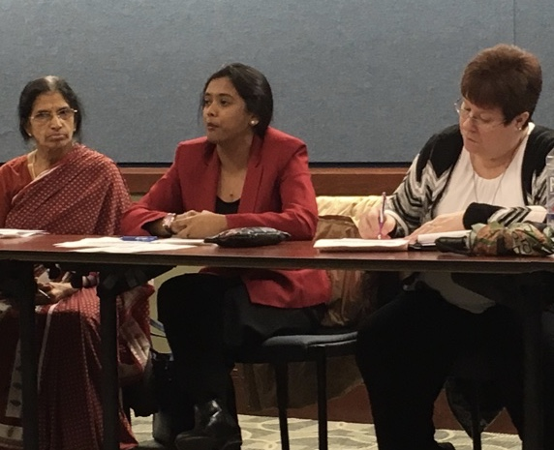**Academic Forum:**

On April 4, 2018, Dr. Diane Galbraith made a presentation on Principles for Responsible Management Education (PRME) at the Academic Forum meeting. Academic Forum brings together faculty, staff and student government body representatives from all departments across campus to discuss pertinent issues. She encouraged faculty from all departments to join the discussion about how business schools can participate in addressing U.N. sustainable development goals in curricula, programs, processes and partnerships.

**CareBreaks**

SRU CareBreaks are community service experiences held over Fall, Winter, and Spring Break that gives students the opportunity to travel in need across the United States and the world. Within the last twelve years, over one thousand SRU students, faculty, and staff have spent over 200,000 hours in 26 U.S. cities and 7 countries as they tutor children, build low-income housing, assisting the homeless and the hungry, protecting the environment, and creating Slippery Rock University’s international reputation as a place where students develop strong ethics of service.

**CareBreak Trip for National Park Services**

14 students from Slippery Rock University travelled with their faculty advisor Dr. Diane Galbraith on a week-long spring break trip to work on Hatteras Island in North Carolina. The group painted the interior of two seasonal houses and cleaned the Cape Hatteras Lighthouse for the upcoming climbing season. The National Park's senior administration were very appreciative of the contribution to improve the environment. The Park's personnel offered the opportunity to begin a meaningful relationship with SRU in terms of care breaks and internship opportunities.

**Business Advisory Council**

In April 2018, Dr. Diane Galbraith presented to the Business Advisory Council (BAC) of the School of Business. She emphasized the ways the BAC can help to enhance the impact of PRME, and to achieve a more sustainable future through continuous support. Dr. Galbraith shared information with the group as to how business can also become signatories of the U.N. Global Compact and thereby voluntarily commit to advance ten universal principles on human rights, labor standards, environmental protection and anti-corruption.

**Speaker Series: Success Starts Here**

The Success Starts Here is a speaker series sponsored by the School of Business to bring regional business leaders to campus to talk to students about their success, their journey, their initial transition from school to work, and the tools for success as well as the challenges along the way. SBUS strives to showcase the opportunities that exist for our students in western Pennsylvania and the tri-state region.

These speakers share relevant job experience and advice for the students including the vast array of opportunities available within their respective organizations. Students can interact with the speakers on many topics like corporate social responsibility and other vital aspects of the business world. Speakers are scheduled throughout the fall, plus during School of Business Week in the spring. These presentations are valuable learning opportunities and offer essential networking sessions.

Some of the past speakers include:

* Janice McGee - The Empyrean Group
* William G. (Gus) Pagonis - Genco
* Joe Finney - Tire Centers, LLC
* David Boucher, CEO UCI Medical
* Magali Abadie, Dir. International Clinical Operations and Quality University of Pittsburgh Medical System (UPMC)
* Margaret Hardt DiCuccio, CNO & COO Allegheny General Hospital
* William O’Rourke, former VP of Health, Environmental and Safety, Alcoa
* Jen Sunday Crowley, Recruiter, Google

**PASSHE Directors’ Conference**

In October 2017, Dr. Diane Galbraith and Erin Strain were invited to present to the PASSHE Directors from all of the 14 institutions on personal and professional negotiation. They received 'rave' reviews from the participants.

**Claire Schmeiler Leadership Symposium**

In February 2017 and February 2018, Dr. Diane Galbraith conducted negotiation workshops for the Leadership Center at SRU, as part of the Claire Schmeiler Leadership symposium.

**Personal Finance Workshop for Slippery Rock High School**

Invited by the school Superintendent, Dr. Diane Galbraith and Dr. Melanie Anderson conducted a workshop for Slippery Rock high school students on personal finance. This serves as a new partnership and opportunity to engage with the community.

**School of Business**

PRME initiatives and outreach were presented at various department meetings and the faculty retreat for the School of Business, SRU.

* 1. **Principle 6 Goals:**



* We strive to continue dialogue with internal (students, other Colleges

within the university, etc.) and external (Business Advisory Council members,

Chamber of Commerce members, etc.) about the sustainable development

goals.

* Revamp the Business Advisory Council to further diversity its membership.

**Appendix 1. The State System, Slippery Rock University, School of Business Strategic Goals and PRME Principles**

|  |  |  |  |
| --- | --- | --- | --- |
| **PASSHE GOALS** | **SRU UNIVERSITY GOALS** | **SCHOOL OF BUSINESS GOALS** | **PRME Principles** |
| 1.Ensure academic program excellence and relevance  2. Increase accountability and transparency; focus on results  3. Enable more students to obtain credentials that prepare them for life, career and the responsibilities of citizenship  4. Develop new funding strategies, diversify resources and manage costs to preserve affordability | 1. Offer a quality, flexible, agile and integrated curriculum and co-curriculum to develop the intellectual, social, physical, and leadership capacities of students.  2. Maintain an unwavering focus on success for all students  3. Fuel learning with powerful pedagogies and transformational experiences.  4. Provide a caring campus experience supported by quality housing, dining, recreation, health, safety and administrative services.  5. Increase financial resources, enhance physical facilities, employ cost-effective technology and adopt sustainable practices  6. Engage alumni and friends in the life of the university  7. Support external communities through programming and expertise  8. Increase enrollment while enhancing student quality and diversity  9. Attract, retain, and develop highly qualified and diverse faculty, staff and administrators. | 1. SBUS is committed to providing high quality curriculum designed to make students ‘career ready’. We emphasize excellence in teaching incorporating high impact practices to facilitate student engagement.  2. SBUS faculty and staff in conjunction with the University administration are highly engaged in the recruitment and retention of quality and diverse students.  3. SBUS strives to recruit and retain academically qualitied, experienced and diverse faculty and staff.  4. SBUS faculty conduct scholarship that enhances student learning.  5. SBUS is engaged with faculty, students, its advisory board, University staff and other external stakeholders.  6. SBUS strives to develop principle-centered students who are responsible global citizens. | **Purpose:** Develop the capabilities of students to be future generators of sustainable value for business and society and to work for and inclusive and sustainable global economy.  **Values:** Incorporate into our curricula and academic activities the values of global social responsibility as portrayed in international initiatives such as the United Nations Global Compact  **Method**: Create educational frameworks, materials, processes and environments that enable effective learning experiences for responsible leadership.  **Partnership:** Interact with managers of business corps to extend our knowledge of the challenges in meeting social and environmental responsibilities and to explore jointly effective approaches to meeting these challenges.  **Dialogue**: Facilitate and support dialogue and debate among educators, students, business, government, consumers, media, civil society organizations and other stakeholders on issues related to global social responsibility and sustainability |