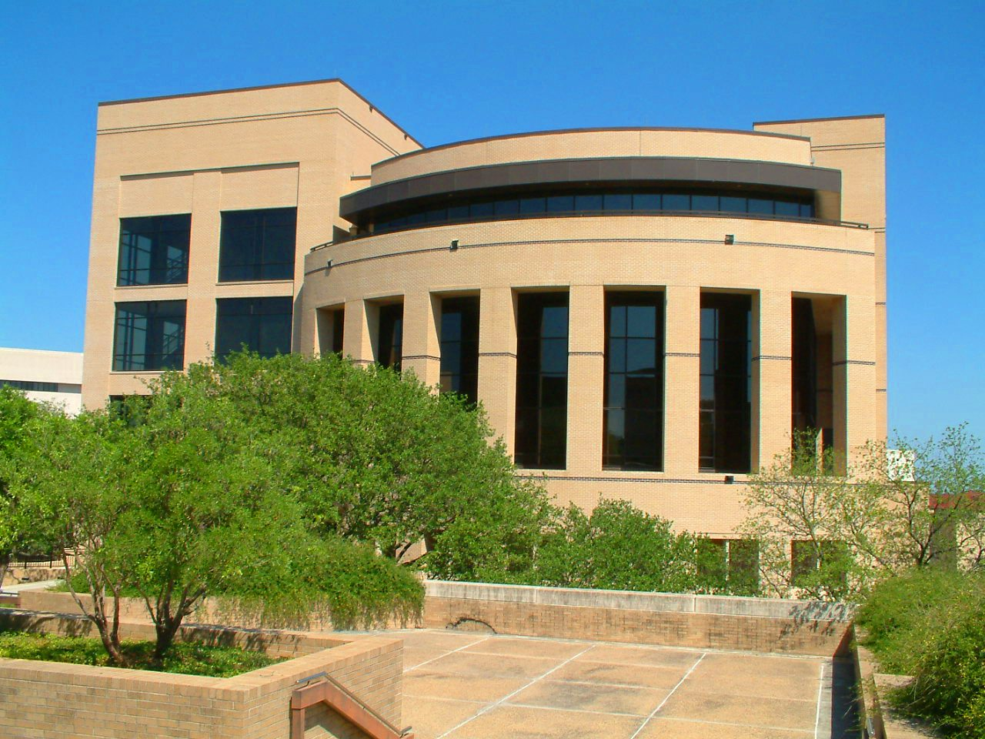

**McCoy College of Business Administration**

**Texas State University-San Marcos**

**Report on Progress**

**2009-2010**



**PRME Principles for Responsible**

**Management Education**

**From the Dean**

This is our second Sharing Information on Progress (SIP) report pursuant to the United Nations Global Compact. McCoy College of Business Administration is proud to participate in this effort to advance universal principles in human rights, labor, environment and anti-corruption. McCoy College looks to the Principles for Responsible Management Education (PRME) to guide its curricula into a greater acknowledgement of corporate social responsibility. The McCoy College of Business Administration became a signatory institution on November 30, 2007.

Our mission reflects the responsibility of the College to make the education of its students the focus of all activities and to create and continuously improve programs that add value to students’ educational experiences through relevance and quality. The foundation of the College is an enthusiastic, student-oriented faculty knowledgeable in their discipline through the pursuit of intellectual contributions, professional development, and business experience. The faculty are active in academic, professional, and civic service, and they also mentor students and support student organizations.

PRME’s mission, to establish a process of continuous improvement in order to develop a new generation of business leaders capable of managing the complex challenges faced by business and society in the 21st century, likewise makes the total education of students the focus of all activities. Once students learn what is right and what is wrong they are prepared to do what is right. The mission and values of the McCoy College have always included ethical behavior, so PRME is a natural extension of our own values.

McCoy College provides a curriculum that focuses on conceptualizing a complex issue into a coherent, persuasive written statement or oral presentation. Graduates should understand the importance of effective communication in an organization, acquiring analytical tools and critical thinking skills for evaluating information, solving problems, and making sound decisions, acquiring information technology skills that are useful in business decision-making, recognizing and applying general concepts of ethical behavior in dealing with various stakeholders, acquiring and using the skills needed for effective teamwork, understanding the importance of group dynamics in achieving organizational goals, understanding the importance of culture and diversity to organizations, and understanding the impact of globalism and multiculturalism.

Equal emphasis is placed on teaching and applied intellectual contributions. This applied orientation is endorsed by AACSB and our advisory boards. The following values are widely shared within the College and are fundamental to its success:

1. Excellence in all endeavors through reliance on self-study and continuous improvement
2. Integrity and adherence to professional and ethical standards
3. Commitment to the personal and professional development of faculty, staff, and students
4. Responsiveness, accountability, and contribution to the community and region
5. Respect for individuals and a diverse culture that creates community among faculty, staff, and students.

Our award-winning academic advising center is a source for information about undergraduate business programs at Texas State.  The staff welcomes students and invites them to explore the Web site's extensive resources for both current and prospective students. Students develop a strong working relationship with their academic advisor and the faculty. Students are expected to follow the university's honor code as well as the McCoy values of integrity and adherence to professional and ethical standards.

We ask our students to follow the advice in “My First Book of Business Ethics;” 1) that a business is only as ethical as the people who run it; and 2) that in the long run ethical people are more likely to be successful in business than unethical people. This second Report on Progress testifies to the fact that the McCoy College of Business Administration at Texas State University is committed to educating business students who share our determination to create ethical and sustainable businesses.

Denise T. Smart, Ph.D.

Dean

McCoy College of Business Administration

**The Mission of McCoy College of Business Administration**

The McCoy College of Business Administration is a student-centered learning community dedicated to sharing values, knowledge, and skills that enable students to compete responsibly and successfully in a global business environment. The College serves a diverse population of undergraduate and graduate students primarily from Texas. Emphasizing an applied orientation, we value teaching excellence and intellectual contributions, complemented by service.

**Introduction to the Report on Progress**

As a signatory to the United Nation’s Principles of Responsible Management Education (PRME), the McCoy College of Business Administration prepares and posts a Sharing Information on Progress (SIP) report outlining the actions it has taken to support, abide by and promote the six principles of PRME. The following report provides an overview of how McCoy College incorporates and inspires business responsibility. The report is categorized by the six principles of PRME along with specific examples of how McCoy College supports each respective principle.

**Principle 1**

**Purpose:** We will develop the capabilities of students to be future generators of sustainable value for business and society at large and to work for an inclusive and sustainable global economy.

The McCoy College of Business Administration at Texas State University examined the areas of ethics and sustainability in the undergraduate curriculum and determined the most appropriate method for infusing those concepts into core classes. As a result

* The Department of Management converted its Business Ethics special topics course into a permanent course, MGT 4370. The new course will be offered at least once a year on both the San Marcos and the Round Rock campuses.
* Dr. Janet Hale attended a "Sustainability Across the Curriculum" leadership workshop in Atlanta for faculty who wish to develop curriculum change programs around sustainability on their campuses. She led a similar workshop on campus and is qualified to do so around the country on behalf of the Association for the Advancement of Sustainability in Higher Education (AASHE).
* The Ethics, Diversity and Sustainability (EDS) committee investigated the development of a McCoy College Sustainability Certificate and how to inform Bobcats about EDS initiatives and goals. The committee also selected and prioritized a number of initiatives, continued to integrate initiatives and materials into relevant courses, implemented feasible project initiatives, including relevant student projects, and sponsored events to increase community awareness, such as verifying and updating the carbon footprint of McCoy College.
* Several McCoy College faculty participated in the first Texas State Interdisciplinary Symposium on Sustainability, hosted by the Texas State Department of Philosophy. Drs. Eric and Susan Kirby presented research on long run business sustainability, Drs. Janet Butler and Cecily Raiborn presented “Integrating Sustainability Reporting Measures into Business Reporting Processes” and Dr. Joni Charles, Dr. Janet Hale, and Ms. Vicki West presented “Incorporating Sustainability into the Business Curriculum.”
* Dr. Janet Hale's Business Law Honors (BLAW 2361) class developed an accessibility rating proposal for Texas State and the San Marcos community with the Downtown Business Association, Central Texas Medical Center and the Phoenix School, a part of the San Marcos Consolidated School District. The class was awarded a $5,000 grant by the Texas State Environmental Service Committee to create a short film on solar drying for use in the University Seminar 1100 classes during the 2010-2011 Common Experience theme of Sustainability. Another portion of the grant will be used for the purchase of drying racks to be used by students in the campus' dormitories. Professor Hale's class also started a campus chapter of Net Impact, a network of business students and professionals who are committed to using the power of business to improve the world.
* Texas State students placed first and third in the AMASavesLives video competition, third in the website competition and received honorable mention in the UNICEF video competition and the UNICEF Fundraiser Competition at the 33rd Annual American Marketing Association International Collegiate Conference in New Orleans.

**Texas State Common Experience**

Texas State students have many opportunities through course work, research, and community involvement to learn about and address sustainability challenges whether they be environmental, economic, or social issues. Faculty and staff are working to green their departments by reducing material consumption, increasing recycling, reducing energy use, and encouraging other responsible behaviors.

The university’s Common Experience theme for 2010-2011 is "Sustainability: Science, Policy, and Opportunity," an interdisciplinary theme that affects all students, staff, faculty, and administrators of Texas State, as well as the San Marcos community. Because of the integrative nature of the problems that humanity faces, the only way in which these problems can be realistically addressed is through interdisciplinary dialogue, outreach, and education. The capacity of humanity to adapt in a dynamic world that is constantly presenting new challenges is essential in the 21st century.

The questions and challenges embedded within the sustainability enterprise require the input of all members of the university community and beyond. Indeed, issues of sustainability not only involve an understanding of our history, but compel us to look ahead to the future. The challenges facing Texas State students are many, but a central topic of concern revolves around sustainability. Changes in behavior and social policy, building scientific understanding, connecting the local and the global, and reshaping values are all crucial components to a "sustainability revolution" — an opportunity for the Texas State community to embrace and actively participate in the science and practice of sustainability.

McCoy College participated in the Common Experience by hosting a series of events with the theme “Exploring Business Sustainability: Ethics, Environment, Economy.” Started in 2009, Business Leadership Week is a signature event for McCoy College. The week is designed to engage the Texas State community in discussions relating to contemporary issues in leadership. The McCoy College is committed to encouraging discussions on these important topics while enriching the experiences of business students. Attendance more than doubled from 2009 to 2010 and even more growth is expected as we attract more high profile speakers. Students and faculty alike praise the week for providing cutting-edge and informative events. In addition to thought provoking speakers, the week includes interactive workshops where student participants develop skills that will allow them to compete in a dynamic business environment.

Speakers at the 2011 Business Leadership Week included Mr. John Oehlke, Vice President of Business Transformation, Coca-Cola North America, Mr. Clay DeStefano, Administrative Director of PR and Marketing, Central Texas Medical Center (winner of the first Chamber of Commerce “Green” award, Graciela Tiscareño-Sato, Author of Latinnovating: Green American Jobs and the Latinos Creating Them, Suzanne Perkins, Owner and Chef of Cool Mint Café & Market, Green Business of the year for 2010, and L. Celeste Bottorff, Vice President of Living Well, Coca-Cola North America. Celeste’s work is instrumental in designing and communicating the Company’s vision for how it delivers on its promise to consumers all across the country that Coca-Cola can be counted to make a positive difference in their lives.

**Principle 2**

**Values:** We will incorporate into our academic activities and curricula the values of global social responsibility as portrayed in international initiatives such as the United Nations Global Compact.

**Graduate Courses**

**MBA Program**

Students entering the McCoy College **Master of Business Administration** (MBA) program may choose one of five program options, the general MBA or the MBA with an emphasis in health administration, international business, Latin American business, or engineering technology. A new course, Legal Issues of Sustainability and Responsibility covers corporate responsibility and sustainability, including ethical, environmental and social issues in the business world tied to PRME and the AACSB sustainability goal of peace through commerce. The entire MBA curriculum is built around a sustainability framework as shown below.

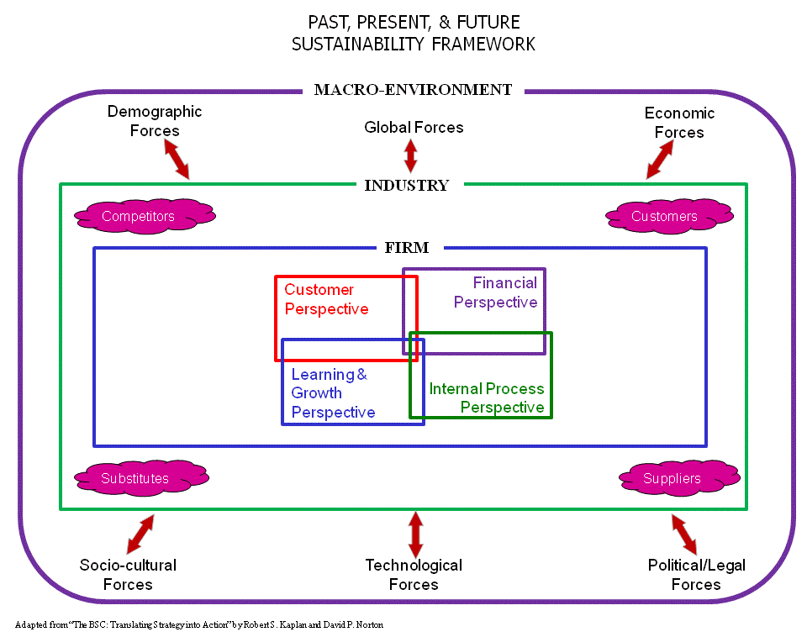

**MAcy Program**

The **Master of Accountancy** (MAcy) program produces accounting graduates who are broadly educated in accounting concepts and practices. Students explore the social and environmental effects of accounting information on those who rely on it for decision making. A unique aspect of the program is its emphasis on the ethical implications of accounting, auditing, and financial reporting.  The Macy program prepares students for careers as auditors, tax professionals, business consultants, financial planners, internal auditors, controllers, and to work in public accounting, government, not-for-profit, and industry.

**MSAIT Program**

The McCoy College **Master of Science in Accounting and Information Technology** (MSAIT) program prepares students for successful careers in management of accounting information systems and IT auditing, governance, controls, and compliance. The program offers an applied learning approach that blends accounting and information technology knowledge, skills, and abilities.

ACC 5340:“Individual Income Tax" - Regulatory and ethical issues are incorporated into the discussion of taxes.

ACC 5389: "Corporate Governance and Ethics" - A study of the corporate governance and ethical issues in accounting, including ethical reasoning, integrity, objectivity, independence, core values and professional issues.

BLAW 5368B:“Law and Ethics in the Business Environment" –An examination of the ethical dimensions of management decision-making. Problems are viewed through the lens of a value

system determined, in part, by the legal system.

CIS 5360: "E-Commerce: Strategies, Technologies, and Applications" – Covers the social, political, global, and ethical issues associated with e-commerce.

CIS 5368: "Information Security" – Topics include legal, ethical, and professional duties associated with the use of information.

**Undergraduate Courses**

ACC 2361:“Introduction to Financial Accounting” **-** Students develop an understanding of the role and nature of accounting, the social, political, legal and regulatory environment of accounting in the U.S. and the issues and principles that underlie the preparation of financial statements, including the ethical expectations.

ACC 2362:“Introduction to Managerial Accounting" – Within the business decision-making environment, students learn to effectively demonstrate skills in applying ethical values to various situational issues.

BLAW 2361: “Legal Environment of Business" – Students learn to understand the competing interests inherent in the law and the ethical implications resulting from both personal and business decisions.

CIS 3380: “Enterprise Information Technology and Business Intelligence” - Students learn to understand the ethical and security issues surrounding the use of information.

MGT 3303: “Management of Organizations” – Students analyze how ethics and social responsibility impact stakeholders of a firm.

MKT 3343:“Principles of Marketing” – A study of individual responsibilities in organizations and society, including ethical and socially-responsible marketing.

MGT 4335: “Strategic Management and Business Policy” – Students learn to recognize an ethical dilemma and resolve it using an evaluative framework.

MGT 4390C:“Business Ethics" – This course considers both what is required for ethical leadership in business and what it takes to achieve something more- leadership in ethics.

MGT 4390G:“Cross-Cultural Human Relations" – A focus on the international dimension of business ethics at all levels of business: personal, organizational and systemic.

FIN 4325:“Advanced Financial Planning" – Capstone course for finance majors interested in financial planning. Topics include ethics in the financial services industry.

**Principle 3**

**Method:** We will create educational frameworks, materials, processes and environments that enable effective learning experiences for responsible leadership.

**Educational Frameworks**

The Texas State Environmental Service Committee funds $60,000 worth of student projects that bring environmental awareness to the university. Current projects include Bobcat Blend, which makes compost from dining hall waste on campus.

Texas State's Marketing Department is committed to educating and supporting ethical values through a variety of learning, teaching, and outreach activities. Every marketing student, faculty member, and professional should be aware of industry standards for professionalism and ethics.  Every marketer's career, each marketing organization's success, and the industry's reputation are grounded in integrity and adherence to high standards.

### Bobcat Build participants paint, mulch, plant flowers, rake leaves, prune trees and bushes, wash windows, clean up neighborhoods, participate in can food drives, clean up rivers, and volunteer at other community projects. The mission of Bobcat Build is to create a Texas State tradition of pride through a day of service projects that builds awareness, builds community and builds tradition. The Bobcat Build Student Planning Committee envisions the Bobcat Build event as an opportunity for students, faculty, and staff to focus on the needs of the areas around Texas State. Through campus collaboration and an open line of communication, Bobcat Build helps bridge the gap between the Texas State community and the citizens of San Marcos.

The River Systems Institute has become an international center for watershed studies and includes a watershed science lab for sustainability. The Research Center for River Recreation at Aquarena Center focuses on sustainable water conservancy in the Rio Grande and the protection of endangered species.

The Department of Agriculture practices sustainable agriculture on the University's 4,200 acre Freeman Ranch, studying the site's avifauna, soil, topography, and vegetation.

The Center for Migrant Education partners the University with the US Department of Education to coordinate activities, programs and agencies concerned with the education, health and welfare of migrant workers.

The Center for Multicultural Gender Studies infuses an interdisciplinary curriculum supporting pluralistic society resources that address race, class, gender and ethnicity.

|  |
| --- |
| The Ethics, Diversity and Sustainability Committee **e**valuates diversity and ethical issues in the College and develops recommendations for enhancement. The committee works with the Undergraduate Curriculum Committee and Graduate Policies Committee to ensure adequate coverage of concepts related to diversity and ethics in the curriculum. The committee also initiates programs to educate and enhance awareness of diversity and ethical issues. |

**Principle 4**

**Research:** We will engage in conceptual and empirical research that advances our understanding about the role, dynamics, and impact of corporations in the creation of sustainable social, environmental and economic value.

The vision of the McCoy College is to be recognized as a national model for excellence in applied business education, valuing applied scholarly activity. The College encourages diversity of research interests and desires a faculty that, as a whole, will produce a complete portfolio of applied research contributions. Resources are available to promote research activities, and awards are made to faculty members who excel at such activities.

The McCoy College Research Committee finalized a Statement of Research Philosophy which reaffirms that, in accord with our mission, the faculty shares its knowledge and skills through the dissemination of applied research and other intellectual contributions. The committee also published objective criteria for ranking publications in a Statement on Research and Publications.

The College spent $217,718 on research related expenses in 2009-10; the faculty published 59 peer-reviewed journal articles, 37 conference proceedings and 148 other intellectual contributions.

**Faculty Research Activities**

* Dr. Cecilia Temponi was selected as guest editor for a special issue of *Computers and Industrial Engineering*, a well-respected journal in operations management.
* Dr. Li Feng is now an affiliated researcher with the National Center for Analysis of Longitudinal Data in Education Research (CALDER), which is using longitudinal data from multiple states to inform educational policy.
* Drs. Ivilina Popova and David Beckworth received Research Enhancement Program grants. Dr. Popova is working on a project entitled "Investment Decisions in the Presence of Long Term Dependencies,*”* which investigates portfolio construction and how it reacts during different market regimes. Dr. Beckworth’s project is "Measuring the Stance of Monetary Policy: An Alternative Measure." It deals with how best to gauge the actual stance of monetary policy.
* The Department of Management’s journal rating task force made substantial progress toward balancing the department’s portfolio of A+ and A journals. Faculty in the various sub-disciplines within the department provided critical input and feedback during this phase of the classification refinement process.
* The Department of Accounting sponsored six brown bag research seminars, the Department of Finance & Economics sponsored five, and the College Research Committee sponsored two.
* Dr. Cecilia Temponi developed a grant proposal in collaboration with Jesus Jimenez, Ingram School of Engineering, which was submitted for one-time research support from the Associate Vice President for Research. The proposal, "Multidisciplinary Project: Next Generation Factory Characterization in the Semiconductor Industry," was awarded$35,000.
* Dr. James LeSage was awarded a grant from the National Science Foundation for $47,473 for "Modeling Business Return in New Orleans after Katrina."
* Dr. Li Feng submitted a grant request to the Department of Education for $411,478.
* The Small Business Development Center (SBDC) received grant funding of $716,544.
* Mrs. Vicki West received an Armstrong Foundation private grant for $2,500 to support Students in Free Enterprise.

**Principle 5**

**Partnership:** We will interact with managers of business corporations to extend our knowledge of their challenges in meeting social and environmental responsibilities and to explore jointly effective approaches to meeting these challenges.

**Advisory Board**

The McCoy College Advisory Board provides support to the College through the business expertise of its members. These members provide guidance to help ensure that the College programs and curricula remain relevant and leading edge. Board members invest their time, energy and knowledge to keep the McCoy College of Business Administration among the leaders of graduate and undergraduate business education in Texas.

**A New Center**

In 2011 Texas State opened the Center for Research Commercialization.  The Center serves to act as two-way conduit - to assist industry to draw on significant university resources, and conversely for faculty to start businesses and liaise with industry. The model is simple - to be agile to the needs of each partner, recognizing that "no size fits all".  Each industrial partner is treated on a case-by-case basis, and the university takes pride in being able to respond rapidly, actively, and adaptably.

**Principle 6**

**Dialogue:** We will facilitate and support dialog and debate among educators, business, government, consumers, media, civil society organizations and other interested groups and stakeholders on critical issues related to global social responsibility and sustainability.

We understand that our own organizational practices should serve as an example of the values and attitudes we convey to our students.

**The Philosophy Dialogue Series**

This is a unique series of lectures, interactive presentations, and discussions. Philosophy faculty and majors select weekly topics like The Global Village, Aesthetics and Athletics, Patriotism and Democracy, Passion, Animal Consciousness, and Time Travel, to name a few.

For over twelve years, the series has provided a forum for the lively exchange and critical evaluation of diverse ideas. This series has grown from a few presentations a month to four or five each week during most of the fall and spring semesters. Faculty and student presenters come from all eight Colleges on campus, and the Department recruits nationally recognized scholars, like Antony Flew, Richard Swinburne, Parker Palmer, and David Luban, to participate each semester. Everyone is welcome to attend, and informal dialogues between faculty, students, and visitors is encouraged.

The Dialogue Series allows students to apply their classroom study of the principles of good thinking and ethical conduct to such controversial issues as euthanasia, stem cell research, and capital punishment. The series is also connected with a course, “Dialogue: Theory and Practice,” which is offered at both the undergraduate and graduate level.

 **The McCoy College Advisory Board**

At a board meeting in October, 2010 Dr. Janet Hale, Department of Finance and Economics, gave a brief presentation on sustainability along with three students from her Business Law Honors Class. They explained how 16 students from this class took on the extra responsibility of forming the Net Impact Student Organization. They wrote a $5,000 grant and during the summer filmed a video entitled Wear the Sun! The video educates Bobcats about the value of saving the earth by reducing coal usage and wear on clothes by line drying. An additional part of the grant purchased drying racks for dormitory students to check out to make green choices.

At that same meeting three McCoy students presented their project for The Force for Change Award, an annual international competition that recognizes and rewards outstanding members who have led a project that results in a tangible, positive, social and/or environmental impact on their campus, in their workplace, or in their community. The Texas State students won the silver award in the student category. This video was shown to all 4,000 Texas State 2010 entering freshmen in support of the university-wide Common Experience topic, sustainability. The Board also viewed the video.

**Sustainability: An Interdisciplinary Symposium**

Texas State hosted this symposium, which is one of a number of informational projects and events about sustainability on campus. Included are field trips to the San Marcos River and the Cypress Creek watershed in Wimberley, dialogues on sustainability, and multi-media presentations. Drs. Joni Charles and Janet Hale presented a paper on how to incorporate sustainability into the business curriculum. Drs. Susan and Eric Kirby presented a version of their AMA paper on "Why be Green?" Selected papers were published in the *Texas Journal of Science.*

Dr. Hale also brought Net Impact, a global network of 7,000 emerging business leaders committed to using the power of business to create a better world, to campus.