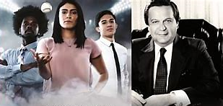
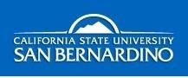
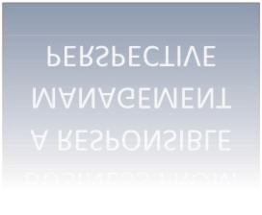
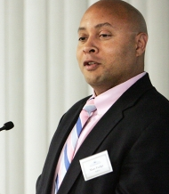

BUSINESS FROM

A RESPONSIBLE

MANAGEMENT

PERSPECTIVE

PRME, STATUS-IN-PROGRESS
REPORT 2022, THE JACK H. BROWN COLLEGE

“The Mission of the College of Business and Public Administration at California State University, San Bernardino is to create a student-centered learning community that prepares students to become productive members in business, government, and global society. We provide quality undergraduate and graduate programs that positively affect students' development as responsible management professionals.”

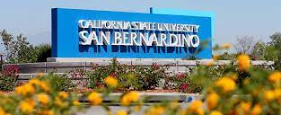

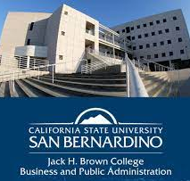
JHBC Interim Dean Dr. Shanthi Srinivas
Dear Dr. Mette Morsing and respected Global PRME colleagues:
It gave me great pleasure to be appointed as the Interim Dean of the prestigious Jack H. Brown College of Business and Public Administration (JHBC) in 2021. I have been closely associated with the United Nations’ Principles of Responsible Management, (PRME) in my prior CSU portfolios, and I will enthusiastically continue this connection.
Since I arrived at JHBC, our College has greatly increased its commitment to the PRME principles and to the United Nations’ 17 Sustainable Development Goals (SDGs). Our performance on PRME has been thriving despite the COVID-19 pandemic.
Firstly, throughout the year we will be producing periodic “News Flashes” emphasizing one or more of the UNs 17. SDGs. The purpose of this JBHC product is to bring to the fore these SDGs to our faculty, students and stakeholders, in our teaching and information dissemination.
Secondly, we have instituted a more comprehensive “Magalogue” twice yearly that links our campus’ strategic initiatives on sustainability with our PRME responsibilities.
Thirdly, we will continue to provide biennial reports, which we have produced since 2012, known as “PRME Bulletins.” Documents in this category emphasize actions of critical importance undertaken within the College, such as faculty engagement on the Six PRME Principles in their teaching and research, and student engagement.
Fourthly, we will continue with our obligations for the PRME Status-in-Progress Reports every two years, as required by the PRME Secretariat.
Our efforts continue to be a vital source of inspiration to the entire California State University San Bernardino campus. To close, I wish to thank Professor Emerita Dr. Breena Coates for her dedication to PRME and for compiling all our PRME communications and activities since 2012.
Sincerely,
Shanthi Srinivas, Interim Dean

JHBC Latest Rankings:
#50 of Top Graduate Schools for Entrepreneurship Studies
Top On-Campus MBA Program in the Nation, #3 for Best MBA for Human Resources, #25 in Top 50 Online MBA Programs
Best Online Certificate in Accounting Programs
Ranked 1 – Intelligent Pick
Best Online MBA Degree Programs (No GMAT Required)
Ranked 11 – Best in the West
Best Master’s in Public Administration Degree Programs
Ranked 17 – Best for Cybersecurity
Best Online Master of Public Administration Programs
Ranked 19 – Good Value
Most Affordable Online Master’s in Accounting Programs
Ranked 36 – Best Cohort Program
Intelligent.com 2022
Top Grad School - Public Affairs (MPA) & MBA (Online/Part-time)
U.S. News & World Report, 2021
Online MBA Program is #5 in CA, #9 in the West, #49 Nationwide
Online MBA Report, June 2021
Tier 1 Global MBA Program/#47 MBA Online Program
CEO Magazine, May 2021
Best Bang for the Buck
Washington Monthly, 2021
#15 of 50 Best Online MBA Programs in US
College Consensus, Sept. 2019
Top 25 best value online MPA programs in US
Value Colleges, July 2019

TABLE OF CONTENTS
DEAN’S MESSAGE 2
JHBC LATEST RANKINGS 3
MISSION, VISION, & VALUES 5
JHBC-PRME STRATEGIC INTEGRATION MODEL 7
JHBC-PRME EXEMPLAR CASE ACTIVITIES 2020-2022 8
Renowned Cyber Security Center 9
Green Entrepreneurship 10
Inland Empire Women’s Center 11
The Diversity Initiative Program 12
The Faculty Research Development Program 13
Institute of Applied Leadership 14 The Women’s Labyrinth Colloquy 16
Leonard Transportation Center 17
Women’s Leadership Collaborative 18 Leadership In Higher Education Colloquy 19
Women on Corporate Boards Colloquy 20
CSUSB-JHBC Ombudsman Office 21
Ethics, Strategy &NCIS Colloquy 23
Global Management Center 24
Women’ Empowerment in Accounting/Finance Departments 25
Impact Investing 26
Students-at-Work 27

JHBC SERVICE CLUBS 35
JHBC STUDENT SUCCESS CENTER 41
JHBC CELEBRATED MBA PROGRAM 42
JHBC INNOVATIVE SPEAKING CENTER 43
JHBC VALUE-ADDING WRITING CENTER 44
JHBC ROBUST FACULTY RESEARCH & INFLUENCE 46

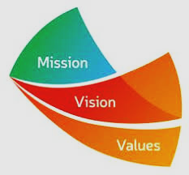
THE JACK H. BROWN COLLEGE

JHBCBPA VISI0N, MISSION, & VALUES:
Vision Statement We strive to be an exemplary regional educational institution that serves our students, community, and alumni. We will emphasize teaching, partnerships/service to our region, and research in business and public administration.
Mission Statement The Mission of the Jack Brown College of Business and Public Administration at California State University San Bernardino is to create a student-centered learning community that prepares students to become productive members in business, government, and global society. We provide quality undergraduate and graduate programs that positively affect students' development as professionals. We place priority on excellence in teaching that is enhanced by the commitment of faculty to continuing professional development, intellectual contributions and service. The faculty's intellectual contributions will primarily be a mix of applied research or contributions to practice and learning or pedagogical research. We serve a culturally and globally diverse student body by preparing the student to deal with a changing and diverse environment as responsible management professionals. Through community service, partnerships and initiatives, the College serves as an intermediary for the exchange of knowledge and expertise between the University, the regional community, and the larger world.
Shared Values Our Mission and vision are supported by a set of shared values that form the foundation of all our activities. These are not presented in order of preference or importance – we view all as equally important: We value our students. Our actions are judged first on the effect on the education and career achievement of the students. We value the inputs and points of view presented by the diversity of our student body. We strive to provide excellence in classroom teaching and in the advising of students.
- We value our faculty and staff. The College respects the opinions and perspectives of each individual and strives for a collegial atmosphere for the interchange of ideas and diverse points of view. We provide professional development opportunities for both faculty and staff and are a productive and cooperative unit within the greater University. We recognize the value of the faculty's efforts in teaching, university and community service, and professional development.
- We value our alumni. Our alumni are in leadership positions in business, the community, and public organizations. We work to keep them involved in the University and College, and we recognize them for their long-term accomplishments.
- We value our local community and region. As a state-supported regional university, our Mission is to serve the local region through our programs and community partnerships. We serve as a respected regional resource center for business and public administration data.
- We value select opportunities to infuse our curriculum and programs with knowledge and experience from the international environment.
Diagrams used, sourced from:
II. JHBC EARNING COMPETENCIES:
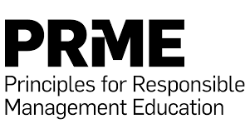
We have embedded the following values (called Learning Competencies) into our curriculum, and these values are explicitly stated in the majority of CBPA’s course syllabi for the B.A. P.A., and B.S. degrees. In addition, we embed these same values in special programs such as our Executive MBA program, our MBA for Professionals, our MPA program, and our MSA program. These values are consistent with our AACSB guidelines, and PRME values. They are:
LEARNING COMPETENCIES:
- Specific Knowledge and Skills: Each student should obtain specialized knowledge and skills for the creation of value through integrated operations and distribution of goods, services, and information.
- Communication Written: Each student can effectively communicate in writing.
- Communication Oral: Each student can effectively present information orally.
- Ethical Reasoning: Each student can recognize/analyze problems and choose/defend resolutions for practical business situations.
- Information Technology: Each student can use information technology to support the structure and processes of the organization, and use information technology in decision-making.
- Problem Solving: Each student can apply knowledge in new and unfamiliar circumstances and devise innovative solutions to cope with unforeseen events.
- Global Context: Each student understands varied cultural perspectives and global environments and can develop innovative business solutions and practices that address complexity.

We maintain a dedicated space for PRME archives, records, and activities in Room 240 Jack Brown Hall. Important to PRME is the development of a data base for Syllabi from each of our five departments--Accounting & Finance, Information & Decision Sciences, Management, Marketing, and Public Administration.
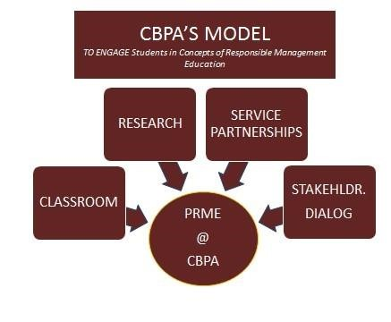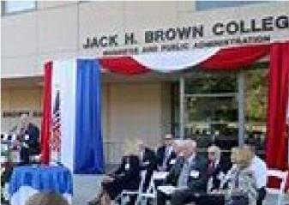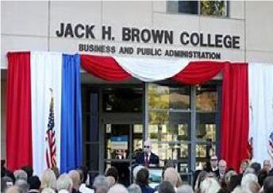
STRATEGIC INTEGRATION:

2020-2022
JHBC EVENTS APPURTENANT
TO UN-PRME VALUES
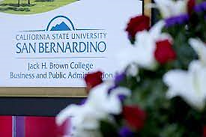
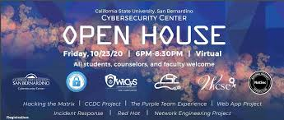
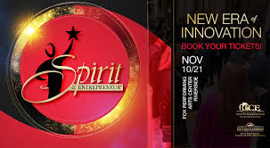
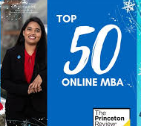

JHBC’s Professor Tony Coulson is a
Nationally-Recognized Cyber Security Expert

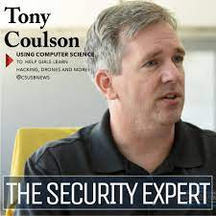
Under Professor Tony Coulson’s leadership, the Jack Brown Cybersecurity Center was named the Community National Center for Cybersecurity Education by the National Security Agency, which selected the center for a $10.5 million grant and the university to be a leader of the agency’s core workforce development initiative, the CAE in Cybersecurity Community. In its designation as a “national center,“ the CSUSB Cybersecurity Center will establish and manage three Centers of Academic Excellence-C Communities of Practice, coordinate cutting-edge research, establish and support five regional hubs around the country, and support cybersecurity education nationally. The center, from 2010-2020, has brought in over $28 million worth of grant sponsored programs from entities that include NICE, the NSA, DoD, the National Cybersecurity Training and Education (NCYE) Center, and the National Science Foundation (NSF).
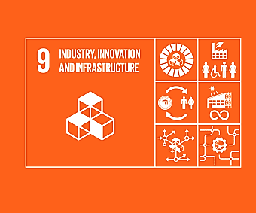
Dr. Coulson is a frequent invitee to scholarly conferences and national forums. Recently he was in a panel session at the National Initiative for Cybersecurity Education (NICE) 2020 Conference and Expo virtual series that were held in October and November, 2020.Dr. Tony Coulson, the executive director of Cal State San Bernardino’s Cybersecurity Center, and lead for the newly designated Centers of Academic Excellence (CAE) National Center for Cybersecurity Education, was in a panel session at the National Initiative for Cybersecurity Education (NICE) 2020 Conference and Expo was a virtual panelist on the topic “Creating the Next Generation Cybersecurity Workforce.” During the testimony, Coulson addressed the national 500,000 person deficit in cybersecurity workforce, “Cal State San Bernardino is committed to solve this workforce problem. Working with our partners at the National Security Agency Centers of Academic Excellence program, Cal State San Bernardino established and leads the National Centers of Academic Excellence Community in Cybersecurity, a strong collaboration of 335 NSA designated community colleges and universities all working to solve this cyber workforce shortage.”
The work of Professor Coulson is a critical part of the PRME Initiative and The U.N. Sustainable Development Goal #9. …..

A VALUABLE ASSET IN
GREEN ENTREPRENEURSHIP
WITHIN THE SCHOOL OF ENTREPRENEURSHIP
JACK H. BROWN COLLEGE

Interest in Green Entrepreneurship in society has created an exciting and burgeoning field in entrepreneurship studies. Corporations around the world find that creating sustainable products and services is not just good for the environment and community, but can be a source of business competitive advantage and financial stability. This interest spills over into higher education.
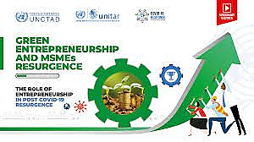
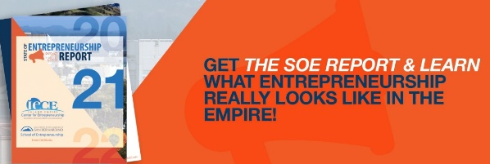
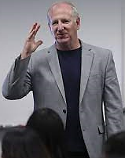
In 2020, the California State University established the School of Entrepreneurship within the Jack H. Brown College, under the leadership of Dr. Michael Stull, who also serves as Director of the Inland Empire Center for Entrepreneurship. The School offers a Master of Science in Entrepreneurship. The School offers courses like Ethics in Entrepreneurship and Sustainability and Green Entrepreneurship. It also provides students with knowledge from practice from the national and local regional entrepreneurs. At the opening celebration for this enterprise, Dr. Stull observed that the new school “will further cement the JHBC’s reputation as a leader in the field of entrepreneurship education and increase the college’s ability to engage with the local business community in terms of relationships, collaboration, and resources.”
The JHBC follows the UN-PRME initiatives and the UN Sustainable Development Goals. The UN is particularly interested in resurgence in Green Entrepreneurship in the Micro, Small and Medium Enterprises (MSME) sector, which took a hit in the COVID-19 pandemic. ……..
Women on Fire!
The Inland Empire Women’s Business Center (IEWBC) is part of The School of Entrepreneurship and the Inland Empire center for Entrepreneurship (IECE). Michelle Skiljan, a Professor in the School of Entrepreneurship is the founding director of IEWBC and has be successful in obtaining nearly 8 million dollars in funding. She brings 20 years of entrepreneurial experience to classroom and to the IEWBC.
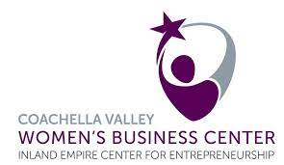
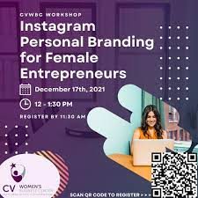
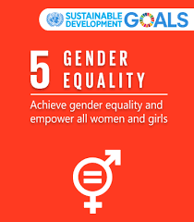
The Women on Fire! series of events will promote the appreciation of female business leaders who have magnificently successfully steered through the crests and dips that come with entrepreneurship. An important focus in this series is alerting women about the entrepreneurial prospects that are on hand, the existing support networks, and the multitude of opportunities that are there for them. Once again JHBC through its entrepreneurship divisions steps up to the challenge of the United Nations’ Sustainable Development Goal #5—the empowerment of Women.
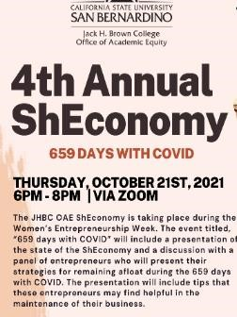
THE SHECONOMY
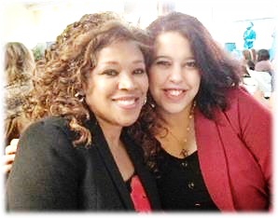
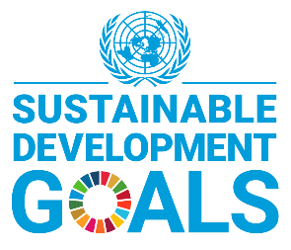
The term “ShEconomy” has been applied to rising female market power around the globe. Today, women are positioned to propel meaningful socioeconomic colloquy in four critical directions. First, in the employment sector where greater numbers of professional women are entering the workforce, and are recognized as valuable assets, and corporate influencers. Second, as vital components of the global economic machine, the discourse of gender-pay and upward mobility of women is more pertinent than ever before. Third, women have consumer power in world markets and cannot be ignored in financial compensation and advancement. The impetus for the Sheconomy came from Dr. Francisca Beer.
DR. FRANCISCA BEER
MARINA KAMEL
The Jack H. Brown College of Business and Public Administration (JHBC) recognizes its vital role as educators in all these things and there are on-going events that focus in just these areas.
Furthermore, as a PRME signatory, JHBC is cognizant of the United Nations’ Sustainable Development Goal #5—gender equality which is fifth of the 17 Sustainable Development Goals established by the United Nations in 2015. The wording of SDG 5 is “Achieve gender equality and empower all women and girls”.” Reduced Inequalities” under which the following statement is of central interest to Professor Francisca Beer: “Women and girls, everywhere, must have equal rights and opportunity, and be able to live free of violence and discrimination. Women’s equality and empowerment is one of the 17 Sustainable Development Goals.
………..

The Faculty Research Development Program

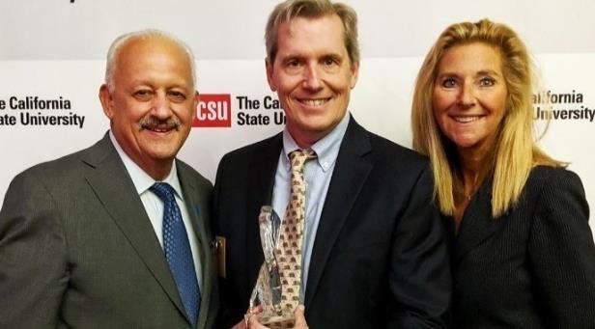
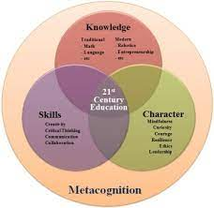
The Faculty Research Development Program of the Jack Brown College is spearheaded by Professor Montgomery van Wart of the Department of Public Administration—who is, himself, a maestro of the research and publications arena. He has integrated his ethics research into his management and leadership research, and vice versa. In a series of special research development seminars for faculty members, held throughout the year, Dr. Van Wart explains the techniques for successful research with such topics as “Professionalizing Your Research Agenda, and Enhancing Research Visibility, Utility, and Multiuse.” For example, in the use of human subjects there are many technical issues to improve research quality on one hand, but also many ethical pitfalls that must be completely avoided. The PRME-related standards principles of ethical research reflect the overarching concerns that Van Wart discusses in detail in various seminars as shown next:
- Do no harm
Researchgate.net
- Social and clinical value
- Scientific validity and reliability
- Fair subject selection
- Integrity in writing
- Independent review
- Informed consent from subjects
- Obligations and respect for potential and enrolled subjects

In his teaching, and his own research, Professor Van Wart emphasizes the known prohibitions against concoction, misrepresentation, fabricating, falsifying, or misrepresentation of data. In scholarly research keeping moral principles in mind is essential. Not only are ethical principles essential in and of themselves, researchers have obligations to be accountable to a society. Ethical norms also serve to ensure research funding, because funders must be able to trust the integrity of the work done in their behalf. The six PRME standards can be used as ethical guideposts to researchers. ……
Istockphoto.com

Clarifying Needs of Disadvantaged Communities
From the Applied Research and Policy Studies Center
is a Passion for Dr. Barbara Sirotnik

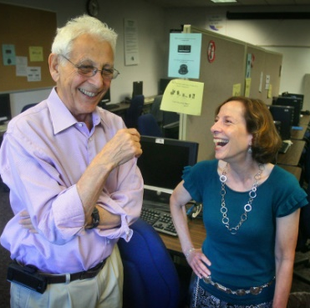
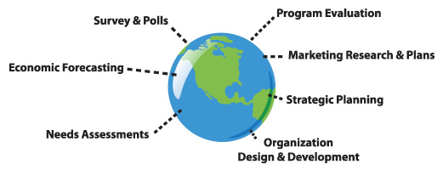
Professor Barbara Sirotnik via her numerous research statistical studies over the years has brought needs assessments regarding the Inland Empire Region to non-statisticians and scholars alike. Many of these projects have been singularly important for policy-decision makers as they evaluate economic necessities in the area. The Institute of Applied Research and Policy Analysis at California State University, San Bernardino (IAR), led by Professor Barbara Sirotnik of the JHBC. It is a full-service consulting and applied research organization. The multi-disciplinary institute started in 1985 with a mission to provide a variety of research and consulting services to public agencies and private organizations in the Inland Empire and beyond. Since that time the Institute has offered customized research to provide practical and timely information tailored for the decision-making needs of clients. The IAR emerged from the minds and hearts of the late Professor Sheldon Bockman and Barbara Sirotnik shown on right.

Some recent important studies of IAR relate to quality of life in the Inland Empire and surrounding regions. In the “High Desert Quality-of-Life Survey”. The High Desert region of the Inland Empire has long been known for its clear air and sunshine, it was noted that while the region’s rural lifestyle, and natural sites are known, on the flip side, in recent years the region has been plagued by crime, lack of educational attainment, poverty, welfare, lack of code enforcement, lack of a qualified workforce, lack of shopping and restaurant venues, need for upgrade in city services, low rates of home ownership (vs rental), and lack of quality jobs. IAR worked with Dr. John Husing and High Desert community leaders to craft solutions to the regional issues mentioned by survey respondents.

Another research study focused upon the Pomona Valley Hospital Medical Center (PVHMC).As part of their IRS mandated process, for non-profit organizations, hospitals must collect input from the community, ensuring that information regarding low-income, minority, and medically underserved populations is included in the study. IAR has contributed to Pomona Valley Hospital Medical Center’s via a needs assessment study involving needs of less-advantaged communities.

“Taking the Pulse of Inland Empire Businesses” is a significant project that IAR conducted a survey of Inland Empire businesses to determine the effects of COVID-19 on their organization. Questions included plans for layoffs and/or shutting d own, ability to survive without financial assistance from the government, ability of employees to work remotely, and top business concerns.

“Inland Empire Growth and Opportunity” (IEGO). In 2017, a Brookings Institution study was commissioned to develop strategies for improving the area economy and “accelerating the growth of promising emerging industries in areas with the potential to grow higher-wage jobs for those with mid-level skills.” IAR was a contributor to the study which listed four recommendations, the first of which was to “make the region a global hub for innovation in logistics, trade, and e-commerce.” The report called for “significant commitments and investments by industry leaders in logistics and supply chain management” and “coordination across research institutions” as a major part of its strategy for inclusive economic development in the region. One of the outcomes of that report was the formation of IEGO: Inland Empire Growth and Opportunity Organization. Through these policy studies and more, Dr. Barbara Sirotnik brings the PRME, and the UN’s Sustainability goals #s 8, 9, 10 and 11 shown below) into studies critical to policy action in the Inland Empire region.

AN IMPORTANT COLLOQUY:
WORKING THROUGH THE LABYRINTH

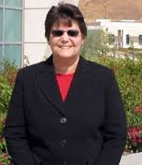
The Women’s’ Leadership Collaborative of the Jack Brown College, featured Professor Kathie Pelletier, at its November 12, 2021 meeting. In a passionate speech about Navigating The Labyrinth of workplace journeys for women that are often toxic in nature. Her skilled allocution resonated with her audience of women faculty of the College. she addressed the toxic issues that women face in the workplace.
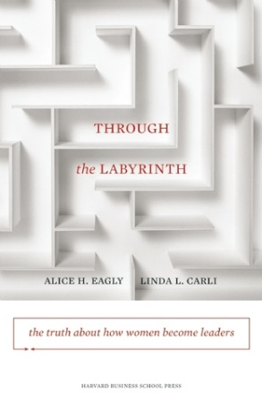
Dr. Pelletier explained that the glass ceiling is no longer a useful metaphor and she suggested that Alice Eagly and Linda Carli’s model of the labyrinth is a better, more useful metaphor. It is symbolic of what has confronted working women all over the world from ancient to modern times.
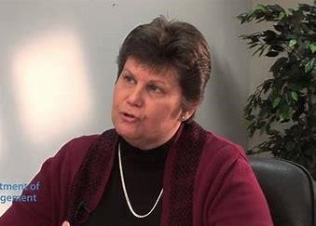
Professor Pelletier clarified that for women in the 21st century it conveys the idea of a multifaceted trek toward a goal worth striving for. Passage through a labyrinth is not simple or direct, but if women increase awareness and understanding of the pitfalls in the contours of the mazes they can reframe how they react to difficult situations. Dr. Pelletier explained that she wanted to:
- Identify and discuss the myriad challenges that await us in the labyrinth.
- To dispel the myths (glass ceiling, and imposter syndrome) by presenting research evidence attesting to women’s capabilities as leaders.
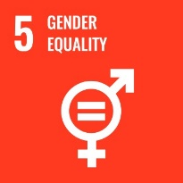
She also said: “By the end of this event, hopefully we will not only reframe how we think about women, we will be able to motivate our less supportive colleagues to view women as the assets we are, rather than viewing us as “lacking” in some way.

Professor Pelletier’s work supports the United Nations SDG #5, gender equality

Professor Kimberly Collins Advocates Improving

Mobility through Big Data
Kimberly Collins, Ph.D. is the Executive Director of the William and Barbara Leonard Transportation Center (LTC) at California State University, San Bernardino. The LTC is a regional transportation center focused on improving innovation in transportation administration and policy through data driven decision making. In addition to her role at the LTC, she is a Professor of Public Administration at CSUSB.

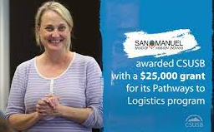
Dr. Collins says that the most pressing problem in today's transportation industry is a lack of time. Transportation companies need strategies to better manage logistics and supply chain operations. An increasing number of enterprises are embracing the possibilities that big data offers. As more industries become familiar with big data, public transportation agencies are realizing the benefits of data-driven decision making. Operational performance and flexibility has increased, fuel consumption has decreased, and by providing better service has improved customer loyalty.
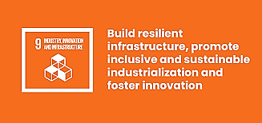
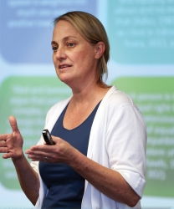
The Leonard Transportation under the leadership of Professor Collins, has recently been looking specifically at the role big data plays, when it comes to solving transit issues in the Inland Empire. She asks: “How can transit agencies utilize big data to reduce the amount of time it takes to travel, making the time it takes to get from point A to B predictable?” How can big data be used improve and optimize transit operations systems? What role does transit play and how can our agencies leverage data to help them do their part?
The work of Dr. Collins promotes PRME values and relates to the United Nations Sustainable Development Goal #9—Sustainable Infrastructure. …..

The JHBC Women’s Leadership Collaborative:
Promoting the Empowerment of Women at JHBC:

This association for the Jack H. Brown College of Business and Public Administration is a platform created by Professor Victoria Seitz Chair of the Department of Marketing and Interim Chair of the Department of Public Administration. Several years ago, Dr Seitz realized that the women faculty of the Jack Brown College needed a forum in which they could discuss common challenges in a safe and meaningful way. From this idea has grown lectures, seminars, and inspirational events from the creative mind of Dr. Victoria Seitz.

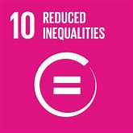
Dr. Seitz’ forum links with the United Nations’ Sustainable Development Goal #10, which JHBC promotes through its PRME initiative, and also with Goal #5, shown in Professor Beer’s ShEconomy detailed earlier in this document.

Goal #10 is about reduction of world inequalities by 2020, and four of its targets have resonated in the JHBC Women’s’ Leadership Collaborative and they have been pursued in the JHBC Seminars from various disciplinary perspectives. They are:
- TARGET 10.1 REDUCE INCOME INEQUALITIES.
- TARGET 10.2 PROMOTE UNIVERSAL SOCIAL, ECONOMIC AND POLITICAL INCLUSION
- TARGET 10.3 ENSURE EQUAL OPPORTUNITIES AND END DISCRIMINATION
- TARGET 10.4 ADOPT FISCAL AND SOCIAL POLICIES THAT PROMOTE EQUALITY.

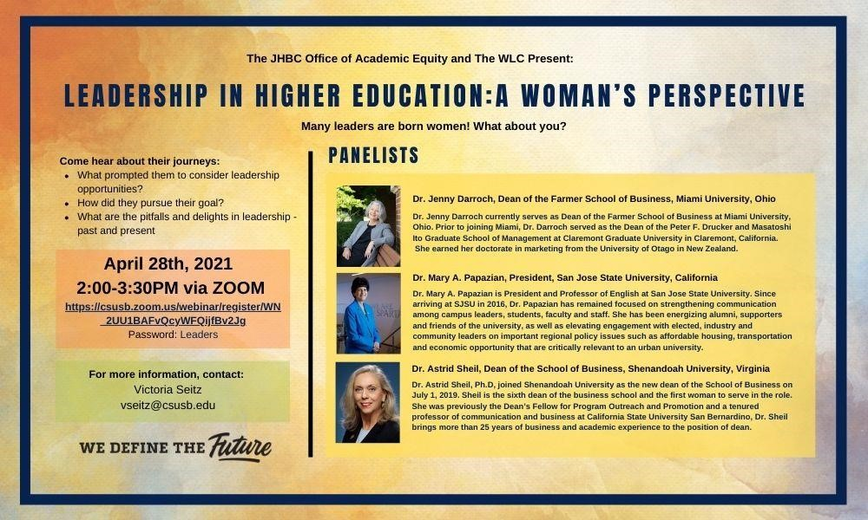
‘let’s
Inve Service

This was an event designed by JHBC’s
Office of Diversity & Equity and
Women’s Leadership Collaborative under
the leadership of
Professors Seitz (above left) and Beer (above right)
…………

WOMEN ON CORPORATE BOARDS:

Why Diversity Matters

“This is an opportunity for Women!” Professor Anna Phillips, Jack H. Brown College

On September 30, 2020, Governor Gavin Newsom signed into law Senate Bill (SB) 979, which was another sharp policy instrument that obligates publicly-held corporations in California to achieve diversity on their boards of directors by January 2023. This policy followed an earlier law, SB 826 which required that California corporations to have at least one director by the close of 2022. She spoke at a Webinar in November, 2020 to a packed audience.

This law requires that every
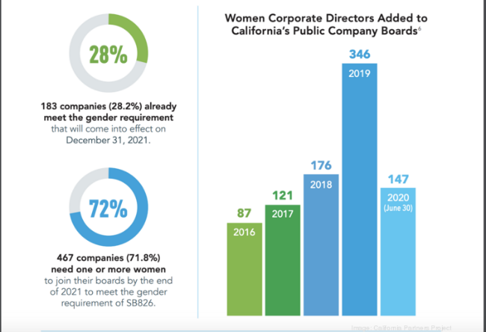
Public company with securities listed on a major U.S. stock exchange and that has its principal executive office in California, as listed on its form 10-K (“covered corporations”), to have at least one director from an underrepresented community on its board of directors by the end of the 2021 calendar year and upwards of three directors from an underrepresented community on its board of directors by the end of the 2022 calendar year.

Under the new law, the California secretary of state may impose a $100,000 fine “[f]or failure to timely file board member information” for the first violation and $300,000 for each subsequent violation.

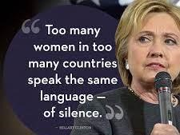
This Webinar was sponsored by the
Office of Academic Equity of The Jack H. Brown College of Business and Public Administration.
The CSUSB-JHBC OMBUDS ALLIANCE:

Professor Twillea Evans-Carthen, is a faculty member in the Jack H. Brown College, also serves as the CSUSB organizational Ombuds (also known as ombudsman.) She serves as a designated neutral party for students, staff, faculty, and community within the campuses of CSUSB and Palm Desert. As the organizational ombuds, she listens impartially to problems, develops options for actions, and provides confidential, informal, independent and impartial assistance through problem-solving methods that may include informal mediation, conflict coaching, facilitation, shuttle diplomacy, and/or identifies systemic problems. Professor Evans-Carthen does not advocate for any individual, issue or interest, nor does she represent any side in a dispute. Evans-Carthen is bound by ethical principles and as a Professor of Business, she also respects our PRME values.
Professor Evans-Carthen has illustrated that conflict is unavoidable in a university institution. However, if the situation is left untreated, the consequences can be debilitating to an institution. Thus, the role of the University Ombuds is vital in ensuring organizational harmony.
Twillea Evans-Carthen has further explained that the Ombudsman designation

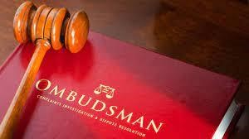
was first employed in the 1800s in Sweden, and since then has grown to be an essential feature of any complex organization across the globe. Based upon its Scandinavian roots, the word ombudsman is gender-neutral in origin, as the ‘man’ suffix, itself, is gender neutral. The International Ombudsman Association, for example, has stated that: The word “Ombudsman” is Scandinavian and means “representative” or “proxy.” The term is used by the International Ombudsman Association (IOA) to communicate to the widest possible community.

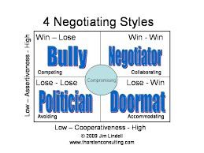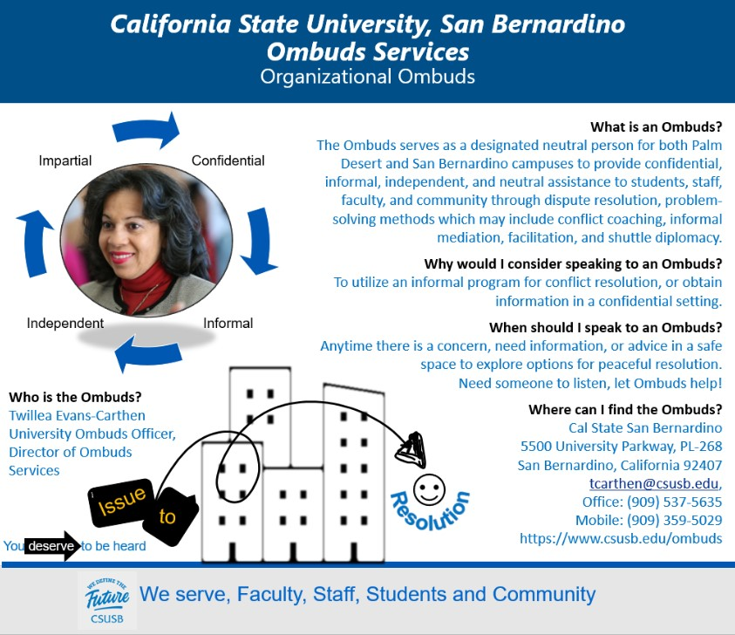

ETHICS, STRATEGIC MANAGEMENT & LEADERSHIP:

ETHICS, STRATEGIC MANAGEMENT & NCIS TRANSFORMATION

Following on the heels of the recent national discourse on policing and law enforcement, Professor Thomas G. McWeeney brought this timely topic to the CSUSB campus. His high level public administration contacts, faculty and students heard Speakers discuss Strategic Management and Law Enforcement Reform. He noted that in light of recent public calls for transformation of police departments, their role and relationship to local communities requires a change in culture, accountability, and leadership.

Conference Topics:
- Strategic Planning—Results Matter in order to achieve strategic planning success.
- Relevance to Contemporary Law Enforcement Reform—Challenges faced by Law Enforcement Require Commitment to Progressive Planning.
- The NCIS Transformation—How Leadership in the Aftermath of a Tragedy Drove Full Agency Engagement and High Risk Initiatives

Dr. Thomas McWeeney is a political scientist, strategic planner, management consultant, and professor of government and public administration. Dr. McWeeney has served as the principal consultant to key executives in several federal law enforcement agencies. In these efforts, he has worked on behalf of agency senior executives and has led comprehensive projects that provided innovative thinking, new direction, and organizational transformation to high profile agencies facing challenges from a changing external environment and diminishing internal capacity.

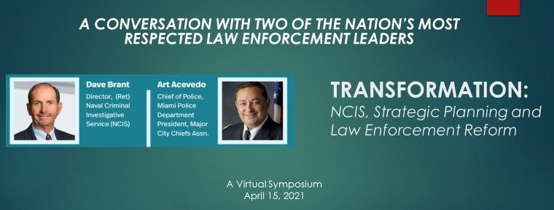

The Global Management Center’s Virtual Business Matchmaking & Education Series
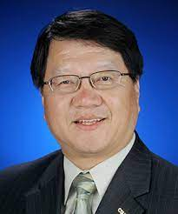

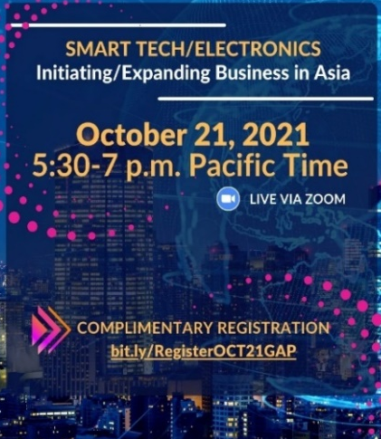
Professors Frank Lin and Vipin Gupta and Manager, Jamie Ayala (above) are the Executive Team, of the JHBCs Center for Global Management have been working with business leaders, government officials and others to offer business resources, support student talent and a broad spectrum of high-quality activities to participate in international programs to succeed in a global business environment.
The Center’s Virtual Business Matchmaking & Education series of monthly Zoom sessions focused on specific sectors and opportunities in Asian markets starting October 2021.Their goal is for participants interested in initiating or expanding their business to get connected with key resources with valuable preliminary research for their business ventures/information, business partners/sponsors and potential student intern guidance.
The Center’s Global Ambassador program provides CSUSB students opportunities to spark global engagement, raise cultural awareness, develop meaningful relationships with peers and enhance global leadership skills. The program encourages students with international interests to volunteer their talents, creativity and time to increase JHBC collaboration, connectivity and leadership.
The Global Management Center’s
offerings emphasize studies on
the whole planet;
they capture the entire gamut of the
UNPRME and UNSDG values,
SDG Goals 1-17

In the Investment Area—
JHBCs Accounting and Finance Department Faculty Empower Women

The Jack H. Brown College of Business and Public Administration knows that diversity in the financial sector continues to be a global need—especially the area of empowerment of women in terms of education in financial tools. This is also the aspiration of Finance and Accounting Department Chair, Dr.Taewon Yang (left).
A Fortune Magazine report in November 2021, noted that: “While their 401(k) contributions dwindled in some cases, women entered the equity markets at sky-high rates. Nearly 67% of women are investing outside of retirement accounts now, according to Fidelity’s 2021 Women and Investing Study—that’s up from 44% in 2018. Half of the 1,200 women surveyed said they’re more interested in the markets now than they were at the beginning of the pandemic. And those trends are playing out within Fidelity’s own customer base: There was a 43% increase in accounts opened by women in the three months ending in Sept. of this year compared to the same period in 2020, according to company data (Jessica Matthews)
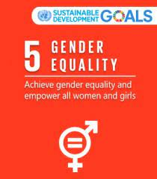
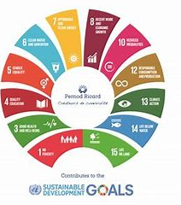
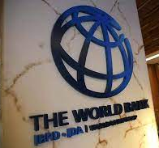
The Global Findex—database is the world's most comprehensive data set on how adults save, borrow, make payments, and manage risk. payments, and manage risk. reveals remarkable global progress in the world’s ability to reduce the unbanked communities—such as minority and female populations. Yet the data also reveals a glaring gap: women lag behind men when it comes to financial access. The World Bank has noted that globally, this gender gap is seven percentage points, while in developing countries, it is nine percentage points. This gap between men’s and women’s financial access is even more visible in some regions – for example, South Asia has an 18% gap in ownership of accounts and the Middle East has a 10% gap. The gap exists also for access to formal savings or credit. Without access to finance, women face difficulties in collecting and saving income, growing their businesses, and pulling their families out of poverty. As a result, women remain largely excluded from the formal economy. By bringing these issues before our students, the Accounting and Finance Departments of JHBC stay true to the JHBC promise to PRME and UNs Sustainable Development Goal #5.
…….
IMPACT INVESTING

Professor Ghulam Sarwar, is Professor of Finance in the JHBC who incorporates PRME and UN SDG values into Investment Education, also known as impact investing.

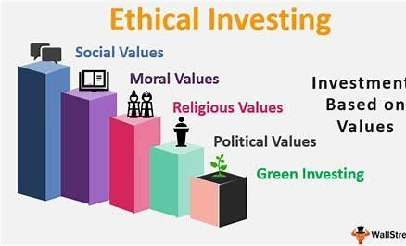
Dr. Sarwar elucidates that another term for this type of investment is called “environmental, social, and governance (ESG).” ESG criteria are a set of yardsticks for a company’s operations that socially conscious investors use. Environmental criteria analyze how a company performs as a trustee of the natural environment. Social criteria considers how it handles affiliations with employees, suppliers, customers, and the communities where it operates. Governance is about how a corporation manages factors such as leadership, executive pay, audits, internal controls, and shareholder rights.
Companies have embraced corporate social responsibility (CSR) in the last decade, giving investors a wide range of options to choose from. They commit investment capital to companies around the globe. Their investments may include money aimed at supporting sustainable agriculture, renewable energy, or microfinance. Impact investors also favor companies in emerging market economies that provide fundamental services, such as housing and healthcare. ESG appeals directly to the millennial generation who have become active investors because this demographic tends to have higher levels of interest in pursuing positive social and environmental change
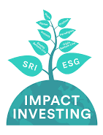
Dr. Sarwar explains that: “The first step in a disciplined investment process is to construct an investment policy statement that specifies not only risk and return goals but also investment constraints and preferences…I emphasize in my investment classes how students can include environmental, societal, and governance (ESG) attributes in a policy statement and evaluate companies on ESG criteria to meet their investment preferences. This use of ESG attributes is consistent with applying PRME PRINCIPLES in education.”
Econreview.berkeley.edu
Dr. Sarwar stated that the latest research indicates that ESG-focused stock funds outperformed the broader stock market during a market downturn caused by Covid-19 pandemic.

……….

Our JHBC Students at Work
& Are Making a Difference in the World

STUDENTS-AT-WORK:

MBA student Aaron Brill spotlighted
The recent U.N. COP-26
Conference in November 2021, in Glasgow, Scotland. Aaron Brill clarified that COP26 was the global event where nations revisited climate pledges made under the 2015 Paris Agreement. Ahead of it, 200 countries were asked for their plans to cut emissions by 2030. The goal is to keep cutting emissions until they reach net zero by mid-century.
Earlier this year, a report from the
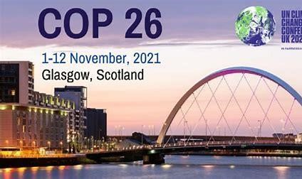
UN-backed Inter-governmental
SPC.IN
Panel on Climate Change indicated that global temperatures have already risen by 1.1 degree Celsius on pre-industrial levels.
Shutterstock.com
COP 26, President Alok Sharma stated that “We have kept 1.5 degrees alive. But, its pulse is weak and it will only survive if we keep our promises and translate commitments into rapid action.” This statement shows the disappointment the conference attendees felt as the event that was dubbed the “most important COP since Paris” just couldn’t fully deliver on its ambition.
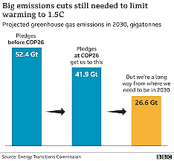
Some countries are already feeling the impact of rising global temperatures and several developing countries, some of which are already facing rising sea levels eating into their territories and extreme weather events devastating lives and livelihoods, branded a rise of 2 degrees Celsius in global temperatures as a “death sentence.” Developing countries and civil society campaigners were disappointed with the failure to create a robust mechanism to disburse financial aid towards loss and damage in the face of climate change.
Aaron Brill explained that COP26 was neither success nor failure—absolute concepts that don’t reflect the complexities of high-level international negotiations—but a mixed bag of progress on some issues, disappointment on others, and a whole lot of pledges. ……..

In Spring 2021, MGMT 6850, MBA student,
Martin Saiz’, paper highlighted the California-based premium shoe manufacturer ,and retailer, Allbirds, Allbirds’ CSR strategy is a simple three-step process that was created to eliminate its carbon footprint, starting by measuring the total carbon dioxide emissions emitted during their manufacturing process and publicly reporting the data for transparency and accountability.
Allbirds made it their mission to go against the grain and improve the industry's corporation’s Corporate Social Responsibility (CSR) strategy when sustainable resources, such as merino wool and eucalyptus tree fibers, weren’t being utilized in the footwear industry, since lower-cost synthetic alternative materials are more advantageous. Their first and most valuable resource is merino wool and they have since added several other sustainable materials to create what they market as “the most comfortable shoes in the world.”
Enmeropress.com
Tim Brown, Zealand professional soccer player, and his business partner Joey Zwillinger, a biotech engineer and renewables materials expert were motivated to enter a relatively new shoe-making market that creates environmentally friendly products for their customers and began designing and producing footwear, using all-natural sustainable materials.
Packhacker.com

Rollingstone.com
Martin Saiz reported that “current performance data has proven that the company is making an impact with 4.9 fewer kilograms of carbon dioxide emitted (CO2e) per sneaker than the average manufacturer, which is the equivalent of driving 12 miles in a small gasoline vehicle.”
Austockphoto.com.au
Fastcompany.com
……….

Kirstyn Hansen, MBA student (and also our stellar professional in the JHBC MBA office) looked at corporate social responsibility from the lens of COSTCO, Inc. Her work links with PRME, AACSB and un SDGs.

COSTCO’S strategy to uphold diversity, shows up in its supply chain management. The corporation makes to use minority and women-owned business in their supply chain choices. It also prefers to source from local communities as the primary choice.
COSTCO ‘s success is in part due to its fair treatment of its employees. For instance, the firm pays around 40% more than rivals, and provides more comprehensive health and retirement benefits than competitors, such Walmart and Target. This keeps the workforce stable and saves COSTCO large amounts in employee turnover costs. The company resists layoffs, invests in training its employees, and grants them substantial autonomy to solve problems. U.S. Secretary of Labor Thomas Perez stated, “And the remarkable loyalty that [employees] have to [Costco cofounder Jim Sinegal] is a function of the fact that he categorically rejects the notion that, ‘I either take care of my shareholders or my workers .’ That is a false choice.” This last statement is MGMT 6850’s underlying emphasis in all strategy analyses—i.e., being conscious capitalists.
…..

MBA student Jamie Ayala, adds insights and Best Practices in the area of sustainability at the Global Management Center. As a former newspaper journalist, Jamie was already well versed in ethics and social responsibility, and their impact on her work, reputation, and the government organizations that she covered. But she notes that her MBA courses have allowed her to broaden her outlook and broach related matters with a new lens.

Jamie says, she “learned business theories and practical applications that better equip me as a manager to make more responsible decisions, especially in areas of sustainability—finance, management, and marketing. I learned how to consider environmentally-friendly supplies and techniques, diversity and safety among the workforce, as well as healthy relationships within a supply chain. I have applied lessons to company analyses and recommendations. For instance, in my cumulative project, our company was looking for a way to differentiate itself from the competition on the market research world. One of our solutions was to become thought leaders in sustainability by connecting with clients that needed research in this niche area, especially as companies grapple with maintaining their target audiences. Meanwhile, I have a greater awareness and conviction to be an advocate of and incorporate social responsibility in both my professional and personal life.”

As the coordinator of a small university center that organizes study abroad trips on such issues as Environmental Sustainability, Jamie led an initiative to take the entire application process online, which helped reduce paper waste and increase two issues: staff efficiency and time management. She initiated the process of recycling them into notepads. Outside of work, she has come to support businesses that have significant corporate social responsibility initiatives such as Warby Parker eye wear, which is currently using the majority of its proceeds to distribute personal protective equipment and preventative health supplies to healthcare workers and communities in need during the current health crisis. Jamie adds: “I truly appreciate the education, support and guidance of the Jack H. Brown College professors.” …………

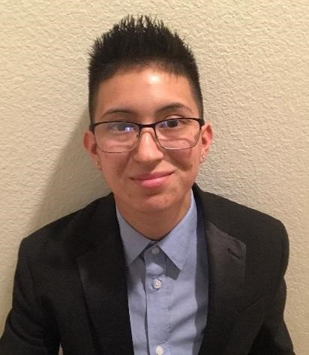
MBA Senior Alyssa Flores wrote her final paper for Management 685 on the European Union's Global Data Protection Regulation (GDPR). The policy was created to give users more control over how their data are collected, used, and protected online. and it protects every EU citizen. GDPR gives any user the right to request data that was collected on them. The users then have “the right to be forgotten” which means the right to have their data deleted if they withdraw consent.

Alyssa’s paper analyzed the effectiveness of GDPR on Facebook, as well as the complications with implementation and accountability of such a powerful company. The paper also explores a way to better implement GDPR in firms
to achieve desired outcomes, rather than simply being an obstacle .

Alyssa stated that: “GDPR has a great effect on a business--even upon one that seems untouchable--like Facebook. Facebook has recently been in the news when over 50 million users’ personal data were made accessible to Cambridge Analytica. This is a research firm with a system that could target US voters with political advertisements without their permission.” This violation under the new regulation would be more easily prosecutable, but as it stands, the saga of Facebook is still ongoing, and Facebook although having full knowledge about the breach has only to date received warnings on its data security policies.

MBA student Monika Lebrecht wrote her final paper for MGMT 685 on the nearly non-existent corporate social responsibility initiatives of Amazon, Inc. Noting Amazon’s destructive nature in terms of the economic viability of both small businesses and Amazon’s own employees, the analysis centered on the emerging field of humane entrepreneurship.
Humane entrepreneurship (HumEnt) is a new model of entrepreneurship in which the attention that firms have traditionally paid to business is integrated with care for the following: firm members, the planet, and society at large. Lack of humane practices in its warehouses, show that Amazon’s practices, have all focused on wealth creation, that propagates inequitable outcomes, such as employee exploitation.

…..

Patrick Bangui, MBA Student in the Spring quarter of 2020, researched the Dodd-Frank Act Section 1502 (“conflict minerals” provision) and its impacts on U.S. companies in the technology industry. This provision requires U.S. publicly traded corporations to disclose use of minerals that originated in the Democratic Republic of the Congo (DRC) or an adjoining country. This public policy constitutes U.S. efforts to discourage funding of armed groups through illegal trades of minerals from conflicts zones in Congo and increase transparency in the international supply chain process.
Although relatively successful with its objectives, this provision demonstrates how the U.S. Congress created regulatory constraints that compelled multinational corporations to revise their global supply chain strategy, adapt their behaviors with a due diligence requirement on minerals sourcing, and be socially responsible in host countries. Sourcing countries for minerals in the DRC, is risky. The DRC has been for decades, one of the most unstable countries with highest corruption, endless conflicts, massacres, and countless human right violations. There have been concerns that the exploitation and trade of minerals from the DRC were used to finance conflict by armed groups. Patrick asked: “How can multinational companies ensure proper supply from such environments?”
From the analysis of the data collected, Patrick noted that Dodd-Frank Act Section 1502 provision did not completely put a stop to the funding of armed groups, and the provision has not resolved human right s violations in D.R. Congo. In addition, multinationals are still being supplied from the Congo, conflict-minerals through neighbor countries who have taken advantage of Section 1502 to launder and certify mineral resources from the illicit and illegal trade in D.R. Congo.
……..

JHBC SERVICE CLUBS PROVIDE OPPORTUNITIES FOR STUDENTS TO BECOME
“RESPONSIBLE MANAGEMENT PROFESSIONALS”

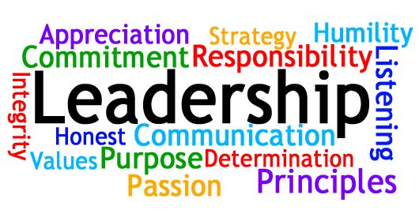
The Jack H. Brown College and the California State University, San Bernardino (CSUSB) considers student organization activities and programs an integral part of the College’s and University’s mission. The programs and activities conducted by student organizations contribute significantly to a student’s total educational development and progress. Student activities provide experiences which stimulate interest and understanding of current social, economic, political, and cultural issues. Student organizations provide a leadership laboratory for students to gain and apply real-world experience in order to succeed in their chosen professions in the future. (CSUSB Student Club & Organization Handbook 2016-2017).

Accounting Association

Membership: Open to all Accounting students.
Advisors:
Xiang (Samantha) Liu
xliu@csusb.edu
909 537 5775
Hang.pei@csusb.edu
909.537.4329, Jack Brown 234
To advance efficient and responsible
management in the Accounting Profession.

Master in Accounting and Finance Association

Membership: Open to all MBA and MSA students.
Advisors: Dr. Dong Man Kim, Jose Navarrete Cruz, and Alfonso Anaya
Email: dkim@csusb.edu, Jose.NavarreteCruz@csusb.edu Alfonso.Anaya@csusb.edu
(909) 537-5783

American Marketing Association
Membership: Open to all Business Administration students.
Advisor: Dr. Wendy Paik Email: Sung-Hee.Paik@csusb.edu
Jack Brown Hall, Room 419 (909) 537-5716
To advance efficient and responsible management in the Marketing Profession

American Production & Inventory Control Society (APICS)
Membership:
Open to all Business Administration students. Advisors:
Dr. Jay Varzandeh and Dr. Kamy Farahbod
Email: jvarzand@csusb.edu, kfarah@csusb.edu
Jack Brown Hall
(909) 537-5730
To provide preeminent cocurricular opportunities for professional development and supplemental education in the current global business environment to the students of California State University, San Bernardino by operating on a platform of service, excellence, and ethics.

Beta Alpha Psi - National Scholastic Fraternity for Financial Information Professionals
Membership: Open to all accounting, finance, and information management students.
Advisors: Xiang (Samantha) Liu
xliu@csusb.edu
Email
xliu@csusb.edu
909-537-5775
Jack Brown 221
Hang Pei
Hang.pei@csusb.edu
909-537-4329
Jack Brown 234
Ebenezer Lamptey
Ebenezer.lamptey@csusb.edu
909.537.5795
Jack Brown 436

Beta Alpha Psi encourages and recognizes scholastic and professional excellence in the business information field, promotes the study and practice of accounting, finance and information systems, opportunities for self-development, service and association among members and practicing professionals. It "strives to encourage a sense of ethical, social, and public responsibility". The organization also promotes the development of technical and professional skills that are used to complement the university education, philanthropic activities, and interaction between students, faculty and professionals.

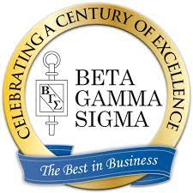
Beta Gamma Sigma

Scholastic Honor Society Recognized by AACSB
Membership: Open to the top 5% of undergraduate class, top 10% of graduate class.
Advisor: Dr. Haakon Brown
Email:
HBrown@csusb.edu
Jack Brown Hall, Room 458
(909) 537-5749
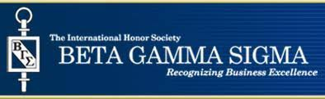
International Honor
Society Beta Gamma
Sigma
The Mission of the International Honor Society Beta Gamma Sigma is to encourage and honor academic achievement in the study of business, to foster personal and professional excellence, to advance the values of the Society, and to serve its lifelong members.
The Mission is supported by the five Objectives of the Society. These include:
Encourage and honor high academic achievement by students of business and management through chapters in business programs accredited by AACSB International.
Foster in Beta Gamma Sigma members an enduring commitment to the founding principles and values of the Society: honor and integrity, pursuit of wisdom, and earnestness.
Support the advancement of business thought and practice to encourage lifelong learning.
Enhance the value of Beta Gamma Sigma for students and alumni members in their professional lives.
Advance the visibility and reputation of Beta Gamma Sigma.

Financial Management Association

Professor Kristen Stutz
kstutz@csusb.edu
909-537-73925
UH 355

Professor Liang Guo
lguo@csusb.edu
909-537-3257
JB 225

Professor Austin Shelton,
austin.shelton@csusb.edu
909-537-7479
JB 556

Professor Gilna Samuel
gilna.samuel@csusb.edu
909-537-75738
Office Location
Jack Brown Hall 431

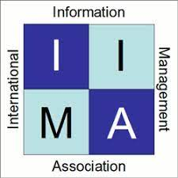
Information Management Association
Membership: Open to all CSUSB students.
Advisor: Dr. Tony Coulson
Email: coulson@csusb.edu
Jack Brown Hall, Room 516 (909) 537-5768
To advance knowledge and responsible professionalism in the Information Management Profession

Information Security Club

Membership: Open to all CSUSB students.
Advisors:
Dr. Tony Coulson
Professor Vincent Nestler
Emails:
coulson@csusb.edu, vnestler@csusb.edu
Jack Brown Hall, Room 516
(909) 537-5768
To advance knowledge and responsible professionalism in the Informational Security Profession.

Latino Business Student Association
Membership: Open to all Business Administration students.
Advisor: to be assigned
To engage the community and promote values
Master in Accounting and
Finance Association
Membership: Open to all MBA and MSA students.
Advisors:
Dr. Dong Man Kim and
Dr. John Jin
Email: dkim@csusb.edu, jjin@csusb.edu
Jack Brown Hall, Room 545,407
(909) 537-5783
(909) 537-5721

Public Administration Organization
Membership: Open to all CSUSB students.
Advisor: to be assigned

Society for Human Resource Management
Membership: Open to all CSUSB students. Advisor:
Prof. Patrick Flaherty
Email: Pflaherty@csusb.edu
Jack Brown Hall, Room 563
(909) 537-3751
To provide California State University San Bernardino students with the opportunity to gain knowledge and insight into the effective management of human capital in the field of Human Resource Management through affiliation with the Inland Empire of SHRM and the National SHRM organization.
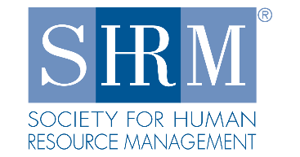
Students in International Business
Membership: Open to all CSUSB students.
Advisors: Dr. Vipin Gupta and Dr. Frank Lin
Email: vgupta@csusb.edu or flin@csusb.edu
Jack Brown Hall, Room
404 and 278 (909) 537-5718
The International Business Club will be a resource for students to gain a better understanding of International Business through various academia, social, and cultural events. In International Business Club students will have opportunities to network with like-minded students, faculty, entrepreneurs and other various professionals. Our club will involve itself in the local and international communities through our volunteer efforts. We also want to offer students the chance acquire
internships in international businesses to give them valuable experience. ……….

CODY COYOTE, CSUSB CAMPUS MASCOT

The Student Success Center:
JHBC Undergraduate Division

Associate Dean, Professor Anna Ni (left) leads The Jack H. Brown College of Business and Public Administration Success Center. This pivotal JHBC unit offers a major in administration designed to prepare students for careers in business, government service, institutions and related fields. Within the mission of the university, the Jack H. Brown College of Business and Public Administration has three central objectives:

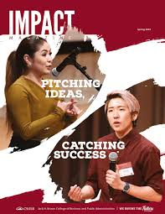
- Provides high quality business and public administration programs which will prepare our students for successful careers in business and government.
- Participates in scholarly activities which will assist in keeping our students, faculty, and our constituent businesses and governments abreast of current developments in their respective disciplines.
- Provides professional service to our university, community and professional organizations.
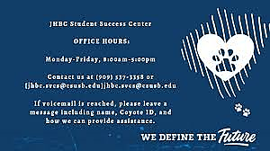
The curriculum, with its core requirements and areas of specialization, provides the student with a broad-based behavioral and quantitative understanding of the concepts of management with the express purpose of graduating responsible management professionals. The managerial function and decision-making processes are studied with coverage in methods of analysis of quantitative information; judgment and appraisal of social, economic and human relations issues; and effective communication.

The College offers two degrees, a Bachelor of Arts, Administration, and a Bachelor of Science in Information Systems and Technology. Students majoring in the Bachelor of Arts, Administration degree will select and complete courses within a designated concentration, in addition to lower and upper-division core courses. Students are encouraged to identify a concentration by the beginning of junior year. ….

The MBA Graduate Program of JHBC

The flagship unit of the Graduate Program of the Jack H. Brown College of Business and Public Administration is the acclaimed, award-winning MBA degree program superbly led by Professor Ernest Silvers (Left).

The entire Graduate Program is committed to nurturing a high quality graduate educational environment that ensures student, faculty, and staff success in their pursuit of academic excellence and achievement. We seek to transform the lives of our students and alumni, ensuring that they become responsible management professionals within a dynamic region and a globally connected world.

Welcome to the Silvers Connection, a video podcast hosted by CSUSB MBA Director Ernie Silvers!
The events of the past year have changed life as we know it, and navigating through this new landscape can be challenging.
Fear not!
The Silvers Connection is here with expert advice from industry leading professionals on the power of resilience, self-care, courage, and much more! Tune in every other Thursday for new episodes and valuable insights to help harness the power of YOU!
……..

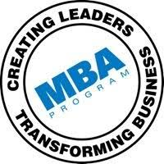

The JHBC Speaking Center…
….helps refine Undergraduate and Graduate student public speaking skills

Professors Maggie Boyraz, Matthew Habich, and Ying Cheng (above), affirm that communication competence is crucial to the individual success in the workplace and to the meaningful intra- and inter-organizational dialogues, and thus the JHBC’s Speaking Center has the goal of preparing students to excel in public speaking moments both inside the classroom and beyond. Importantly, the Speaking Center’s philosophy is that communication skills can be enhanced over time, which is why JHBC has this vital resource on campus. The three professors from the Department of Management lead the strategic effort to create this center in collaboration with a Professor from the Communication Department based in the College of Letters and Arts. They, and a team of trained graduate teaching assistants have had a multitude of public speaking experience. They are dedicated to student success, and to graduating responsible management professionals in consonance with our commitment to PRME values.
They have stated that: “As a client works one-on-one with a communication consultant who can give you feedback on your oral communication skills in terms of content and delivery. The consultants can help both in rehearsing almost ready presentations and in the beginning stages of assignments or public speaking moments. They can also help in rehearsing interview questions and developing elevator pitches in order for students to create stronger impressions when entering job markets and their respective local communities. The Center’s offerings include: help with speech organization, topic ideas, the structure of a speech, refining quality research to support arguments and content. As experts, we are also able to help with overcoming speaking anxiety and provide strategies to learn to cope and manage speech apprehension.”
Professors Maggie Boyraz, Matthew Habich, and Ying Cheng (above), affirm that communication competence is crucial to the individual success in the workplace and to the meaningful intra- and inter-organizational dialogues, and thus the JHBC’s Speaking Center has the goal of preparing students to excel in public speaking moments both inside the classroom and beyond. Importantly, the Speaking Center’s philosophy is that communication skills can be enhanced over time, which is why JHBC has this vital resource on campus. The three professors from the Department of Management lead the strategic effort to create this center in collaboration with a Professor from the Communication Department based in the College of Arts Letters. They, and a team of trained graduate teaching assistants have a multitude of public speaking experience. They are dedicated to student success, and to graduating responsible management professionals in consonance with our commitment to PRME values.
The Speaking Center has the capability to record student speeches to provide real-time constructive feedback in order to hone the invaluable soft skills related to communication and self-presentation. …...
THE JHBC PROFESSIONAL WRITING OFFICE
“Writing is thinking. To write well is to think clearly. That's why it's so hard.” David McCullough
The JHBC Professional Writing Office is led by Professor Melissa Bakeman (left). She leads an elite team of writing tutors who have helped scores of JHBC students to write clearly, thoughtfully, superbly. Melissa Bakeman’s efforts in constant refining, and innovations have provided grateful students with excellent tutoring experiences. She seeks to meet the mission of the primary mission to help a learner to address the various challenges that they may encounter, with the realization that no writing is decontextualized—it’s always focused upon an explicit audience. The JHBC Writing Center offers customized one-on-one scheduled coaching appointments, group coaching, and writing workshops. The facility accommodates drop-in learners. The Center is open to both graduate and undergraduate students.
Tutoring is provided to students across the disciplines in all stages of the writing process, but focus primarily in writing associated with business. The overall purpose is to create responsible management professionals in line with the collaboration JHBC has with the United Nations’ PRME platform. Professor Bakeman hopes shortly to run a San Bernardino Community Resume and Interviewing Workshop with local libraries in an effort to reach out to people who may not have access to higher education. She says: “Learning resume writing and interviewing skills shouldn't be exclusive to those who have the privilege of a 4 year education but to help those who more than likely need the skills we possess to get positions that lead to bigger and better outcomes--and possibly a pathway and financial stability to pursue a college education.”
JHBC’s talented team of tutors are shown below: Left to Right: Alejandra Marquez Lead Tutor, Jacinta Mercado-Knowles, and Serina Item.
“The most important of all talents is that of never using two words when one will do."

Thomas Jefferson

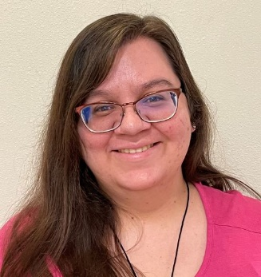

PRINCIPLE #4
Research:
“We will engage in conceptual and empirical research that advances our understanding about the role, dynamics, and impact of corporations in the creation of sustainable social, environmental and economic value.”

At CBPA we recognize that it is important to adhere to ethical principles in research. We know that the academic research must be built on a structure of trust, truth, accountability, and avoidance of error. Those who study our research need to know that the results reported are truthful and without bias. We not only hold these principles to ourselves as faculty members, but inculcate them in our students as they go about making intellectual inquiry. We also know that adhering to strong ethical norms in research build support for our research. We know also that deliberate misleading statements in our research can have far-reaching consequences on individuals, organizations and societies.

The publications listed below cover the period from 2012 to present; and, only relate to publications that contain PRME values.

I. RESEARCH:
Journal Publications:
A

Niloufar Fallah Shayan, Nasrin Mohabbati-Kalejahi, Sepideh Alavi, et.al.,
"Sustainable Development Goals (SDGs) as a framework for Corporate Social Responsibility (CSR)" published in Sustainability 2022, 14, 1222 https://doi.org/10.3390/su14031222

Silard, A., Anderson, J. F. (May 2018). The Influence of Disparate Emotional Labor Performances by Diverse Group Members on Government Legitimacy. Public Administration Quarterly, 42(2), 159-182. https://paq.spaef.org/
Anderson, J. (2014). An Open Letter to “Dirty Hands” Theorists from a Public Manager (or the pitfalls of divorcing theory from practice), Public Integrity.
Anderson, J. (2013). The Gospel According to Merit: From Virtue to Rationality to Production, International Journal of Organizational Theory and Behavior, 16:4.

B

Lee, S., Siebeneck, L. K., Benedict, B. C., Yabe, T., Jarvis, C. M., & Ukkusuri, S. V. (accepted). Patterns of social support and trajectories of household recovery after Superstorm Sandy. Natural Hazards Review.
Benedict, B. C. (2020). Examining the experiences of remaining employees after a coworker dismissal: Initial message characteristics, information seeking, uncertainty, and perceived social costs. Management Communication Quarterly, 34(4), 495- 526.https://doi.org/10.1177/0893318920949327
Hall, J., Benedict, B. C., Taylor, E. P., & McCullock, S. P. (2020). Managing uncertainty in a pandemic: Transitioning multi-section courses to online delivery. Susan Bulkeley Butler Center for Leadership Excellence and ADVANCE Working Paper Series, 3(2), 73-83. https://www.purdue.edu/butler/documents/WPS-Special-Issue-Higher-Education-and-COVID-19---2020-Volume-3-Issue-2.pdf

Johnson, A. M., Baker, D. L. (December 2018). Business Student Internships: A Pathway to Resolving the Perils of Unpaid Placements. Business Education Innovation Journal, 10(2), 41-51.
Baker, D., Ni, A., and Van Wart, M. “AACSB Assurance of Learning: Lessons Learned in Ethics Module Development.” Business Education Innovation Journal 4(1, June, 2012): pp. 19-27.

Beer, F., K.R. Rawls, M.D. Robinson, H.R. Timblin, J.M. Craig (2021)“Are universities ready for change? Improving faculty diversification”
The American Journal of Humanities and Social Sciences Research, 4(3), pp. 340-347, 2021.
Beer, F., Estes, J.P., and H. J. Munte (2012) “The Performance of Faith and Ethical Investment Products: An Empirical Investigation of the Last Decade”
Beer, F. and J. Thompson (2017). “Undergraduate and Graduate Research and Creative Activities: Faculty’s evaluation, time commitment and perceived barriers.” A Practice Report Student Success, Vol. 8, No. 1, 2017, pg. 73-78. doi: 10.5204/ssj. v8i1.329.
Beer, F., Estes, J.P., and C. Deshayes (2014) “The Performance of Faith and Ethical Investment Products: Prior to and following the 2008 Meltdown”, Financial Services Review Journal of Individual Financial Management, Vol. 23, No. 2.
Beer, F. and M. Zouaoui (2013) “Measuring Investor Sentiment in the Stock Market,” Journal of Applied Business Research, Vol. 29, No. 1, January/February 2013
Beer, F., Herve, F., and M. Zouaoui “Is Big Brother Watching US: Google, Investor Sentiment and the Stock Market” (with F. Hervé and M. Zouaoui), Forthcoming in Economics Bulletin. Available at SSRN: http://ssrn.com/abstract=2185979 or http://dx.doi.org/10.2139/ssrn.2185979 EB-13-00050
Beer, F.,Watfa, M and M Zouaoui (2012) “Do investors Care about Noise Trader Risk?” Capco Journal of Financial Transformation, Vol. 35, Sept. 2012, pp. 49-56. Beer, F., Wafta, M., and M Zouaoui, (2012) “Is Sentiment Risk Priced by Stock Market? Journal of Applied Business Research, Vol. 28, No.4, pp1-18.

Boyraz, M. (July (3rd Quarter/Summer) 2019). Faultlines as the “Earth’s Crust”: The Role of Team Identification, Communication Climate, and Subjective Perceptions of Subgroups for Global Team Satisfaction and Innovation. Management Communication Quarterly.

C

Meng, J., Peng, W., Tan, P.-N., Liu, W., Cheng, Y., Bae, A. (December 2018). Diffusion size and structural virality: The effects of message and network features on spreading health information on twitter. Computers in Human Behavior, 89, 111-120. https://www.sciencedirect.com/science/article/pii/S0747563218303613
Cheng, Y., Meng, J., Liu, S. (September 2018). Personal Network Structure and Perceived Social Support in the Context of Intercultural Adjustment. Communication Quarterly, 66(5), 576-594. https://www.tandfonline.com/doi/abs/10.1080/01463373.2018.1515782
Boster, F. J., Liu, R. W., Cheng, Y., Kim, W., Shaikh, S. J. (January (1st Quarter/Winter) 2018). The Suasory Force of Sticky Messages: An Application to the Application of Sunscreen. Communication Studies, 69(1), 4-22. http://dx.doi.org/10.1080/10510974.2017.1414067

Coates, B.E., (2021) The Selfish Nous of Dasein: The Being who Thinks-in-Time, Journal of Consciousness Exploration & Research, November 2021, Volume 12 (4) | pp. 314-333.
Coates, B.E. and T.G. McWeeney (2020) “An Indicator of Syergy between Government and Corporate Goals? The Case of the Benefit Corporation,” SSRG, International Journal of Humanities and Social Science, Vol. 7(3) May-June
Coates, B. (June 2019). Can “Rational” Intuition be a VRIO for Competitive Advantage? A Strategic Management Perspective” American International Journal of Business Management Vol 2(6).
Coates, B.E. (2019) “Chit—the Original Principle: Towards a More Comprehensive Theory of Everything,” Journal of Consciousness, Exploration & Research, 10(2) March 2019
Coates, B.E. and Stull, M. (2016) “Ethics and Entrepreneurship: A Supply Side Examination” Strategic Management Quarterly, Vol. 4 No. 3, September 2016.
Coates, B.E. (2016) “Is There an Enhanced Role for Corporate Leadership to Integrate its CSR Strategies into Supply Chain Management: A Conceptual Inquiry,” Journal of Business Theory and Practice, Vol. 4(1), 2016
Coates, B.E., (2016) “Corporate Social Responsibility in Supply Chain Management: Arm’s Length Interactions to Deeper Buyer-Seller Strategic Unification,” The Journal of Global Business Management, Vol. 11(2), October 2015
Coates, B.E. (2015) “The Increasingly Visible Hand of Government Behind Corporate
Citizenship and Conscious Capitalism, Journal of Business Theory & Practice, Vol. 3, No.1, 2015
Coates, B.E., (2013) “Embedding Leadership-Driven Conscious Capitalism into Corporate DNA” in Advances in Management, Vol 6(4), 14-24.
Coates, B.E., (2012) “More Cheers for Conscious Capitalism: The Growth of Corporate Deontology,” International Journal of Global Management Studies, Vol;. 4:2.
Coates, B.E., & D. Verzi, (2012) Strategic Power Balance between Eastern and Western Countries: The Competitive Extinction Model,” in Journal of Interdisciplinary Mathematics, Vol.15: 6.

Hou, Y., Nestler, V. J., Collins, K. “Iintersection Management, Cybersecurity, and Local Government: ITS Applications, Critical Issues, and Regulatory Schemes”. Journal of Transportation Security.

Livine-Offer, E., J. Coyle-Shapiro, J. L. Pearce, (2019) “Eyes Wide Open: Perceived Exploitation Audits Consequences,” Academy of Management Journal, Vol 62(6).

Coulson, A., Mason, M., Nestler, V. J. (October (4th Quarter/Autumn) 2018). Cyber Capability Planning and the Need for an Expanded Cybersecurity Workforce. Communications of the IIMA, 6 (2https://scholarworks.lib.csusb.edu/cgi/viewcontent.cgi?article=1401&context=ciima).

D

Dorocak, J., Estes, J. (April (2nd Quarter/Spring) 2018). ” The California Rule on Modifying Public Employees’ Protected Pension Rights: Reasonable Pension or Reasonable Modification? “University of La Verne Law Review, 39(2), 270- 303.
Estes, J.P. and J. Dorocak (2012) “State and Local Government Funding of Health and Retirement Benefits for Employees: Current Problems and Possible Solutions With California Health Benefits as an Example”.

E

Newman, E., Estes, J. (October (4th Quarter/Autumn) 2018). “Are Gratuities Becoming a Service Tax.” Journal of International Finance Studies, 18(2), 27-34. IABE.org
Dorocak, J., Estes, J. (April (2nd Quarter/Spring) 2018). “The California Rule on Modifying Public Employees’ Protected Pension Rights: Reasonable Pension or Reasonable Modification?” University of La Verne Law Review, 39(2), 270-303.
Estes, J., Awais, M., Sher, A. (January (1st Quarter/Winter) 2018). “Prevalence and Dimensions of Sexual Harassment of the Female Workforce in Public Sector Organizations of Pakistan. Human Resources Management and Ergonomics, XI(1), 15 - 22.
https://frcatel.fri.uniza.sk/hrme/index.html
Estes, J.P. and J. Dorocak (2012) “State and Local Government Funding of Health and Retirement Benefits for Employees: Current Problems and Possible Solutions With California Health Benefits as an Example”.
Estes, J.P. (2013). “Pensions vs. Health Care: It’s Not All About Pensions”. Review of Business Research.
Estes, J.P., F Beer and H. J. Munte (2012) “The Performance of Faith and Ethical Investment Products: An Empirical Investigation of the Last Decade”
Estes, J.P. and J. Dorocak (2012) “State and Local Government Funding of Health and Retirement Benefits for Employees: Current Problems and Possible Solutions With California Health Benefits as an Example”.

F

Farahbod, K., Varzandeh, J. (October (4th Quarter/Autumn) 2018). Impact of Technology on Global Supply Chain Risk: An Empirical Study. Journal of Business and Behavioral Sciences, 30(2), 89-97.

Seal, C. R., Fan, D., Sanchez, S., Guzman, M. G, Rawls, K. M., & Flaherty,
P. T. (2022, March). Development of an Employee Centric Performance Management System (PMS) to foster a Culture of Resilience: An exploratory case-based research study, from surviving to thriving, Developmental research proposal at Western Academy of Management (WAM) 2022, Hawaii.

G

Wiley, J. A., Liu, Y., Guo, L. (., Gallimore, P. (June 2019). “The Information and Bargaining Roles of Commercial Brokers When Investors are Uninformed,”
Theoretical Economics Letters, 9(5), 1651-1668.
https://www.scirp.org/Journal/paperinformation.aspx?paperid=93302
Guo, L. (2013) “Determinants of Credit Spreads: The role of Ambiguity and Information Uncertainty”, The North American Journal of Economics and Finance, Vol. 24, Pages 279-297.
Guo, L. (2012) “Types of Liquidity and Limits to Arbitrage: The Case of Credit Default Swaps”, Journal of Future Markets, Vol. 32, Issue 4, pp. 301-329.
Guo, L. (2011) “Negative Credit Spreads: Liquidity and Limits to Arbitrage”, Journal of Fixed Income, Vol. 21, No. 1: pp. 32-41.

Gupta, V., Levenburg, N & Mahadevan, S. (2013). Technological Exchange Perspective to Understand the MNCs. International Journal of Business Insights and Transformation. 6(1): 4-15.
Gupta, V. and Kirwan, P. (2013) Role of In-group Collectivism in the Longevity of Family Firms. Global Business Perspectives, 1(4): 433-451.
Gupta, V., Shapiro, M., Maxfield, S. & Hass, S. (2013). Risk-seeking Career strategies and women’s career success. Journal of Contemporary Issues in Business Research, 2(6): 189-204.
Gupta, V. & Saran, A. (2013). “Making of the Trendsetter Generation of Women Leaders in India: Dimensionalizing the Impact of Economic Liberalization” IUP Journal of Business Strategy, 10(2): 1-15.
Gupta, V. & Khilji, S.E. (2013),"Revisiting Fortune at the Base of the Pyramid (BoP)", South Asian Journal of Global Business Research, 2(1): 8-26.
Gupta, V. & Qiu, Renfeng (2013). The Rise of the Indian Multinational Corporations and the Development of Firm-Specific Capabilities. Journal of Business Theory and Practice. 1(1): 45-65.
Gupta. V. (2012). Comparatistics India Overseas: FEMNCs and MNCs. SCMS Journal of Management, 9(4), 22-34.
Gupta, V. (2012). Varieties of Capitalism and the case of the Lebanese Overseas Family Businesses. International Journal of Management Prudence, 4(2): 79-88.
Gupta, V. & Saran, A. (2012). “Seeding of women leadership in India: A life course event analysis of the trailblazers” International Journal of Arts & Sciences, 5(7): 131-145.
Gupta, V., & Iakovleva, T., (2012). Personal Influence and Entrepreneurial Capability: A Study of Women as Contrarian Group in Russia. Arash – A Journal of ISMDR. 2(1): 10-19.
Gupta, V. & Levenburg, N (2012). Cultures, Ideologies, and Family Businesses. Journal of Family Business Management, 2(1): 57-75.
Gupta, V. & Mahadevan, S. (2012). Making, Unmaking and Remaking of the Pennar Group: Engineering excellence through leadership. Vidwat: The Indian Journal of Management, 5(1): 23-33.

H

Yang, F., Huang, X., Wu, L. (March 2019). “Experiencing meaningfulness climate in teams: How spiritual leadership enhances team effectiveness when facing uncertain tasks.” Human Resource Management Journal, 58(2).
Yang, F., Qian, J., Liu, Huang, C. X., Chau, R., Wang, T. `. (October ,4th Quarter/Autumn, 2018). Bridging the Gap: How Supervisors’ Perceptions of Guanxi HRM Practices Influence Subordinates’ Work Engagement. Applied Psychology: An International Review, 67(4), 589- 616. https://onlinelibrary.wiley.com/doi/full/10.1111/apps.12144
Yang, F., Liu, J., Huang, C. X., Qian, J., Wang, T., Wang, Z., Yu, H. (July (3rd
Quarter/Summer) 2018). How supervisory support for career development relates to subordinate work engagement and career outcomes: The moderating role of task proficiency. Human Resource Management Journal.
Feng, C., Huang, X., Zhang, L., “A Multilevel Study of Transformational Leadership, Dual Organizational Change and Innovative Behavior in Groups,” Journal of Organizational Change Management, Vol. 28 (6) pp. 855-877.
Huang, C. X., Feng, C., Zhang, L. The Impact of Human Resource Differentiation on Corporate Strategic and Financial Performance. International Journal of Manpower (0143-7720).
Yang, F., Huang, C. X. Climate into Performance: A Multilevel Model of Voice Climate, Voice Behavior, Collective Regulatory Focus, and Performance. Journal of Business Ethics.

J
Jang, Youngseok., and M. Morris, 92015) “The Ethics of Guerilla Behavior in early Stage Firms,” Advances in the Study of Entrepreneurship, Innovation and Economic Growth, vol. 25, 2015.
Jang, Y., Hadley, B., Son, J., Son, C. (July (3rd Quarter/Summer) 2019). Determinants of Students' Entrepreneurial Intention to Compete in A Fast-Pitch Competition. Journal of Education for business, 94(6), 359- 368. https://www.tandfonline.com/toc/vjeb20/current

Johnson, A. M., Baker, D. L. (December 2018). Business Student Internships: A Pathway to Resolving the Perils of Unpaid Placements. Business Education Innovation Journal, 10(2), 41-51.

K

Kim, T. (October (4th Quarter/Autumn) 2019). “Investigating the Impact of Advertising during economic Shocks on Firm Performance in the Hospitality Industry.” Journal of Hospitality Marketing & Management, 28(8), 1010–1031.
https://www.tandfonline.com/toc/whmm20/current
Paik, D. G., Kim, T., Krumwiede, K., Lee, B. B. (December 2018). The Association Between Audit Fees and Accounting Restatement Resulting from Accounting Fraud and Clerical Errors. Journal of Forensic & Investigative Accounting, 10(3), P.332-P.356. http://s3.amazonaws.com/web.nacva.com/JFIA/Issues/JFIA-2018-No3- 3.pdf

Kordrostami, M., Kordrostami, E. (February 2019). “Secure or fearful, who will be more resentful? Investigating the interaction between regulatory focus and attachment style.” Journal of Product & Brand Management, Vol. 28 No. 5, pp. 671-683. https://doi.org/10.1108/JPBM-03-2018-1830
https://www.emeraldinsight.com/doi/abs/10.1108/JPBM-03-2018-1830
Kordrostami , M. & Russell N. Laczniak (2021) Female power portrayals in advertising, International Journal of Advertising, DOI: 10.1080/02650487.2021.1998878

Gong, F., Kung, D., Zeng, T. (2018). “The impact of different contract structures on IT investment in logistics outsourcing.” International Journal of Production Economics, 195, 158-167.

L

Lamptey, E., Singh, R. (December 2018). Fraud Risk Management over Financial Reporting: A Contingency Theory Perspective. Journal of Leadership, Accountability and Ethics, 15(4).

Wiley, J. A., Liu, Y., Guo, L. (., Gallimore, P. (June 2019). “The Information and Bargaining Roles of Commercial Brokers When Investors are Uninformed,”
Theoretical Economics Letters, 9(5), 1651-1668.
https://www.scirp.org/Journal/paperinformation.aspx?paperid=93302

M

Van Wart, M., Ni, A., Rose, L. C., McWeeney, T. G., Worrell, R. (April (2nd Quarter/Spring) 2019). A Literature Review and Model of Online Teaching Effectiveness Integrating Concerns for Learning Achievement, Student Satisfaction, Faculty Satisfaction, and Institutional Results. Pan-Pacific Journal of Business Research, 10(1), 1-22. http://ppbri.org/journal/publications/year-2019

Niloufar Fallah Shayan, Nasrin Mohabbati-Kalejahi , Sepideh Alavi, et.al. "Sustainable Development Goals (SDGs) as a framework for Corporate Social Responsibility (CSR)" published in Sustainability 2022,
14, 1222 https://doi.org/10.3390/su14031222

Munsif, V., et.al. (2011). “Audit Fees after Remediation of Internal Control Weaknesses,” American Accounting Association, Vol. 23: 1, pp. 87-105

N

Yang, T., Son, J., Yoon, S. W., Navarrete, J. G. (April (2nd Quarter/Spring) 2018). “Accrual Based Earnings Management and Stock Returns in Mergers and Acquisitions in the pre and post Sarbanes-Oxley and Dodd-Frank periods. “Pan-Pacific Journal of Business Research, 9(1), 1-16.

Coulson, A., Mason, M., Nestler, V. J. (October (4th Quarter/Autumn) 2018). (PRJ) Cyber Capability Planning and the Need for an Expanded Cybersecurity Workforce. Communications of the IIMA, 16 (2https://scholarworks.lib.csusb.edu/cgi/viewcontent.cgi?article=1401&context=ciima).
Nance, K., Nestler, V. J., Bishop, M. (December 2019). (PRJ) Use My Digital Forensics Tool…It’s Shiny! Communications of the IIMA, 28(3).

Van Wart, M., Ni, A., Rose, L. C., McWeeney, T. G., Worrell, R. (April (2nd Quarter/Spring) 2019). “A Literature Review and Model of Online Teaching Effectiveness Integrating Concerns for Learning Achievement, Student Satisfaction, Faculty Satisfaction, and Institutional Results.” Pan-Pacific Journal of Business Research, 10(1), 1-22. http://ppbri.org/journal/publications/year- 2019
Ni, A. (April (2nd Quarter/Spring) 2013). “Comparing the Effectiveness of Classroom and Online Learning: Teaching Research Methods. “ Journal Public Affairs Education, 19(2), 199216.
Ni, A., Van Wart, M., Medina, P., Collins, K., Silvers, E., Pei, H. (2020) “A Profile of MPA Students’ Perceptions of Online Learning: What MPA Students Value in Online Education and What They Think Would Improve Online Learning Experience.” Journal of Public Affairs Education, 27(1): 50-71. DOI: 10.1080/15236803.2020.1820288
Baker, D., Ni, A., and Van Wart, M. “AACSB Assurance of Learning: Lessons Learned in Ethics Module Development.” Business Education Innovation Journal 4(1, June, 2012): pp. 19-27.
Ni, A. (December 2012). (B- PRJ) The Risk-Averting Game of Transport Public- Private Partnership. Public Performance and Management Review, 36(2), 253- 274.
Baker, D. L., Ni, A., Van Wart, M. (June 2012). (PRJ) AACSB Assurance of Learning: Lessons Learned in Ethics Module Development. Business Education Innovation Journal, 4(1), 1927.

Newman, E., Estes, J. (October (4th Quarter/Autumn) 2018). Are Gratuities Becoming a Service Tax. Journal of International Finance Studies, 18(2), 27-34. IABE.org

P

Christensen, T. E., Pei, H., Pierce, S. R., Tan, L. (March 2019). Non-GAAP reporting following debt covenant violations. Review of Accounting Studies.
https://link.springer.com/article/10.1007/s11142-019-09492-1
Ji, A. E., Kumar, K. R., Pei, H., Xue, Y. (March 2019). “Does the Market Value Auditors' Industry Specializations? Evidence from the Contagion Effects of Restatements”, Accounting Horizons. https://www.aaajournals.org/doi/abs/10.2308/acch-52350

Pelletier, K. L., Kottke, J. L., & Sirotnik, B. (2019). “The toxic triangle in academia: A case analysis of the emergence and manifestation of toxicity in a public university”in Leadership, 15(1) on line. https://us.sagepub.com/en-us/nam/journal/leadership#description
Pelletier, K.L., Kottke, J.L. & Reza, E.M. (2015). “During furloughs, who is more attached to a public university? Staff? Faculty? Managers.” Public Personnel Management, 44(1), 120-142.
Kottke, J.L., Pelletier, K. L., & Agars, M. D. (2013). “Measuring confidence in top leadership direction.” Leadership and Organization Development Journal, 34(4), 292-307.
Kottke, J. L., & Pelletier, K. L. (2013). “Advancing Women into Leadership: A Global Perspective on Overcoming Barriers.” In M. Paludi (Ed.). Women and Management Worldwide: Global Issues and Promising Solutions, Santa Barbara, CA: Praeger.
Kottke, J. L., & Pelletier, K. L. (2013). ‘Measuring and Differentiating Perceptions of Supervisor and Top Leader Ethics.’ Journal of Business Ethics, 113(3), 415-428.
Pelletier, K. L. (2012). “Perceptions of and reactions to leader toxicity: Do leader-follower relationships and identification with victim matter?” The Leadership Quarterly, 23(3), 412-424.

Pryor, S., Adkins, N. R. (December 2018). Collisions: Negotiating tensions in a shared marketplace. International Journal of Nonprofit and Voluntary Sector Marketing, 24(2), 1-9.
Yin, Bingqing and Pryor, Susie and (2012), “Beauty in the Age of Marketing,” Review of Business and Finance Case Studies, 3: 11, 119-132.

R

Roman, A. V. (2013). “Framing the questions of e-government ethics: An organizational perspective.“American Review of Public Administration. XX(X), 1–21. DOI: 10.1177/0275074013485809.
Roman, A. V., & Miller, H. (2013). “New questions for e-government: Efficiency but not (yet?) democracy. “ International Journal of Electronic Government Research, 9(1), 65-81. DOI: 10.4018/jegr.2013010104.
Roman, A. V. (2012). The myths within anticorruption policies. Administrative Theory & Praxis, 34(2), 238-255. DOI: 10.2753/ATP1084-1806340204.
Diggs, S., & Roman, A. V. (2012). “Understanding and tracing accountability within the public procurement process: Interpretations, performance measurements and the possibility of developing public-private partnerships.” Public Performance and Management Review, 36(2), 289-314. DOI: 10.2753/PMR1530-9576360207.
Roman, A.V. (2012). “Challenges in maximizing transformative impacts: Public policy and financial management through e-procurement.” Proceedings of the 5th International Public Procurement Conference, 349-369.
Roman, A. V. (2013). “’Dirty hands’ and ‘collective action’ – The multi-shade paradox of public corruption in Eastern Europe.” Crime, Law and Social Change, 62.1, pp. 65-80.
Roman, A. V. (2012). “Rebirth of rationality: Is e-government bringing Taylorism back?”A paper presented at the ASPA conference, March 2-6, 2012, Las Vegas, Nevada.

Van Wart, M., Ni, A., Rose, L. C., McWeeney, T. G., Worrell, R. (April (2nd Quarter/Spring) 2019). A Literature Review and Model of Online Teaching Effectiveness Integrating Concerns for Learning Achievement, Student Satisfaction, Faculty Satisfaction, and Institutional Results. Pan-Pacific Journal of Business Research, 10(1), 1-22.
http://ppbri.org/journal/publications/year-2019

Rosso-Murillo, J. W., Forero, S. M., Fagua, E. O. Systemic competitiveness for the exploitation planning of strategic minerals in Boyaca, Colombia. 39(32), 1-16. https://www.revistaespacios.com/

Silvanto-Ryan, S., Ryan, J. (December 2018). An Investigation into the Core Appeals for Nation Branding to Attract and Retain Talent to Enhance a Country’s Competitiveness. Competitiveness Review, 28(5), 584-604.
Ryan, J., Silvanto-Ryan, S., Seitz, V. (2013). The Promotion of UNESCO Biosphere Reserves as Tourist Destinations: A Preliminary Examination of Trends and Implications. International Journal of Business and Globalization, 10(3), 309-324.

S

Seal, C. R., Fan, D., Sanchez, S., Guzman, M. G, Rawls, K. M., & Flaherty,
P. T. (2022, March). Development of an Employee Centric Performance Management System (PMS) to foster a Culture of Resilience: An exploratory case-based research study, from surviving to thriving, Developmental research proposal at Western Academy of Management (WAM) 2022, Hawaii.
Gill, K., Hackett, R. & Seal, C. R. (2013). Associations between teacher-student relationship quality and academic achievement by ethnicity, gender, and socio- economic status. Proceedings of the 2013 AERA Annual Meeting.
Seal, C. R., Royce-Davis, J., Miguel, K., Shipp, D., Juarez, K., Andrews-Brown, A. & Doan, D. (2012). Responsible Leadership: A Model and Method of Student Development. Poster presentation at the 21st Annual Kravis-de Roulette Leadership Conference, Claremont McKenna College Claremont, CA.
Seal, C., Shipp, D., Royce-Davis, J., & Jacobson, S. (2011). Responsible Leadership: A Model and Method of Student Development. General Interest Presentation at the NASPA Annual Conference in Philadelphia, PA.

Coates, B.E. and Stull, M. (2016) “Ethics and Entrepreneurship: A Supply Side
Examination” Strategic Management Quarterly, Vol. 4 No. 3, September 2016.

Ryan, J., Silvanto-Ryan, S., Seitz, V. (2013). The Promotion of UNESCO Biosphere Reserves as Tourist Destinations: A Preliminary Examination of Trends and Implications. International Journal of Business and Globalization, 10(3), 309-324.
Moslehpour, M., Chau, K. Y., Dadvari, A., Do, B.R., Seitz, V. (December 2019 What Killed HTC and Kept Apple Alive? Brand Sustainability Comparison of Two Asian Countries. Sustainability, 11(24), 6973. https://www.mdpi.com/journal/sustainability
Mihai, O., Seitz, V., Rizkallah, E., Khamas, E. (2013). Attitudes Toward Green Computing in Transistor Economies: A Romanian Perspective. Monterey.
Seitz, V., Karant, Y., Yanti, F., Mihai, O., Rizkallah, E. (2013). Attitudes Regarding Green Computing: A Step Towards E-Waste Reduction. Long Beach, CA: WDSI 2013 Proceedings.

Bhandari, A., Mammadov, B., Shelton, A. C., Thevenot, M. (May 2018). “It Is Not Only What You Know, It Is Also Who you know”. Auditing—A Journal of Practice and Theory, CEO Network Connections and Financial Reporting Quality. 37(2), 27-50. https://aaajournals.org/doi/10.2308/ajpt-51821

Silard, A., Anderson, J. F. (May 2018). T”he Influence of Disparate Emotion Labor Performances by Diverse Group Members on Government Legitimacy. “Public Administration Quarterly, 42(2), 159-182. https://paq.spaef.org/
Silard, A. (April (2nd Quarter/Spring) 2018). “Emotions for a Cause: How the Emotion Expression of Nonprofit Leaders Produces Follower Engagement and Loyalty. “Nonprofit and Voluntary Sector Quarterly, 47(2), 304-324.
http://journals.sagepub.com/doi/full/10.1177/0899764017737383

Pelletier, K. L., Kottke, J. L., Sirotnik, B. (August 2019). The toxic triangle in academia: A case analysis of the emergence and manifestation of toxicity in a public university. Leadership, 15(4), 405-432. http://journals.sagepub.com/doi/full/10.1177/1742715018773828

Song, C., Tameez, R. The Effectiveness of Perceived Social Support at Supermarkets in Korea. Asia Pacific Journal of Marketing and Logistic.
https://www.emeraldgrouppublishing.com/apjml.htm
Morgan, T., Anokhin, S., Song, C., Chistyakova, N. (March 2019). The Role of Customer Participation in Building New Product Development Speed Capabilities in Turbulent Environments. International Entrepreneurship and Management Journal, 15(1), 119 – 133.
https://www.springer.com/business+&+management/entrepreneurship/journal/11365

T

Song, C., Tameez, R. The Effectiveness of Perceived Social Support at Supermarkets in Korea. Asia Pacific Journal of Marketing and Logistic.
https://www.emeraldgrouppublishing.com/apjml.htm

V

Wang, XiaoHu, Van Wart, Montgomery, and Lebredo, Nick. “Sustainability Leadership in a Local Government Context: The Administrator’s Role in the Process,” Public Performance and Management Review, 37 (March 2014), 3: 362-386. (In queue)
Van Wart, Montgomery, M., Baker, D., and Ni, A. Using a Faculty Survey to Kick-Start an Ethics Curriculum Upgrade), accepted at Journal of Business Ethics, (6/8/2013 in Online First currently).
Baker, D., Ni, A., and Van Wart, M. “AACSB Assurance of Learning: Lessons Learned in Ethics Module Development.” Business Education Innovation Journal 4, (1, June, 2012): pp. 19-27.

Farahbod, K., Varzandeh, J. (October (4th Quarter/Autumn) 2018). Impact of Technology on Global Supply Chain Risk: An Empirical Study. Journal of Business and Behavioral Sciences, 30(2), 89-97.

W
Randolph, R., Wang, Z. H, Memili, E. (October (4th Quarter/Autumn) 2018). Entrenchment in Publicly Traded Family Firms: Evidence from the S&P 500. Long Range Planning, 51(5), 736-749. https://doi.org/10.1016/j.lrp.2017.12.006
Taras, V., Memili, E., Wang, Z. H, Harms, H. (April (2nd Quarter/Spring) 2018). Family Involvement in Publicly-Traded Firms and Firm Performance: A Meta-Analysis. Management Research Review, 41(2), 225-251. https://doi.org/10.1108/MRR-05-2017-0150

Y

Yang, T., Son, J., Yoon, S. W., Navarrete, J. G. (April (2nd Quarter/Spring) 2018). “Accrual Based Earnings Management and Stock Returns in Mergers and Acquisitions in the pre and post Sarbanes-Oxley and Dodd-Frank periods.” Pan-Pacific Journal of Business Research, 9(1), 1-16. http://ppbri.org/accrual-based-earnings-management-and-stock-returnsinmergersand-acquisitions-in-the-pre-and-post-sarbanes-oxley-periods-and-doddfrankperiods

Z

Ohu, E. A., Spitzmueller, C., Zhang, J., Thomas, C. L., Osezua, A., Yu, J. (December 2018). hen work–family conflict hits home: Parental work–family conflict and child health. Journal of Occupational Health Psychology. https://europepmc.org/abstract/med/30589277
Spitzmueller, C., Zhang, J., Thomas, C. L., Wang, Z., Fisher, G. G., Matthews, R. A., Strathearn, L. (May 2018). Identifying job characteristics related to employed women's breastfeeding behaviors. Journal of Occupational Health Psychology, online, https://www.ncbi.nlm.nih.gov/pubmed/29756788. https://www.ncbi.nlm.nih.gov/pubmed/29756788

Books and Book Chapters
C

Coates, B.E. (2015) “A Truly Representative Political System Requires Women in Congress,” in Michele Paludi ed., Why Congress Needs Women, Praeger Publishers.
Coates, B.E., (2013) Instructor’s Manual, 8/e, for Pearson Longman Publishers, Introducing Public Administration by Shafritz, J.M, and E.W. Russell.
Coates, B.E., (2012) “Gender Mainstreaming: Leveling the Playing Field in the Global
Academic Environment, Chapter for book edited by Michele Paludi, Women and Management Worldwide: Global Issues and Promising Solutions, Praeger Publishers.
Coates, B.E., (2012) “Gender Mainstreaming,” in New Paradigms: Study of Best Practices in Lead Organizations, edited by Kaul, A., and M. Singh, Prentice Hall of India.

G

Gupta, V (2022). What is Cultural Factor. Biology Beyond Darwin. Indypub.Gupta, V. (2014). Management in India, In Harukiyo Hasegawa and Carlos Noronha (eds). Asian Business & Management – theory, practice and perspectives, HK: Palgrave.
Gupta, V. (2013). Strategic Leadership, In Rumsey, M.G., (ed.) The Oxford Handbook of Leadership, pp. 203-241, New York: Oxford University Press.
Gupta, V. (2013). “To socially responsible leadership: Navigating the pluralistic complexities in a global world.” Pp. 93-110, In Groschl, S. (ed.). Uncertainty, Diversity and the Common Good: Changing Norms and New Leadership Paradigms. Surrey, UK: Gower Publishing.
Gupta, V. (2013). Are family Firms reluctant internationalizes?: Insights from the Historical Analysis of Indian Businesses. pp. 21-37, In Christina Lubinski, Paloma Fernández Pérez, and Jeff Fear (eds.) Family Multinationals. Entrepreneurship, Governance and Pathways to Internationalization, NJ: Routledge.
Gupta, V. (2013). Cultural Forces in Large Family Firm Persistence: A Model based on the CASE Project. Pp. 133-157, In Paloma Fernández Pérez and Andrea Colli (eds.) A Global Revolution. The endurance of family businesses: A global overview, UK: Cambridge University Press.
Gupta, V. & Levenburg, N (2012). Women in Family Business: Three
Generations of Research. In Kosmas Smyrnios, Panikkos Poutziouris, Sanjay Goel (eds.), Handbook of Family Business Research, IFERA- ELGAR.
Gupta, V. (2012). Scenarios of Gender Inclusivity in Corporate India. In Kaul, Asha & Singh, Manjari (eds.). New Paradigm: Study of Best Practices in Lead Organisations. Prentice Hall of India.

M

Medina, P. (2019). Linking Emotional Labor and Workplace Outcomes: Bolivia. The Palgrave Handbook of Global Perspectives on Emotional Labor in Public Service. Palgrave/McMillan.

P

Pelletier, K.L., & Lipman-Blumen, J. (in press). Toxic Leadership. In G. Goethals, S. Allison, and G. Sorenson (Eds.), The SAGE Encyclopedia of Leadership Studies. SAGE Publishing.

R

Roman, A. V., D. M. (January (1st Quarter/Winter) 2018). (Bk) Public
procurement a guide to the body of knowledge through exercises and case studies.
Roman, A.V. (2013). Globalization and its environmental impacts: From understanding to governance. In The Encyclopedia of Environmental Management (pp. 1218-1225), edited by Sven Erik Jorgensen, CRC Press. DOI: 10.1081/E-EEM-120048169ISBN-10: 1439829276, ISBN-13: 978-1439829271.
Roman, A.V. (2013). Globalization and its environmental impacts: From understanding to governance. In The Encyclopedia of Environmental Management (pp. 1218-1225), edited by Sven Erik Jorgensen, CRC Press. DOI: 10.1081/E-EEM-120048169ISBN-10: 1439829276, ISBN-13: 978-1439829271

V

Berman, E., Bowman, J., West, J., Van Wart, M. (January (1st Quarter/Winter) 2019). (Ed.), Human Resource Management in Public Service: Paradoxes, Processes, and Problems (6th edition ed.). Sage.

Book Reviews
B

Baker, D. L. (May 2018). Technology and Public Management. Journal of Public Affairs Education (2nd ed., vol. 24, pp. 286-288). Journal of Public Affairs Education.
https://www.tandfonline.com/action/journalInformation?journalCode=upae20

R

Roman, A. V. (2012). Global corruption report: Climate change. [Review of the book Global Corruption Report: Climate Change, by Transparency International]. Environment and Planning C: Government and Policy, 30(4), 751-752. DOI: 10.1068/c3004rev
Roman, A. V. (2011). Global governance organizations: Effectiveness or accountability? [Review of the book World Rule: Accountability, Legitimacy, and the Design of Global Governance, by Jonathan GS Koppell]. Public Administration Review, 71(6), 965-968. DOI:10.1111/j.1540-6210.2011.02451.x

S

Seal, C. R. (2012). Scholarship of Teaching and Learning [Review of the book Scholarship of Teaching and Learning in Higher Education: Contributions of Research Universities]. Mountain Rise, 7(3).

Conferences and Proceedings
A
Anderson, J. (2013). The Evolution of Citizen Engagement. Paper delivered to the annual conference of the American Society for Public Administration, New Orleans.
Anderson, J. (2012). San Bernardino League of Women Voters – “Citizens United and Campaign Financing,” San Bernardino, Ca.

C

Coates, B.E. (2021) “A Review of the UN’s Strategic Development Goal #13”
Keynote Speaker at ICMS Conference, September 30, 2021, Nagpur, India.
Coates, B.E., and T.G. McWeeney (2020). "An Indicator of Synergy between Government and Corporate Goals? The Case of the Benefit Corporation." ASPA Annual Conference, April 2020, Orange County, Ca.
Coates, B.E. (2019) “Earth’s Overshoot Day: It comes Earlier Each Year,” Keynote Speaker, The Institute of Management Technology Nagpur, International Conference on Sustainability and Management Strategy, September 27-28, 2019, Nagpur, India.
Coates, B.E. (2018) “” Sustainability in Action: The Case of CSUSB Walking the Talk,” Keynote Speaker, The Institute of Management Technology Nagpur, International Conference on Sustainability and Management Strategy, September 28-29, 2019, Nagpur, India
Coates, B.E. (2014). Sustainable Organizations: The New Benefit Corporation in the United States, “ Keynote Speaker, The Institute of Management
Technology Nagpur, 3rd International Conference on Sustainability and Management Strategy (ICSMS-2014) on March 21-22, 2014, Nagpur, India.
Coates, B.E., (2013) Learning Organization, Somiya University, Mumbai, India, Keynote Speaker--via virtual electronic form from CSUSB, “Case Study: The Socratic Methodology,” Conference on Case-Study Methodology, Dhruva University, Hyderabad, India.
Coates, B.E., (2013) United States Army War College—the Premier Learning Organization, “Conference on the Learning Organization, Somiya University, Mumbai, India.
Coates, B.E., (2013), Invited Speaker, UC Berkeley, California, Association of Global Management Studies, Invited, Speaker. Topic: “More Cheers for Corporate Capitalism: The Growth of Corporate Deontology” Clark Kerr Center, UC, Berkeley.

E
Estes, J.P. (2013). “Capital Appreciation Bonds: A ruinous decision
for an unborn generation” Paper Presented at the Winter meeting of the Academy of Business Research.
Estes, J.P. (2013). Capital Appreciation Bonds: A Toxic Waste Dump in our Schools. Paper Presented at the Academy of Business Research.

J

Jang, Y, and J, Zhang, (2019) “Entrepreneurship & Workplace Incivility: Moderating Effect of Task Characteristics,” 2019 the United States Association for Small Business and Entrepreneurship (USASBE) Conference. The presentation was given Jan 25, 2019.
Jang, Youngseok, “Moral Organizations and Immoral Entrepreneurs,” United States Association for Small Business and Entrepreneurship (USASBE) Annual Conference, Los Angeles, Ca. January 10-14, 2018.
Jang, Youngseok , “Passion Pay? Exploitation of Talent by Entrepreneurial Ventures on the case of WeMakePrice, Proceedings United States Association of Small Business Entrepreneurship, Annual Conference, January 19-22, 2016, Philadelphia, PA

K
Raju, S., Anderson, M. H., Kordrostami, M. (August 2018). (Conf Pro) Brand Personality and Organizational Personality: Do Consumers Differentiate Between Them. American Marketing Association Conference, Boston, Ma.
Kordrostami, M., Kordrostami, E., Rahmani, V. (May 2018). (Conf Pro) Attachment Styles and Brand Relationships. Academy of Marketing Science Annual Conference, New Orleans, La.
Kordrostami, M., Kordrostami, E., Rahmani, V. (May 2018). (Conf Pro) Individual Differences in Reactions to Aggression in Advertising,Knowledge Structures’ Perspective. Acad. Marketing Science Annual Conf. New Orleans,
Kordrostami, M., Laczniak, R. N. (March 2018). Female Power Portrayals In Ads, Underlying Dimensions. American Academy of Advertising Annual Conference, New York City, N>Y>

M

Coates, B.E., and T.G. McWeeney (2020). "An Indicator of Synergy between Government and Corporate Goals? The Case of the Benefit Corporation." ASPA Annual Conference, April 2020, Orange County, Ca.

P

Tuttle, D., Kottke, J. L., & Pelletier, K. L. (2019) Susceptible Followers of the Toxic Triangle and Moral Reasoning. Paper presented at the Western Psychological Association, Annual Conference, Pasadena, CA.
Malla, K., Lee, Kottke, J. L., & Pelletier, K. L. (2017, April 28). Toxic
Followership: Development of the Follower Categories Assessment (FCA). Paper presented at the Society for Industrial and Organizational Psychology Annual Conference, Orlando, FL.
Pelletier, K. L., Kottke, J. L., Alvarado, C., Malla, K., & Sirotnik, B. (2017, March 25) Dismantling the Toxic Triangle: The Initiative Required to
Restore Organizational Health. Chaired symposium at the Western Academy of Management Annual Conference, Palm Springs, CA.
Malla, K., & Kottke, J. L., & Pelletier, K. L. (2017, March 25). Toxic
Followership: Sharpening the Typologies Within the Toxic Triangle Framework. Paper presented at the Western Academy of Management Annual Conference, Palm Springs, CA.
Pelletier, K. L., & Kottke, J. L. (2017, March 25). The Initiative to Challenge Toxic Leaders: Courageous Effective and Ineffective Followers. Paper presented at the Western Academy of Management Annual Conference, Palm Springs, CA.
Sirotnik, B., & Pelletier, K. L. (2017, March 25). Initiatives for Dismantling the Toxic Triangle. Paper presented at the Western Academy of Management Conference, Palm Springs, CA.
Kottke, J.L., DiPonio, G., Alvarado, C., Pelletier, K.L., Nguyen, B., Hutabarat, D., & Beckles, V. (2014, May). Updating the Glass Cliff: Female Characteristics Perceived Essential for Leading Thriving Companies. Paper to be presented at the Association for Psychological Sciences Annual Conference, San Francisco, CA.
Kottke, J. L., Pelletier, K. L., Beckles, V., Hutabarat, D.J, Diponio, G.L., Nguyen,
B.N., & Gonzalez, A. (2013, August 1). Re-visiting Leadership Characteristics of the Glass Cliff Phenomenon: Gender Typed? Paper presented at the American Psychological Association Annual Conference, Honolulu, HI.
Vega-Cartwright, L., & Pelletier, K. L. (2013). The Relationship Between Attitudes
Toward Women Managers and Gender-Typing of Toxic Behaviors. Paper presented at the American Psychological Association Annual Conference, Honolulu, HI.
Pelletier, K. L. (2012). Economic Challenges in Academia: Reactions of Employees to Furloughs. Symposium chair and panel member. Symposium addressed employees’ reactions to mandatory furloughs. Paper presented at the 2012 Society of Industrial Organizational Psychology Annual Conference, San Diego, CA.
Kottke, J. L., Pelletier, K. L., & Reza, E. M. (2012). Justice through the Lens of
Furloughs: Process Matters. Paper presented at the 2012 Society of Industrial Organizational Psychology Annual Conference, San Diego, CA.
Baird, M., Pelletier, K. L., & Kottke, J. L. (2012). Psychological and Occupational Effects of Mandatory Furloughs on Faculty. Paper presented at the 2012 Society of Industrial Organizational Psychology Annual Conference, San Diego, CA.
Pelletier, K. L., Kottke, J. L., & Reza, E. M. (2012). The Ties That Bind: Organizational Membership During a Financial Crisis. Paper presented at the 2012 Society of Industrial Organizational Psychology Annual Conference, San Diego, CA.
Pelletier, K. L. (2012). Keeping Students on Their Toes and on Their Game. Paper presented at the 24th Annual Lilly Conference on College & University Teaching, Pomona, CA.
Pelletier, K.L. (2013) – Invited speaker on the topic of How to Avoid the Toxic Cliff at Rogers, Anderson, Malody and Scott, LLC’s Annual Retreat.
Pelletier, K.L. (2013) – Invited speaker on the topic of motivating the Millennial workforce at the Business Alliance Annual Meeting, San Bernardino, CA.
Pelletier, K.L., (2013) - Invited speaker on the topic of leadership and motivation at the Wells Fargo Leadership Workshop, San Bernardino, CA. Pelletier, K.L., (2012) – Invited speaker on the topic of toxic leadership and motivation at the Wells Fargo Accelerated Management Program Conference, Des Moines, IA.
Pelletier, K.L., (2012) - Invited speaker on the topic of motivation in organizations at the College of Extended Learning’s Managerial and Staff Retreat.
Pelletier, K.L. (2012) - Invited speaker on the topic of toxic leadership at the LIFE Society-UCR extension.
Pelletier, K.L., (2012) – Invited speaker on the topic of women and leadership at
the American Business Women’s Association, Redlands Chapter.

R

Roman, A. V. (2013). “Linking values and administrative decision-making: A structural equation model of the Broker-Purist lens.” A paper presented at the 71st Annual Midwest Political Science Conference, April 11-14, 2013, Chicago, IL.

S

Gill, K., Hackett, R. & Seal, C. R. (2013). Associations between teacher-student relationship quality and academic achievement by ethnicity, gender, and socio-economic status.

Seitz, V. (2012), Public/Community, Goodwill Work Source, Guest Speaker, Seminar leader, Pro Bono, Local.
Seitz, V., Conducted a seminar at the Los Angeles location titled, "I Don't Wear a Suit: Dressing for Today's No Suit Workplace."

Z

Jang, Y, and J, Zhang, (2019) “Entrepreneurship & Workplace Incivility: Moderating Effect of Task Characteristics,” 2019 the United States Association for Small Business and Entrepreneurship (USASBE) Conference. The presentation was given Jan 25, 2019.
