Slippery Rock University

School of Business

United Nations Principles for Responsible

Management Education (PRME)

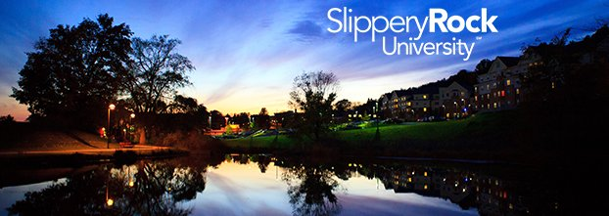

Sharing Information on Progress (SIP)

2020 PRME Report



**Sharing of Information on Progress Report**

**Academic Years 2018-2020**

**Celebrating 5 years of Responsible Management Education**

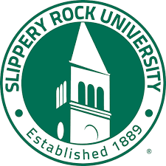

Members of the PRME Task Force who collaborated on this report include: Frances Amatucci, Diane Galbraith (Chair), Jeffery Forrest, Baek Joo, Yi Li, Sunita Mondal, Pavani Tallapally, and Liang Xu. We gratefully acknowledge the cooperation and valuable input from the faculty and staff of the School of Business at Slippery Rock University.

**Primary Contact:**

Dr. Diane D. Galbraith

Professor, and Internship Coordinator

School of Business

Slippery Rock University of Pennsylvania

313 H Eisenberg

Slippery Rock, PA 16057

Tel: (724) 738-4918

E-mail: [diane.galbraith@sru.edu](mailto:diane.galbraith@sru.edu)

**Table of Contents**

1. Letter from Lawrence Shao, Dean of the College of Business 4.
2. PRME Overview 5.
3. History of Slippery Rock University 6.
4. Introduction 7.
5. Principle 1 – Purpose 9.

1. Principle 2 – Values

GreenMetric World University Rankings, SRU 12.

Strategic Goals 13.

SRU Curriculum Alignment with SDG’s 14.

1. Principle 3 – Method 18.
2. Principle 4 – Research 27.
3. Principle 5 – Partnerships

SEA 32.

Internal, Government, Business Community 34.

Regional Chambers of Commerce, Internships 35.

Service Learning, Professional Associations 36.

1. Principle 6 – Dialogue

Business Advisory Councils 38.

School of Business Week, Speakers 40.

Workshops, Community 41.

1. Alignment of Goals 43.



Letter from Dr. Lawrence Shao

Dean of the College of Business

June 2020

Dear PRME Members,

We are honored for the School of Business at Slippery Rock University of Pennsylvania to continue its membership as a signatory institution in the United Nations Principle for Responsible Management Education (PRME) program. Slippery Rock University (SRU) has a long history of incorporating sustainability practices into its culture and operational processes. The School of Business continues to educate future business leaders about the importance of responsible leadership. As an example, our SRU Sustainable Enterprise Accelerate (SEA) Center has been a resource for students and entrepreneurs to jump-start or grow businesses with sustainability in mind.

As an active member of AACSB International, we are constantly working to “continuously improve” our business programs as we pursue AACSB accreditation. We are always thinking about ways to cultivate engagement, hasten innovation, and strengthen the impact of the educational experience we provide our students. Being a member of PRME provides important structure for us to improve our programs and to incorporate responsible management practices into our curriculum.

By referencing the principles established by PRME, we are better able pursue our ultimate goal of developing business leaders who are able to meet the growing challenges faced by businesses and society at large. Our School of Business has had a tradition of embracing the core principles of PRME in both our business curriculum and program offerings. We continue to foster close cooperation between student entrepreneurs and businesses to create environmentally friendly, sustainable business practices.

The fundamental goals of the School of Business are to promote responsible management business education and corporate sustainability that demonstrate positive societal impact. Welcome to the Rock!

Sincerely,

Dr. Lawrence Shao Dean, School of Business



Dr. Lawrence Shao, Dean, School of Business

PRME Overview

The Principles for Responsible Management Education (PRME) is a United Nations initiative founded in 2007 at the UN Global Compact Leaders’ Summit in Geneva by an international task force comprised of deans, university presidents and official representatives of leading business schools and academic institutions. With over 700 signatories across the globe, PRME creates a bridge between the United Nations and academia, specifically universities with management programs to communicate and collaborate among the stakeholders. PRME’s goal is to inculcate the United Nations’ Sustainable Development Goals (SDGs) into responsible management curriculum and programs in higher education.

The Sustainable Development Goals are listed below. Slippery Rock University as a signatory, has committed to the Six PRME principles and this report will highlight some of the progress.

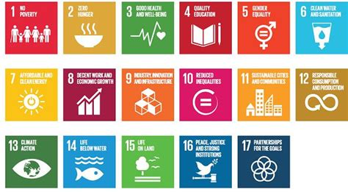

.

**SLIPPERY ROCK UNIVERSITY**

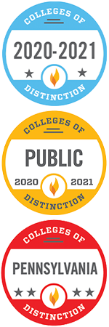Slippery Rock University, founded in 1889, is a member of Pennsylvania's State System of Higher Education. The University is shaped by its normal school heritage and characterized by its commitment to intellectual development, leadership and civic responsibility. SRU provides students with a comprehensive learning experience that intentionally combines academic instruction with enhanced educational and learning opportunities that will help them succeed in their lives, professional careers and be engaged citizens.

Slippery Rock University opened its doors March 26, 1889 as Slippery Rock State Normal School with the primary purpose of training teachers. In 1926, the institution was purchased by the Commonwealth, renamed Slippery Rock State Teachers College, became a four-year teachers college, and continued the tradition of teacher training.

Slippery Rock State College was established in 1960 and for the first time, could award undergraduate and graduate degrees in the liberal arts and in the professions. Expanded curricular offerings and an increased number of degree programs created an appreciable rise in enrollment. It was granted university status in 1983.

Today, Slippery Rock University is a four-year, public, coeducational, comprehensive university offering a broad array of undergraduate and select graduate programs to more than 8,500 students. The University has earned full institutional accreditation through the Middle State Commission on Higher Learning and discipline specific accreditations.

Located in the rolling hills of western Pennsylvania, the 660-acre campus is less than an hour north of Pittsburgh, one hour south of Erie, and 45 minutes east of Youngstown, Ohio. Two major highways, I-79 and I-80, intersect with seven miles of the University, conveniently linking it to the entire Commonwealth and its contiguous regions.

The campus is situated in the borough of Slippery Rock in Butler County, Pennsylvania, a safe and friendly community of approximately 3,500 people.

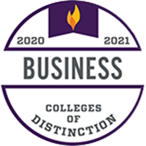We are proud of the many awards that we receive annually including the four most recent College of Distinction awards listed. According to COD, "Globalization and the intricacies of modern business operations require effective communication and apt problem-solving strategies. SRU's programs in business keep their future leaders adaptable as they grow alongside their industry." <https://www.sru.edu/news/061920a>

In addition, the National average for employment placement is 58-60% rate, according to NACE.  SRU is at 78-80% plus another 15% FT for Graduate school.

**INTRODUCTION**

Slippery Rock University (SRU) is one of the fourteen institutions of higher education in the [Pennsylvania State System of Higher Education](http://www.passhe.edu/) (the State System). It is a four-year, public, coeducational, comprehensive university offering a broad array of undergraduate and select graduate programs to more than 8,500 students. Located in western Pennsylvania, the 660-acre campus is less than an hour north of Pittsburgh, Pennsylvania (USA). The University just celebrated its 125th anniversary and has a long tradition of embracing values that are consistent with the six PRME principles.

The School of Business became a signatory institution in PRME in the spring of 2014. During the past 6 years, we continue to make progress toward integrating PRME principles into our business climate and curriculum. We have incorporated PRME principles into the strategic planning process as noted by the addition of a strategic goal related to ‘**principle-centered students who are responsible global citizens.**

**VISION, MISSION AND STRATEGIC GOALS**

Slippery Rock University is situated within the hierarchy of the Pennsylvania System of Higher Education (State System). Vision, mission, strategic goals and core values should be aligned within the State System. Likewise, the College of Business and School of Business vision, mission and core values must be consistent with the University.

A. Pennsylvania System of Higher Education (State System)

**State System Mission Statement**

The primary mission of the System is to increase educational attainment in the Commonwealth, to prepare students at the undergraduate and graduate levels for professional and personal success in their lives, and to contribute to the economic, social and cultural development of Pennsylvania’s communities, the Commonwealth, and the nation.

B. Slippery Rock University of Pennsylvania (amended 2016)

**SRU Vision**

Slippery Rock University will excel as a caring community of lifelong learners connecting with the world.

**SRU Mission**

The fundamental educational mission of Slippery Rock University (SRU) is to transform the intellectual, social, physical, and leadership capacities of students in order to prepare them for life and career success. Complementary missions are to engage in scholarly activity and professional service.

SRU is committed to serving a diverse student body and empowering anyone regionally, nationally, and internationally who can benefit from its programs and lifelong learning opportunities. Thereby SRU addresses the educationally related economic, health, environmental, social, cultural, and recreational needs of the communities served by the university.

In pursuit of SRU's educational purpose, talented faculty and staff provide creative integrated curricula and experiences that are connected to the world in which graduates will work and live. Students are taught using powerful and engaging pedagogies in appropriate learning spaces employing State-of-the-art technology. They study in an open, caring, nurturing, and friendly environment, and live in a safe community with access to high-quality student services. SRU strives to be a best-value institution with an affordable cost and substantial student financial support. <http://www.sru.edu/about/mission-and-vision>

Environmental Analysis

A. Internal – SRU and SBUS

Although many of the universities within the State System are experiencing declining enrollments and budget deficits, SRU remains among the stronger organization. Aside from the reorganization within the SBUS, there have been several recent administrative changes. William Behre became the 17th President of SRU on July 1, 2018. Dr. Philip Way served as Provost from 2012-2019 and interim President for one year upon the departure of President Cheryl Norton. During 2019-2020, Jerry Chmielewski, Dean of Health, Engineering and Science, has served as interim Provost. In June 2020, Dr. Abbey Zink will become the new Provost. The Dean of SBUS continues to be Dr. Lawrence Shao. While SRU is accredited by Middle States regionally, SBUS is ACBSP-accredited and in the fifth year of seeking AACSB-accreditation.

B. External – Trends in Business Education – National, Regional and Global

In the paragraphs below, several environmental opportunities and threats to business management education are summarized. While they are primarily global, state and local environmental changes are also important. As mentioned earlier, the State System is transforming itself for the future through a process that began in 2016 with a top-to-bottom review of the entire System. This led to Phase 1 of the [System Redesign](https://www.passhe.edu/systemredesign/Pages/redesign.aspx) process in 2017. Phase 2 began in the fall of 2018 with the arrival of the new chancellor, Dan Greenstein. Phase 3 is scheduled to begin in 2020.

This external environmental analysis primarily focuses on national and global trends. Like many business schools in Western Pennsylvania, SBUS faces a decline in the number of high school graduates that increases competition and forces schools to take advantage of opportunities in the non-traditional and international markets.

***Lifelong Learning***

We are entering what has been referred to as the Fourth Industrial Revolution as dubbed by Klaus Schwab of the World Economic Forum. This revolution is shaped by the acceleration of the rate of which new technologies are adopted and the disruption these new technologies are causing to the economy. This revolution accentuates the need for managers and employees to be lifelong learners.

<https://bized.aacsb.edu/articles/2018/03/learning-in-the-digital-age>

***Shorter more focused MBA programs***

There is a decrease in interest in two-year MBA programs with increase in accelerated formats

<https://www.usnews.com/education/best-graduate-schools/top-business-schools/articles/2018-04-02/how-to-get-an-mba-in-less-time>

***Technology Trends***

According to Forbes magazine, five technology trends that will transform education by 2025 are: an increase in open, online courses so students can learn from anywhere; ‘flipped’ classroom deliveries; peer-to-peer learning that alters the traditional professor-student relationship; an increase in the use of digital credits through virtual badges, etc.; and an increase in the use of adaptive learning tools such as Pearson MyLab to offer digital courses.

<https://www.forbes.com/sites/centurylink/2015/08/11/5-tech-trends-that-will-transform-education-by-2025/#ca0d3ba58908>

***United Nations Sustainable Development Goals***

In September 2015, the United Nations replaced the Millennial Goals with the release of seventeen Sustainable Development Goals. In his address as President of the Academy of Management in 2015, Paul S. Adler, identifies these sustainable development goals as having profound influence on management education in the future. Corporate and business school participation in the U.N. Global Compact and the Principles for Responsible Management Education (PRME) respectively has increased significantly during the past five years.

<http://aom.org/Multi-Media/Archives---2015-Annual-Meeting/2015-Annual-Meeting-Presidential-Address.aspx>

***AACSB Research Report: Five external environmental opportunities***

In the AACSB research report ‘A Collective Vision for Business Education’ the authors identify five opportunities for business schools to thrive. They are: 1) catalyst for innovation, 2) co-creators of knowledge, 3) hubs of lifelong learning, 4) leaders on leadership, and 5) enablers of global prosperity. These opportunities create the needs for cultivating the intersection between the academe and practice, being a driver of innovation in higher education, and seizing opportunities to reinforce interdisciplinary learning.

<https://www.aacsb.edu/publications/researchreports/collective-vision-for-business-education>

***Voice of the Customer Study***

A 2015 market trends survey report entitled ‘Future Trends in Business Education’ was released by AACSB, Executive MBA Council (EMBAC) and Executive Education Consortium (Unicorn). Using the ‘voice of the customer’ market research approach, it surveyed more than 70 organizations globally. Some of the important themes that were apparent were the following: to take advantage of growing markets; adapt or face consolidation in the future; match the pace of corporations in developing women and minorities; measure the impact of learning; build capability to partner with corporate universities; and incentivize faculty to employ more pedagogical approaches involving experiential learning.

<https://www.uniconexed.org/wp-content/uploads/2017/01/Future_Trends-Revised_Final_Report_Executive_Core-August-Jan.12.2016-v2.pdf>

PRINCIPLE 1 – PURPOSE

We will develop the capabilities of students to be future generators of sustainable value for business and society at large and to work for an inclusive and sustainable global economy.

**SLIPPERY ROCK UNIVERSITY**

SRU has a long tradition of embracing core values that are consistent with PRME principles. According to the 2019 UNGC/Accenture study, 92% of CEOs believe that sustainability is critical to business success, although only 48% are doing it. SRU School of Business understands our role to help inculcate the PRME principles into the curriculum. In 1990, the Robert A. Macoskey Center for Sustainable Systems Education and Research was founded. The Pennsylvania Climate Action Plan detailing what the state will undertake to reduce greenhouse gas emissions was completed in 2009. SRU’s former President, Robert Smith, was the first signatory in The State System to commit the University to net climate neutrality. SRU has been a member of the Association for the Advancement of Sustainability in Higher Education (AASHE) since 2009.**SCHOOL OF BUSINESS (SBUS)**

**SBUS Vision Statement:** *We will provide transformational educational experiences that equip students to be lifelong learners who engage the world as knowledgeable, principle-centered and responsible global citizens.*

**SBUS Mission Statement**

*The School of Business at Slippery Rock University prepares students to be career-ready emerging leaders by developing competencies for success professionally and personally. All of our academic programs are student-centered with high levels of engagement in an environment where student learning is enhanced through faculty scholarly activities. The School of Business also serves as a catalyst for regional economic development through outreach and partnerships.*

**School of Business Core Values (developed by SPC AY2016-17)**

*Collaboration Social Responsibility*

*Engagement Quality*

*Caring community Innovation*

*Impact Respect*

*Resource Database for Faculty*: A resource database by discipline was created for faculty to assist in further revising their course content to incorporate issues related to the sustainable development goals.

*Student-Led Activities and Organizations*: Student organizations such as Alpha Kappa Psi, the Society for the Advancement of Management (SAM), American Marketing Association, Enactus, the Sustainable Enterprise Accelerator, Future Health Care Leaders, Finance and Economics Club, and APICs provide opportunities for discussing sustainability topics. Solar Women’s Business Center was developed in the spring of 2016 by students as an educational and networking group to address gender-related issues in business.

SRU is committed to being at the forefront of preparing the next generation of thinkers, innovators and entrepreneurs to help the world meet its profound environmental challenges. We are focused on meeting the sustainability goals outlined in our [Climate Action Plan](https://www.sru.edu/documents/about/sustainability/climate_action_plan.pdf). That is our road map to achieving carbon neutrality by the year 2037, in keeping with the President's Climate Commitment and our long term Strategic Plan, [Trend Five: "The world is reaching a point of diminishing returns regarding resource utilization"](https://www.sru.edu/documents/about/sustainability/00000%20Trend%20Five%20Update%2002-01-19.pdf). We are proud of our achievements to date, which include:

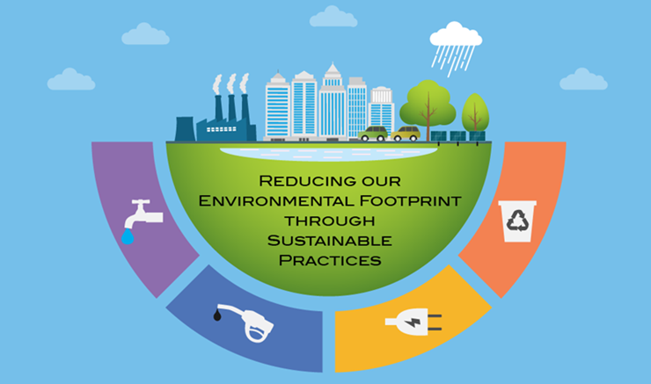

* Consistently making the **Sierra Club's Top 100 Cool Schools** list, the **Princeton Review's Guide to Green Colleges,** and ranking in the top 100 schools in the **University of Indonesia's International Green Metric Survey**
* Being the first 4-year college in Pennsylvania to be named a **Green Ribbon School** by the U.S. Department of Education
* **Reducing our net GHG Emissions by approximately 30% since 2005**
* Achieving the **Silver Rating** by the Association for the Advancement of Sustainability in Higher Education (AASHE) - see our latest [AASHE STARS report](https://stars.aashe.org/institutions/slippery-rock-university-pa/report/) for a complete description of all our sustainability initiatives and curricula.
* Regularly exceeding our **EPA Green Power Partnership** minimum green power purchasing requirement.
* 2018 *Governor's Award for Environmental Excellence*. Slippery Rock University is among 23 "innovative and impassioned" organizations selected by Pennsylvania's Department of Environmental Protection to receive the prestigious 2018 Governor's Award for Environmental Excellence. The Governor's Awards for Environmental Excellence are awarded each year by the DEP and highlight the best in environmental innovation and expertise throughout the state. The awards provide statewide recognition to businesses and organizations involved in a cross-section of environmental initiatives from cleaning up watersheds, saving energy, eliminating pollution, reducing waste and more. View our [student-produced highlights video here](https://www.youtube.com/watch?v=a7s7GkJ7oaM&feature=youtu.be).

Sustainability initiatives and resources at SRU are coordinated through the SRU Office of Sustainability, which coordinates and leverages the efforts of all sustainability and environmentally related SRU organizations and groups. The SRU Office of Sustainability is also responsible for collecting data on sustainability curriculum, co-curricular activities and events, research and publications; reporting our progress in all these areas; and providing community outreach for all sustainability initiatives on and off campus. The President’s Commission on Sustainability is comprised of a cross-section of representatives from the SRU community to advise the President on sustainability initiatives, strategies, and policies. The current University sustainability initiatives include Earth Day Celebrations, Can’t Reuse it? Refuse It! - #SRUbeyondplastic, Certificate in Sustainability, and Energy Action Pledge. For more information, please visit [Sustainability at SRU](https://www.sru.edu/about/sustainability).

**The Robert A. Macoskey Center at SRU:** The Robert A. Macoskey Center for Sustainable Systems Education and Research (RAMC) was created in 1990 to promote sustainability at SRU and in the local community. The Center is located on 83 acres of the University campus and enacts its mission in three ways: education about sustainability, physical demonstration of sustainable technologies and systems, and supporting sustainability-focused academic initiatives and research. The Harmony House is a newly renovated facility certified LEED-Silver for existing buildings: operation and maintenance and serves as a classroom and public meeting space.

**Weather and Air Quality Observatory:** The PA Departmental of Environmental Protection has partnered with Slippery Rock University to operate weather and air quality observatory (WAQO) on the Slippery Rock University campus. This observatory produces environmental data that is publicly available to the Slippery Rock community and serves as an excellent resource for both teaching and research.

In addition to environmental ecology, many University initiatives address social justice and promote diversity throughout the academic year. They include:

* Office of Diversity and Equal Opportunity
* Office of Global Engagement
* President’s Commission on Women
* President’s Commission on Gender Identity and Sexual Orientation
* President’s Commission on Race and Ethnic Diversity
* President’s Commission on Disabilities
* APSCUF Committee on Social Justice
* APSCUF Gender Issues Committee
* Solar Women’s Business Center
* SRU Women’s Center
* SGA Committee on Social Justice

Slippery Rock University is also an institutional member of the Ph.D. Project ([www.phdproject.org](http://www.phdproject.org)) demonstrating a strong commitment to diversifying the faculty, staff and student populations by encouraging minorities to become part of the SRU community.

**2020-2022 Principle 1 Goals:**

* Continuously assisting faculty members in obtaining information about best practices in curriculum development related to sustainability through the resource repository
* Encouraging faculties to integrate sustainability across various business functional areas.
* Enhancing communication with student organizations to incorporate global citizenship values into their activities.



PRINCIPLE 2 – VALUES

We will incorporate into our academic activities and curricula the values of global social responsibility, as portrayed in international initiatives such as the United Nations Global Compact.

Slippery Rock University (SRU) is a signatory to the UN Global Compact. As a member of SRU, the School of Business (SBUS) promotes the UN Global Compact principles of Human Rights, Labor, the Environment and Anti-Corruption through our University’s core values of academic excellence and impact, inclusiveness and diversity, integrity and transparency and effective stewardship. The SBUS supports this principle by incorporating topics like reduced inequalities, the environment and ethics into our curriculum, speaking engagements, student projects and campus environment.

**Values of Global Social Responsibility at the University Level**

Slippery Rock University is committed to being at the forefront of preparing the next generation of thinkers, innovators and entrepreneurs to help the world meet its profound environmental challenges. We are also focused on meeting the sustainability goals set forth in our [*Climate Action Plan*](http://www.sru.edu/Documents/about/sustainability/climate_action_plan.pdf). This serves as our road map to achieving carbon neutrality by the year 2037, in keeping with the [*President's Climate Commitment* and our Long Term Strategic Plan, Trend Five: *The world is reaching a point of* *diminishing returns regarding resource utilization*.](http://www.sru.edu/Documents/about/sustainability/00000%20Trend%20Five%20Update%2011-08-2017.pdf)

We are proud of our achievements at the University level, which include:

* Slippery Rock University has again been ranked among the world's most environmentally friendly colleges and universities by the University of Indonesia's GreenMetric World University Rankings. SRU was ranked 9th in the United States and 153rd in the world. SRU moved up 11 spots in national ranking while its global position jumped 41 spots from one year ago, 2019. This year, 780 universities from 85 countries participated in the rankings. The UI rankings are the only university rankings that measure each participating university's commitment in developing an "environmentally friendly" infrastructure by looking at six indicators for each university, including: setting and infrastructure, energy and climate change, waste, water, transportation and education.

Data for the rankings was collected through an online questionnaire with answers validated through evidence provided by each participating institution

Many of the methods we're using to reduce our greenhouse gas emissions and to prepare our students to be good stewards of our environment are summarized in the topic areas shown below, which also include reports on our progress in each area and additional resources relevant to that topic. For link see: <http://www.sru.edu/about/sustainability>

* SRU recognized in Business Officer magazine for *Powering Forward*: Four Slippery Rock University administrators co-authored a case-study article about the SRU’s approach to deferred maintenance and energy savings that was published in Business Officer, the magazine of the National Association of College and University Business Officers in May 2018.
* Sustainability Grant: Two Slippery Rock University professors received a $29,010 grant from *ASIANetwork* to conduct a sustainability study that will benchmark outcomes from rapid modernization initiatives in China by accounting for economic, environmental and social influences. John Golden, assistant professor of business, and Li Pu, associate professor of communication, wrote the successful proposal, "*The Development and Benchmarking of Contemporary Sustainability Indicators for Rural Ethnic Chinese Villages: A Case Study of the Social, Economic, and Ecological Issues of Two Gelao Villages Near Chongqing Municipality*."

**Alignment of the Values between PRME and The School of Business**

The participation of SBUS at Slippery Rock University as a signatory institution in the U.N. Global Compact’s *Principles for Responsible Management* education has important implications for curriculum content. Faculty members are challenged to incorporate not only PRME principles but also the newly promulgated U.N. sustainable development goals into the business school curriculum. SBUS is the first business school in the State System to make this commitment.

The SBUS is aligned with the values of the PRME as the strategic management processes associated with being mission-driven and developing a strategic planning process have become embedded. Moreover, these processes are expected to be continued. The SBUS has a well-developed mission statement that serves as a basis for instituting innovation, engagement and impact into the culture.

**Strategic Goals**

To pursue the vision, mission, and values of the SBUS, the Strategic Planning Committee developed **Six**

**Strategic Goals**, which are consistent with the University goals and the SBUS mission Statement. The six strategic goals include:

#1 **Curriculum:** SBUS is committed to providing high quality curriculum designed to make students ‘career ready’. We emphasize excellence in teaching incorporating high impact practices to facilitate student engagement.

#2 **Recruitment, Retention and Graduation**: SBUS faculty and staff in conjunction with the University administration are highly engaged in the recruitment and retention of quality and diverse students.

#3 **Qualified Faculty**: SBUS strives to recruit and retain academically qualitied, experienced and diverse faculty and staff.

#4 **Scholarship:** SBUS faculty conduct scholarship that enhances student learning.

#5 **Partnerships:** SBUS is engaged with faculty, students, its advisory board, University staff and other external stakeholders.

#6 **Global Citizenship**: SBUS strives to develop principle-centered students who are responsible global citizens.

The newly revised SBUS vision, mission, and value statements emphasize the roles of engagement, innovation and impact that are embedded within the curriculum development process. As a teaching-centered institution, our primary emphasis lies with our commitment to students. Moreover, an additional point of distinction is our applied and experiential approach to business education. In fact, the slogan for the University is *Experience the Difference*. Our academic programs are ‘student-centered’ with high levels of engagement and our graduates are principle-centered and responsible global citizens.

**Curriculum Development**

Slippery Rock University has been progressive in terms of adopting a curriculum that addresses sustainability concepts and processes. The Robert A. Macoskey Center, McKeever Environmental Learning Center, Sustainable Enterprise Accelerator, and the Weather and Air Quality Observatory all offer non-credit educational programs related to environmental protection. There are many programs and courses which either are devoted entirely to sustainability or have sustainability content. The Certificate in Sustainability is an interdisciplinary certificate that provides foundations in sustainability that diverse student groups may not be introduced to in their degree programs. The Hospitality, Event Management and Tourism (HEMT) department offers three courses in Sustainability: HEMT114 Sustainability in the Hospitality Industry; HEMT210 Ecotourism; and HEMT314 Sustainable Planning for Tourism.

In an effort to benchmark the coverage of sustainability topics within the business program, the 2016 UN Sustainable Development Goals were utilized to map sustainability coverage across the core business curriculum. The business faculty was surveyed as to which development goals were covered in various courses, and at what level. The levels chosen were text chapter (T), module within a chapter (M), a topic box within the text (TB), current events discussion (C), and/or as part of a graded assignment (A). Not all of the core courses had coverage reported. The results for those that did report coverage of at least one topic are found in Table 1 below. All of the topics were covered in at least one of the core courses and many were covered in significant detail. Table 2 lists business courses that cover significant amounts of sustainability in their content.

**Table 1. 2018 UN Sustainable Development Goals and SBUS Core Curriculum**

|  |  |  |  |  |  |  |  |  |  |
| --- | --- | --- | --- | --- | --- | --- | --- | --- | --- |
|  | A210 | A340 | B303 | B458 | E201 | E202 | M320 | M351 | MK330 |
| No Poverty |  |  | M,TB,A |  | T,M,C,A | T,M,C |  | M | C |
| Zero Hunger |  |  | M,C |  |  | TB |  |  | C |
| Good Health and  Well-Being | M,T,C,A |  | M,TB | M | M,C,A | T |  |  | C |
| Quality Education | C,A |  | M |  | M,C | M |  | C | C |
| Gender Equality |  |  |  | C | TB | M,C |  | M | C |
| Clean Water and  Sanitation |  |  | C |  |  | M,C |  |  | C |
| Affordable and  Clean Energy |  |  | M,TB,C |  | M |  |  |  | C |
| Decent Work and  Economic Growth | M,T,C,A |  | T,C,A |  | T,M,C,A |  | M | M,C | TB |
| Industry, Innovation  and Infrastructure | M,T,C,A |  | T,C,A | C | T,M,A | T,M,A | M | C | M,TB,C |
| Reduced Inequalities |  |  | M,C |  | T,C | T,C |  | M,C |  |
| Sustainable Cities  and Communities |  |  |  |  |  | M,C |  |  | C |
| Responsible  Consumption and Production | C,A |  | TB,C | T,M |  | M,C | M |  | M,C |
| Climate Action |  |  | M |  |  | M,C |  |  | C |
| Life Below Water |  |  | M,TB,C |  |  | C |  |  | C |
| Life on Land |  |  | M,TB,C | T |  | C |  |  | C |
| Peace, Justice, and  Strong Institutions | C, A | T | T,M,C,A |  | T,M,C,A | T,M,C |  | T,M,C | C |
| Partnerships for the Goals | C, A |  | M,C | T |  | M |  |  |  |

*Note*, T: Text Chapter, M: Module within a Chapter, TB: Topic Box, C: Current Events, A: Assignment

|  |  |  |
| --- | --- | --- |
| A210: Managerial Accounting  A340: Legal Envir. of Business  B303: Issues in Global Business | B458: Business Capstone  E201: Macroeconomics  E202: Microeconomics | M320: Operations Management  M351: Organizational Behavior  MK330: Principles of Marketing |

**Table 2. 2017-2020 Sustainability Courses Taught at the School of Business\***

|  |  |  |
| --- | --- | --- |
| Course # | Title | Description |
| ECON 315 | Economics of  Sustainable Development | Economic causes and effects of pollution are discussed along with the issue of sustainable economic development. Government policy with respect to the environment and renewable energy is surveyed. The connection between sustainability and the core functions of business for profit are presented. |
| BUSA 370 | Sustainable Entrepreneurship  and Innovation | This integrative course introduces students to issues related to sustainable new venture creation and the design of sustainable business models, industry/market analysis, resource acquisition and disposition, assessing a venture’s financial strength, and ethical/legal issues. Students learn the entrepreneurial process while acknowledging multiple stakeholders and addressing social, economic, and environmental concerns. |
| BUSA 459 | Sustainable Business Consulting | In this course student teams engage in field=based consulting to analyze actual problem situations involving sustainability for regional businesses. |

Although there is no separate Ethics course, many courses discuss the issues of Ethical Leadership, Business Ethics and Organizational Culture. Ethics is one of the learning objectives of the *Bachelor of Science Degree in Business Administration* (BSBA) programs in five majors: Accounting, Economics, Finance, Management, and Marketing. Students graduating with a degree in business administration will demonstrate an understanding of the legal environment and ethical standards of business and an awareness of the implications of their behavior and actions as a business professional.

**2018 – 2020 Sustainability-Related Courses Taught\***

|  |  |  |
| --- | --- | --- |
| Course # | Title | Description |
| BUSA 105 | Economics of Social Issues | An introductory course intended to provide an understanding of how our economic system works. A framework of building blocks from macro, micro and international economics is developed to enable students to comprehend the differences among alternative solutions and to understand the implications of policy issues. This includes addressing the environment, policies to protect the environment, and the tradeoffs society face. |
| BUSA 303 | Issues in Global Business | This course focuses on fundamental issues in the modern global business environment. The topics covered include comparisons of different economies with respect political economy, culture, and standard of living. The role of international trade in economic development is also discussed. Finally, principled decision making on the part of multinational firms, which includes sustainability issues, is covered in detail. |
| MGMT 456 | Management and Society | This course engages students in exploring the social, ethical, environmental, economic, and political/legal restraints on organizational decision-making that managers face. Students develop critical thinking, communication, and management skills necessary to be effective in a global business setting where multiple stakeholder interests must be addressed. |

**Cultural Diversity**

SBUS students are exposed to values associated with cultural diversity and social justice in many ways through the curriculum. In the SRULiberal Studies core curriculum that all University students must complete, the Human Institutions and Interpersonal Relationships goal states that the student will:

Identify and evaluate issues and problems within human institutions and interpersonal relationships using ethical criteria.

Demonstrate how ethical criteria can be used to foster cooperation and promote respect for diversity.

Evaluate social, emotional, cognitive, and/or biological aspects of personal development within human institutions and interpersonal relationships and explain how these affect human beliefs and behavior in everyday life.

* Analyze and evaluate how globally diverse contexts affect beliefs and behaviors of individuals, groups, organizations, and human institutions and how these contexts influence civic engagement.

Students are also required to take two non-US courses in the Global Community area that will:

* Describe how values, attitudes and beliefs affect the ability of people to relate to that which is different
* Evaluate general theories, models, arguments or perspectives that explain contemporary or historical relationships among social, political, economic or environmental systems
* Communicate an understanding of how language or culture affect one’s perception of the world

The Office of Global Engagement offers a variety of programs from week-long spring break seminars to a traditional academic year abroad. It organizes international exchange opportunities for faculty, staff and students. During recent spring breaks, an average of 22 students per trip, participated in SBUS trips including Costa Rica, Greece, Barcelona, and Italy.

**HCAM 420: International Health Care Systems** Twenty-one students toured Greece**, s**upervised by Dr. David Jordan. Some of the historical cities and sites included Corinthos, Knossos, Chania Town, Heraklon, Rethymnon Hospital, etc.

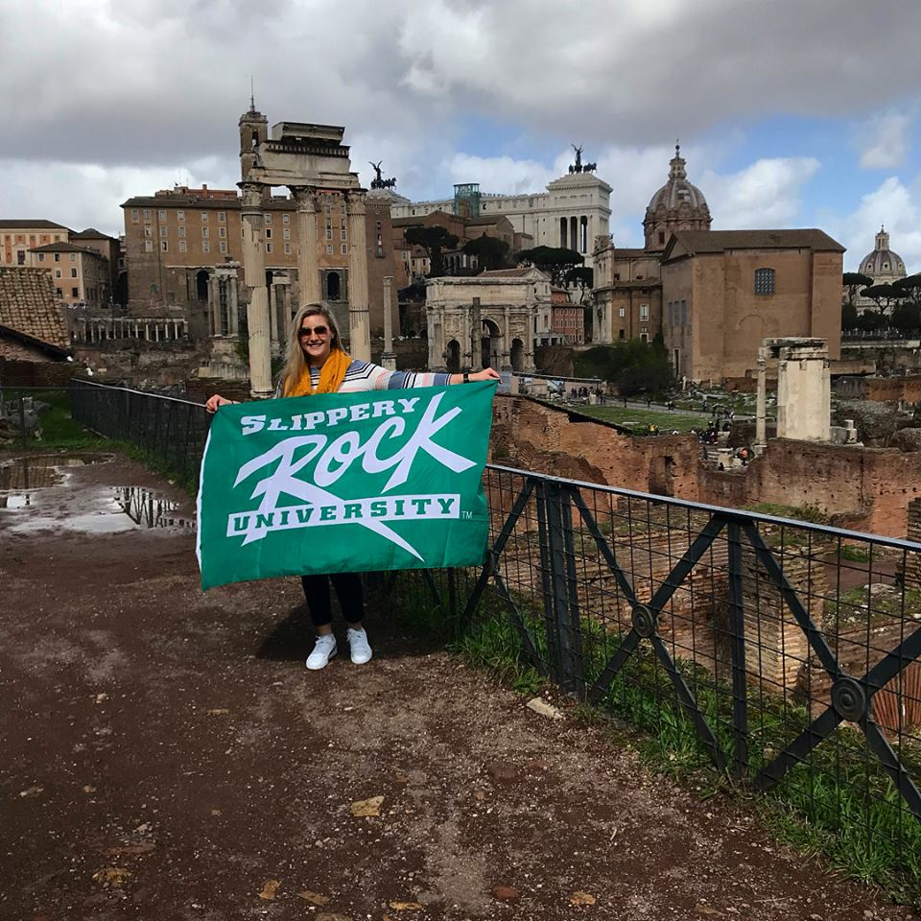**MKTG 335: Retail Management and Hospitality Event Management and Tourism majors**   
Dr. Bruce Orvis, traveled with Dr. Bruce Boliver and a total of 40 students to Florence, Venice, Pisa, Siena, La Spezia and Rome for a study abroad course in Italy. Tours included the Murano Glass company, a winery, the Vatican, Pantheon, the Leaning Tower of Pisa, St. Peter’s Cathedral, etc. Dr. Orvis has chaperoned 11 consecutive trips abroad during Spring breaks including approximately 250 students.

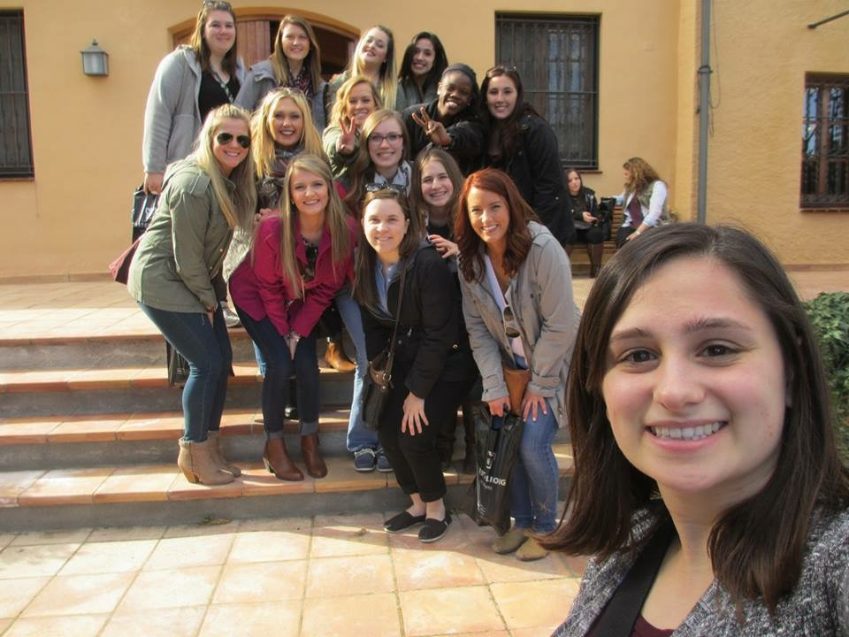

**ACCT 411: Auditing Theory**

**MGMT 454: Management Seminar**

Under the supervision of Drs. Diane Galbraith and Melanie Anderson, 23 students visited Barcelona, Spain. During the visit students participated in many cultural activities and tours including Montserrat Abbey, the Caixa Bank, Montjuic, Sagrada Familla, Picasso Museum, Barcelona University, Park Guell and other Gaudi buildings. They also experienced a Flamenco show, soccer game and wine tasting at Castellroig.

**2020-2022 Principle 2 Goals:**

* To make progress on incorporating sustainable development goals and practices into the curriculum
* To increase curriculum content related to gender, ethnic, cultural diversity and international experience.

PRINCIPLE 3 – METHOD

We will create educational frameworks, materials, processes and environments that enable effective learning experiences for responsible leadership.



**Sustainable Enterprise Accelerator (SEA)**

* + Slippery Rock University maintains one of the world’s few sustainable business accelerators, known as the SEA, or, the Sustainable Enterprise Accelerator. Its mission is to promote economic development through applied student learning opportunities in new venture creation and business consulting.
  + The world today is in the midst of a quandary of what to do about issues regarding climate change, global warming, social justice, income disparity and many other issues. In order to bring about the changes necessary to ensure a better world will be available to future generations, we must act personally, innovatively and entrepreneurially.
  + At the Slippery Rock University Sustainable Enterprise Accelerator (SEA), we believe that our future depends on the choices we make today. If we desire better lives for ourselves and future generations, we must utilize the power of markets and commerce to make changes that will insure a better world for future generations.
  + The SEA’s vision is to become a primary resource for student and community involvement in the development of sustainable business enterprises. For those with an idea for a new business, the SEA provides guidance in transforming promising ideas into thorough business plans and early stage sustainable businesses. For those operating established businesses, the SEA provides help in identifying opportunities for improving sustainable value creation.
  + The SEA is excited to announce that we have recently (2019) become a founding member of the world’s largest digital incubation platform, IdeaGist. IdeaGist's Emerging Technology Accelerators Initiative (ETA) will be working with the SEA to bring a better understanding of featured emerging technologies. The seven featured technologies include Artificial intelligence, 3D Printing, Blockchain, Internet of Things (IoT), Augmented Reality, Intelligent Vehicles, and Smart Robots. · [www.seasru.com](http://www.seasru.com)

Several of the projects the SEA has undertaken, or plans to undertake, are described below:

* **SEA Wilderness Project:** Humans possess an innate connection to nature.  Exposure to outdoors is believed to create positive therapeutic benefits. The under-served folks lacking wilderness experience are susceptible to suffering from what Last Child in the Woods author, Richard Louv, defined as nature deficit disorder.  Inadequate amount of interaction with nature may lead to behavioral, stress-induced disorders that negatively impact one’s health.  One solution, ecotherapy, is a relatively recent therapeutic approach with promising potential. The goal of the SEA Wilderness Project is to research the positive effects of ecotherapy and tactics to administer these services to those lacking the ability to access nature themselves.

A potential direction for The Wilderness Project is through virtual reality implementation.  The technological method provides an immersive, sensory-packed experience to the user.  This project requires guidance from an ambassador with a true spirit for the wild and a passion for bringing that essence to those in need. The SEA Wilderness Project has been accepted into the Clinton Global Initiative University and was represented at its conference

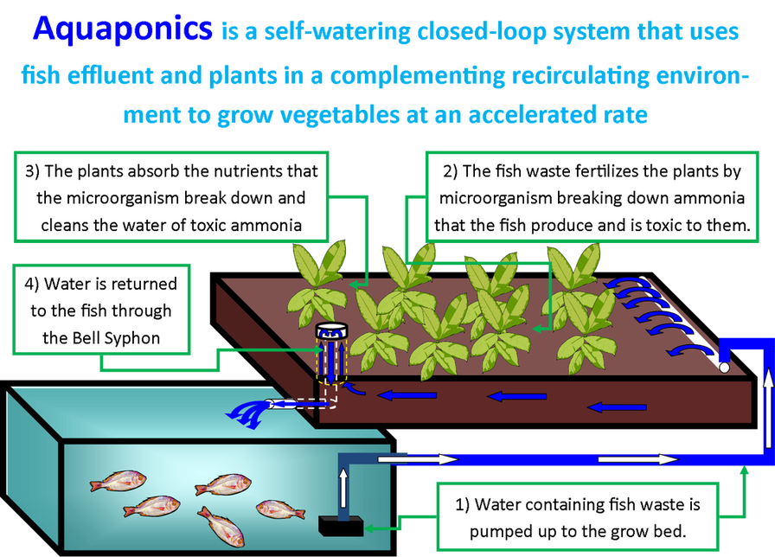

* **SEA Aquaponics**: Aquaponics is a method of farming that combines conventional aquaculture (raising aquatic animals in tanks) with hydroponics (cultivating plants in water). Aquaponics creates a symbiotic environment between fish and plants. The aquatic life provides nutrients for the crops, and in return, the plants filter the water for the fish to prosper.

The Aquaponics Project involves the construction of an aquaponics system in Lukaya, Uganda. The project is expected to benefit residential students by extending the local growing season, providing students with incentives and tools for engaging in empirical research, and establishing a market for innovative sustainable agricultural systems in the future.

This will provide a potential solution to alleviating poverty by providing a sustainable method of producing nourishment (vegetables, fish). The Aquaponics Project is the product of ongoing collaboration and communication efforts between professionals, Slippery Rock community members, Slippery Rock University students and faculty, Uganda Martyrs University and S.E.A. ambassadors. Professor Joseph SSekandi from Uganda Martyrs University and SRU are exploring a MOU for partnering in other areas as well.

* **S&N Nutrition:** is a small business located at Slippery Rock, PA. Their store primarily sells muscle building supplements such as protein, creatine, pre-workout and much more. My task during the semester was to create marketing strategies to help promote their business to Slippery Rock University students and members of the community.

### **J & R Unique Woodworking:** formed when craftsman Ron Boy and antique hunter Jill Hockenberry crossed paths. Ron, who followed in his father’s footsteps, was instilled with a love of crafting. He had over 30+ years of experience in carpentry when he met his co-founder. Jill, who has a love for all things

vintage, hooked Ron of the thrill of finding old artifacts. From there, the kindred spirits teamed up to fulfill their passions together by creating custom-made wood workings from repurposed barn materials and rediscovered antiques.

Since then, Ron and Jill have been clients of the SEA for approximately four years. In years past, they have received assistance with designing a logo, business cards, and copy writing for their recently completed website : jandruniquewoodworking.com. This semester, Ron and Jill needed social media guidance and the development of a portfolio. In addition to being provided with a social media strategy, they received assistance with the set-up of a Twitter and Etsy account so far.

* **The Center for Ageless Entrepreneurship** (CAE) is an entrepreneurship education platform designed to support people exploring entrepreneurship in the second half of life.  The platform is designed to be housed at the Sustainable Enterprise Accelerator at Slippery Rock University. The Center for Ageless Entrepreneurship (CAE) at SEA will be the first of its kind in the U.S. as a center that is designed to be an introduction to entrepreneurship, business training, and mentorship for people exploring entrepreneurship in the second half of life.
* **Mural Dedication and Pollination Garden**: This project is implemented to create a sustainable, yet beautiful atmosphere around Slippery Rock University.  Last semester, three ambassadors wrote a grant that was approved for $2,307. A local artist is in the process of recreating the mural for the side of SEA’s building using entirely recycled and reused materials. In addition, the project is creating a sustainable Lasagna structure-inspired garden.  A Lasagna garden utilizes recyclable materials (such as newspaper and cardboard), as well as non-dyed mulch to improve compost quality and accelerate plant fertilization. Lastly, the Kaleidoscope Festival will take place in April.  The Mural and Beautification Project team members must coordinate with Kaleidoscope to prepare this event.  The mural reveal will take place during the festival and SEA will debut its sustainable garden during the festival.

## **Food 21's:** plan is to act as a catalyst across our many communities to connect existing resources, innovate new solutions with our partners and continue to promote and share both ideas and challenges in what it takes to grow a robust and active food economy. The SEA will act as an academic hub for the regional project development of creating a Pittsburgh food shed, which will serve our community for generations. We are very excited to be a part of such an amazing project and to see our community come together in an effort to source our food locally.

**Check out Food21 for yourself:** [**https://www.food21.org/**](https://www.food21.org/)



:

* **Idealab** is an open forum for aspiring entrepreneurs to pitch their ideas. The mission of the Idea lab is to assist

entrepreneurs in transforming their bright ideas into profitable business ventures. We can provide a wide range of services including guidance, resources and idea incubation for startup businesses. Our strategy is focused on the success of startup businesses through combining sustainability with innovative business strategies and critical problem solutions. We believe utilizing sustainability and innovation can promote dynamic opportunities that contribute to the growth of a startup business and mitigate challenges, making business ventures not only profitable, but environmentally, economically, and socially responsible.

* **Green Leaves Project**—SRU Sustainable Certification project.
* **Veterans Outreach Project**-- As a group project, the SEA wanted to directly reach out to the area veterans. As a result, we put on the SEA’s first ever Entrepreneurial Resource Fair. This event was designed to connect community groups and the veterans who can use their services for business start-ups. Our resource groups ranged

from those who can help with starting and running your own business, to those such as the Center for Community Resources who can help veterans get back on their feet again in life.

* **ImPress Digital Badges**:digital badges are a validated indicator of accomplishment, skill, quality, or interest that can be earned in many learning environments. The badges are designed to allow users to accumulate visual proof of their abilities that they acquired in a variety of learning environments over a lifetime. One potential use of digital badges is to show potential employers the skills and accomplishments of the user while providing them with actual examples of their proficiencies that have been vetted by professionals from that particular field. The Progress: Since the Impress Digital Badges is in the beta phase, the project is starting out with some short-term goals to achieve measurable outcomes and data for research that will pave the way for the future of Impress as a company. Completed so far is preliminary research, the logo, and a beta website, along with several badge examples. This summer, the Impress Digital Badges team started on the adventure of badge system creation.
* **“Money Talks”** Financial Literacy project-- this project introduces free financial planning basics into lower income communities within Butler and the surrounding counties. We developed a series of workshops throughout the year in targeted communities that focused on providing financial planning basics to self-starting individuals that are ready to establish a plan for their finances.
* **Entrepreneurship Outreach**-- is a program that gives the SEA an opportunity to connect with entrepreneurs that are sustainable, and create sponsorships with them. Right now, we are co-sponsoring a solar panel installation certification workshop hosted by Jay Warmke, and the 2017 Farmer's Market Conference taking place at the SEA on March 24 with Heather Manzo of PSU Extension.

Some Events and Programs:

* The Clinton Global Initiative University (CGI U) is an annual event where college students from all over the globe may apply to participate in the program. Students must be actively volunteering their time to a cause they are passionate about helping to create a more perfect world. This ranges from social justice issues, world poverty, environmental concerns and anything that is deemed to help others and create change. Freshmen Hiruni Herat from American University and senior Mia Vereb from Slippery Rock University were accepted and was scheduled to travel to Edinburgh, Scotland with SEA Director John Golden, the second week of April to present their initiative of continuing to provide education to communities in Sri Lanka, South Asia. Close to my Heart Foundation is working to provide equal opportunity to underprivileged populations with education, healthcare, and social equality. To learn more about past and future projects or to donate to this cause, check out their website: [*https://www.closetomyheartfoundation.org/*](https://www.closetomyheartfoundation.org/)

* Slow Food: Slow Food USA is part of the global Slow Food network of over 100,000 members in more than 150 countries. Through a vast volunteer network of local chapters, youth and food communities, it links the pleasures of the table with a commitment to protect the community, culture, knowledge and environment that make this pleasure possible. Sea operates local chapter.
* Rock the Boat: SRU Elevator Pitch Competition (cash prizes to student winners)
* Penn State College of Agriculture joint workshops
* Pennsylvania Association for Sustainable Agriculture joint workshops

**Office on Sustainability:**

## In keeping with SRU’s long tradition of sustainability, University initiatives are primarily coordinated through the Office of Sustainability led by Mr. Paul Scanlon. This department has organized numerous events including the annual Earth Day celebrations. In the fall of 2019, an event called ‘Beyond Plastic’s was hosted on campus.

## Slippery Rock University “Beyond Plastic: Can’t Reuse it? Refuse it!” Symposium and Product Expo

### America’s reliance on single use “disposable” plastic products threatens our health, as well as our environment. While this has been an on-going issue, it is today’s students that will have to come up with innovative solutions to the many environmental issues that we, as a society, urgently need to address. This symposium is designed to empower our students to think of themselves as agents of positive change, and to equip them with the knowledge they need to be effective in doing so.

With China and other developing countries no longer accepting our plastic trash, our ability to recycle plastics is even more problematic than ever. Recycling isn’t, and never really was, the best option to solve this problem anyway.

In answer to these concerns, the Presidents Commission on Sustainability at Slippery Rock University is beginning a large-scale campaign to emphasize the overriding need to “Refuse and Reuse”, rather than to “Recycle”, single-use plastic products.

The **Beyond Plastic: Can’t Reuse it? Refuse it! Symposium and Product Expo** was held on Thursday, October 24, 2019 from 9:30 am to 4:45 pm on the third floor of the Smith Student Center. It is open to all SRU students, faculty and staff, as well as invited regional high school students and teachers. One hundred sixty high school students were bussed into the campus and the daylong event was also attended by five hundred students and faculty with thirty-two poster sessions. The day included guest speakers Mark Dixon, filmmaker and environmental activist, Dr. Brian Bonsteel, President and Founder of Humane Action, and Lisa Ann Hamilton from the Center of International Environmental Law. Additionally, there was an ‘Alternative to Plastics Expo’, DIY Workshops, films and documentaries, and an art exhibition.

**BUSA459: Sustainable Business Consulting**

Typically scheduled for every spring, BUSA459 is a course that adopts the Small Business Institute® program and process for field-based student consulting projects. <http://www.smallbusinessinstitute.org> Student teams are able to apply theories related to entrepreneurship, sustainability and small business management into practice with hands on projects with local businesses. Through BUSA459 over the past seven years, 164 SBUS students have participated in approximately twenty-five business consulting projects involving start-ups, for-profit and not-for-profit organizations. Clients included North Country Brewing, the Butler County YMCA, Philon’s Farms, National Grind Coffee & Tea, D&D Drafting, the Butler County Transit Authority, Friends of Bantam Jeep Association and the Butler County Community Development Corporation. Clients are typically sourced through the SBUS Business Advisory Council and the Butler County Chamber of Commerce. The primary faculty mentor is Dr. Frances Amatucci.

**AMA (American Marketing Association)**

The SRU chapter of AMA has been focusing a lot on professional development this year. Speakers have come from Northwestern Mutual and Industry Weapon to speak to the members. Members have also come together to work on case studies for both the AMA International Colligate Conference and a Regional Case Competition. Some of the members have also gone to AMA’s Pittsburgh Professional chapter networking events. This chapter has also done work to give back to the community. A loose change competition was held on campus to raise money for a donation to the Mission Stay Scholarship. This year the group also held a bake sale to help raise money for the Butler Humane Society. This chapter also volunteered for the Annual E-waste Event here in Slippery Rock this Spring. The faculty adviser for the AMA chapter is Dr. Jeananne Nicholls.

**MGMT454: Management Seminar**

MGMT454 is the capstone course for management majors. This course is involved in high impact practices through service learning with external stakeholders. Students work collaboratively in a semester-long project to assist community members and small business owners solve operational issues, market their respective business, create a social media presence, etc. Organizations include: working with the *Pittsburgh Passion*, a women’s American football league located in Pittsburgh, Pennsylvania, owned by Teresa Conn and former Pittsburgh Steeler Franco Harris., In addition to the Pittsburgh Passion, the class has worked with Valley Points,YMCA to update their strategic plan, pricing model, marketing presence,  *Café Kolache* a locally owned shop that sells Czechoslovakian pastries and *Kellner Stair and Rail*, a local family owned business and other small proprietors, and Convert to Earn to create a fund-raising opportunity for bands and athletic organizations as well as working with social entrepreneurs. Each semester the owners visit the class and present their company’s current challenges with the expectation that the students will conduct research and analysis, and present their recommendations in a presentation at the end of the semester. This course helps students to get out of their comfort zone and have a real-life learning experience comparable to situations they will face when they enter the workforce. The latest on-line semester-long project was for Good 501C and involved designing social media marketing materials for fund-raising efforts. The faculty instructor for this course is Dr. Diane Galbraith.

**Alpha Kappa Psi**

The oldest and largest professional co-ed business fraternity, Alpha Kappa Psi develops principled business leaders by adhering to their lifetime values: brotherhood, knowledge, integrity, service, and unity. With over eighty collegiate members, the Iota Upsilon chapter has won numerous awards including being awarded the Chapter of the Year distinction by the national office for four successive years; 2014-2017. Bringing in professional speakers and alumni, Alpha Kappa Psi fosters connections between both students and professionals to help them lead a successful life.

**Delta Mu Delta**

Delta Mu Delta (DMD) is a business honor society that recognizes and encourages academic excellence of students at qualifying colleges and universities to create a DMD community that fosters the well-being of its individual members and the business community through life-time membership.

The invitation to join DMD is extended to SRU Junior and Senior Business Administration Majors who have completed a sufficient number of courses in the top 20% of their respective classes (minimum GPA of 3.50). The induction ceremony was scheduled for April 18, 2020 where we had 11 inductees with a 3.8 GPA or above. The ceremony will be res-scheduled, due to the COVID-19 pandemic. The members have participated in various events including the etiquette luncheon at the Business Advisory Council meeting, networking events and panel discussions. This picture highlighted some of the inductees from last year. Dr. Sunita Mondal and Dr. Diane Galbraith are the faculty advisors.

**2020-2022 Principle 3 Goals:**



* Continue and publicize SEA initiatives
* Implement the Aquaponics Project
* Increase student engagement in University and SBUS Activities

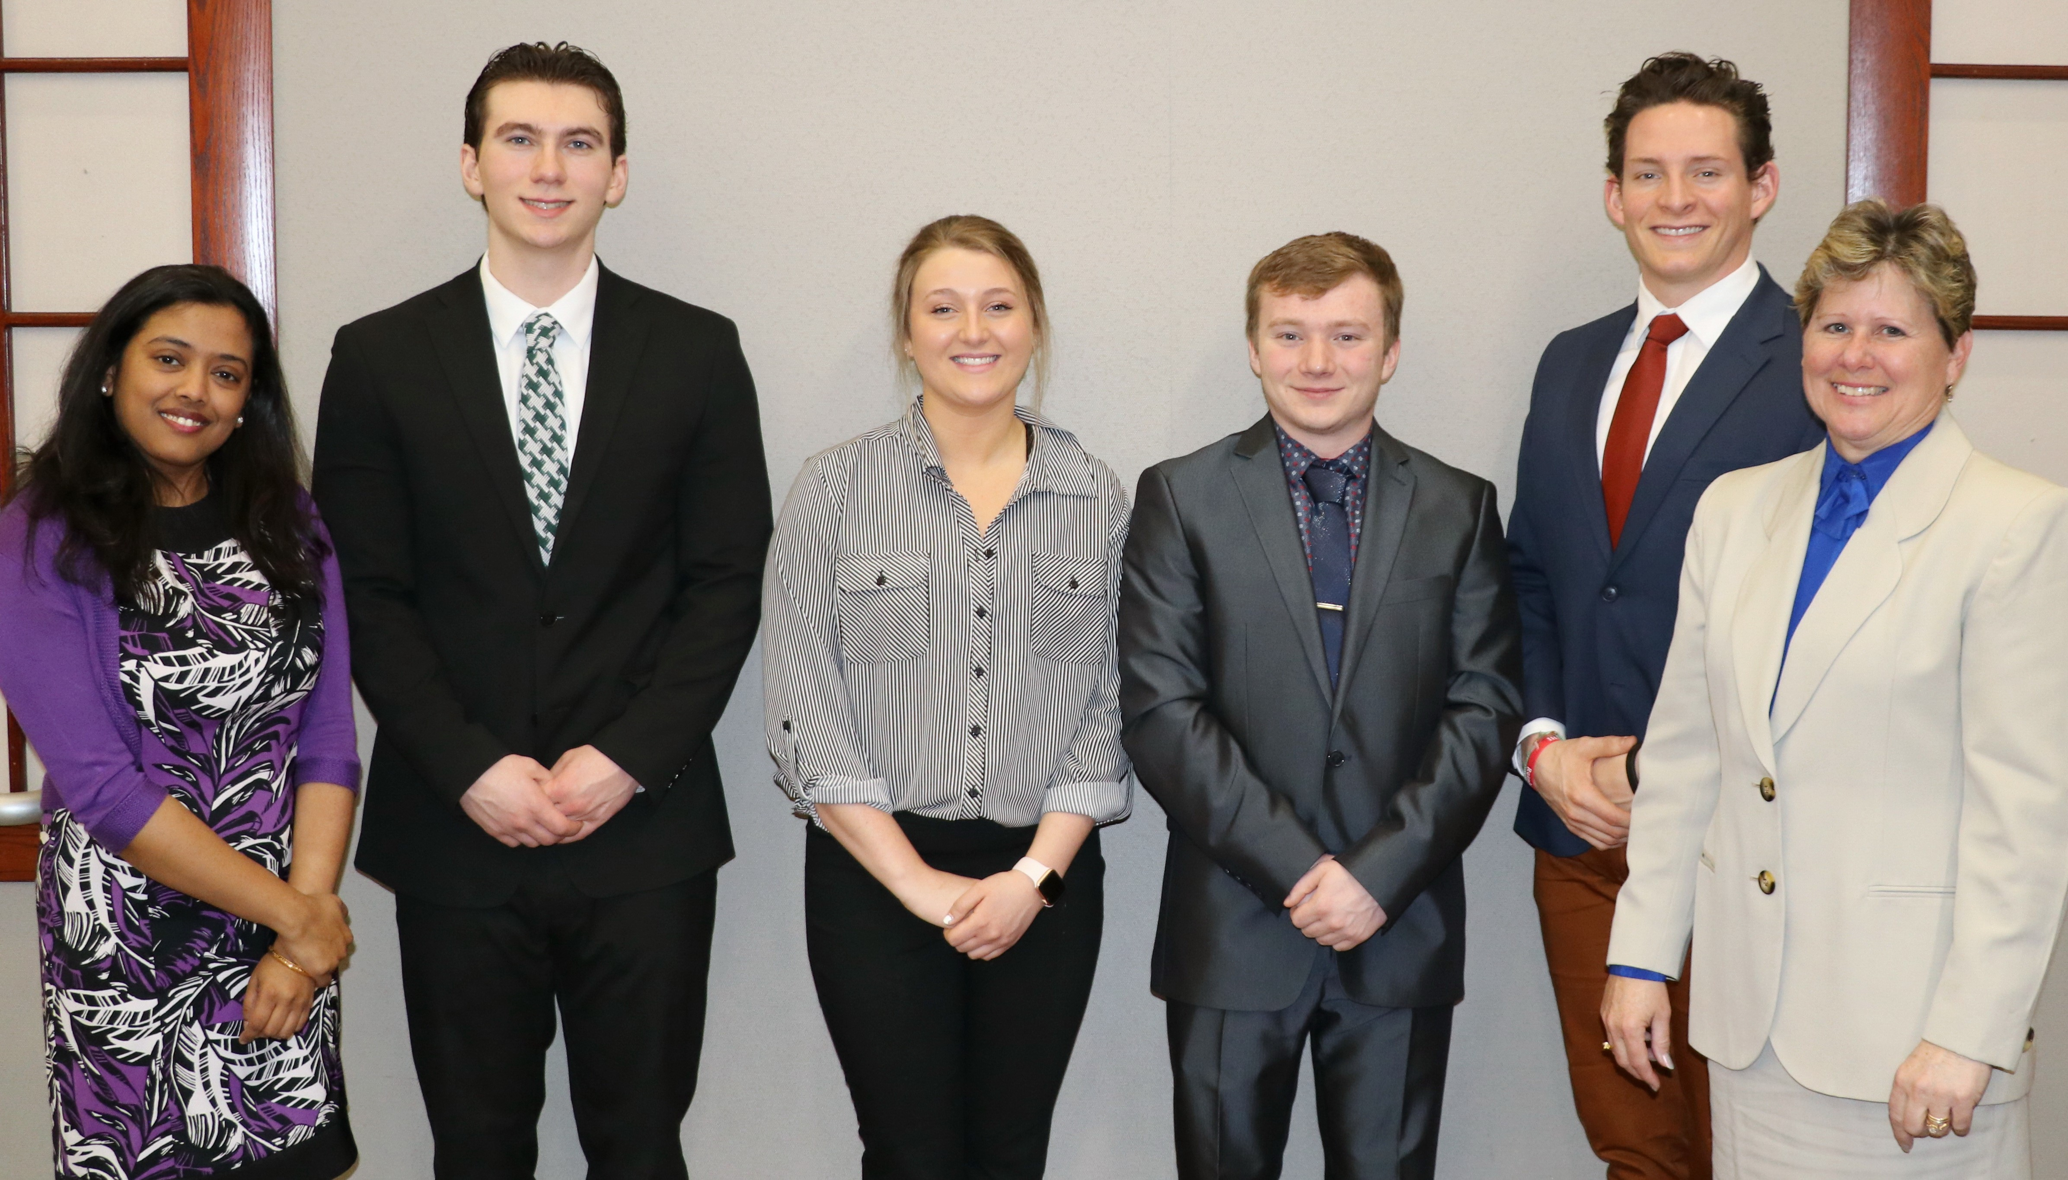Delta Mu Delta Induction (2019)

(sample, not all pictured)

**Slippery Rock University Sustainability Features**

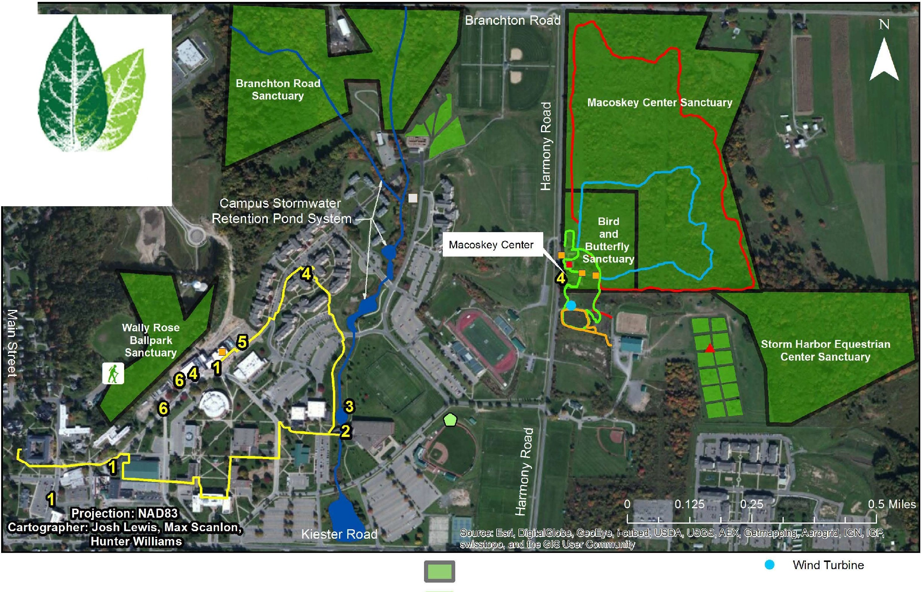

**SRU Orfha : or Su:duimd.111ily**

**WWYJ. srn .edu/susli!imibili ty**

**www .foocbook .oom /8RU!lu r<lninnbi l i 1y**

**Wildlife Sanctuaries**

1. Green Roofs
2. "Harnessing Human Energy" Project
3. Wind-Powered Lake Aeration System
4. LEED
5. Solar-Powered Rainwater Collection & Drip Irrigation System
6. Rain Gardens, Bioswales, PV- Powered Rainwater Drip Irrigation System

**Description of Sustainable Features Around Campus**

Green roofs offer both environmental and economic benefits - they decrease run-off (which very often picks up contaminants along the way) into storm systems by allowing rainfall absorption into the planting s, they protect the roof membrane from UV deterioration , greatly increasing roof life , and provide additional mass/insulating value to reduce heating/ air conditioning costs.

* 1. **"Harnessing Human Energy" Project**

An SRU Green Fund Grant was used to convert 13 elliptical machines at the ARC with technology that allows for the carbon-free generation of electricity produced from the kinetic energy of those using the machines. This project includes educational material developed to inform users as to how much carbon-free electricity is being generated and the environmental implications of their contributions.

* 1. **Wind-powered Lake Aeration System**

Uses renewable wind energy to oxygenate a retention pond on campus to inhibit the growth of harmful algae.

* 1. **LEED (Leadership in Energy & Environmental Design) Certified Buildings**

Residence Halls, Phase I: LEED Certified

Residence Halls, Phase II: LEED Silver Certified

Smith Student Center: LEED Silver Certified (in process)

Macoskey Center Harmony House: LEED Silver Certified , Existing Buildings O&M

* 1. **Solar-Powered Rainwater Collection & Drip Irrigation System**

The Smith Student Center East Parking Lot features a green area where an environmentally friendly rainwater collection system captures rainfall in an underground manhole, where a 65-watt pump distributes the water to a drip irrigation system serving the planters in this area. The pump is powered by a solar photovoltaic panel located on the roof of the building.

* 1. **Rain Gardens, Bioswales, PV-Powered Rainwater Drip Irrigation System, & Pervious Pavement**

The Smith Student Center West Parking Lot features an environmentally friendly stormwater bio swale , porous pavement, and three bioretention rain gardens that minimize soil erosion silt run-off by capturing/filtering stormwater runoff on-site, rather than channeling it to the municipal stormwater system.

**Samples of other sustainable campus features funded by the SRU Green Fund:**

* 21 filtered **Water Bottle Filling Stations** have been installed in major buildings across campus to encourage the use of reusable water bottle s, reduce the number of plastic bottles and cans used/disposed of on campus, to reduce SRU's carbon footprint , and to protect the environment. From July 2013 this program had avoided the use of over 250,000 single-use disposable water bottles.
* The **Green Bike Initiative** provides free bicycles for student use, as well as many bike stand s located around campus to encourage physical fitness and reduced reliance on automobiles.
* **Energy Dashboard Displays** installed in Residence Halls A - F aid in educating students on how their behavior can affect energy usage and related environmental emissions; these are estimated to save an estimated $1.5 million over the next ten years, reducing SRU' s carbon footprint and making the campus community more environmentally conscious .
* **Recycled Composite Plastic Benches** have replaced the deteriorated wooden benches on campus, while reusing the original bench frame s, offering a more sustainable and longer-lasting solution to replacing the original wooden benches.
* A **Biofuels Processor** converts used cooking oil from our Dining Halls to create biofuel that is

mixed with diesel fuel for use in the campus grounds equipment such as tractors and lawnmowers, reducing the campus carbon footprint.

For more information, visit the SRU Office of Sustainability at [**www.sru.edu/**](http://www.sru.edu/) **sustainability!**

**2020-2022 Principle 3 Goals:**



* To continue to expand SEA projects and market the progress
* To continue to implement the projects
  + Increase the student outreach on campus to include additional student

engagement.

PRINCIPLE 4 – RESEARCH

We will engage in conceptual and empirical research that advances our understanding about the role, dynamics, and impact of corporations in the creation of sustainable social, environmental and economic value.

|  |
| --- |
| Slippery Rock University School of Business has a strategic focus on research and the role of responsibility and sustainability. |

The following table provides a list of faculty publications related to the seventeen sustainable development goals (SDGs) developed by the United Nations, plus other research.

|  |  |
| --- | --- |
| **School of Business Faculty Publications** | |
| **2016-2019** | |
|  |  |
| **Author(s)** | **Citation** |
| Amatucci, F., et al. (2019) | Embedding Sustainability in the Entrepreneurship Curriculum, Chapter in Incorporating Sustainability in Management Education: An Interdisciplinary |
| Amatucci, F., et al. (2018) | Framing Second Generation Gender Bias: Implications for Women's Entrepreneurship, Journal of Developmental Entrepreneurship, 23(1):1-17. |
| Amatucci, F., et al. (2018) | An Interdisciplinary Framework to Deconstruct Second Generation Gender Bias and Why it Matters in Women's Entrepreneurship, Chapter in Women's Entrepreneurship: Going Beyond the Gender-Neutral Approach, Gower Publishing: United Kingdom |
| Amatucci, F., et al. (2016) | Using a Multiple Method And Mixed Mode Approach to Examine Women Entrepreneur Negotiating Styles, Intl Journal of Gender and Entrepreneurship, Vol 8, No. 1 |
| Amatucci, F. (2016) | Women Business Angels: Theory and Practice, Handbook of Research on Venture Capital, Vol. 3 |
| Amatucci, F. (2016) | Still a Man's World? Second Generation Gender Bias in Negotiating for External Equity Term Sheets, Proceedings of the U.S. Association for Small Business & Entrepreneurship |
| Anderson, M. (2017) | Customers’ Indecisiveness: A Pricing Strategy Approach, Pennsylvania Economic Review, Vol. 24, No. 2, pp. 46 – 64. |
| Anderson, M. (2017) | Mylan's Epi-cal Breach at the Top, Journal of Business Cases and Application. Vol (18) 1-11 |
| Bui, Thuy (2017) | Hedge Funds: Structure, Strategies, and Performance, Chapter 21: Issues in Hedge Fund Research, Oxford University Press. |
| Chatterjee, Anindya (2018) | “Predictive Validity For a Short Form of the Material Values Scale, Journal of Marketing Perspectives |
| Chatterjee, Anindya (2019) | Domestic Firms, Exporters and Importers: A Systemic Perspective, Theoretical Economic Letters |
| Forrest, et al., (2019) | How Sustainable and Transient Competitive Advantages Interact at a Freezing Moment of time, Advances in Systems Science and Applications. |
| Forrest, et al., (2018) | Currency Wars: Offense and Defense through Systemic Thinking, Contemporary Systems Thinking of Business and Economics Series, Springer Nature, New York. |
| Forrest, J., Ying, Y., Gong, Z. W. (2017) | Currency Wars: Offense and Defense through Systemic Thinking, Contemporary Systems Thinking of Business and Economics Series, Springer Nature, New York, ISBN: 978-3-319-67764-4 |
| Galbraith, D. (2019) | How Sustainable and Transient Competitive Advantages Interact at a Freezing Moment of Time? Advances in Systems Science and Applications |
| Galbraith, D. (2018) | The Road to Graduation: On-line or Classroom, Research in Higher Education Journal |
| Galbraith, D. (2017) | The MBA Factor: A Study of Progression. Archives of Business Research. Vol (5) 2, 135-146 |
| Galbraith, D. & Mondal, S. (2016) | University Business Students: A Destination Study, International Journal of Strategic Management, Vol. 16, No. 1 |
| Gias, Shahriar (2018) | Salespeople's Job Attitude and Organizational Ethical Climate, International Journal of Business and Applied Social Science, 3(11), 1-7 |
| Golden, John (2018) | Steepest Optimal Policies for Regulating Capital Flows and Exchange Rates, Currency Wars: Offense and Defense through Systemic Thinking (Contemporary Systems Thinking_ 1st Ed. 2018 Edition, Springer Publishing |
| Jallow, Abdou (2019) | Integrated Change and Knowledge Management System - Development and Evaluation, Journal of Information Technology in Construction, Vol., 24, pp. 112-128. |
| Jallow, Abdou (2019) | Integrated Change and Knowledge Management (ICKM) Approach for Energy Efficient Building Retrofits, Journal of Architectural Engineering, DOI: 10.1061/(ASCE)AE.1943-5568.0000380 |
| Jallow, Abdou (2017) | Integrated Change and Knowledge Management (ICKM) Approach for Energy Efficient Building Retrofits, International Journal of Knowledge Management |
| Jallow, Abdou (2017) | An Enterprise Architecture Framework for Electronic Requirements Information Management, International Journal of Information Management, Vol. 37 (5), pp. 455-472 |
| Jirasakuldech, B. (2017) | The Impact of Bonus Depreciation on Capital Spending, Advances in Taxation |
| Jirasakuldech, B. (2018) | A Multi-Country Analysis of Cyclical Asymmetry in Unemployment Rate, Pennsylvania Economic Review |
| Jirasakuldech, B. (2018) | A Game Analysisof Trade Dumping and Antidumping, Theoretical Economic Letters |
| Joo, B.K. (2016) | Enhancing work engagement: The roles of psychological capital, authentic leadership, and work empowerment, Leadership and Organization Development Journal |
| Joo, B.K. (2017) | The effects of perceived authentic leadership and core self-evaluations on organizational citizenship behaviors: The role of psychological empowerment as a partial mediator, Leadership and Organization Development Journal |
| Joo, B.K. (2018) | Servant leadership, commitment, and participatory behaviors in Korean Catholic church, Journal of Management, Spirituality, and Religion |
| Joo, B.K. (2019) | A dimensional analysis of psychological empowerment on engagement, Journal of Organizational Effectiveness: People and Performance, 6(3), 186-203 |
| Jordan, D. (2016) | Paul Argenti - Corporate Responsibility (Contributed), Sage Publications |
| Jordan, D. (2016) | Corporate Responsibility (Reviewed), Corporate Responsibility, 1st Ed., Sage Publications |
| Jordan, D. (2016) | Consumer Directed Health Plans and the Association between Medical Savings Accounts and Plan Choice, Journal of the Northeastern Association of Business, Economics and Technology (JNABET) |
| Jordan, D. (2017) | Key Influencer Analysis of Employee Choice Between Consumer Directed and Managed Care Health Plans, Journal of the Northeastern Association of Business, Economics and Technology |
| Jordan, D. (2017) | Factors Associated with Health Savings Account Funding, Pennsylvania Economic Review |
| Jordan, D. (2018) | UNITED STATES HEALTHCARE INTERNATIONAL COMPARISONS: WHAT ARE WE COMPARING? International Journal of Healthcare Policy |
| Jordan, D. (2019) | The Association of Out-of-Pocket Spending and Health Status with Consumer Directed Health Plans Choice, Journal of Healthcare Management (HJM), Vol. 64 (1) |
| Larson, S. (2017) | Key Influencer Analysis of Employee Choice Between Consumer Directed and Managed Care Health Plans, Journal of the Northeastern Association of Business, Economics and Technology |
| Li, Yi (2016) | Binary Data, Hierarchy of Attributes, and Multidimensional Deprivation, Journal of Economic Inequality, DOI:10.1007/S10888-016-9336-4 |
| McCarthy, Larry (2017) | Employment, Wages and Labor Market Dynamics in Pennsylvania: A Resource for Local Government, Pennsylvania Economic Review,, Vol. No. Pp. |
| McCarthy, Larry (2017) | Sales Associates’ Compensation: A Game Theoretic Approach, Pennsylvania Economic Review, Vol. 24, No. 1, pp. 28 – 43. |
| Mondal, S. (2017) | The MBA Factor: A Study of Progression. Archives of Business Research. Vol (5) 2, 135-146 |
| Mondal, S. (2018) | The Road to Graduation: On-line or Classroom, Research in Higher Education Journal, 35, 1-12 |
| Mondal, S. (2019) | The Innovativeness of Manufacturing Firms from the Angles of Organizational Culture, Structure and Leadership, Journal of Business, Economics and Technology, 22(1) |
| Mong, Donald (2016) | Developing the Legal Environment of Healthcare Course, Atlantic Law Journal, Vol. 18 |
| Muthusamy, Senthilkumar (2017) | Power of Positive Words: A Strategic Communication Perspective, Academy of Management Proceedings, Vol. 2017, Issue 1 (Abstract) |
| Muthusamy, Senthilkumar (2019) | Power of Positive Words: Communication, Cognition, and Organizational Transformation, Journal of Organizational Change Management, Vol. 32 (1): 103-122 |
| Nicholls, J. (2017) | Prior Satisfaction as Reasons for and Against Generosity Decisions: a Behavioral Reasoning Exploration, Marketing Management Journal, Vol. 26 Iss. 2, pp 86-100 |
| Nicholls, J. (2017) | Economic Security under Disturbances of Foreign Capital, Advances in Systems Science and Applications, {S.1.}, v. 17, n. 2, p. 14-28, |
| Nicholls, J. (2018) | Factors Associated With Health Savings Account Funding, Pennsylvania Economic Review, Vol. 25, No 2 pp. 1-12 |
| Nightingale, Jennifer (2019) | Adapting to the Era of Fast-Moving Markets with Competitive Advantages Becoming Transient, Journal of Business, Economics and Technology |
| Nightingale, Jennifer (2019) | Using Simulation Games to Teach About ERP, Journal of Computing Sciences in Colleges, 35(3) |
| Orvis, Bruce (2016) | Principles of Management Efficiency and Organizational Inefficiency, Kybernetes, Vol. 45, Issue 8, pp. 1308-1322 |
| Orvis, Bruce (2019) | General Systems Theory - Foundation, Intuition and Applications in Business Decision Making, Springer Nature Switzerland AG, Chapter 19 |
| Pak, Sunjin (2018) | Relative earnings and depressive symptoms among working parents: Contrasting gender effects of changes in relative income on depressive symptoms over time, Sex Roles, 78 (11-12), 744-759 |
| Schimmell, K. et al. (2019) | Chapter 1: Facing the Challenge Holistically, Managerial Decision Making: A Holistic System-Based Approach |
| Scott, Edward (2017) | Inclusion Strategies: The Effect of Blacks' Perspective-Taking in White-Dominated Spaces, Proceedings of the 77th Annual Meeting of the Academy of Management |
| Solano, R. (2017) | Identifying Automatic Vehicle Location (AVL) Data Completeness Issues in a Rural Transit Authority System, Asian Journal of Empirical Research, Vol. 7 (1) |
| Tallapally, Pavani (2018) | Customers are less patient, sustainable advantage becomes transient and the key for firms to succeed in fast changing markets, Journal of Business, Economics and Technology |
| Tu, Yanbin (2016) | China's E-tailing Blossom: A Case Study, Chapter in E-Retailing Challenges and Opportunities in the Global Marketplace, pp 72-98 |
| Tu, Yanbin (2017) | After Auctions Complete, What Will Buyers Do Next? -- A Case Study of Feedback Rating at eBay, International Journal of E-Business Research, 13(3), 39-56 |
| Tu, Yanbin (2018) | A Study of Tourism Market for Chinese Citizens Traveling to USA, International Journal of Leisure and Tourism Marketing, 6(1), 23-68 |
| Tu, Yanbin (2019) | Enhancing Online Auction Transaction Likelihood - A Comprehensive Data Mining Approach, International Journal of E-Business Research, 15(2), 116-132 |
| Valencia, Jesus (2016) | Measuring Intercultural Competence - An Exploratory Factor Analysis Case Study, Pennsylvania Economics Review Journal, Vol. 23 (2), pp 101-120 |
| Valencia, Jesus (2018) | Identifying Involuntary College Dropouts: A Survival Analysis Case Study, Pennsylvania Economics Review, Vol. 25 (2), pp. 101-120 |
| Valentine, David (2017) | Etudes for Parallel Programming Using the Traveling Salesman, The Journal for Computing in Small Colleges, Vol. 32 (6), pp 152-164 |
| Xu, Liang (2017) | Information Technologies and Analytical Models for Strategic Design of Transportation Infrastructure, Strategic Information Systems and Technologies in Modern Organizations, Chapter 13, p. 300 -321. |
| Xu, Liang (2018) | Combining Traditional Accounting and Value-Added Activity Measures to Maximize Supply Chain Performance, Journal of Accounting & Finance (2158-3625).Jul2018, Vol. 18 Issue 3, p80-93. |

In addition to these faculty publications, SBUS faculty delivered approximately 200 presentations on topics related to the seventeen sustainable development goals. Fifty-four grants, including two from external sources, were awarded for research related to the sustainable development goals. Dr. John Golden received funding from ASIANetwork/Freeman Foundation Fellowship Grant in 2018 and one from Internal Revenue Service VITA Grant in 2016 – 2017. Drs. Roger Solano and Sunita Mondal received a 2017 Research Mini Grant from the Center for Rural Pennsylvania’s 2015 Research Mini Grant for the project, *“Analysis of 2012 Census of Ag Data”*.

**2018-2020 Principle 4 Goals:**



* Encourage scholarly activities related to the sustainable development goals
* Continue to emphasize need for financial support for research from administration
* Promote research opportunities to SBUS faculty related to sustainable development goals

PRINCIPLE 5 – PARTNERSHIP

We will interact with managers of business corporations to extend our knowledge of their challenges in meeting social and environmental responsibilities and to explore jointly effective approaches to meeting these challenges.

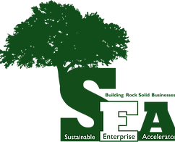A Rock Solid education refers to a solid, integral education program, from both interior and exterior. Inside the classrooms, students experience a comprehensive learning environment, inspired by passionate faculty members and guided by caring support services. Outside the classrooms, through partnership to connect with stakeholders and the community, students experience the difference they can make by applying their knowledge and skills.

“Experience the Difference”, the new tagline of SRU, sends out the promise to deliver a unique Rock Solid education. All the stakeholders, the current students, faculties, staffs, alumni, organizations, business partners, form the community SRU. We are experiencing the difference, and we are making a difference.

* **SEA Internships**

The best way to consolidate and test the knowledge and skills learned in the classroom is to apply in the real world. The students are offered such opportunity through SEA internship program by serving a variety of regional clients. It is a team-oriented environment, and students are encouraged to collaborate and delegate with fellow interns. Furthermore, an internship with the SEA provides extensive networking opportunities and a real chance to improve the face of business with sustainable objectives. Through the SEA internship program, students serve the regional clients and help to solve a variety of cases. It’s a great opportunity for the students to link what they have learned in the classroom to real-life problems as well as work and collaborate as a team. SEA also provides the interns networking opportunities and help them start building careers in the sustainable business area.

* **SEA Partnerships**

The clients of SEA are student entrepreneurs, regional entrepreneurs and existing businesses. For effective implementation of its various projects, the SEA has partnered with numerous individuals and institutions including:

1. North Country Brewing Company—Client, Marketing projects, workshops, beer releases, financial support.

2. PPG Industries—multiple project partner.

3. Penn State College of Agriculture—pending grant partner, several joint workshops, model farm plot program, beginning farmer program, food for profit, etc.

4. Reyna Foods—client sponsor, workshops and projects.

5. Intermediate Unit 4—project partner.

6. The Butler Eagle—project partner.

7. Hammersmith Digital Marketing—project partner, sponsor.

8. Pennsylvania Association for Sustainable Agriculture (PASA)—workshops, project partner.

9. Tier III—project partner.

10. Volant Merchants Assn.—client, project partner.

11. Center for Community Resources—sponsor, project partner.

12. Nonprofit Development Corporation—sponsor, project partner

13. United Way/Internal Revenue Service—VITA program project partners and sponsors.

14. Rotary International/Slippery Rock Rotary—project partners and sponsors.

15. Northwest Growers Cooperative—project partner.

16. Ideagist:(World community of emerging tech entrepreneurs), project and workshop partner.

17. Close to My Heart Foundation—project partner

18. Seed Aquaponics, LLC—project and workshop partner.

19. Big Rail Brewing Company—project and workshop partner.

20. Real World Scholars/EdCorps—project and workshop partner.

* **Partnership with the Office of Career Education and Development at SRU**

For better assisting students preparing and starting their careers in the business industry upon their graduation, School of Business has partnered with the Office of Career Education and Development at SRU. Students are encouraged to work on the resumes and interview skills, establish their online professional profiles with the team and attend the job fairs, internship fairs organized by the office. Dr. John Rindy also does guest lectures during the semester and gives lectures to business students on etiquette and professional manners during the business week.

* **Partnership with the Internal Revenue Service**

Slippery Rock University’s School of Business, in conjunction with the federal Internal Revenue Services’ Volunteer Income Tax Assistance (VITA) program, offers free, federal income tax preparation services to individuals and families earning approximately $54,000 or less annually. VITA interns are IRS trained and certified prior to preparing taxes. The School of Business at SRU has partnered with the Butler County Center for Community Resources for the past 12 years.

In 2018-2019 tax season, 23 students have been trained and helped 2,463 filings which result in over $4.2 million tax returns. The tax preparation service is being funded by grants from the IRS and United Way of Butler County in collaboration with SRU volunteer students. The primary contact for this program is Jean Bowen, Program Specialist and VITA Coordinator with Center for Community Resources, Inc. The faculty advisor for the School of Business is Theresa Phipps. Unfortunately, 2019-2020 season VITA program was cancelled due to the COVID-19 pandemic outbreak.

* **Partnership with Businesswomen**

**Women’s Solar Center**: Enlightening, Empowering, and Igniting Women in Business

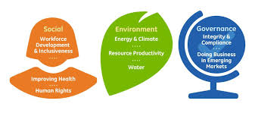

We will continue to seek partnerships with a variety of Women’s organizations like the SRU President’s Commission on the Status of Women, Women’s Center, Gender Studies, as well as many other organizations. Plans are underway to participate in the Women’s Entrepreneurship Week organized by Montclair State University. Plans are also being made to collaborate with the Women’s Business Center at Chatham University.

* **Partnership with the Business Community**

Business Advisory Council (BAC) plays an important role in our business education. The advisory boards in the School of Business support the students and programs of the SBUS, advocate for curriculum and experiential learning opportunities, and ensure programs are aligned with industry needs as well as with current market needs. These boards are comprised of community business leaders from the public, private and nonprofit sectors. Business faculty have created their own internal department advisory boards. They also sit on outside community and company boards. Within each Department, you will find one or more advisory boards. In some instances, this is a discipline-specific advisory board (ex., The Accounting Advisory Board, The Health Care Management Advisory Board, etc.), while in other instances, a more generalized Department advisory board prevails (ex., The Marketing and Management Advisory Board, the Board of Advisors).

The School of Business week is held every year, and our Business Advisory Council meets on campus and interacts with students and faculty through a variety of activities, including mock interviews, resume building, guest lectures, etiquette meals, etc. In 2020, the School of Business week was scheduled from April 6th to April 10th, 2020 with series of events and speakers. (See the next section for the detailed itinerary. Unfortunately, the School of Business week got cancelled due to the COVID-19 outbreak.) In addition, some of our business partners are recruiters at their respective companies (for example, from Allegheny Health Network and UPMC), and have worked with SRU applicants to place them in various positions.

* **Partnerships with the local and regional Chambers of Commerce**.

Specifically, we have a partnership with the Pittsburgh North Regional Chamber of Commerce, whereby many faculty members belong and students are afforded a free membership. SRU, School of Business also partner in various community events plus Dr. Diane Galbraith participated in an internship presentation with 4 other area universities to inform the Chamber members of the definition, the process, the benefits, the challenges, the evaluation, etc. associated with hosting interns.

Our business partners help our students to understand the real world and the challenges in the companies as well as their respective industries at both micro and macro levels. In the past few years, SBUS students have had guest lecturers from Alumni and others through AKPSI, Direst Selling Foundation CEOs, Joseph Gabriel Joseph Fink, Fastenal, Sales Biz, Ron Antonucci, Federated Investors, NY Life, Alcoa, Packer, Naval Audit Service, Affordable Housing Accountants, Hill Barth King, CCR Butler PA, Beckers, Brian Kalmar (Principal Software Architect), UPMC Fellows Panel Event.

Additionally, numerous faculty sit on external boards in the business community. A sample list includes: Board of Visitors, Board of Directors- Education Partnerships, Board of Directors- Pittsburgh American Marketing Association (AMA), Board for Valley Points YMCA, Deer Lakes Council, North East Ohio (NEO)Tech Collaborative, etc.

* **Partnership through Internships**

Other than SEA and VITA internship programs, students in the School of Business are encouraged to take internships with local, regional, national or international organizations. Each major has an option for an internship as an elective that include up to 12 credit or 480 hours. An average of 15 – 25 students take internships each semester.

Students and their respective organizations understand the value of the internship as they can be mutually beneficial. Through the partnership with local and national businesses and organizations, the students are exposed to how the organizations operate and can apply what they have learned in college to solve business problems from the real world. The interns are mentored and evaluated by the supervisor and received a final written evaluation report. The positive interactions between our internship partners, students and faculties sometimes can lead to formal job offers to School of Business students directly. Dr. Diane Galbraith is the faculty coordinator for the SBUS internship program.

* **Partnerships through Service Learning**

As described earlier, many SBUS courses include semester-long projects whereby the students work as consultants with external stakeholders to solve business problems. These assignments are great opportunities for real-world experience, while assisting the respective organizations.

In some courses in the SBUS curriculum, the students have the opportunity to serve as consultants to assist existing business organizations in solving their business problems. Such project assignments are a win-win for both our students and the business organizations. For example, other than VITA program mentioned above, other organizations include Central Blood Bank of Pennsylvania, Boy Scouts of America, Butler Eagle Newspaper, Convict Choppers, Eat N’ Park Incorporated, National Marrow Donor Foundation, Northeast Ohio (NEO) Tech Collaborative, Beyond Plastics Poster Session (President's Commission on Sustainability), Sustainable Business Consulting Students (North Country Brewing), Butler County YMCA, Valley Points YMCA, Outdoor Immersion, National Grind Coffee & Tea, Irene Hooks and Tabea Ohle, Conquer Entertainment, Pittsburgh Passion, LEONE Foundation, Electronic Payment System, AI Chabot System- Giant Eagle, SRU-Energy Conservation Committee, etc.

The impact of incorporating those service-learning projects by business faculties are student’s understanding of numerous aspects of cultural diversity, social awareness, accountability, as well as their critical thinking and decision-making ability under uncertainty.

* **Partnership with Professional Associations**

Professional association affiliations are important to keeping current in our respective disciplines as well as providing networking opportunities for our students and the University. Numerous internships and job opportunities for our students have been derived from these relationships. Additionally, we have brought exciting programs, speakers and events to campus based on these professional contacts.

Dr. Jeananne Nicholls, who currently serves as a fellow for the Direct Selling Foundation, created a day-long direct-selling speaker series/conference. Three prominent CEO’s from reputable direct selling companies spent the day educating both students and faculty about the industry and about running a business.

Supervised by Dr. Jeananne Nicholls and Dr. Kurt Schimmel, the SRU student chapter of American Marketing Association participated in AMA’s Annual Plan competition, the AMA’s International Collegiate Case Competition on “the Wall Street Journal”, in which our students tied with several other well-known universities and earned a “commendable” designation. They also participated in Pittsburgh AMA Regional Case Competition, “New York Life," which is authored by SRU faculty.

Students in Dr. Melanie Anderson’s auditing class participated in the Institute of Internal Auditors (IIA) Pittsburgh Chapter student case competitions and fraud seminar along with faculty. Competing with twenty-six teams from universities in the Pittsburgh Area, a team of four students from Auditing class supervised by an Accounting professor placed second at the Institute of Internal Auditors and Pennsylvania Institute of Certified Public Accountants Fall Case/Presentation Contest in 2019, winning $1,000 cash award.

* **Other SRU’s Partnership Related to Sustainability**

The Slippery Rock University office of Sustainability received a $25,000 grant from the Scott Electric Foundation (the philanthropic organization of Scott, Electric, a wholesale electrical distributor and supply store based in Greenburg) to create a workforce development training program that will be used by companies in the food industry to incorporate sustainable practices and compliance. SRU will partner with Kroff, Inc., a Pittsburgh-based company that provides wastewater treatment and recycling services. As part of the grant, two SRU student interns, will work with Paul Scanlon, SRU director of sustainability; a Kroff representative; and an SRU faculty member in summer 2020 to develop a training manual for a variety of companies to follow for guiding sustainable practice, like the proper treatment of food byproducts and wastewater.

During the COVID-19 pandemic, three SRU faculty, Jack Livingston, Jon Shumway and Sam Thangiah have been operating a group of eight SRU 3D printers at home to facilitate the construction of more than 100 face shields. The PPE are donated to Allegheny Health Network Grove City Hospital and Slippery Rock Volunteer Fire Company and Rescue Team to aid in the fight against the pandemic.

* **Students Clubs and Organizations**

In the School of Business, we also have the roundtable with student clubs and organizations participated, including: Alpha Kappa Psi, American Marketing Association, Society for the Advancement of Management, Finance & Economics Club, Future Healthcare Leaders, Rock Solid Investment Club and Student Accounting Society.

**2020-2022 Principle 5 Goals:**



* Continue to increase and leverage partnerships within the university and

with external stakeholders

* Search for additional community partners to further the

PRME initiatives

PRINCIPLE 6 - DIALOGUE

We will facilitate and support dialogue and debate among educators, business, government, consumers, media, civil society organizations and other interested groups and stakeholders on critical issues related to global social responsibility and sustainability.

The School of Business has been quite active in pursuing a dialogue regarding PRME principles.

**Business Advisory Council**

The Business Advisory Council (BAC) have Board of Advisors (BOA) for Accounting, Economics and Finance (AEF) Department, the Marketing & Management (MM) department., and the HCAM as well as IS department. The board is a combination of external stakeholders and professionals in their respective fields in these departments. In addition, some of them are SRU alumnae.

For the AEF department, the committee consists of 15 to 20 people in the accounting, economics and finance field from the Pittsburgh area. The Board meets twice a year, fall and spring semesters. Several of the BAC members have come to speak in the classroom to share their industry experience. As an example, Nicole Saldamarco is scheduled to speak at the Master’s in Accountancy Risk Analysis and Internal Control course on April 27th. Some of the Advisory Board Members are scheduled to meet with the AACSB peer review chair on March 26th. Several of our students have received an internship or a job offer from our Business Advisory Council members.

For the MM department, the committee consists of 12-15 people, including faculty and several business leaders from Butler and Pittsburgh area. The committee meets every fall and spring. In November 2019, Dr. Diane Galbraith, Chair of Board of Advisors (BOA) presented to the Board of the School of Business. She emphasized how the BOA can help to further scale the impact of PRME and, through this, support achieving a more sustainable future. Dr. Galbraith outlined how businesses can become signatories of the U.N. Global Compact. This could be achieved by a voluntarily commitment to advance ten universal principles on human rights, labor standards, environmental protection and anti-corruption. She emphasized that PRME plays a key role in shaping the mindsets and skills of future leaders. The organization has a clear purpose and 17 Sustainable Development Goals. It is important to ask, what can we do and what can students do to impact the future? If you see a problem, it can be changed through an organization and/or give back programs. PRME is a differentiator and Slippery Rock University believes in the process. The MM department BOA discussed PASSHE System Redesign, School of Business Reorganization and Program Development, Enrollment Trends, AACSB Timeline & Strategic Plan, and Competencies and Trends in the Workforce and Alignment with What is Taking Place at SRU, Internships, student scholarships, etc. during their meetings.

Within the HCAM/IS department, there are two separate BACs. The IS department has a Board of Visitors which meets with them 2-3 times a year at SRU to discuss their curriculum and what they can do to help SRU students. The Board of Visitors also conduct an industry awareness night where they bring in industry professionals to discuss their jobs and IS jobs in general. And they hold resume and interview workshops, which lets the students get feedback on their resumes, and the interview workshop gives them practice with phone and in-person interviews. HCAM department is in the process of reconstituting their advisory council. Due to faculty medical leave and project requirements, the new entity is still in development stages to create new bylaws and membership development. The program has remained in close discussions with several prior members for continued engagement and program input.

Advisory Board Members (2020):

Joseph Fink, RGP

Joseph Gabriel, Packer-Thomas

John Gilliland, Mercer County State Bank

Charles Gottshalk, Chip Gannassi Racing

Stephen Horne, Hill, Barth, & King

Philip Kennedy, Retired Faculty Member

Jacques Moye, Clark-Hill

Matthew Pullins, PNC

Angele Stoebener, F.N.B Corporation

Dominic Verdi, Ernst & Young

Melissa Visco, US Government-Patent and Trademark Office

Nicole Saldamarco, Arconic

Calvin Slegal, Ernst & Young

Shane Jacobovic – Covestro

Jeff Black – PPG

Jen Crowley – Astrobotic

Robert Solano – SAP Ariba

Tracy DeLucia – Giant Eagle

Jessica Lynch – Lynch Legal Consulting, LLC

John Nabozny – BNY Mellon

Lyndse Costabile – FunD Av Consulting

Shannon Baker – Gatesman Agency

Bill O’Rourke – Merit Leadership, LLC, ALCOA

Bill Ringle – System Ringle

Paul Lamping – Lamping and Associates, LLC

**School of Business Week**

Business Student Round Table was formed to promote events and opportunities to the School of Business students. The Round Table includes: Alpha Kappa Psi, American Marketing Association, Finance and Economics Club, Future Healthcare Leaders, Rock Solid Investment Club, Student Accounting Society, Society for the Advancement of Management. The mission is to create opportunities for students to connect with their major, their peers, and to their professors. To support this mission Business Round Table will host a week-long festivity for the School of Business, which will be held during the School of Business week, April 6-10*, 2020. The School of Business week has a variety of different events, including brining regional business leaders to campus to talk to students sharing their success stories, their initial transition from school to work, and the initiatives taken by these speakers to achieve success. SBUS strives to showcase the opportunities that exist for our students in the local region of western Pennsylvania.

*This year, the first eventwill be Coffee and Donuts held on April 6th from 8:30 AM – 10:00 AM, where students will have the opportunity to start the week on a sweet and energized note. On April 7th, keynote speaker Rebecca Lucore, **Head of Sustainability and Corporate Social Responsibility**, Covestro, will be coming to SRU. April 8th from 12:00 PM – 1:30 PM Round Table will be hosting Games of Chance in the Quad. Students will have the opportunity to compete in yard games with their peers. Also, on April 8th from 4:00 PM – 7:00 PM Round Table will be hosting a Ropes Course event at the SRU Leadership Center. For many students, this could be the first time they are using the exciting Ropes Course recently built by SRU. April 9th from 12:30 PM - 1:45 PM an Etiquette Luncheon (organized by the Career Services Office) will be held in room 104 at Weisenfluh. To end the week of festivities, Round Table will host a Debate on Fiscal Sustainability on April 10th from 12:00 PM – 1:00 PM.

* The event got cancelled due to the COVID-19 outbreak.

Some of the recent Business speakers include:

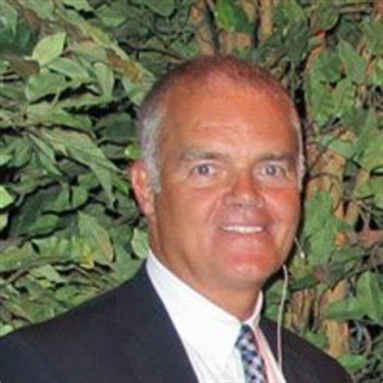

* Bill O’Rourke – Merit Leadership, LLC ,Speaker, Board of Advisors member, former ALCOA Executive, Consultant
* Raul Valdez Perez - Vivisimo Inc.
* Enzo Santilli - MarketSphere Consulting
* Amy Veltri - Novel Geo-Env.
* Steve Smith - Plus Consulting
* Paul & Lisa Scarmazzi - Hawthorne Partners, Inc.
* Laura Deklewa - Allegheny Construction Group
* Dennis Lejeck - Black Knight Security
* Janice McGee - The Empyrean Group
* William G. (Gus) Pagonis – Genco

**Personal Finance Workshop for Slippery Rock High School**

For the third year, Dr. Diane Galbraith and Dr. Melanie Anderson were invited by the high school Superintendent to conduct a workshop for Career Day. On Oct 1, 2019, Drs. Galbraith and Anderson conducted a workshop for high school students of Slippery Rock Area school that emphasized personal finance tools, budgeting and financial stewardship.

**School of Business**

PRME initiatives and outreach were discussed at various department meetings and presented at the faculty retreat in the School of Business, SRU.

**Volunteer Income Tax Assistance (VITA)**

The VITA program offers free tax preparation service to the community and is a great learning experience for Slippery Rock students. Individuals and families earning less than $50,000 in annual income are eligible for this free program. The students are IRS-certified volunteers and provide free basic income tax return preparation with electronic filing – for both federal and state taxes. The VITA Program is run with the Center for Community Resources out of an office near campus on 165 Elm Street in Slippery Rock. For the 2018-2019 tax season the program completed 2,463 returns refunding over $4.2 million dollars. 23 students helped families get real refunds at no cost to the families. The students gain valuable tax preparation experience, and families get free tax preparation services. This is a great resume item as it increases students’ professional competencies. Additionally, students gain the experience of community service, and many of them feel highly rewarded after they help a family get a sizeable return.

**SRU combines 3D printing resources to create face shields for local health care workers**

Jack Livingston, Slippery Rock University associate professor of geography, geology and environment, helped lead a project where SRU faculty, staff and students created face shields for local first responders and health care workers using SRU’s 3D printers. Eight 3D printers from various SRU departments have been used to create more than 100 face shields. Livingston delivered 80 face shields to Allegheny Health Network Grove City hospital, while Kris Benkesser, Director of SRU's Student Health Services, delivered another 20 to Slippery Rock Volunteer Fire Company and Rescue Team.

**2020-2022 Principle 6 Goals**:



* Continue with dialogue with internal (students, other Colleges within the university, etc.) and external (Business Advisory Council members, Chamber of Commerce members, etc.) about the sustainable development goals.

* We strive to continue dialogue with internal (students, other Colleges

within the university, etc.) and external (Business Advisory Council members, Chamber of Commerce members, etc.) about the sustainable development goals.

* Evaluate the Business Advisory Council to further diversify its membership.

**Appendix 1. The State System, Slippery Rock University, School of Business Strategic Goals and PRME Principles**

|  |  |  |  |
| --- | --- | --- | --- |
| **PASSHE GOALS** | **SRU UNIVERSITY GOALS** | **SCHOOL OF BUSINESS GOALS** | **PRME Principles** |
| 1.Ensure academic program excellence and relevance  2. Increase accountability and transparency; focus on results  3. Enable more students to obtain credentials that prepare them for life, career and the responsibilities of citizenship  4. Develop new funding strategies, diversify resources and manage costs to preserve affordability | 1. Offer a quality, flexible, agile and integrated curriculum and co-curriculum to develop the intellectual, social, physical, and leadership capacities of students.  2. Maintain an unwavering focus on success for all students  3. Fuel learning with powerful pedagogies and transformational experiences.  4. Provide a caring campus experience supported by quality housing, dining, recreation, health, safety and administrative services.  5. Increase financial resources, enhance physical facilities, employ cost-effective technology and adopt sustainable practices  6. Engage alumni and friends in the life of the university  7. Support external communities through programming and expertise  8. Increase enrollment while enhancing student quality and diversity  9. Attract, retain, and develop highly qualified and diverse faculty, staff and administrators. | 1. SBUS is committed to providing high quality curriculum designed to make students ‘career ready’. We emphasize excellence in teaching incorporating high impact practices to facilitate student engagement.  2. SBUS faculty and staff in conjunction with the University administration are highly engaged in the recruitment and retention of quality and diverse students.  3. SBUS strives to recruit and retain academically qualitied, experienced and diverse faculty and staff.  4. SBUS faculty conduct scholarship that enhances student learning.  5. SBUS is engaged with faculty, students, its advisory board, University staff and other external stakeholders.  6. SBUS strives to develop principle-centered students who are responsible global citizens. | **Purpose:** Develop the capabilities of students to be future generators of sustainable value for business and society and to work for and inclusive and sustainable global economy.  **Values:** Incorporate into our curricula and academic activities the values of global social responsibility as portrayed in international initiatives such as the United Nations Global Compact  **Method**: Create educational frameworks, materials, processes and environments that enable effective learning experiences for responsible leadership.  **Partnership:** Interact with managers of business corps to extend our knowledge of the challenges in meeting social and environmental responsibilities and to explore jointly effective approaches to meeting these challenges.  **Dialogue**: Facilitate and support dialogue and debate among educators, students, business, government, consumers, media, civil society organizations and other stakeholders on issues related to global social responsibility and sustainability |