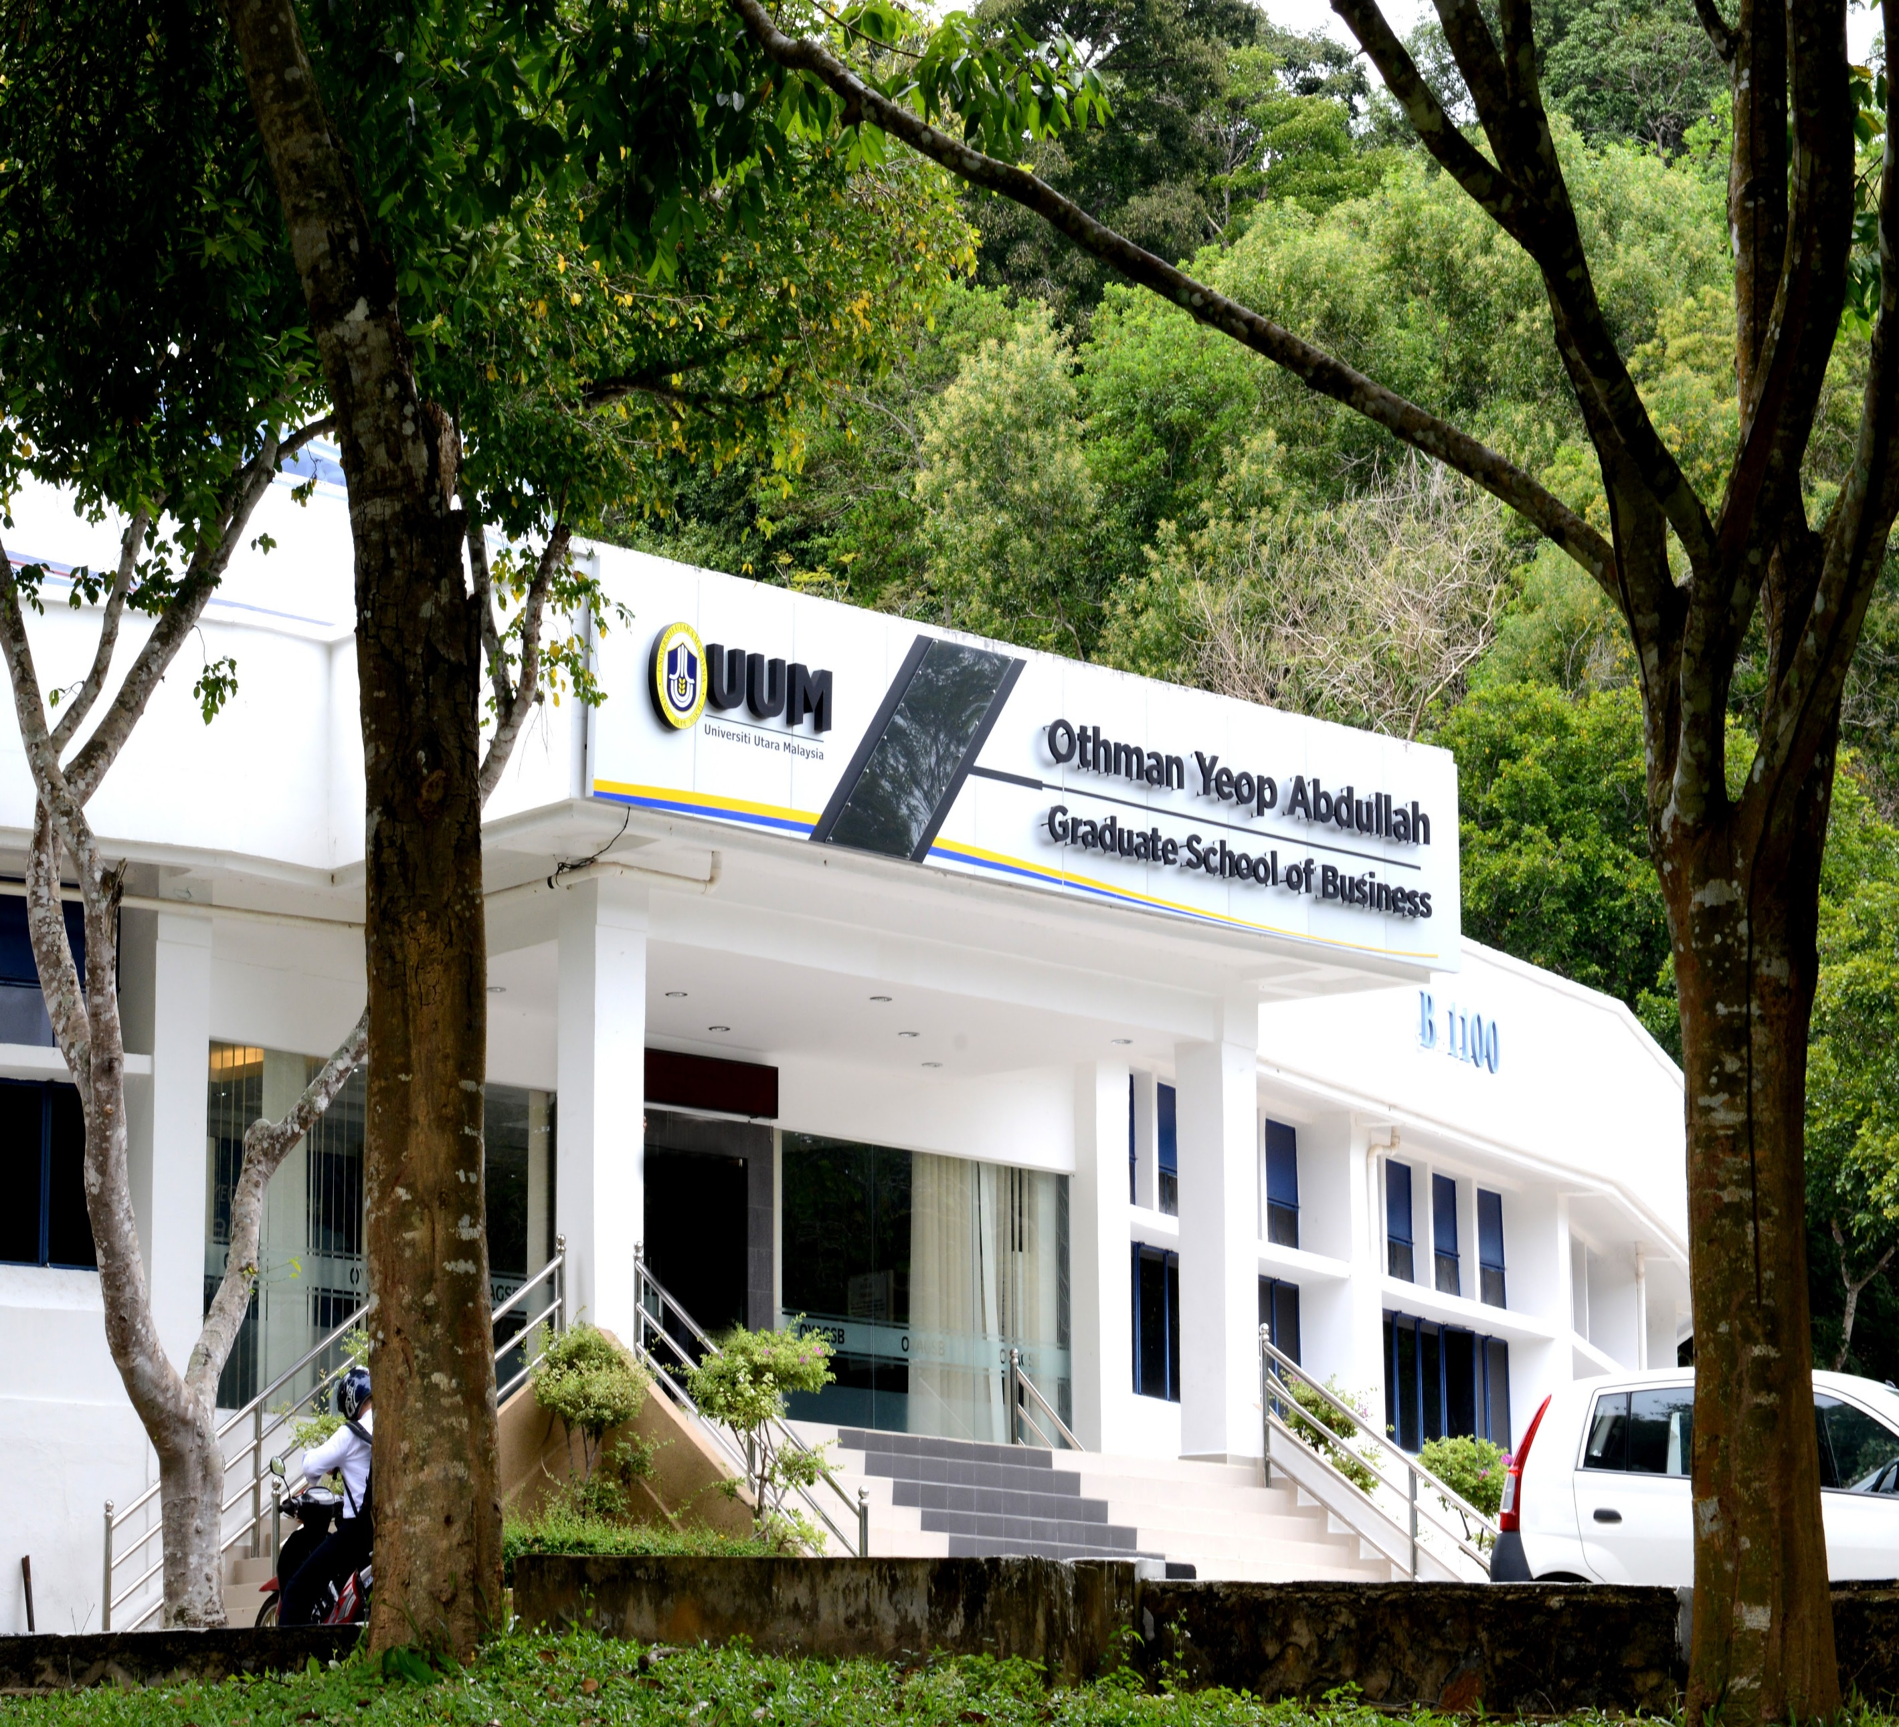

Renewal of Commitment to PRME

The Othman Yeop Abdullah Graduate School of Business (OYAGSB), Universiti Utara Malaysia (UUM) is committed to the Principles of Responsible Management Education (PRME). We believe that business schools today have an important role to play in moulding students into socially responsible managers and in responding to the social and environmental challenges that the world is confronted with. This report offers examples of past initiatives as well as ongoing ones that have been undertaken in support of the aforementioned beliefs. We are proud to be a PRME signatory and hereby express our continued commitment to PRME principles.

Professor Dr Shahizan Hassan
Dean
Othman Yeop Abdullah Graduate School of Business

OYAGSB SHARING INFORMATION ON PROGRESS (SIP) PRINCIPLES FOR RESPONSIBLE MANAGEMENT EDUCATION (PRME)

This SIP provides a report on the activities of the School from 2018 to 2019 under PRME

OTHMAN YEOP ABDULLAH GRADUATE SCHOOL OF BUSINESS, UNIVERSITI UTARA MALAYSIA

Universiti Utara Malaysia (UUM) was established in 1984. Although the Graduate School was established in 1991, the Othman Yeop Abdullah Graduate School of Business (hereinafter referred to as ‘the School’ and/or OYAGSB), in its present form and structure, was established in 2011. Throughout 2016-2017, the School underwent some ‘transformational’ episode in that it had made a conscious decision to revisit its current practices and ways of doing things. The School as a whole underwent some ‘soul searching’ in its attempt to meet the University’s aim to place OYAGSB on a higher world ranking. The episode culminated in changes in the School’s mission and vision toward this lofty goal. While still maintaining the philosophy and ideal that the School should deliver management and business education to develop responsible future business leaders, the vision and mission had been changed to spell out what the School aspires to achieve in light of the future trends and challenges facing business schools all over the globe. Consistent with the new vision and mission, the School also embarked on revisiting the values that guide the School’s way of doing things, consistent with PRME principles.

Vision: To be a premier graduate school of business
Mission: We nurture leaders who make a difference in a responsible and sustainable manner Core Values:
O— Openness: We inculcate openness to new possibilities in pursuit of excellence.
Y— Yearning: We yearn for a continuous innovation-focused education and excellence in scholarly work.
A— Accountability: We foster the culture of accountability, responsibility, integrity and professionalism in our pursuit of excellence.
G— Growth: We believe in continuous efforts for growth to meet the demands of an increasingly complex and dynamic environment.
S— Sustainability: We strive to achieve our goals for sustainable future in our continuous pursuit of excellence.
B— Balance: We strive for work-life balance in our quest for excellence.

Client Charter:

Towards realising our vision to become a premier graduate school of business and in line with Universiti Utara Malaysia's motto of "KNOWLEDGE, VIRTUE, SERVICE", we hereby pledge with complete resolve and commitment to:

o Demonstrate high integrity and ethics in delivering our programmes and curriculum.
o Create knowledge and ideas that advance the practice of management.
o Prepare students to be thoughtful and effective leaders.
o Create an environment that recognises the value and potential of each individual.
o Create a culture of intellectual curiosity.
o Pursue opportunities that serve the society, environment and economy better.

The change in the School’s vision and mission necessitated that the School’s organisation had to be relooked as well. The years 2018-2019 saw a renewed focus on student experience. In keeping with the Client Charter, the School continues to provide the necessary support and environment to students so that they can get the best learning experience. The School now has dedicated staffs that oversee Alumni and Corporate Relations, Student Experience and Customer Care, and Career Advisory Services. The Accreditation, Rankings and Reputation Management Office was re-organised to take care of the School’s accreditation/certification exercises and to work closely with other units to ensure that the School’s strategies and action plans are well implemented.

Corporate and Executive Development Education (CEED) Unit/Office was also re-organised with the employment of a full-time director to oversee the whole business operations. In making an impact to our students and business community, the CEED focused on leadership development and training programmes at various levels of the organisation by providing participants with enhanced and advanced skills and competencies for business sustainability.

The School further showed its obligations to PRME principles by getting its management practices certified by the International Standard Organisation (ISO). ISO9001:2015 is a mark of quality in the School’s practices. The certifications necessitate that the School develop an Integrated Management System (IMS), spelt out in the IMS Manual that is reviewed annually to ensure that the School’s objectives and strategies are met by considering the associated risks. To strengthen our practices in line with these certifications, the School has several policies, which are shared and communicated to our key stakeholders. Some of the policies include:
• Code of Conduct
• Social Responsibility Policy
• Environmental Policy
• Examiner Selection Policy
• Recruitment Policy
• Research and Publication Policy
• Teaching and Learning Policy

Programmes

The School offers four academic programmes, i.e. MBA, DBA, Doctor of Management, and PhD. The School also continues to administer other postgraduate programmes offered by the UUM College of Business, such as Master of Science and PhD programme in other management areas.

The School has embarked on MBA programme review to ensure that it remains relevant and consistent with the School’s vision and aim and successfully relaunched it. In reviewing the programme, the School has considered all the suggestions made by AMBA. It has also mapped it to the Chartered Management Institute Level 7 qualification (Diploma in Leadership and Management) and secured Chartered Manager Status for new graduates. Topics related to sustainability, ethics, and social responsibility have been embedded in various courses/modules to reflect our awareness and commitment to sustainability. In fact, the embedding of these topics in our curriculum has been the key emphasis in our revision exercise.

On our doctoral programmes, the School has offered increased support to ensure that our research students develop the necessary skills to become independent and ethical researchers. Research methodology workshops and other experience-enrichment programmes were organised to buffer compulsory modules on research methodology and academic writing. In relation to the research enhancement exercise, the School also is a member of the European Doctoral Programmes Association in Management and Business Administration (EDAMBA). Through such membership, our research students will be able to benefit, especially from the various resources and materials available. The membership also provides an essential platform for our research students to gain international exposure through various activities and programmes offered by the Association.

Research and Publication

The School prides itself as a research-led school where teaching and learning are informed by research. Hence, research is one of the critical areas the School gives much focus. The School continues to concentrate on areas in sustainable development, entrepreneurship, community building, corporate governance and ethics, and leadership and innovation, to name a few. Faculty members are expected to publish in ABS Guide journals and the top three tiers of ABDC journals.

The School’s PhD programme has been key in enriching the research and publication exercise. Our PhD programme focuses on specialist/niche areas, such as Business Information System, Leadership and Organisational Behaviour, Consumer and Market Analysis, Financial Analysis and Policy, Innovation and Entrepreneurship, Industrial and Development Economics, Corruption and Accounting Fraud, Corporate Governance and Contemporary and Critical Accounting, Operations, Procurement and Supply Chain Management, Global Human Capital and Talent Management, Critical Islamic Finance and Banking, and Business Communication Strategy. These important research areas reflect the School’s commitment to PRME initiative and values. In addition to the PhD programme, the School’s DBA and Doctor of Management programmes have also supported the research and publication agenda. However, unlike the contribution to theoretical knowledge, the latter’s research programmes are professional and practice-based, offering practical recommendations for the improvement and betterment of the community.

The School has also managed to strengthen its research activities by consolidating the previous five competency centres into a single research centre of excellence, called the Institute for Leadership, Innovation and Change, or iLead4Change for short. As the name indicates, the research centre concentrates on research on leadership that impacts practice and policymaking from grants given by the government or external institutions.

Another area the School is emphasising is the development of teaching cases for use in class or CEED programmes. The use of cases in the curriculum delivery helps students to reflect on their own organisation’s practices and become effective decision makers and leaders. While the development of the cases was still at the nascent stage, the School is hopeful that such activity will pick up in the immediate future.

The School’s in-house publication or journal, previously known as the International Postgraduate Business Journal which was primarily targeted to research students, has been rebranded to be more inclusive and open to a much wider target group who is interested in sharing their research works and findings. Now, the publication outlet is called the Global Business Management Review. The name change reflects the concern the School shares about trends, challenges, and issues the business community is facing.

Networking

The years of 2018-2019 also saw the School forging new collaborations and partnerships with various institutions, locally and internationally, to strengthen our networking. At the local front, the School is an institutional member of the Malaysian Institute of Management, the Institute of Marketing Malaysia, and the Malaysian International Chamber of Commerce and Industry. The School collaborates with these institutions primarily in CEED programmes to develop business leaders in the country. Besides these organisations, the School has partnered with the following companies in the delivery of its non-academic programmes, such as the Cambridge Judge Business School of the University of Cambridge, the National University of Singapore, AON, PricewaterhouseCoopers, Centre for Creative Leadership, Accenture, and Development Dimensions

International which is an international human resources and leadership development consultancy based in the United States.

The School also is part of the Globally Responsible Leadership Initiative (GRLI) to show our commitment develop globally responsible leaders via our programme offerings. It is also an international member of the Chartered Association of Business Schools in the UK, which previously tended to close membership to business schools outside the UK. Through affiliation with these institutions, the School learns about the current trends, issues and challenges that are affecting business schools worldwide in annual meetings. Such knowledge is then used to inform the School about the necessary adjustments in the way it operates for it to be relevant.

We also invested in building further our international links. The School is working with several Schools in on the Schools in China, Russia and the Gulf Countries. The School will continue looking for appropriate European and North American partners, but as the School would like to present itself as a very strong Asian player, the priority lies in building an excellent network with the Asia based schools.

CSR Activities

The School continues to carry out several CSR activities for the benefit of the community. The following lists the CSR activities organised by the School.
- Every year, without fail, the School make donations to its cleaning staff to help their family with the preparation for festive seasons. Also, last year, in conjunction with Ramadhan and Eid, the School donated cooking oil and used clothes and other items in collaboration with the Islamic Relief, a UK based NGO, and a local NGO to the community in need.
- The Alumni Club of MBA of the School also contributed by organising a Free Market programme with the aim to assist the needy in selected area in Kuala Lumpur and Sintok. The programme involved giving away used clothes and food items.
- A Green Awareness Day was another contribution of the School toward the preservation of the environment by creating the awareness of the community. The Green Awareness Day was also carried out in support of the School’s ISO14001 and SR10 initiatives.

Dialogue Sessions

To facilitate dialogue and debate in the community about issues that matter to the School and the broader community, the School has organised various events and programmes. One of our regular programmes is the BizTalk Series, which feature local and international guest speakers to talk about topics that are currently affecting the society, the country and the world. Some of the topics discussed in these Series include:
- sustainable leadership and change in a fluid and divergent environment
- building peace through corporate-community relations
- protection of Mother Earth
- a forum on current Malaysian economic issues
- entrepreneurial behaviour and leadership in a digital economy
- developing society through social entrepreneurship
- Talent that matters

Continuous Commitment

The School is committed to ensuring the six core principles, and values of PRME are reflected in its programmes and activities.

Contact:

Professor Dr Shahizan Hassan
Dean
Othman Yeop Abdullah Graduate School of Business Universiti Utara Malaysia
06010 UUM SINTOK
Kedah Malaysia
Tel: 604 -9287100
Fax: 604 - 9285220
Email: shahizan@uum.edu.my

