Centre for Sustainability and CSR

(Work details from 1 June 2018 – 3 April 2019)

Academic Engagement
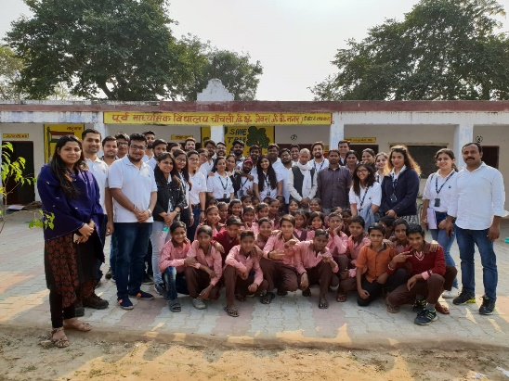
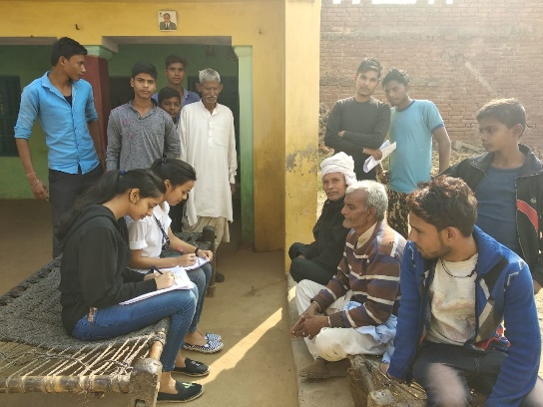
The first-year students of PGDM, PGDM (International Business) and PGDM (Retail Management) participated in the “Community Immersion Programme” integrated with the Responsible Business module. The students conducted household survey in villages located in Jewar block of Gautam Buddha Nagar district in Uttar Pradesh. The details of field visits are given in Annexure 1.

New Book on Responsible Business and CSR “Demonstrating Responsible Business: CSR and Sustainability Practices of Leading Companies in India.
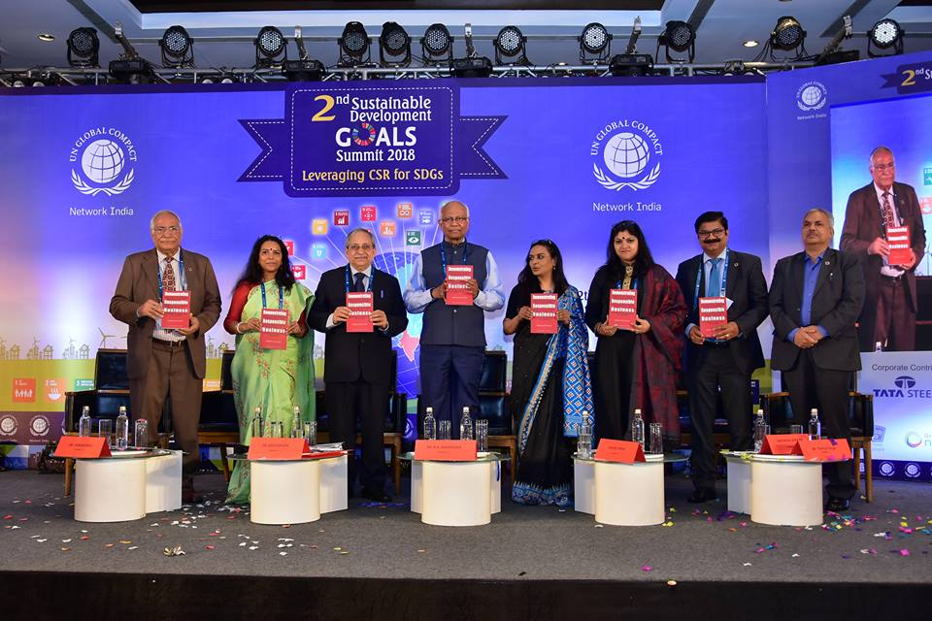
The book entitled “Demonstrating Responsible Business” authored by Dr. Vineeta Dutta Roy, Associate Professor and Lead CSR at Birla Institute of Management Technology (BIMTECH) was pre-launched during the GCNI 2nd Sustainable Development Goals Summit. The Summit with the theme “Leveraging CSR for SDGs” was held on 12th December 2018 at Mumbai. The Book was formally released during the 19th FICCI- Annual CSR Summit and Awards by Smt Rajashree Birla, Chairperson Aditya Birla Centre for CSR, Ms Jyoti Vij, Deputy Secretary General FICCI and Ms Uma Seth, Director FICCI CSR Centre.

Best CSR Author of the Year Award

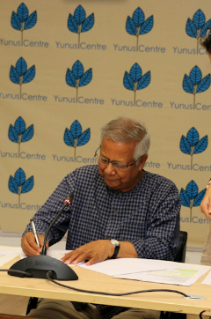
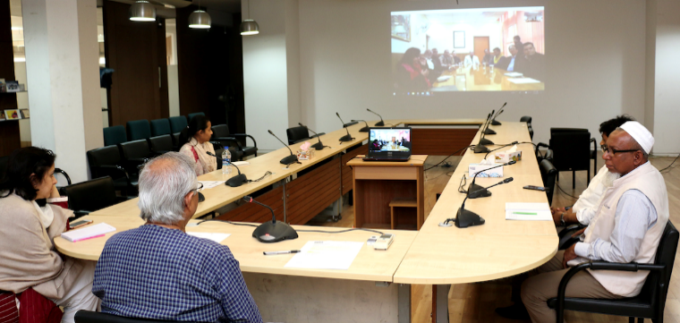
MoU signed with Yunus Centre, Dhaka
An MoU has been signed on 11th February 2019 with Yunus Centre, Dhaka for the establishment of Yunus Social Business Centre (YSBC) at BIMTECH.

Consultancy and Capacity Building
Training programme on Need Assessment and Impact Evaluation for the executives of JK Organisation
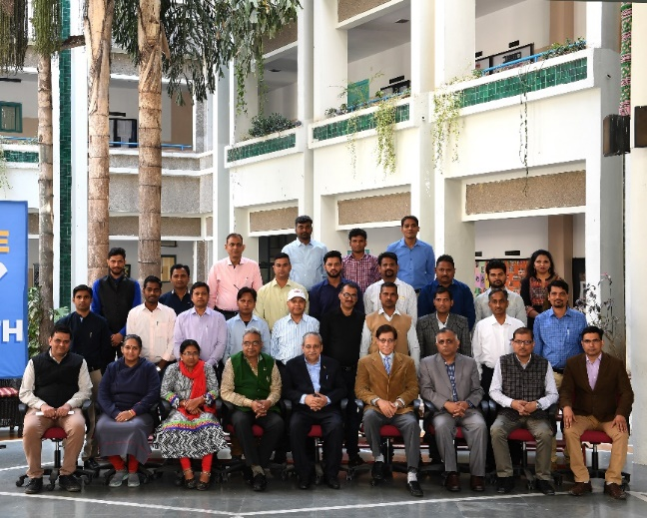
This programme was organised by Birla Institute of Management Technology (BIMTECH), Greater Noida for the CSR professionals of companies of JK Organisation on 15-16th March 2019 at BIMTECH campus in Greater Noida. There were 24 participants from J.K. Fenner (India) Limited, JK Lakshmi Cement Limited, JK Paper Ltd., JK Tyre & Industries Ltd., SPARSH, Odisha, Udaipur Cement Works Limited, Umang Dairies Limited.

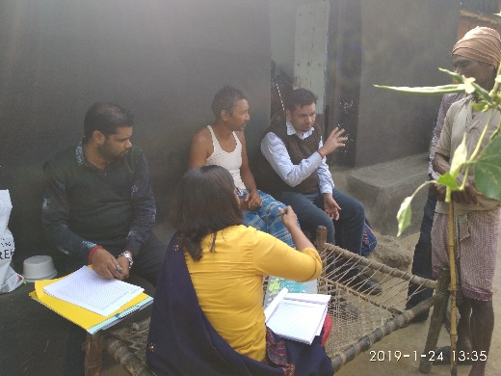
Baseline Survey and Need Assessment for JSW Foundation
JSW Foundation has entrusted BIMTECH to conduct the Baseline Survey and Need Assessment of 35 villages located under its Direct Impact Zone (DIZ) in West Bengal and Odisha. The field visit in 28 villages located near to JSW Cement Plant in Salboni, West Bengal has been completed on 8th February 2019.
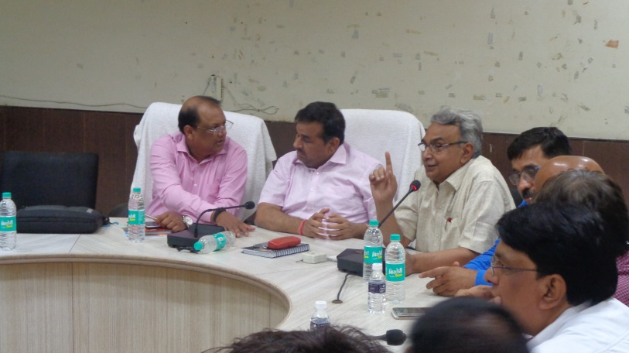
Skill gap analysis in district Mathura for Ministry of Rural Development, New Delhi
The Centre for Sustainability and CSR (CSC) is conducting Skill Gap Assessment of Mathura district. In this regard a meeting was held on 2nd July 2018 at DM office, Mathura. The meeting was chaired by Shri Srawagya Ram Mishra, IAS and District Magistrate and attended by, Shri Vinay Pandey, Head, Roshni & Head Monitoring, DDU-GKY, Prof. N. N. Sharma, Chairperson, Centre for Sustainability & CSR, Birla Institute of Management Technology (BIMTECH), Dr Rishi Tiwari, CEO, BIMTECH Foundation, and Satender Rana, Programme Manager, BIMTECH and officials of various departments, and representatives of industry and, academia.

Situation Analysis and Needs Assessment for ACC
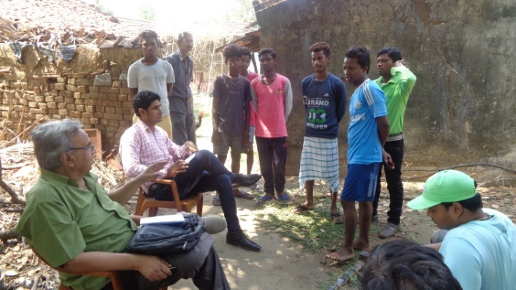
ACC Ltd., being a good corporate citizen, is undertaking initiatives for improving the socio–economic conditions of people residing in locations in the proximity of their manufacturing units. To evolve a strategy for future interventions, it was decided by ACC to conduct situation analyses and to ascertain the needs, aspirations, perceptions and priorities of the community residing near its plant and the adjoining mining areas. The assessment was intended to be the ﬁrst step towards the development of a robust strategy for appropriate CSR interventions. The Centre for Sustainability and CSR at BIMTECH completed Situation Analysis and Needs Assessment of seven villages located in Dhanbad District of Jharkhand from 08-12 May 2018, and six villages located in Purulia District in the state of West Bengal from 26 July 2018 to 01 August 2018.

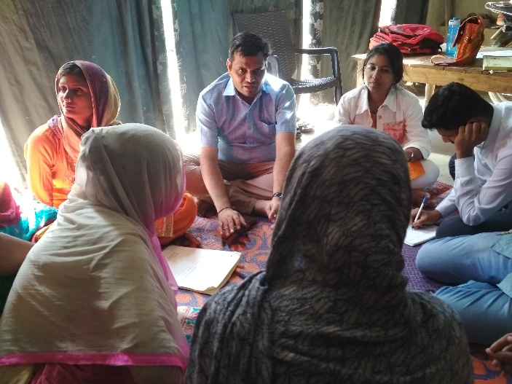
Impact Evaluation for JK Paper Mills
The Centre for Sustainability & CSR (CSC), BIMTECH has been entrusted by JK Paper Mills to conduct Impact Evaluation of 650 Dairy Interest Groups (Self-Help Groups) formed and nurtured by the company under one of its CSR projects. A pilot study has been conducted from 01-03rd April 2019.

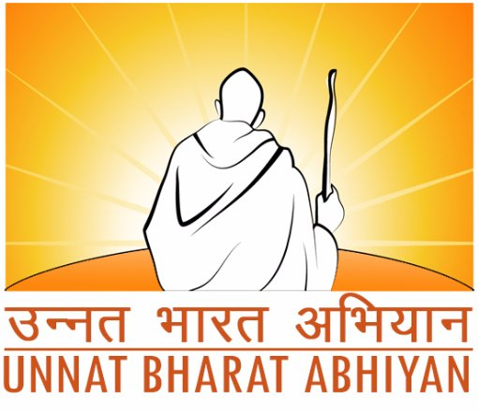
Unnat Bharat Abhiyan
BIMTECH has been selected as Participating Institute (PI) under the Unnat Bharat Abhiyan (UBA) 2.0. UBA is a flagship programme of the Ministry of Human Resource Development which intends to enrich Rural India. The programme envision to involve the reputed higher educational institutions of the country in the process of indigenous development of self-sufficient and sustainable village clusters in tune with the notion of ‘Grām Swarāj’ propounded by Mahatma Gandhi.
All participating institutions (PIs) are expected to establish a UBA Cell which will be responsible for carrying out the activities of the UBA. This will involve the development of an active working group consisting of motivated faculty members drawn from various disciplines. Further, PIs are also expected to identify at least five villages to carry out the out the activities of the UBA. BIMTECH has identified Neemka Shahjahanpur, Alli Ahmadpur Urf Garhi, Bankapur, Khwajpur, and Mahvalipur village in block Jewar of Gautam Buddha Nagar district of Uttar Pradesh. The village and household survey as well as participatory situation analysis will be done shortly to develop development plan for each village.
5th National CSR Summit organized by BIMTECH and NHRDN on 24th August 2018 at Mumbai
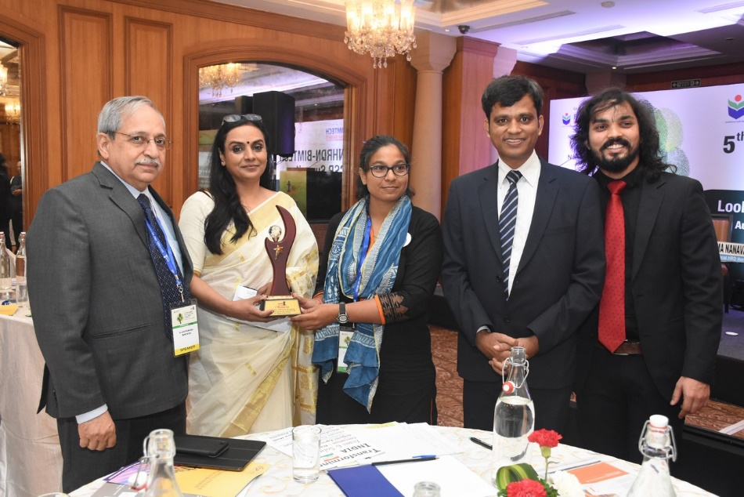
The 5th National CSR Summit was attended by more than 150 participants. About 20 CSR Heads of Companies were present during this event. Awards were also given to the prominent companies and NGOs who have excelled in CSR domain. Mr. Vinay P Sahasrabuddhe, President ICCR, Member of Parliament (Rajya Sabha) & Vice Chairman, Rambhau Mhalgi Prabodhini, Mr. Rajeev Dubey, Group President (HR & Corporate Services) & CEO (After-Market Sector) and Member Group Executive Board, Mahindra & Mahindra Ltd., Mr. Ranjit Singh, General Manager (CSR & Sustainability), Maruti Suzuki India Ltd. and Dr. H. Chaturvedi, Director, BIMTECH along with other dignitaries, addressed the audience during the event.

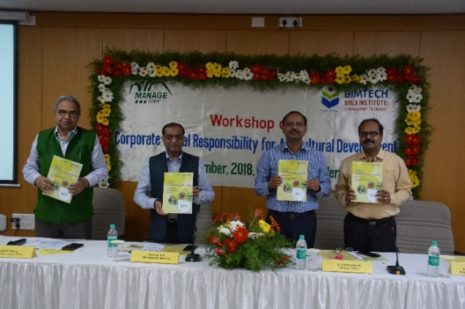
Workshop on CSR for Agricultural Development
The Centre for Sustainability & CSR (CSC), BIMTECH in collaboration with the National Institute of Agricultural Extension Management (MANAGE) organized its 2nd workshop on “Corporate Social Responsibility for Agricultural Development” at MANAGE Campus at Hyderabad on 19-20th November 2018.

Hands- On- Training - Library Management Software: KOHA
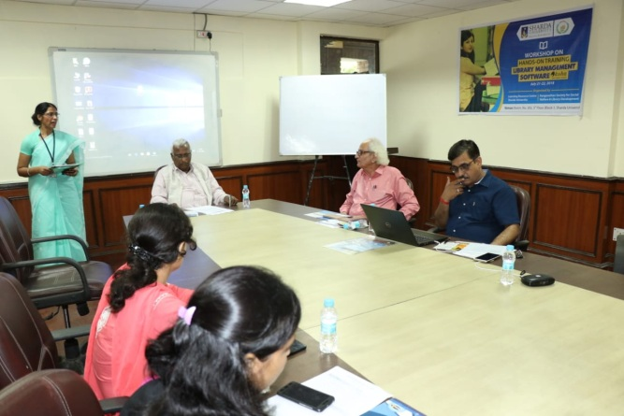
A two days Workshop on Hands- On- Training - Library Management Software: KOHA was organized jointly by Learning Resource Centre, Sharda University and Ranganathan Society for Social Welfare & Library Development in the campus of Sharda University, Greater Noida on 21-22nd July, 2018 for Staff of Library of Sharda University.
The purpose of the workshop is to familiarize the participants with the KOHA software which is open source software. The training offered technical know-how to the participants for the installation, customization and running of various library applications. Dr. Rishi Tiwari, BIMTECH, Greater Noida and Sh. D. P. Tripathi, NIIT Rourkela were invited as resource persons during the workshop. KOHA is considered as a highly sophisticated ILS in the open source domain which offers full featured ILS including OPAC, Circulation, Cataloguing, Acquisitions, Serials control etc.

National workshop on "Open source solutions tools & techniques KOHA & Data Migration
BIMTECH, Greater Noida in Collaboration with Indian Library Association (ILA) , BIMTECH Foundation & Ranganathan Society for Social Welfare and Library Development (RSSWLD) organised a two day workshop on “"Open source solutions tools & techniques KOHA & Data Migration” on 8–10th June 2018 at BIMTECH, Greater Noida.
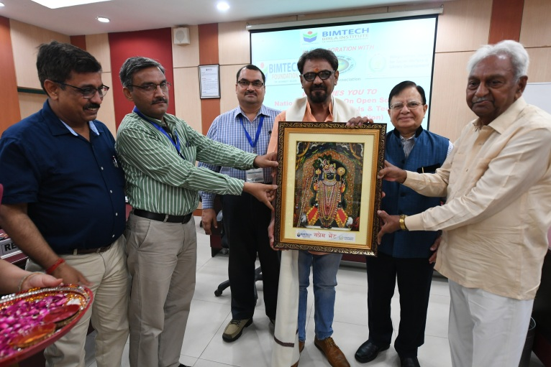
Prof. Lallan Prasad from Delhi University who is also a member of governing body of Delhi Public Library was invited as the chief guest. The event was also graced by the presence of Dr. Ramesh Yernagulla, Director (DOC), ICSSR, New Delhi, Dr. Anupam Varma. Dy. Director BIMTECH, Dr. Anil Singh, Dr. Prabhat Pandey, and Shri D.P. Tripathi. The workshop was attended by 42 participants from ten states.

Workshop on wheels: three-day workshop on KOHA
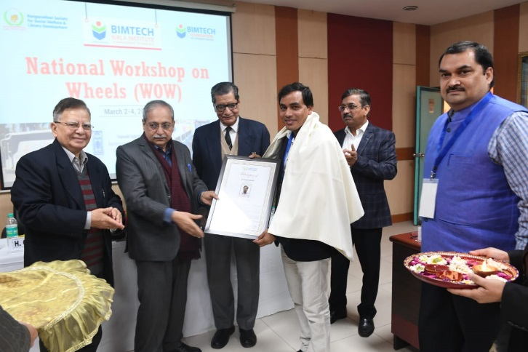
A three-day workshop on library management using KOHA software was organized from 2-4th March 2019 by Ranganathan Society for Social Welfare and Library Developed and BIMTECH Foundation with support from Raja Rammohun Roy Library Foundation (RRRLF). During the inaugural session, Dr. Badan Barman, Assistant Professor, Gauhati University was felicitated by Shri Brij Kishore Sharma and Dr. H Chaturvedi for his contribution in the area of library information system.
UN GCNI 13th National Convention on “Sustainable Development Goals (SDGs): A Blueprint for the Action”
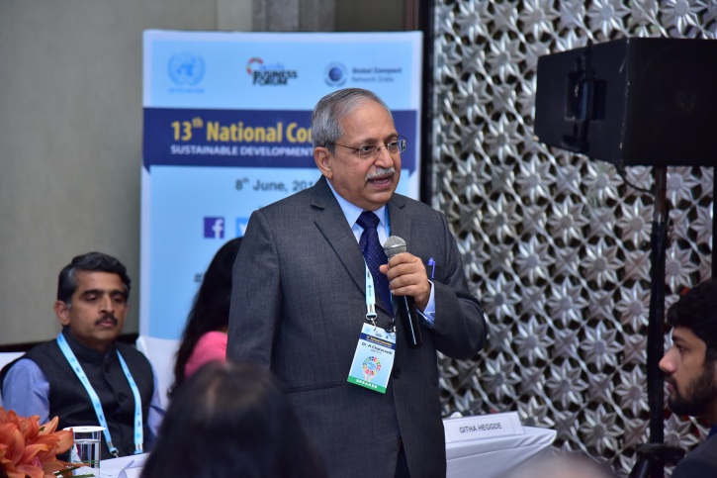
BIMTECH as an academic partner with Global Compact Network India organised the 13th National Convention on the theme of “Sustainable Development Goals: A Blueprint for the Action” on 8 June, 2018 at Hotel Shangri-La, Bengaluru. The theme of the convention “A Blueprint for Action” emphasised on the real, on-ground actions that the businesses need to take to make a real impact on achieving the SDGs while also creating economic value for the nation.
Dr. H. Chaturvedi, Director, BIMTECH who was invited as speaker during the event shared his thoughts on “Providing Quality Higher Education & Lifelong Learning Opportunities for All in India”.
Prior to the above event, best case studies addressing at least one SDG were invited from across India from Public and Private sector companies, NGOs, and academic institutions. A Jury meeting was held on 28th May 2018 to select best case studies for the “Innovative Practices award on SDGs”. Dr. Vineeta Dutta Roy, Associate Professor and Lead CSR, BIMTECH was invited as jury member.
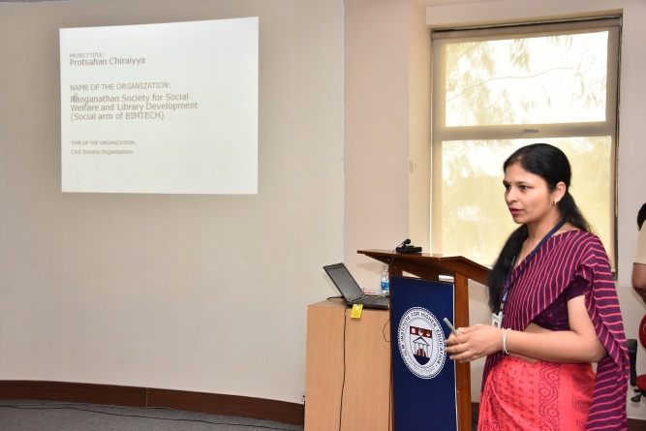
BIMTECH also participated in case study competition for the “Innovative Practices award 2018 on Sustainable Development Goals (SDGs)” organized by the Global Compact Network India (GCNI) for which a presentation was made by Prof. Monika Mittal, BIMTECH and Mr Satender Rana, Programme Manager, BIMTECH at IILM Institute for Higher Education, Lodhi Road, New Delhi on 2nd June 2018.

8th Subir Raha Memorial Lecture
BIMTECH students attended 8th Subir Raha Memorial Lecture delivered by Dr. R.A. Mashelkar, F.R.S., President of Global Research Alliance, Former Director General of Council of Scientific and Industrial Research (CSIR) on theme “ASSURED Inclusive Innovation: Path to CSR 2.” The event took place at ONGC Limited, New Delhi on Friday, July 13, 2018.
UN PRME - Delhi Meet
The PRME - Principles for Responsible Management Education (PRME) meet was organised by S.P.Jain Institute of Management and Research in New Delhi on Wednesday, July 11, 2018. The meet was attended by Dr. Vineeta Dutta Roy, Associate Professor and Lead CSR, BIMTECH.
Roundtable Meeting of CSR Heads of companies
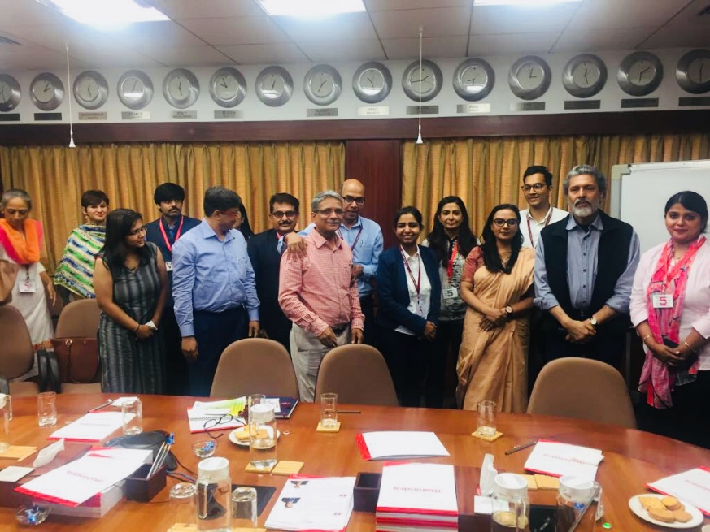
A roundtable of CSR heads of fifteen companies was organised by BIMTECH and NHRDN on 21st July 2018 in the office of Sh. Rajiv Dubey, Group president of HR & Corporate Services, Mahindra & Mahindra. Dr. Vineeta Dutta Roy represented BIMTECH during the meeting. The meeting also observed the presence of CSR head of ACC Ltd., HPCL, JSW, Eureka Forbes, Siemens, Yes Bank etc.

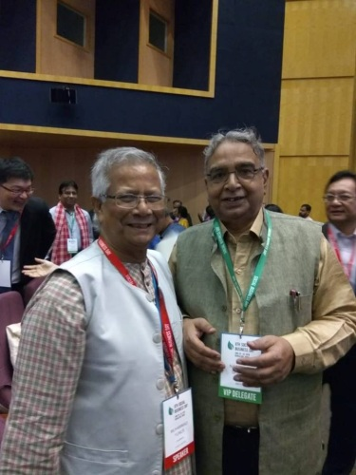
8th Social Business Day, organized by Yunus Centre
The 8th Social Business Day was organised by Yunus Centre on June 28-29, 2018 at Infosys Campus, Electronic City, Bengaluru. The event was graced by presence of Nobel Laureate Prof. Muhammad Yunus. Prof. N. N. Sharma, Chairperson, Centre for Sustainability and CSR, BIMTECH also attended the Social Business Day. The event was attended by nearly 1,100 delegates from more than 42 countries.

Model United Nations (MUN)
BIMTECH collaboration with Model United Nations (MUN) organized Model United Nations on 19 – 20th May 2018 in Greater Noida. The Editor–in- Chief Sh. Konark Pareek and the other journalists present during the event included Ms. Khushi Saxena, Mr. Mihir Tuli, Mr. Lakshay Singh, Ms. Snigdha Deva and Ms. Aarti Jhalani. The major discussion points included arms, and human rights.
International Dialogue and Conference - India and Sustainability Standards
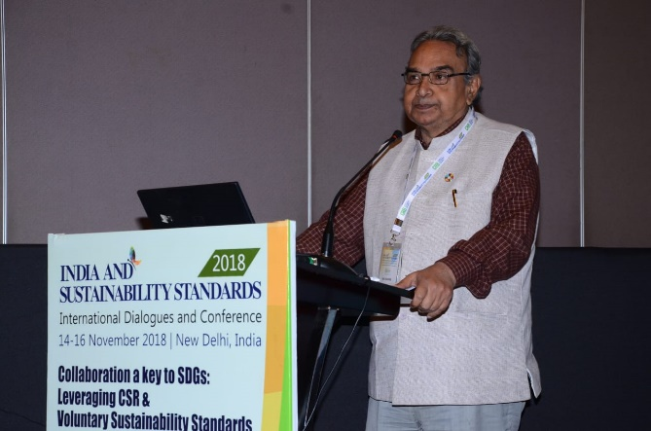
Prof. N. N. Sharma, Chairperson, Centre for Sustainability & CSR, BIMTECH was invited to address the participants during the 5th Annual Conference of Centre for Responsible Business (CRB) titled ‘Collaboration a key to SDGs: Leveraging CSR & Voluntary Sustainability Standards’ organized from 14-16 November 2018.

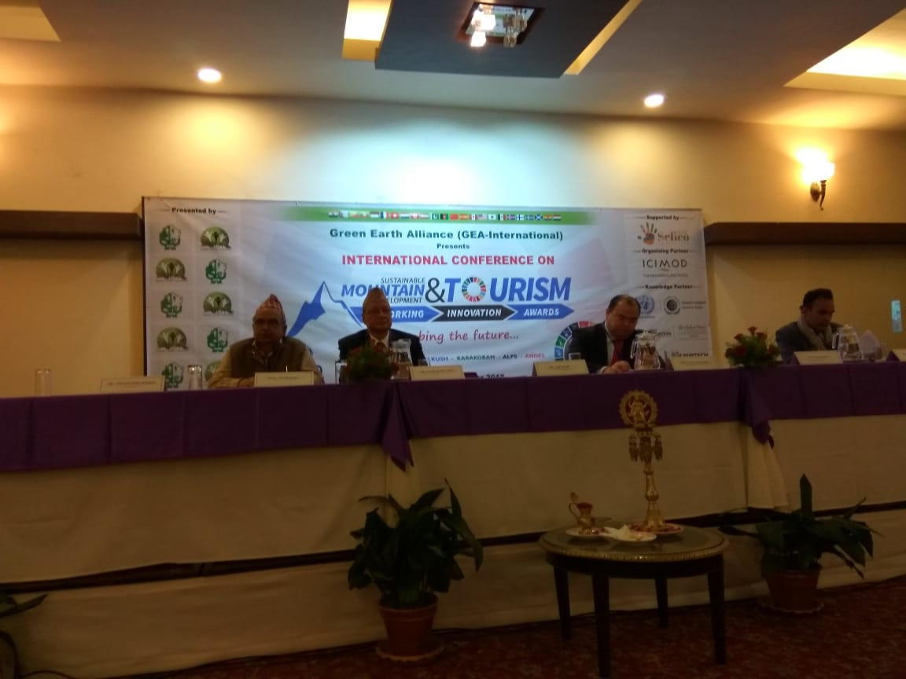
International Conference on Sustainable Mountain Development and Tourism
In order to raise some un-addressed yet fragile mountain development issues, Green Earth Alliance (GEA-International) organized 1st International Conference on “Sustainable Mountain Development & Tourism (SMDT)” at Kathmandu/Nepal. Prof. N. N. Sharma, Chairperson, Centre for Sustainability & CSR, BIMTECH was invited as speaker during the conference.

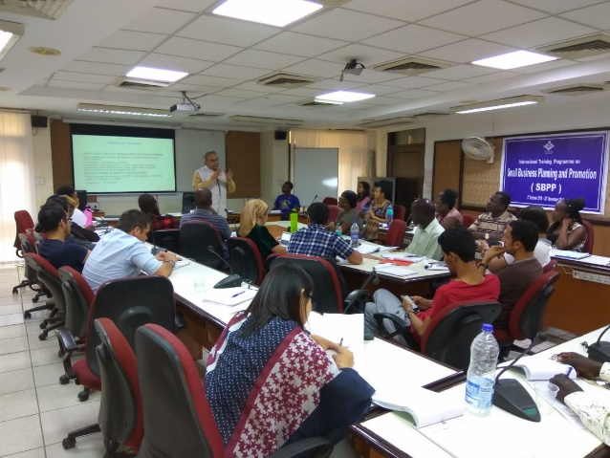
International Training Programme on Small Business Planning and Promotion
Prof. N. N. Sharma, Chairperson, Centre for Sustainability & CSR, BIMTECH took a training session during the International Training Programme on Small Business Planning and Promotion organized by The National Institute for Entrepreneurship and Small Business Development (NIESBUD), Noida. The training programme was attended by persons from 15 nations.

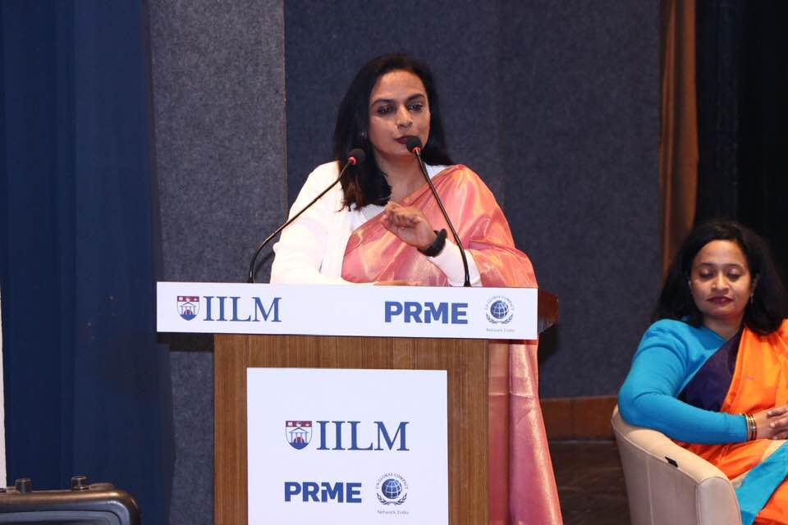
6th IILM International Conference on “Reimagining Sustainable Futures- The SDG Framework” from 31stJanuary – 2nd February 2019.

IILM released a book on the conference theme “Reimagining Sustainable Futures- The SDG Framework” on 31st January 2019. Dr Vineeta participated in the author’s Panel moderated by Dr. Bhaskar Chatterjee, Editor along with other dignitaries.

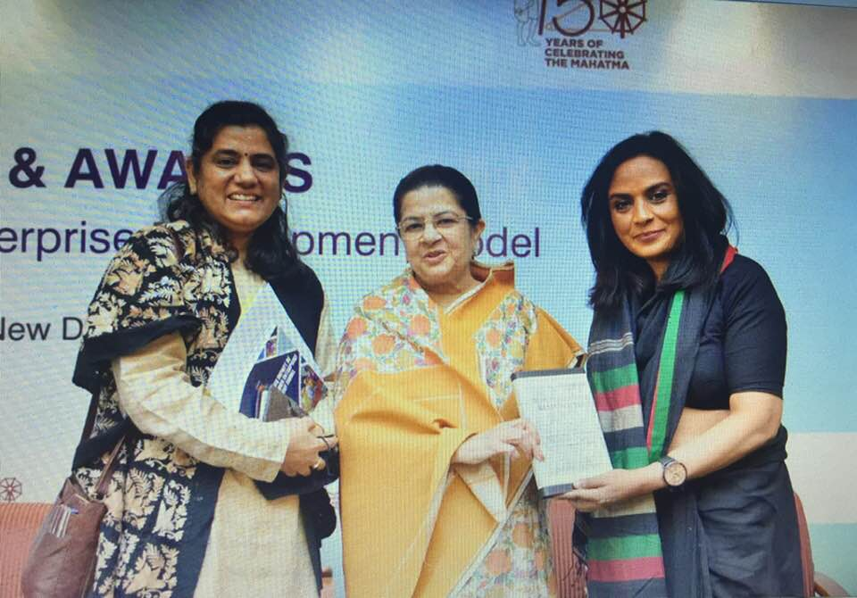
19th FICCI- Annual CSR Summit and Awards, 21st February 2019
Dr Vineeta Roy chaired a session during the event which included speakers from the industry like Tata Chemicals, Nuvoco, Adani Foundation and Amazon India. It was.

Make in Odisha Conclave-2018
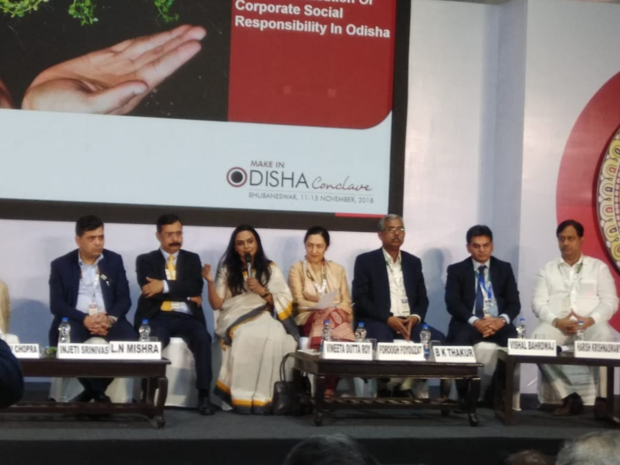
The Government of Odisha organized the Make in Odisha Conclave from 11-15th November 2018 at Bhubaneshwar. During the event, Dr Vineeta Dutta Roy, Associate Professor & Lead CSR, BIMTECH was invited as jury member, eminent speaker and distinguish moderator on 14th November 2018.

Community Outreach
Inauguration of Library in District Jail Bulandshahr
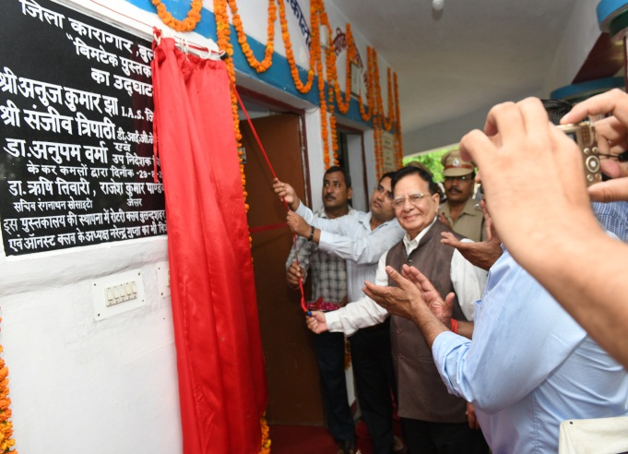
BIMTECH Foundation and Ranganathan Society for Social Welfare and Library Development (RSSWLD) under the guidance of Dr. Rishi Tiwari, CEO, BIMTECH Foundation opened ninth “BIMTECH Pustkalya” at District Jail Bulandshahr on 29th August 2018.

Inauguration of Library in District Jail Firozabad
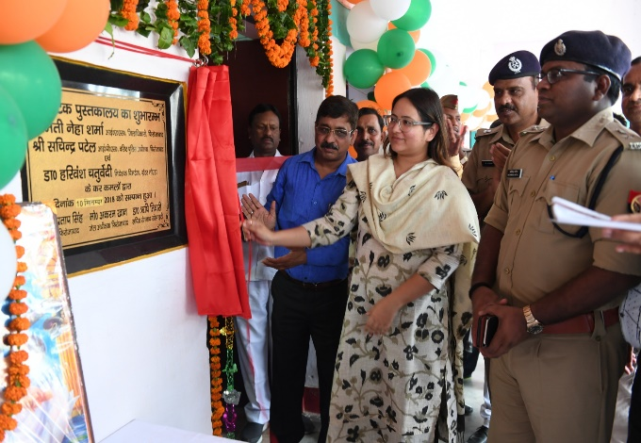
BIMTECH Foundation and Ranganathan Society for Social Welfare and Library Development (RSSWLD) under the guidance of Dr. Rishi Tiwari, CEO, BIMTECH Foundation opened ninth “BIMTECH Pustkalya” at District Jail Firozabad on 10th September 2018. The inauguration ceremony was attended by Ms. Neha Sharma, District Magistrate, Prof. Manoj Pandey, BIMTECH and Jail Superintendent Mr Akram Khan. The library will bring a respite to prison inmates by breaking the monotonous prison schedule and expected to contribute towards their mental wellbeing.
Mathura Jail Inauguration
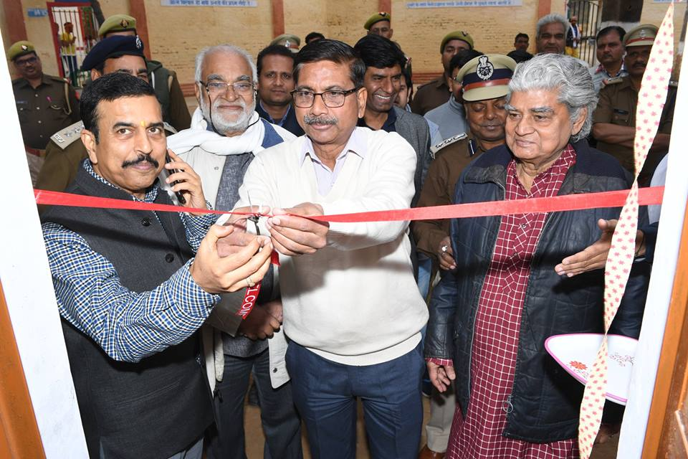
BIMTECH Foundation and RSSWLD inaugurated its 10th Jail Library at Mathura District Jail on 4th January 2019. This library was financially sponsored by the Raja Rammohun Roy Library Foundation. The library was inaugurated by Mr. Ram Niwas, IAS & Chief Development Officer, Mathura.

Launch of HP World on Wheels (HP WoW) – Digital Inclusion Initiative
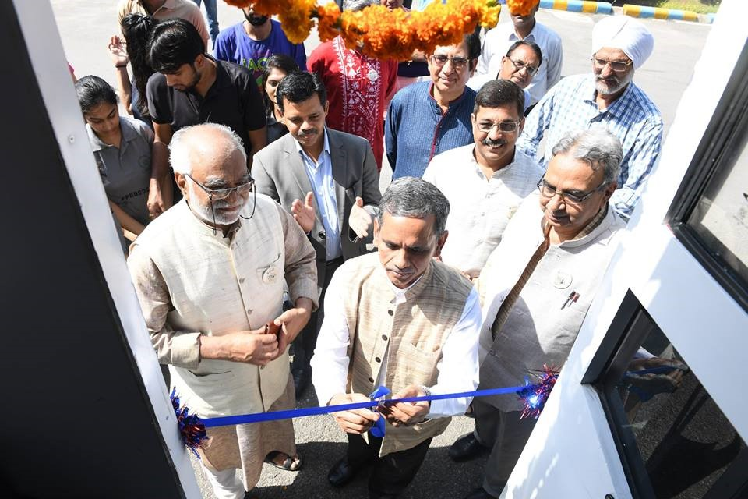
On 2nd October 2018, the 31st Foundation day of Birla Institute of Management Technology, the institute in collaboration with HP India and Jubilant Bhartia Foundation launched the HP World on Wheels (HP WoW) vehicle. Sh. Ram Mohan Mishra, Additional Secretary & Development Commissioner, The Ministry of Micro, Small and Medium Enterprises, a branch of the Government of India, inaugurated the HP WoW bus having 20 computers and IT enabled services. The solar powered backed vehicle is supported by several software suites. The initiate envisions to help bridge the digital divide between urban and rural areas by bringing easy information technology access to the isolated and disadvantaged groups. The vehicle will assist BIMTECH Foundation and RSSWLD in promoting IT enabled education through e-learning modules and help train school children, rural youth and communities, among others. The bus already started the journey of achieving the goal of digital inclusion under the guidance of Dr. Rishi Tiwari, CEO, BIMTECH Foundation.

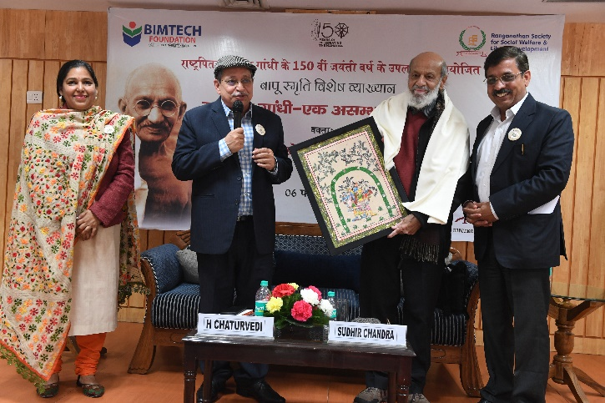
Special Lecture on Mahatma Gandhi
BIMTECH celebrated the 150th birth year of Mahatma Gandhi on 6th February 2019 by inviting Prof. Sudhir Chandra, a renowned historian, and author of the proclaimed book “Gandhi: An Impossible Possibility.” Prof. Chandra shared his ideas and beliefs and presented Gandhiji in a new light.

RSSWLD and BIMTECH Foundation to start an initiative for the welfare of inmates of Kerala prison
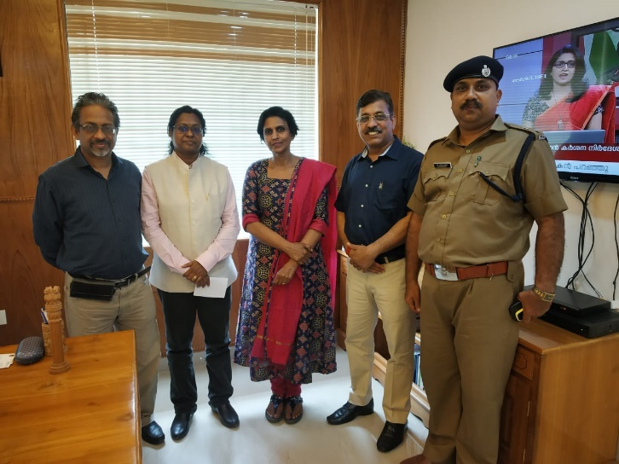
Dr. Rishi Tiwari and Dr. Abha Rishi met Smt. R. Sreelekha, IPS & Director General Prisons and Correctional Services and Sh. Vijay Kumar, Superintendent on 19 February 2019. The meeting was held with the agenda to understand the rehabilitation practices of Kerala Jail inmates. RSSWLD and BIMTECH Foundation will soon start a collaborative initiative with the Kerala Government for the welfare of prison inmates.

Sports at Greater Noida Jail
Two sports competitions were organized between inmates and BIMTECH students on 27th January 2019. The trip was facilitated and organized through Ranganathan Society for Social Welfare and Library Development (RSSWLD), the CSR wing of BIMTECH, Greater Noida total of 28 BIMTECH students were taken to jail for volleyball and cricket competition out of which 4 were executive members of RSSWLD.

Visit of foreign delegates to Neemka village
BIMTECH Foundation and Ranganathan Society for Social Welfare and Library Development (RSSWLD) organized a village to Neemka village for the foreign delegates who participated in the International Conference on Management Cases (ICMC) organized by BIMTECH on 29-30th November 2018. The visit was aimed at giving a flavor of rural dynamics in India to the foreign delegates. Several recreational and educational activities were organized during the visit.

Essay Writing Competition at District Jail, Gautam Buddha Nagar
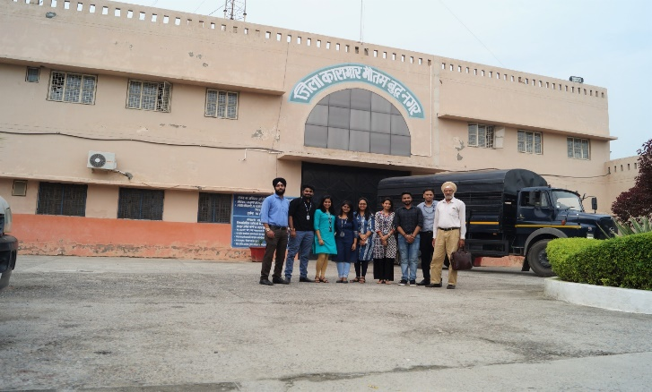
As a part of regular practice to motivate the inmates and to keep them engage in productive activates, an “Essay Writing Competition” was organized for both male and female inmates at District Jail, Gautam Buddha Nagar on 1st September 2018 by Ranganathan Society for Social Welfare and Library Development” and “BIMTECH Foundation” under the guidance of Dr. Rishi Tiwari, CEO, BIMTECH Foundation. 34 males and 9 females inmates participated in the competition.

Felicitation of Inmates
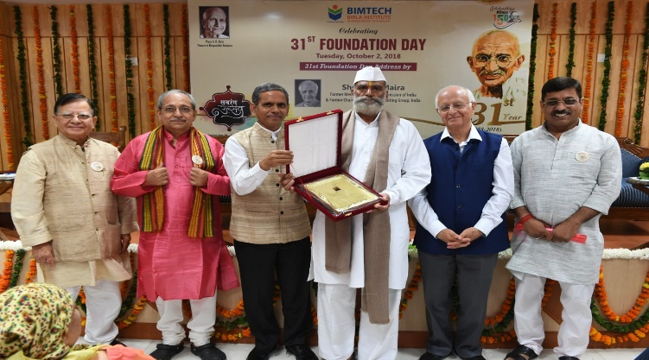
During the occasion of 31st Foundation day of BIMTECH, Sh. Arun Maira, former Member, Planning Commission and former Chairman, Boston Consulting Group, India, felicitated Sh. Vijay Singh (Ghaziabad Jail), Sh. Arun Gaur and Sh. Chandra Mohan Sharma (Gautam Buddha Nagar Jail) for being instrumental, while serving their term, in smooth and effective functioning of “BIMTECH Library” stabled by BIMTECH Foundation and RSSWLD in these jails.

Blood Donation Camp
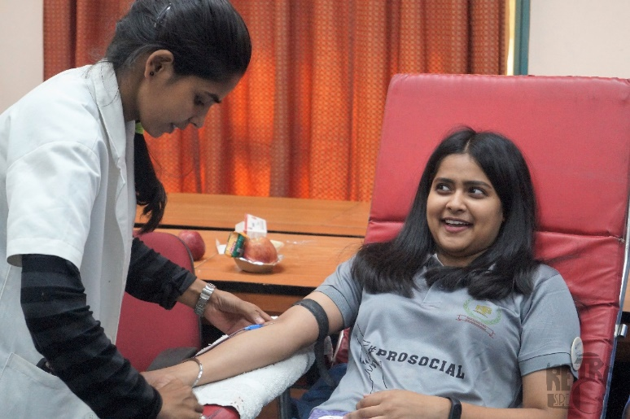
On 2nd October 2018, on the eve of 150th birth anniversary of Mahatma Gandhi, a blood donation camp was organized at BIMTECH Campus in collaboration with LIONESS CLUB PRAGATI and NOIDA CHARITABLE BLOOD BANK. The event was organized by Ranganathan Society for Social Welfare and Library Development (RSSWLD). 124 individuals donated the blood including Dr. H. Chaturvedi, Director, BIMTECH & Dr Anupam Verma, Deputy Director & Dean- Academics, BIMTECH.

Diya Selling - Charity Event
Under the guidance of Dr. Rishi Tiwari, CEO, BIMTECH Foundation, BIMTECH Foundation and RSSWLD organized a Diya Selling - Charity Event for the beneficiaries of Project “Protsahan Chiraiyya”. A stall was setup at BIMTECH campus on 17th October 2018 to sell Diyas for Diwali. A profit of INR 6000 was earned which will be used for the said project.

Recreational Activities for Chiraiyyas
The girls from Neemka village participated in the festivities of celebration of Gandhi Jayanti at BIMTECH on 2nd October 2018. The Ranganathan society organized an event for the underprivileged. Beside showing documentaries on the life of Gandhiji, several interactive sessions with students and teachers, quizzes and games were organized for the girls and villagers accompanying them by the executives of RSSWLD which was followed by community lunch.

Orientation session on Digital Literacy
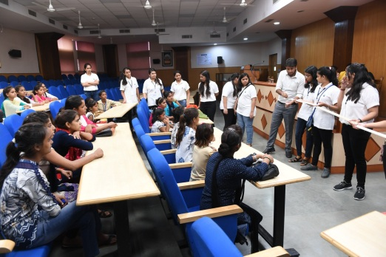
Ranganathan Society for Social Welfare and Library Development (RSSWLD) conducted an orientation session for the beneficiaries of project “Protsahan Chiraiyya”. The girls were informed about the Digital Literacy intervention soon to be implemented by RSSWLD. BIMTECH students volunteered to provide basic computer skills. They provided basic information about how to use E – Books, mobile, internet or new technologies.

Future Planning
- Consultancy
- Impact Evaluation of CSR project of JK Paper Mills in Gajraula, Uttar Pradesh.
- Baseline Survey and Need Assessment in respect of 35 villages located near to cement plant of JSW group in West Bengal and Odisha.
- Situation Analysis and Need Assessment of 10 villages near to cement plant of ACC Limited in Lakheri, Rajasthan and a few locations in Tamil Nadu.
- Situation Analysis and Need Assessment of 11 villages near to JSW Energy Limited in Chamba, Himachal Pradesh.

- Seminars/Workshops/Conferences
- National Workshop on ‘CSR for Agricultural Development’ in collaboration with MANAGE, Hyderabad.
- National CSR Summit with NHRDN in Bangalore.
- A small workshop on livelihood promotion through goat rearing etc.

- Research and Working Papers
- One research paper related to CSR & Sustainability.
- Publication of a book containing case studies related to CSR interventions in area of agriculture.

Annexure 1
Details of students’ field visits under “Responsible Business” course during the academic year 2018-19
S. No. | State | District | Block | S. No. | Village | Date of Visit | Number of Students | Programme
i | Uttar Pradesh | Gautam Buddha Nagar | Jewar | 1 | Mahvalipur | 11-Aug-18 | 59 | PGDM Sec A
 |  |  |  | 2 | Bankapur | 11-Aug-18 | 57 | PGDM Sec B
 |  |  |  | 3 | Chiroli | 18-Aug-18 | 59 | PGDM Sec C
 |  |  |  | 4 | Alli Ahmadpur | 18-Aug-18 | 58 | PGDM Sec D
 |  |  |  | 5 | Dustumpur | 28-Oct-18 | 50 | PGDM IB
 |  |  |  | 6 | Chicholi | 05-Dec-18 | 57 | PGDM RM
 |  |  |  | 7 | Cancelled due to poor weather | 14-Feb-18 | 59 | PGDM IBM

