Sustainability and CSR Initiatives by Birla Institute of Management and Technology (BIMTECH)

1 June 2020 to May 2021

Creating and Disseminating Knowledge
Webinars on Issues related to CSR and Sustainability organised by BIMTECH (in reverse chronological order)
UNGCNI First Global Roundtable on Water and WASH on 25 June, 2021
Dr H. Chaturvedi was invited to contribute his views in the panel discussion on Water and WASH. The session brought pertinent stakeholders from the academia, Government and the industry together to deliberate on the looming Water Crisis and the possible solutions/best practices s
Webinar on “Impact of Covid-19 on Indian Agriculture: Re-imagining the Way Forward on 30th June 2020
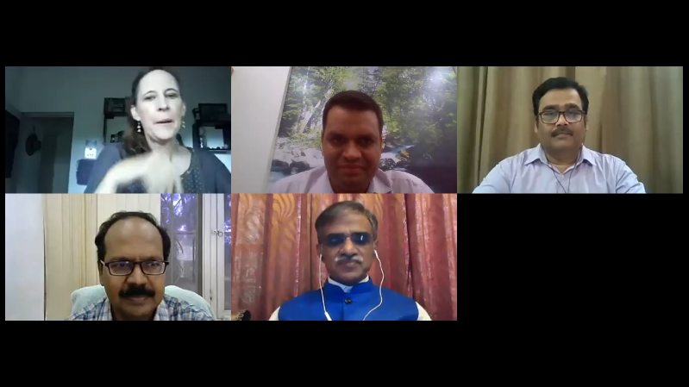
The International Crops Research Institute for the Semi-Arid Tropics (ICRISAT), National Institute of Agricultural Extension Management (MANAGE), Birla Institute of Management Technology (BIMTECH) and Ecociate Consultants partnered to organise a webinar on “Impact of Covid-19 on Indian Agriculture: Re-imagining the Way Forward (A Collective Effort of Government, Corporate and CSOs)” on 30th June 2020. The sessions were moderated by Ms. Joanna Kane-Potaka. Assistant Director General (External Relations), ICRISAT. The panel included Dr Sreenath Dixit, Principal Scientist & Head, ICRISAT Development Center (IDC), Dr N. Balasubramani, Director (CCA) & Principal Coordinator (CFA), MANAGE, and Sh Kirti Prasanna Mishra, Co-founder, Ecociate Consultants. The webinar was attended by 705 participants from 13 countries.

Webinar on CSR through Pandemic and the road ahead on 31st August 2020
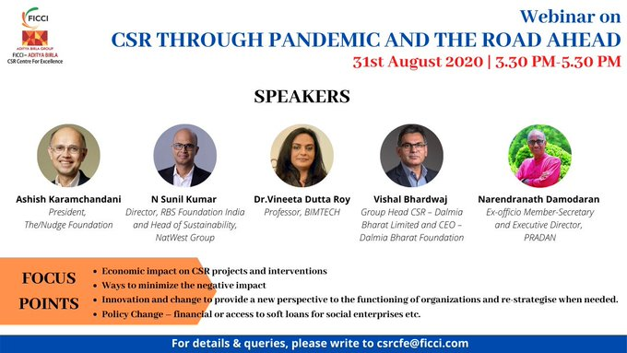
Dr Vineeta Dutta Roy Head CSR and Sustainability BIMTECH moderated the webinar organised by FICCI Aditya Birla CSR Centre for Excellence on 31st August 2020 to discuss “CSR through the Pandemic and the road ahead” in the background of health and financial challenges. Global Downturn due to Covid-Pandemic is having an adverse effect on people, businesses and economies all over the world.
Business operations are already being greatly impacted, not to forget our marginalised sections of the society specially children, women, people with disabilities and the displaced who are the most adversely affected. Corporate India has responded overwhelmingly to the government’s call to support COVID-19 relief efforts by donating to various funds in just few weeks and mobilising immediate relief activities along with NGOs s to end-beneficiaries.
In this context, we need explore ways, adopt innovatively and devise constructive involvement of corporate India in enhancing the activities through its CSR policy to minimise the damage.
The panel included Dr Sreenath Dixit, Principal Scientist & Head, ICRISAT Development Center (IDC), Dr N. Balasubramani, Director (CCA) & Principal Coordinator (CFA), MANAGE, and Sh Kirti Prasanna Mishra, Co-founder, Ecociate Consultants. The webinar was attended by 705 participants from 13 countries.

Webinar on CSR Alignment with NEP 2020, 23rd October 2020
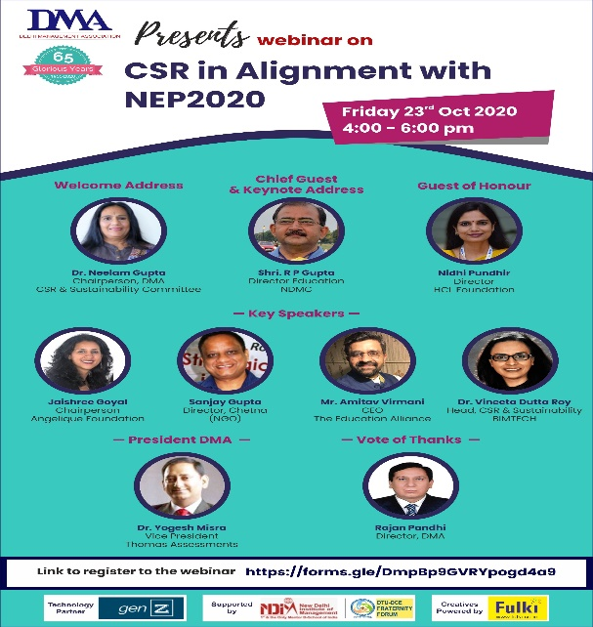
Dr Vineeta Dutta Roy Head CSR and Sustainability BIMTECH was speaker at Delhi Management Association's 'CSR Alignment with NEP 2020' Webinar
Delhi Management Association (DMA) hosted a knowledge sharing session on Aligning CSR with NEP2020 on 23rd October 2020 highlighting the emergent need to align the ongoing and forthcoming CSR programmes in education with NEP2020 and areas where effective interventions are required immediately.
This webinar also featured Shri R P Gupta, Director Education, NDMC, JaishreeGoyal, Chairperson, Angelique Foundation, Sanjay Gupta, Director, Chetna, and Amitav Virmani, Founder & CEO, The Education Alliance.

Webinar on Ideate 2020: “Building Sustainable Communities, 10th November 2020
Dr Vineeta Dutta Roy Head CSR and Sustainability BIMTECH moderated the webinar Ideate 2020: “Building Sustainable Communities: Adapting to Post Pandemic Challenges. FICCI Aditya Birla CSR Centre for Excellence in partnership with Bansidhar & Ila Panda Foundation (BIPF) organised IDEATE 2020 with the theme Building Resilient Communities: Adapting to Post Pandemic Challenges on November 10, 2020 from 3.30 PM – 5.00 PM with an aim to understand, discuss, share & develop a roadmap for creating sustainable communities with special focus on promotion and strengthening sustainable Agriculture, Livelihood and Health.

MANAGING CSR CHALLENGES IN NEW NORMAL on 18th-19th December 2020
Birla Institute of Management Technology BIMTECH in partnership with National HRD Network & knowledge partner Thinking Through Consulting organised 2-days’ National CSR Summit during Dec 18-19 on “MANAGING CSR CHALLENGES IN NEW NORMAL”. The session featured invaluable insights from stalwarts Dr. Harivansh Chaturvedi BIMTECH, Shri Arun Maira and Dr Santanu Rath. The inaugural address of Shri Arun Maira and knowledge partner perspective given by the Shri Parul Soni were highly through provoking.

Webinar on Creating Shared Value, 3rd November 2020
Dr Vineeta Dutta Roy Head CSR and Sustainability BIMTECH was speaker at CII Karnataka digital conclave on CSR amidst the covid-19 pandemic ‘Creating Shared Value’ 3 November 2020: 1400 Hrs-1700 Hrs WebEx with Mr Sandeep Singh Chairman CII Karnataka, Ms Pratima Rao Convenor CII Karnataka CSR Panel Mr Sarbjit Sahota Emergency Specialist UNICEF, Dr Giridhar Babu Professor and Head Life course Epidemiology, Mr Jawaid Akhtar Additional Chief Secretary Department of Health & Family Welfare Government of Karnataka & Mr Ramesh Ramudarai Vice Chairman CII Karnataka.
Webinar has given an overall perspective on how corporates are responding to the pandemic through CSR activities. It will also give both government and the corporate sector a view on the focus areas and action required to address the COVID-19 crisis without compromising on existing programmes of significance.
2-Day National Webinar on Skill, Entrepreneurship and Development [NWSED], 12th-13th March 2021
Dr Vineeta Dutta Roy Head CSR and Sustainability BIMTECH was a key note speaker at the National Seminar for Skill Development and Entrepreneurship, March 12-13,2021organised by Central University of South Bihar (CUSB), Gaya
The eminent panellists for the webinar were Shri Aditya Mohanty Assistant Professor, Department of Development Studies & Organizing Secretary, NWSED, Prof Krishnan Chalil Dean, School of Sciences and Policy, CUSB, Prof. Harish Chandra Singh Rathore Vice Chancellor, CUSB Gaya, Prof. Vidyanand Jha Head, Centre for Entrepreneurship & Innovation, IIM Kolkata, Prof. Niraj Kumar Professor of Agri-Business & CSR, School of Rural Management, XIMB-Xavier University, Bhubaneswar etc.
It was a two days’ webinar which covered multiple topics related to Skill, Entrepreneurship and Development including Entrepreneurship & Issues of Governance, Skill Development – Theory & Praxis, SHGs, Community Participation & Skill Development and many of the present papers on related topics. Key note Address by Dr Vineeta Dutta Roy at the 2 Day National Webinar on Skill, Entrepreneurship and Development, March 12-13, 2021 organised by the Central University of South Bihar

Webinars on “CSR for Agricultural Development” on 24th- 25th September 2020
The Centre for Sustainability & CSR organised webinars on September 24 & 25 on two different topics under the theme of “CSR for Agricultural Development”. These webinars were organised jointly with National Institute of Extension Management (MANAGE).
The objective of both the webinars was to facilitate flow of CSR funds for agricultural development.
Webinar on 24.09.2020
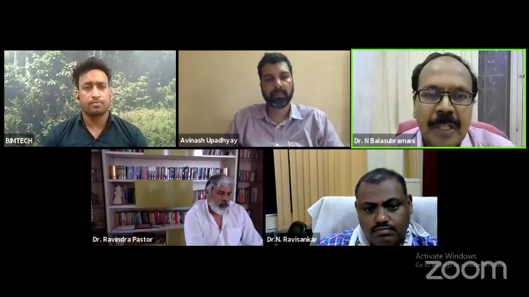
Its topic was “Successful Agricultural Projects: Replication & Upscaling”. Panellists were from organisations who have implemented high impact successful agricultural projects having potentials of replication and upscaling. Salient features of projects implemented by Tata trusts, Reliance Foundation, Proximity Designs (Myanmar), and agricultural scientists were discussed. Shri Siraj Hussain, Ex – Secretary, Ministry of Agriculture & Farmers’ Welfare, GoI, Shri Harsh Singh, Sr Advisor, UNDP and Dr. Ravindra Pastor, Ex- Principal Secretary, Government of Madhya Pradesh gave macro view and also described models which may be replicated and upscaled.
The webinar provided an opportunity for companies to identify projects which may be supported by them under their CSR budget.
It was attended by participants from CSR departments of various companies, NGOs, departments and support organisations of the government, and academicians and researchers.
Webinar on 25.09.2020
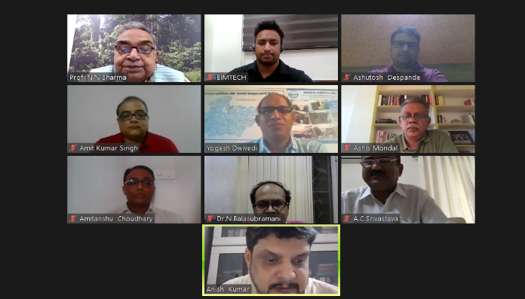
Its topic was “Farmers’ Producers Organisations: Issues & Challenges”. Speakers were from NABARD, MANAGE, Tata trusts, Reliance Foundation, JSW Foundation M.P Federation of FPOs, National Association of FPOs, TANAGER (an affiliate of USA based NGO), ASA (a NGO involved in promotion FPOs). It was attended by representatives of FPOs, officials of government departments and support organisations, NGOs and academicians and researchers.
Best practices being followed by successful FPOs, need for changes in schemes of the government, role of various stakeholders were discussed.
The discussions may help FPOs to adopt best practices and observations and recommendations in respect of policies and schemes may be considered by government and FPOs promoting institutions.

BIJ CSR e-conclave 2020 on 30th September 2020
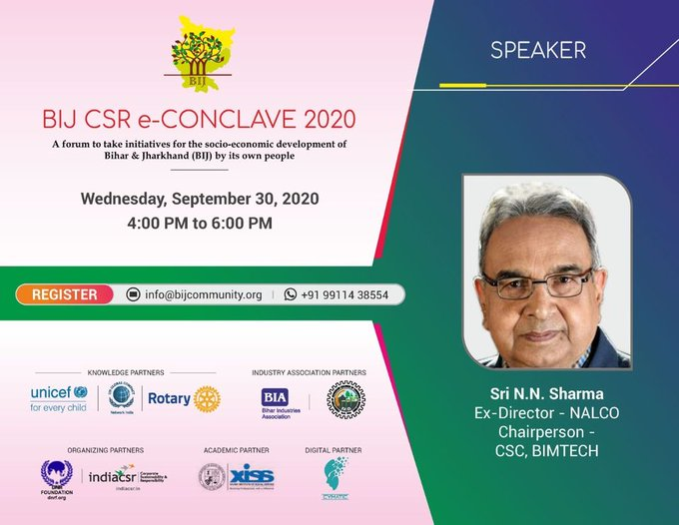
Prof. N.N Sharma who is the chairperson of Centre for Sustainability and CSR BIMTECH headed the session on 30th September at the BIJ CSR e-conclave 2020. A great initiative launched by CSR Leaders from Jharkhand & Bihar for their own people. BIJ CSR a forum to take initiatives for the socio-economic development of Bihar and Jharkhand. A wonderful opportunity to give back to the society especially children, women & the most vulnerable.

Governing Council and Chair of the Membership Committee of the UN Global Compact Network India.
Dr Harivansh Chaturvedi has been nominated as a Special Invitee to the Governing Council (GC) of the UN Global Compact Network India. He has also been selected to Chair the Membership Committee for the term 2021-23. United Nations Global Compact Network India (UN GCNI) is the country level platform of UN Global Compact, New York, and provides a robust platform for Indian businesses, academic institutions, and civil society organizations to strengthen responsible business practices in India.
UN Global Compact Network India (UN GCNI) 17th July, 2021
As an active member of the UNGCNI Secretariat for past several years, the Director - BIMTECH participated in the virtual meeting of the 17th Annual General Body Meeting of the UN Global Compact Network India (UN GCNI).The meeting was chaired by Mr Shashi Shankar, President GCNI.

UNGCNI Work stream
Birla Institute of Management Technology BIMTECH will engage themselves in a gender work stream. For the last several years, we have been working on gender issues of rural and urban women.

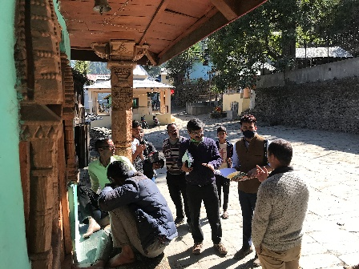
Need Assessment of Community in Villages of Himachal Pradesh
BIMTECH’s team conducted “Situation Analysis and Need Assessment “of villages near to Kutehr in Chmba district of Himanchal Pradesh during November 2020. In spite of very difficult terrain and villages situated at very high altitude and scattered, team successfully completed the survey and assessment.
This assessment will help management of JSW Energy Ltd. to design proper CSR interventions to meet the needs of community who are residing near to their plant operations.

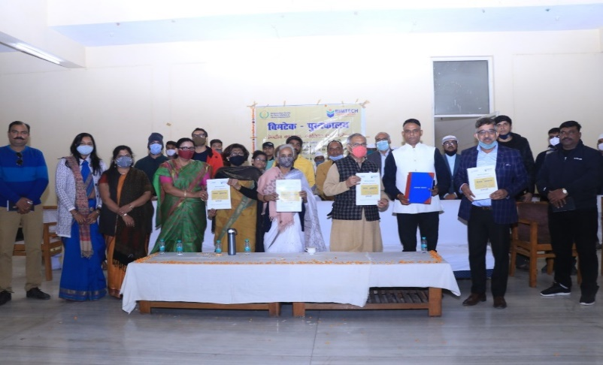
Inauguration of Library at Central Prison, Gwalior MP on 25th December 2020
On December 25, 2020 the nationwide campaign of BIMTECH added another milestone by launching the first jail library in Madhya Pradesh which was inaugurated by Mr. Vivek Shejwalkar, MP, Lok Sabha Sabha in the presence of Dr Rishi Tiwari CEO of BIMTECH Foundation and senior officer of the central prison Shri Manoj Kumar Sahu at the Central Jail Gwalior. It has been provided 1100 popular fiction, non- fiction and inspirational books in Hindi. It will be run under the guidance of Ranganathan Society, BIMTECH. On this occasion Mrs. Pramila Bajpeyi, ex State Minister and jail officials were also present.
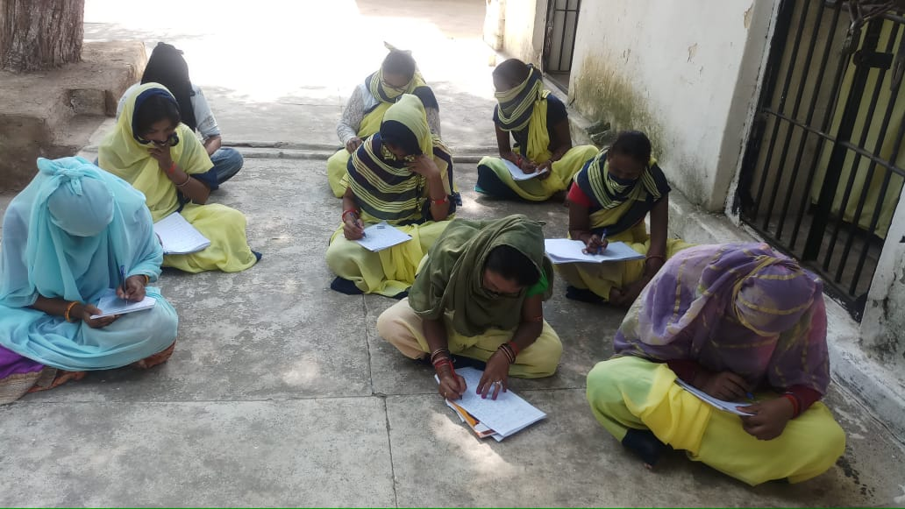
Project Chiraiyya and Uthan
Project Chiraiyya and Uthan, aimed at empowering women Jail inmates to reduce recidivism and re-offense. It formally started in March 2020 and was targeted at the 170 women inmates of the Central Prison, Gwalior, Madhya Pradesh for a period of one year. The project got to a delayed start due to Covid-19 and restarted finally on 25th August 2020 with with a small function consisting of stationary distribution and a confidence-building session. It was funded by SANDVIK.

Impact Assessment of 39 CSR Projects
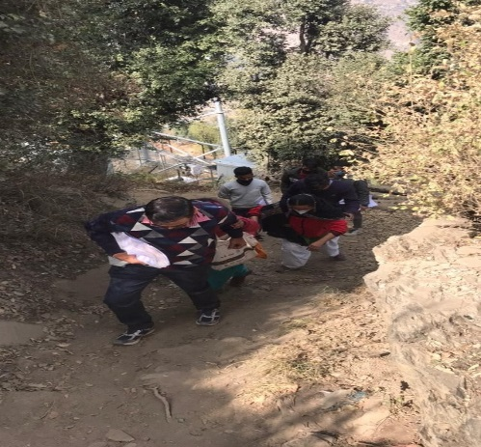
BIMTECH’s team conducted an “Impact Assessment Study“of 39 CSR projects of THDC India Limited in Uttarakhand, Uttar Pradesh and Madhya Pradesh during March and April 2021. Impact assessment study will help the management of THDC India Limited to understand and evaluate the impact of their social investments in programmes and projects on their target beneficiaries and to design appropriate CSR interventions to meet community needs.

BIMTECH FOUNDATION’s RESPONSE TO THE COVID-19 PANDEMIC
In response to the damage caused by the COVID-19 pandemic, BIMTECH has taken a long stride in response to the current humanitarian emergency caused by the Wuhan virus. Various interventions include: -

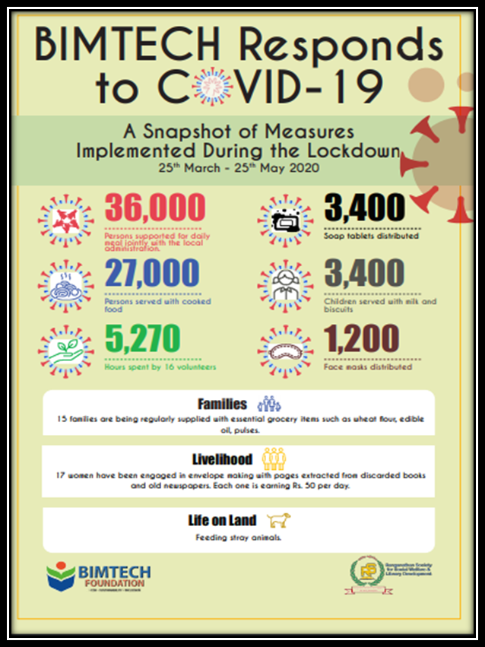
Food for All: BIMTECH is providing nutritious cooked meals and dry ration to 450 persons. The food was prepared under clean and hygienic conditions in the state-of-the-kitchen facilities available at BIMTECH. Mass gathering and following social distancing precautionary measures have also been taken.
Cleanliness and Hygiene: The target beneficiaries are also being informed about the importance of cleanliness and hygiene not only to deal with and prevent COVID-19 infections but also its importance in leading a healthy life. People of all ages are being apprised about the best practices of cleaning hands with soap. To ensure people follow cleanliness and hygiene practices, they are provided with soaps and hand sanitizers.

Collaboration: In addition to the supply of cooked food and dry ration, BIMTECH has joined hands with the district administration to support the food program of the government. BIMTECH’s kitchen is consistently preparing and providing chapatis to local administration for distribution. So far, the initiative has helped 36,000 people.

Livelihood for Women: Lakhs have lost livelihood due to the disruption of industrial activities because of nationwide lockdown enforced in response to the coronavirus pandemic. BIMTECH believes in maintaining the dignity of life and equal work opportunity. To ensure that the pandemic does not damage the capacity of earning, BIMTECH is providing decent work opportunities to women & their family members who have lost their livelihood & engaged 30 women in economic activities. These women are given waste newspapers to make envelopes. Each woman works for 2 hrs per day and earns Rs 50 from this activity. Although the financial gains are limited, however, it helps these women and their families in keeping their morale and spirit high during such stressful times.

Care for All Life Forms: Stray animals living in urban areas depend on household disposal and leftovers for their survival are also the worst hit by the pandemic. The Institute is feeding stray cows, dogs, and other animals in the vicinity. The food leftover after distribution among individuals is fed to free-roaming animals. The beneficiaries are routinely asked about the taste, quality, quantity, and food preferences.

Major initiatives during Second wave

A round- the- clock relief infrastructure including 52 rooms for quarantine differentiated into Symptomatic Wards, Covid Wards, Recovery Wards and ICU Units respectively- appropriate medical instruments like oxygen cylinders, oxygen concentrator, nebulizer machine, BP instrument, pulse oximeter and steamers provide essential covid related aid. Medicines and food are provided under the guidance of a dietician and doctors are available for all necessary support. Mental health care for patients and their family members is undertaken through physical means wherever possible while digital support is extended to all.

Employment generation initiative
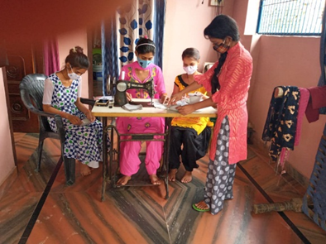
BIMTECH VIDYA KENDRA is committed to support and empower the lives of its women beneficiaries belonging to the support them even in the time of economic crisis brought about by COVID-19. The imposition of a nationwide lockdown led to mass unemployment in the country. To address this problem and help such families, BIMTECH Foundation started a vocational program under which girls and women beneficiaries of “BIMTECH Vidya Kendra –BVK” were trained to stitch face masks of standard quality. The program aimed to provide financial assistance and to boost the morale of the girls and women beneficiaries of the BVK affected by the COVID-19 pandemic. The centre tried to generate employment in the form of envelope and face-mask-making activity.

Selling face masks at metro stations
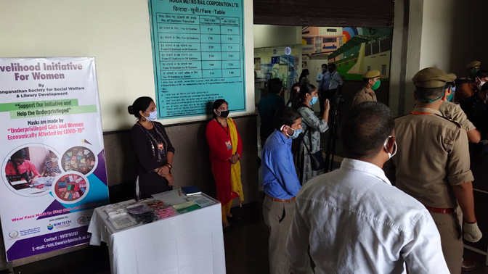
After remaining closed for almost five months, Noida Metro Rail Corporation (NMRC), resumed its services for the public on 7th September. NMRC also happens to be the project partner of BIMTECH VIDYA KENDRA. To comply with government guidelines and promote safe travel by metro rail, NMRC allowed BIMTECH VIDYA KENDRA to place stalls that sold face masks at three of its metro stations. 7th September onwards BIMTECH VIDYA KENDRA sold face masks that were made by its beneficiaries on three metro stations namely – Pari Chowk metro station (G. NOIDA), NSEZ metro station (NOIDA), and Noida Sector 51 metro station (NOIDA), that are operated under NMRC. The sale of face masks received a good response and helped the beneficiaries to make financial gains.

Felicitations:
Dr. Geeta Malhotra
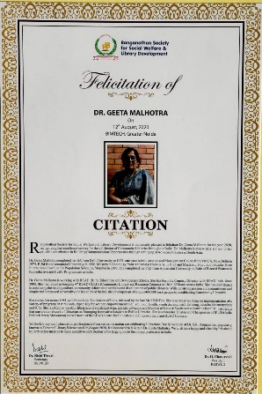
Ranganathan Society for Social Welfare and Library Development is immensely pleased to felicitate Dr. Geeta Malhotra for the year 2020, recognizing her excellence service for the upliftment of Community Libraries throughout India. Dr. Malhotra is also widely known for her valuable contribution in Building Communication Opportunities through setting up of Advocacy Centres in South Asia.

Dr S. R. Ranganathan: A Librarian, 12th August 2020
Ranganathan Society for Social Welfare and Library Development released a documentary “Dr S. R. Ranganathan: A Librarian” to pay tribute to Father of Library Science in India Sh S R Ranganathan on the eve of his birthday on August 12, 2020.

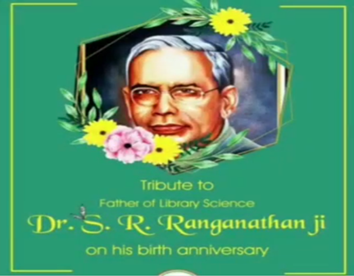

Independence Day Celebration at BIMTECH Vidya Kendra
Independence Day was celebrated with fervour at BIMTECH Vidya Kendra in the presence of Dr H Chaturvedi, Director, BIMTECH, Dr K R Chari, SWO, BIMTECH, Dr Rishi Tiwari and other faculty and staff members of BIMTECH and BIMTECH Foundation, and Ranganathan Society for Social Welfare and Library Development.

