Contents

LETTER FROM THE PRESIDENT OF THE UNIVERSITY 3

ABOUT PRME 4

Introduction-Self Assessment 5

PRINCIPLES 1 & 2: PURPOSE AND VALUES 7
Practical Actions in Support of PRME: Environmental Guiding Principles 7
Practical Actions in Support of PRME: Diversity, Equity, Inclusion Initiatives 9
Practical Actions in Support of PRME: Sustainability 17

principle 3: Method 26
Practical Actions in Support of PRME: School and Departmental Activity 26
Practical Actions in Support of PRME: Semi-Annual Business Conference 29

principle 4: research 33
Practical Actions in Support of PRME: Academic Symposium 33

principle 5 & 6: partnership & Dialogue 35
Practical Actions in Support of Prime: Wesleyan Engaged, Nusbaum Center 36

Outcomes Assessment and Key Objectives 39

appendix
- VIRGINIA WESLEYAN UNIVERSITY – QUICK FACTS 43
- ELIZABETH RIVER PROJECT – RIVER STAR 45
- UPDATE – DIVERSITY, EQUITY, INCLUSION COUNCIL 49
- ACCOLADES 51
- WESLEYAN ENGAGED – COMMUNITY PARTNERS 60

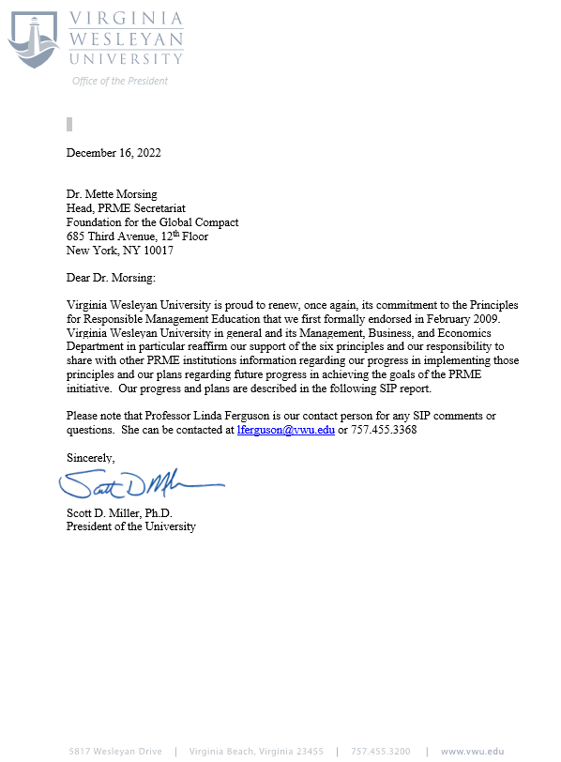
About PRME:
As institutions of higher education involved in the development of current and future managers, we declare our willingness to progress in the implementation, within our institution, of the following Principles, starting with those that are most relevant to our capacities and mission. We will report on progress to all of our stakeholders and exchange effective practices related to these principles with other academic institutions.
Principle 1 | Purpose: We will develop the capabilities of students to be future generators of sustainable value for business and society at large and to work for an inclusive and sustainable global economy.
Principle 2 | Values: We will incorporate into our activities, curricula, and organizational practices the values of global social responsibility as portrayed in international initiatives such as the United Nations Global Compact.
Principle 3 | Method: We will create educational frameworks, materials, processes and environments that enable effective learning experiences for responsible leadership.
Principle 4 | Research: We will engage in conceptual and empirical research that advances our understanding about the role, dynamics, and impact of corporations in the creation of sustainable social, environmental and economic value.
Principle 5 | Partnership: We will interact with managers of business corporations to extend our knowledge of their challenges in meeting social and environmental responsibilities and to explore jointly effective approaches to meeting these challenges.
Principle 6 | Dialogue: We will facilitate and support dialogue and debate among educators, students, business, government, consumers, media, civil society organizations and other interested groups and stakeholders on critical issues related to global social responsibility and sustainability.

Addendum Principle | Organizational sustainability: We understand that our own organizational practices should serve as an example of the values and attitudes we convey to our students.

INTRODUCTION
About Virginia Wesleyan University
Virginia Wesleyan University (vwu.edu) is Coastal Virginia's premier university of the liberal arts and sciences. Situated on a 300-acre park-like campus in Virginia Beach, the University annually enrolls approximately 1,600 students in undergraduate, graduate, and online programs. Undergraduate degrees include a Bachelor of Arts, Bachelor of Science, and Bachelor of Social Work with 42 majors, 31 minors, and 19 pre-professional tracks. Graduate degrees include a Master of Business Administration, Master of Education, and a Master of Arts in Education. Students thrive in average class sizes of 15 and through experiential learning, high-impact leadership, and career development programs. More than 90 percent of Wesleyan's new graduates are employed or enrolled in graduate school within one year of graduation. The state-of-the-art Greer Environmental Sciences Center, the Susan S. Goode Fine and Performing Arts Center, Chesapeake Bay Academy, Tidewater Collegiate Academy, and other outstanding facilities and programs serve a vibrant campus community and regional partners in education. As a learning community located in the rich and unique ecosystems of Coastal Virginia and the Chesapeake Bay watershed, VWU is committed to promoting and developing the next generation of environmental stewards. The ongoing sustainability efforts of the University reflect a larger commitment to ethical conduct and social responsibility through environmental stewardship and education, as affirmed through the University's Environmental Guiding Principles. An inclusive community dedicated to scholarship and service grounded in the liberal arts and sciences, Virginia Wesleyan University inspires students to build meaningful lives through engagement in Coastal Virginia's dynamic metropolitan region, the nation, and the world.
University Organization Related to PRME
VWU is the signatory to the Principles for Responsible Management Education, and as an institution we are committed to these tenets.
Operationally, the Department of Management, Business, and Economics is housed in the Watts School of Professional Studies. The MBE department offers the Business Major/Minor. The interdisciplinary Sustainability Management Major is also housed in the Watts School.

SELF-ASSESSMENT
The 2020 SIP Report detailed the surge of activity across campus in broadening our approach to the notion of sustainability very much in keeping with the six main tenets of PRME and especially the Addendum Principle regarding organizational sustainability. The inclusion of myriad introductions to programs, centers, events, initiatives, and collaborations exhibited a campus culture of operationalizing sustainable practices on all fronts. As the past two years were lived within the realm of a pandemic, changes in the world brought sharper focus to a broader and bolder range of calls to action for all organizations not just those engaged in higher education.

This 2022 SIP Report presents a continuation of our concern for our natural environment as well as a more global perspective, both geographic and social, as we consider our actions as an institution preparing our students to live in this new world. While our last SIP mentioned our Board of Trustees’ adoption of Environmental Guiding Principles, we now present evidence their application throughout this report. It is almost impossible to separate programs, activities, collaborations, policies and practices as addressing one PRME principle exclusively. Our operation, planning, and assessing functions are multifaceted reflecting the rich tapestry knitted over the past few years of both forced and voluntary re-evaluation of our enterprise.

As a University, Virginia Wesleyan has garnered acclaim on many fronts, and we celebrate this recognition in constant communication with our stakeholders as well as those who are only now discovering our strengths. We can point to alumni in highly visible positions, we are sought out by community, regional, Commonwealth as well as mid-Atlantic coastal entities for collaboration, and we are in a post—pandemic phase of strengthening our ties with our sister institution Lakeland-Tokyo with our first student coming to campus in Fall 2021.

Principles 1 & 2: Purpose and Values

Environmental Guiding Principles
Virginia Wesleyan University recognizes our responsibility to protect and enhance the environment and its biodiversity for the health of local and global ecosystems, future generations, and ourselves. We are committed to responsible stewardship of campus resources and to demonstrating leadership in sustainability. As a learning community located in the rich and unique ecosystems of Coastal Virginia and the Chesapeake Bay watershed, we are committed to promoting and developing the next generation of environmental stewards. The ongoing sustainability efforts of the University reflect a larger commitment to ethical conduct and social responsibility through environmental stewardship and education.
We seek to be a campus community:
- In which the University is an environmental leader in all aspects of institutional functions, including planning, operations, purchasing, and maintenance;
- In which environmental efforts encourage interdisciplinary and collaborative teaching and research;
- In which diversity, inclusion, and equity are valued and recognized for their role in supporting and creating a vibrant, sustainable, healthy, and resilient community;
- In which we acknowledge our obligation to live responsibly as part of a forested ecosystem that mantles our campus and promotes a rich learning environment;
- In which we build a campus community that promotes health and wellness efforts in harmony with the natural world; and
- In which University leadership and expertise contribute to Coastal Virginia’s local and regional environmental efforts.

To advance our goals, we will:
- Incorporate environmental and social concerns as a priority in University decision making, planning, and investing;
- Consider social, environmental, and economic impacts of Virginia Wesleyan’s policies, practices, and growth;
- Train the next generation of environmental stewards and professionals of local and regional distinction;
- Foster the University’s national-niche programs in environmental sciences and the Batten Honors College by encouraging investments from internal and external resources;
- Seek practices and procedures that protect, enhance, and regenerate the environment;
- Promote the University as a living laboratory for sustainability, contributing to the education, outreach, and research mission of the University;
- Use participatory processes in developing Virginia Wesleyan’s policies and practices; and
- Fulfill our responsibility as good neighbors by working with the community to foster social equity, environmental justice, and healthy natural systems.
Our decisions and actions will be guided by the Virginia Wesleyan University mission statement, reflective of the University’s values and resources. As a learning institution, we recognize that achieving environmental sustainability will be an evolving practice.

Diversity, Equity and Inclusion Initiatives
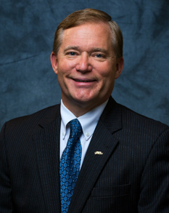
Dear Campus and Coastal Virginia Community:
Whoever you are, and wherever you come from, we welcome you warmly to our campus.
College years need to be times of growth, when we are exposed to new ideas, in conversation with different perspectives, and learning to understand, appreciate, and value others. That doesn't happen unless we celebrate diversity. We grow in important ways through the many viewpoints that come from our differences from each other, whether those differences relate to race, gender, age, and language, or to other differences that may be more subtle, like socioeconomic status, religion, sexual orientation, gender expression, gender identity, political affiliation, or geographical background.
Virginia Wesleyan does not discriminate on the basis of race, religion, color, creed, gender, national or ethnic origin, age, marital status, covered veteran status, disability, sexual orientation, gender identity and expression, or any other legally protected status in administration of its educational policies, admission policies, scholarship and loan programs, and athletic and other University-administered programs.

Critical to the identity we embrace is our going beyond mere legal expectations. VWU's Strategic Plan lays out the importance of diversity on the campus by advocating for a more diverse undergraduate population and a more diverse faculty and staff. We try to be leaders in the area of diversity and inclusion for Coastal Virginia. In 2018, for instance, Virginia Wesleyan became the first higher education institution in the region to expand our statement on non-discrimination to include gender identity and gender expression.
Finally, we believe that we must always work and strive to deepen our understanding and sensitivity regarding all perspectives surrounding diversity. As a residential campus, we provide our students the ability to practice living, learning, and collaborating with others in an environment that is both challenging and supportive in all aspects.
With you, I look forward to advancing Virginia Wesleyan University's commitment to building a more diverse, equitable and inclusive community. The differences of each community member are what make Virginia Wesleyan even stronger.
Sincerely,
Scott D. Miller, Ph.D.
President of the University

Building a Campus Culture of Diversity, Equity and Inclusion (2015-) excerpt 2020 - 2021
In 1866, exactly 100 years before the first class entered Virginia Wesleyan, the land on which our University lies was used to help recently freed slaves make the transition to freedom. Throughout its history, our campus has placed a priority on being a dynamic and cohesive community where significant transitions occur in people's lives, and to be a place that embraces and celebrates diversity, equity and inclusion. We are committed to continual efforts to build a community that is not only welcoming and supportive of all, but that also empowers all members of the Virginia Wesleyan family to have a voice and to be advocates for themselves and for each other.
2020: Recognized by U.S. News & World Report in its 2021 Best Colleges guide, ranked among the top 25 in "Ethnic Diversity" among liberal arts institutions and named a Top Performer on Social Mobility.
2020: Recognized as a 2020-2021 Equity & Inclusion College of Distinction, distinguished as a community dedicated to equal opportunity for all students, faculty, and staff.
2020: VWU established the MLK Jr. Legacy Award, to be awarded each January to a student that represents the ideals set forth by Rev. Dr. Martin Luther King, Jr.
2020: We charged the Robert Nusbaum Center with facilitating discussions of race on our campus, in our community, and in the nation.
2020: We entered into a partnership with Lakeland University Japan, creating an international partnership and campus presence in Asia.
2020: We expanded paid internship opportunities for students from underrepresented populations.
2020: We developed bridge programs between VWU's Office of Diversity, the Robert Nusbaum Center, and the Virginia Center for Inclusive Communities, to offer programs and opportunities for meaningful dialogue.
2020: The Women's Resource Center redefined itself as Office of Gender and Sexuality Equity to better reflect its current mission and campus need.
2020: We reallocated staffing in some sports (cross country, indoor/outdoor track, golf, swimming) to create better gender balance in the Athletic Department coaching staff.
2020: Unconscious Bias workshop was introduced to the campus.
2020: VWU joined the Campus Pride Index, which measures the campus climate for LGBTQA+ individuals. Our Year 1 score was 4 out of 5 stars.
2020: We launched the preferred name initiative so that students can have their preferred name shared with faculty members prior to the start of class to aid inclusion in the classroom.
2020: VWU received an NCAA Division III diversity funding grant for a diversity intern and committed to annual involvement in the NCAA Diversity and Inclusion campaign/program.
2020: We joined the Liberal Arts Colleges Racial Equity Leadership Alliance (LACRELA), coordinated by the University of Southern California Race and Equity Center. Membership in the Alliance includes three campus climate surveys – students (year 1), faculty (year 2) and staff (year 3) and a variety of professional learning opportunities for faculty and staff as well as quarterly meetings for presidents of the Alliance member colleges.
2021: Awarded 5 out of 5 stars by Campus Pride for work in the area of LGBTQIA+ policies on campus and featured on its National Listing of LGBTQ-Friendly Colleges & Universities.
2021: The National Assessment of Collegiate Campus Climates (NACCC) student survey is administered with membership in LACRELA.
2021: Eight members of the faculty and staff participate in twelve, 3-hour, interactive sessions led by highly respected leaders with membership in LACRELA.
2021: The President participates in quarterly meetings to share strategies, seek advice, and identify ways to leverage the Alliance for collective impact on racial equity in higher education with membership in LACRELA.
2021: We named the previously established student award given annually on Martin Luther King Jr. Day the Mavis McKenley '11 Award for our esteemed alumna and member of the Board of Trustees. This award recognizes an outstanding student from an underrepresented population for their academic achievement and contributions to campus and/or the Coastal Virginia community.
2021: We separated the NCAA Senior Woman Administrator role from that of the Athletic Director to ensure another strong female voice in the Athletic Department.
2021: Heritage Plaza commemorative plaque was placed at the flagpoles in front of Godwin Hall. This is an acknowledgement of a special part of VWU history. The plaque reads, "In 1866, a portion of the land on which the University lies, then Baker Farm, was claimed by the Second District Department of Negro Affairs as a site for helping recently freed slaves make the transition to freedom. The first institutional use of the property hallowed it in a meaningful way, and these 300 acres continue to be a place where lives are changed and new opportunities embraced."
2021: We developed a plan to increase diversity in all campus hiring to mirror the profile of the campus community.
2021: We continue to strengthen and market VWU's national ranking in social mobility and diversity among National Liberal Arts Colleges.
2021: We undertook an institutional review of all faculty, staff and student handbooks to ensure fairness and equity in University process and policies.
2021: We expanded our 2 + 2 program for underrepresented men and women to include the Virginia Community College System.

Our next steps (progress to be reported in 2023):
2022: We will establish an annual marquee event, bringing in a keynote speaker and other resources, that focuses on topics impacting underrepresented populations.
2022: We will establish faculty, staff and contract service development programs on diversity.
2022: We will plan for a post-pandemic approach to globalization.

Diversity, Equity, and Inclusion Council
As a means of further enhancing Virginia Wesleyan University's institutional commitment to diversity, equity, and inclusion, President Scott D. Miller introduced the Diversity, Equity, and Inclusion Council (DEIC) in 2022. The DEIC leads institutional efforts to not only understand diversity, equity and inclusion issues, but also to provide resources and layers of support for students who bring rich experiences and perspectives to ensure that Virginia Wesleyan is continually honoring and respecting differences and that all members of the campus community have a voice.
From purpose to function, the DEIC leads the institution in offering programs designed to enhance the educational value of the campus community through purposeful dialogue and celebration of difference. The Council consists of the University's designated Chief Diversity Officer and five deputy diversity officers from key institutional areas: Academics, Athletics, Student Activities, the Lighthouse, and the Robert Nusbaum Center. The Chief Diversity Officer is appointed by the President of the University and shall serve as chair. The DEIC meets monthly to discuss events and initiatives.

Diversity, Equity, and Inclusion Council (DEIC)
Dr. Felipe Hugueño, Deputy Diversity Officer (Assistant Professor of Hispanic Studies)
Dr. Modupe Oshikoya, Deputy Diversity Officer, Academic Liaison (Assistant Professor of Political Science)
Cameia Alexander, Deputy Diversity Officer, Athletic Liaison (Director of Men's and Women's Cross Country and Track and Field)
Kelly Jackson, Deputy Diversity Officer, Robert Nusbaum Center Liaison (Associate Director of the Robert Nusbaum Center)
Audwin Harris, Deputy Diversity Officer
Maria Peña-Pinedo, Deputy Diversity Officer
Bethany Tsiaras, Deputy Diversity Officer
Additionally, Dr. Susan Larkin, (Provost and Vice President for Academic Affairs), and Dr. Keith Moore (Senior Vice President), serve as ex officio liaisons to the President's Cabinet.

Liberal Arts Colleges Racial Equity Leadership Alliance (LACRELA)
Virginia Wesleyan University joined, at the beginning of 2021, a group of 68 National Liberal Arts Colleges collaborating to form the Liberal Arts Colleges Racial Equity Leadership Alliance (LACRELA), facilitated by the University of Southern California's Race & Equity Center. Meetings and resources from this group continue to inform and shape VWU's initiatives in this area.
The University is also consistently recognized for its ethnic diversity and social mobility among National Liberal Arts Colleges by U.S. News & World Report and has repeatedly distinguished itself as a community dedicated to equal opportunity for students, faculty, and staff as an Equity & Inclusion College of Distinction.
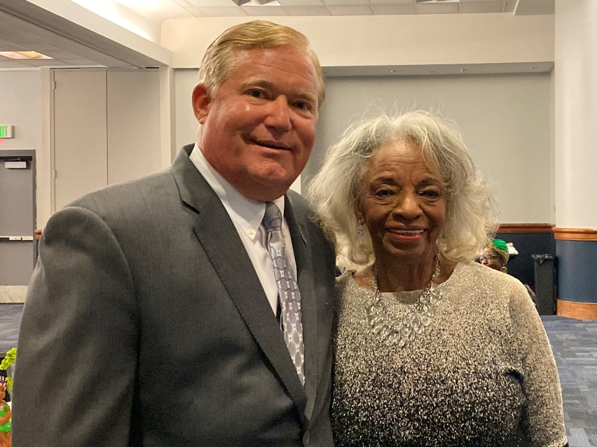
Cee Cee Tucker Named Senior Advisor to the President on Diversity and Inclusion (09-12-2022)
Cecelia “Cee Cee” Tucker has accepted the role of senior advisor to the president on diversity and inclusion, Virginia Wesleyan University President Scott D. Miller has announced. Tucker will assist in furthering the University's action plan with the Diversity, Equity and Inclusion Council and advise senior leadership on related topics. Many know Tucker from her extraordinary 30-year career as assistant to the president and director of community relations at Old Dominion University. "She has been a pillar of the Coastal Virginia community, " said Dr. Miller, "working tirelessly to extend educational opportunities to underserved populations in our area. Through her good work as an educator, a non-profit director, and a community liaison, Cee Cee has defined herself as a leader focused on equity and inclusion." Dr. Miller has worked with Tucker on numerous projects, most recently with the Virginia Center for Inclusive Communities. President’s Blog

Sustainability
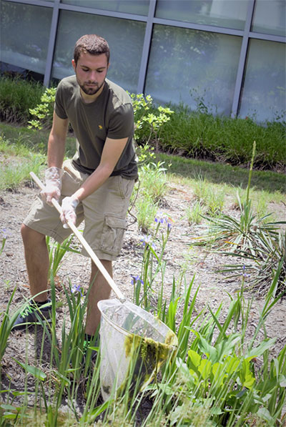
A student collects algae from a bioretention basin outside the Greer Environmental Sciences Center.
Virginia Wesleyan University is not just talking about the importance of sustainability issues—the University is actively greening its campus and taking action to become a more environmentally-friendly place.
Just driving on campus, you get the feeling that the environment is important to Virginia Wesleyan with its wide-open spaces, green fields, wild flowers, and bluebird and bat boxes for nesting. It's not uncommon to see a family of raccoons or Canadian Geese making themselves at home on campus.
With the creation of the Environmental Sustainability Council (ESC) came the development of a more aggressive campus recycling program and the refinement of campus building and business policies and procedures. In conducting campus audits, the ESC found that the University had already been environmentally conscious in many areas.

The grass is greener at VWU
The Virginia Wesleyan University community is dedicated to a greener campus and a greener world. The ongoing sustainability efforts of the University's faculty, staff and students reflect a larger commitment to ethical conduct and social responsibility through environmental stewardship and education.
Virginia Wesleyan has been recognized locally, regionally and nationally for its sustainability practices. VWU has repeatedly been selected by The Princeton Review as one of the most environmentally responsible colleges in the U.S. and Canada and profiled in its Guide to Green Colleges.

Come see for yourself
Wesleyan's beautiful 300-acre park-like campus is an oasis of trees, open fields and flowers that also happens to be a designated bird sanctuary and the home of an old-growth beech forest. You can find bat and bluebird houses, beekeeping boxes and even an eco-friendly worm farm on the University grounds.
The 44,000-sq.-ft. Greer Environmental Sciences Center (GESC) provides unprecedented opportunities for students and fosters regional collaboration with organizations such as the Virginia Aquarium & Marine Science Center and the Virginia Institute of Marine Science. The Center features sophisticated indoor and outdoor learning spaces that promote hands-on experiences, interactive learning, and interdisciplinary research.
The GESC achieved Leadership in Energy and Environmental Design (LEED) Gold Certification for compliance within a rigorous rating system created by the U.S. Green Building Council (USGBC) by proving measurable strategies and solutions aimed at achieving high performance in energy efficiency, material choice, water efficiency and savings, and site enhancement. LEED certification is a globally recognized symbol of sustainability achievement.
In addition, VWU was honored as a Conservationist of the Year by the Chesapeake Bay Foundation at the 2018 DC on a Half Shell event in Washington, D.C. VWU, along with Washington College, was recognized for leadership and commitment to educating the next generation of Chesapeake Bay leaders.
Virginia Wesleyan University has also advanced to the top tier Model Level status in the Elizabeth River Project's River Star Business program. The Elizabeth River Project is an independent non-profit that works with partner organizations to restore the Elizabeth River, a tributary of the Chesapeake Bay.
Virginia Wesleyan is committed to waste-reduction, recycling, energy efficiency, green building practices, composting and other earth-friendly landscaping practices, promotion of public transportation and much more. Many faculty/student research projects integrate learning and community service for the betterment of the planet
.

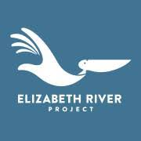 Riverstar Business Update 2022
October 1, 2022
This document summarizes major updates in Virginia Wesleyan University’s sustainability achievements for the last two years.

Campus policies & practices
- Utilizing the Intentional Endowment Network standards, the VWU endowment is entirely invested in an environmentally friendly way with Brown Advisory of Baltimore, Maryland. (Beginning in summer of 2022)
- In 2020 the Board of Trustees approved Environmental Guiding Principles for the university

Recognition & Accomplishments with Outside Organizations
- VWU is a signatory to the President’s Climate Leadership Commitment, which integrates carbon neutrality with climate resilience and provides a systems approach to mitigating and adapting to a changing climate.
- Virginia Wesleyan is a member of the Intentional Endowments Network.
- Virginia Wesleyan is a participant in the Chesapeake Oyster Alliance partnership, a coalition dedicated to helping recover the Bay’s oyster populations, and a member of Virginia’s No Child Left Inside Coalition, a collaborative effort between organizations to promote outdoor learning.
- The Greer center's gardens have been certified as a Monarch Waystation.
- Tidewater Collegiate Academy is a Project Learning Tree (PLT) Certified Green School.
- Deford Manor qualified as an Elizabeth River Project Riverstar home.
- Five scholars from the Batten Honors College took first place in the undergraduate division at the Intentional Endowments Network’s Student Corporate Engagement Competition earlier this year. In this national competition, students pitch an investment in a publicly-traded company based on that company’s plans for addressing inequality and the climate crisis.
- Brown Advisory has committed $50,000 to establish a student-managed investment fund at Virginia Wesleyan. The fund will focus on ESG investing.

Campus events, education & outreach
- VWU conducts an annual audit of its greenhouse gas inventory, which is publicly available (https://unhsimap.org/public/institution/734)
- VWU celebrated Earth Week in 2022 with 1) a tour of the Greer Center native gardens for faculty and staff that included recommendations for home gardens, 2) a fair for students which included information tables from local environmental groups, and 3) a campus litter clean up.
- The Marlin Chronicle student newspaper published articles on sustainability and the environment including the stories “Palmer Mine Project endangers Alaskan river and salmon population”, “Marlins Go Green hosts Earth Week events”, “Art features environmental resiliency in Norfolk”, “VB Bites: Sustainable eats at Commune” and “Marine Science program launches for summer”.
- The campus collected printer cartridges, electronic waste, soft plastic bags, personal care product packaging and used dry erase markers for recycling.
- Speakers are invited to campus every year to give presentations on environmental topics to the whole campus or individual classes.
- Elizabeth Malcolm was a guest panelist on the Atlanta talk radio show “On Point with Juandolyn Stokes” for an episode on "Why Our Community Must Care About Cumulative Impacts of Health Equity, COVID and Extreme Heat."
- Elizabeth Malcolm was a panelist for the Risk Management Association's virtual event "Climate Risk in the Banking Industry," which was attended by 190 professionals from the financial industry and organized by VWU alumna Melissa Burroughs '86.
- Five of Elizabeth Malcolm and Chris Haley's research students presented their research to the Tidewater Master Naturalists Association. The presentations were titled "Virginia Beach Heat Vulnerability: Correlation to Urban Tree Cover and Neighborhood Demographics" and "Carbon Sequestration in Virginia Wesleyan University's Old Growth Beech & Pine Forests."
- President Miller participated in a virtual panel discussion, "Working with an Investment Firm: Making Your ESG Intention Actionable," during the annual Higher Education Climate Leadership Summit along with representatives from the University of New Hampshire and VWU's CIO from Brown Advisory on April 5. During this session, participants heard case studies outlining the relationship between endowment stakeholders and the investment firms they work with to develop and implement their ESG investing strategy. Dr. Miller discussed the environmentally friendly investment of VWU's full endowment and the mission of the Batten Honors College.
- As a part of the NOAA-funded Shared Waters Project, Norfolk Collegiate third graders and their teachers came to VWU's campus to tour the gardens of the Greer Environmental Sciences Center. Skyler Lattuca and 16 aspiring teachers in Bill McConnell's course, EDUC 266: Classroom Management and Teaching Strategies, led the children in clearing invasive species and making leaf rubbings to identify plant species.
- Students of Lisa Lyon Payne’s COMM 328 pitched their campaign, "An Oyster a Day Saves the Bay," to executives from COA and the Chesapeake Bay Foundation. The campaign to support the local oyster industry included: survey and focus group findings, photos, videos, Instagram and TikTok content, fact sheets, website with interactive graphics and feature pitch letter.
- Students in BIO 316 Ecology and EES 450 Biogeochemistry removed invasive species from the campus forests.
- Students in EES 200 Oceanography will work with ERP on a marsh grass planting on October 10-11, 2022
- Batten Honors College students assisted ERP with a tree planting project in 2022

Research and scholarship
- The university participated in a statewide urban heat island research project organized by the Virginia Foundation for Independent Colleges. Dr. Elizabeth Malcolm and her research students organized the citizen science measurement campaign which involved over 20 volunteers driving with heat sensors on a hot day in August 2021. The data was used to create an urban heat island map for the city. Students under the direction of Dr. Chris Haley are using GIS to compare the urban heat island to demographic data such as income and health metrics to determine what neighborhoods are most at risk from extreme heat. The research group is currently working with Lynnhaven River Now and the City of Virginia Beach to plan a tree planting project informed by the heat maps. The study made the local news in the Virginian Pilot and with a story on Wavy TV.
- Several students conducted independent research with a sustainability/environmental dimension.
- Students conducted sustainability or environmentally related internships with the Norfolk Botanical Gardens, Virginia Tech’s Hampton Roads Agriculture Research and Extension Center, the Elizabeth River Project, and other local organizations.
- Maynard Schaus and Vic Townsend presented a talk entitled "Effect of a Hurricane on the Abundance of Puerto Rican Harvestmen along an Altitudinal Gradient" at the Virginia Academy of Science meeting in Lynchburg, VA. Co-authors included VWU alumni Amanda Albert and Dan Proud (currently on the faculty at Moravian University) and Don Yee of the University of Southern Mississippi.
- Maynard Schaus received a grant from the Second Nature Acceleration fund to support student internships with the Elizabeth River Project that support environmental justice and climate equity.
- Elizabeth Malcolm co-presented "Virginia Heat Watch: Heat Mapping to Assess Vulnerability and Address Inequity in Virginia Communities" at the 2022 Higher Education Climate Leadership Summit.
- Elizabeth Malcolm gave a presentation on Virginia Wesleyan University's recent sustainability achievements at the virtual conference, "Climate Action Pursuit: Toward Justice and Resilience."
- Soraya Moein Bartol acted as a consultant to provide scientific review of wind energy environmental monitoring plans off the East Coast of the U.S. for Ørsted, a Denmark based wind energy company.
- Student Phoebe Murrell presented research co-authored by Elizabeth Malcolm and Maury Howard--"Problem to Product: Evaluating the Use of Stormwater Pond Algae to Bioremediate Ponds and Generate Compost" at the Virginia Water Conference.
- Marielle Postava-Davignon gave a talk titled "Adventures of a Termite Ecologist: Learning to Make the Most of What Nature Gives You" as part of the Adventures in Field Research virtual seminar series hosted by the Lincoln Memorial University School of Mathematics & Sciences.
- Elizabeth Malcolm and Bill McConnell co-presented virtually for the Virginia Association of Science Teaching conference. The presentation entitled, "Understanding Environmentally Sustainable Roof Design," highlighted the educational use of the green roof on Greer Environmental Sciences Center and described an elementary science lesson where young students investigated various types of roofs and their impact on the environment.

Supply Chain and Labor Notice
August 19, 2021

(Sodexo is a contract services provider of long standing with VWU and as a leading global food services and facilities management company is a role model for our administration as well as our students in living best practices in an institutional environment.)
Due to the current disruptions in the supply chain we are experiencing frequent menu changes and substitutions for ingredients that may cause changes to the allergens in some of your favorite menu items. Although we have protocols in place, please refer to the allergen signage for any potential changes or speak with the Food Service Manager for additional information.
We appreciate your understanding as we experience some potential changes to product availability and staffing, due to nationwide supply chain and labor shortages. We assure you that delivering exceptional, safe customer experiences is still our top priority, and thank you for the ongoing support of the dining team.

Our Initiatives
Virginia Wesleyan University Dining Services has several program initiatives that support sustainability

Recycling
On Campus we recycle the following products: cardboard, glass, steel, aluminum, paper, plastic and e-waste. Recycling bins can be found throughout our dining facilities on campus.

Xpress Nap
The napkins are made of 100% recycled paper and the dispenser will encourage customers to take (and waste) fewer napkins. Energy is saved because less power is used to recycle paper products than to create them from virgin material.

Trayless
Customers without trays typically waste less food and beverages. It is also a healthier approach to eating, as we all know that at times our eyes are bigger than our stomach. Trayless dining also reduces the amount of water and detergents needed to wash trays - and saves energy too!

Composting
Food waste in landfills creates methane, a greenhouse gas which is 21x more potent than CO2. (www.epa.gov) Our first priority is to reduce food waste. We compost food waste to reduce greenhouse gas emissions and also be enhance and amend soil health by improving soil structure, enhancing micro-organism content, increasing drought tolerance and reducing need for water and fertilizers. We collect pre and post-consumer food waste to create compost to be used across campus. Look for ways to get involved in these initiatives.

Local Suppliers
We work closely with local produce distributors to maximize the fruits and vegetables purchased from local farms. We also purchase from local dairies and participate in farm to school initiatives. Tracking local purchases helps us to meet our Better Tomorrow Plan commitment of 20% local purchase by 2020.
Principle 3: Method
Comprised of four undergraduate departments—Business, Education, Social Work, and Sport and Recreation Professions—the D. Henry Watts School of Professional Studies offers a well-rounded, cross-disciplinary education that prepares students to lead and excel in increasingly complex environments. Each program has required internships, student teaching, or field experiences that prepare students for life and career and underscore the University’s core values of academic excellence, inclusivity, personal integrity, and social responsibility. In the summer of 2019, the Watts School was created to bring these departments into a single administrative unit. These programs had been housed in the Birdsong School of Social Science. The Business and Education departments offer the only graduate programs in the institution while programs in Human Services Administration as well as Sport and Recreation Management are in development.

Department of Management, Business, and Economics - Mission
Through a firm commitment to the liberal arts, global perspectives and ethical decision-making, the Management, Business, and Economics Department develops leaders committed to creating sustainable social, environmental, and economic value through effective and responsible business practices.

According to IPEDS Completion Survey Data Submission, 2020-2021 - Business majors comprised 15.7 percent of undergraduate completions with three online completions. 32 out of 36 masters’ graduates were MBA students (88%).

2021-2022 - Business majors comprised 15.4 percent of undergraduate completions with 4 online completions. 28 out of 35 masters’ graduates were MBA students (80%).
(Office of Institutional Research)

Catalog Description: The Business Major (B.A.)
Virginia Wesleyan College’s Business major combines a practical business education with a commitment to the Principles for Responsible Management Education (PRME) as developed by the United Nations in support of its Global Compact – a framework of universally accepted principles in the areas of human rights, labor, environment and anti-corruption. Firmly committed to the interdisciplinary nature of successful management education, VWU’s Business major integrates its core curriculum with allied course work in a variety of disciplines while also providing opportunities for career-based specialization through coursework and internships. Successful completion of the Business major will prepare our graduates with the skills, knowledge, and attitudes necessary to manage society’s rapidly changing institutions both efficiently and humanely. Moreover, the interdisciplinary nature of the program will provide a solid foundation for graduate school in a wide variety of fields.

Catalog Description: Sustainability Management Major (B.A. and B.S.)
The Sustainability Management major prepares students to utilize their knowledge of the functional areas of business and management to help organizations both adopt and achieve the goals of environmental sustainability and social responsibility. The major employs a multi-disciplinary approach whereby students will learn not only the scientific principles undergirding sustainable business practices but also the philosophical underpinnings of the global need for sustainability and the various regulatory approaches for achieving it. In addition to significant coursework in a variety of academic disciplines, students will synthesize their studies through a senior-level experience entailing either further coursework with an internship or a sustainability-focused Study Away experience. (13 undergraduate MBE courses contribute to either the B.A. or B.S.)

Departmental offerings in Business and Sustainability Management:
MBA – Online
Certificates – Online
B.A. in Business – Online
B.A. in Business – Face-to-face
B.A. in Business – Evening and weekend program
B.A. in Sustainability Management
B.S. in Sustainability Management

Last spring (2022) we made some valuable changes to our online Master of Business Administration, redesigning the curriculum with an added focus on leadership. There is a high demand today for employees who can bring both business and leadership skills to the table. Our MBA course content has been adjusted to reflect that demand, and seeks to develop leaders committed to creating sustainable, social, environmental, and economic value through effective and responsive business practices.
Students don’t need a business degree to get an MBA. Our program is designed to enhance leadership skills and lay the foundation for success in any field, regardless of a student’s background. Upon graduation, students will have the communication and teamwork skills necessary to compete in a global environment, a firm understanding of advanced business concepts, knowledge of relevant emerging business trends, and key leadership skills necessary for managerial roles.
The 10-course program can be completed in as little as 12 months, and students may enroll on either a full-time or a part-time basis. The next start date for our online MBA is January 23. Learn more at online.vwu.edu.

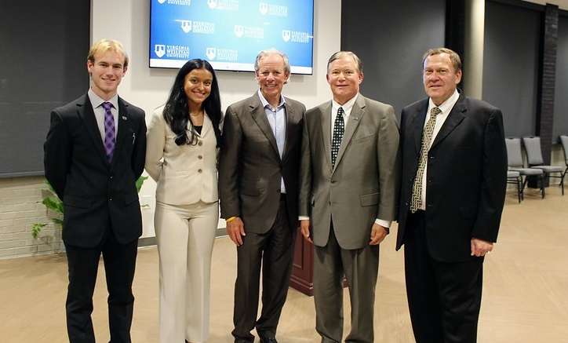 The Fall Marlin Business Conference opened on November 15 with a keynote address from Bruce Thompson (center), CEO of Gold Key-PHR.
The Fall 2022 Marlin Business Conference kicked off this week with "Shark Tank" presentations, an ISP competition, an “Etiquette and Fashion Expo,” and guest speaker Linda Blakemore of G3G, Inc. The formal opening ceremony featured the 2021 Virginia Business Person of the Year and Gold Key|PHR CEO Bruce Thompson as keynote speaker. All sessions were held on campus in the Joan P. Brock Room in Brock Commons.
The theme for this semester’s student-led conference was “Creating Careers for Change.” From November 15-18, members of the community participated in free workshops, presentations and interactive panels, all planned and organized by students in the “Principles of Management” course taught by Frank Futyma, Lecturer of Management, Business and Economics.
The biannual conference represents the culmination of months of hard work by the students who are responsible for coordinating all aspects of the event, as they engage in key management skills such as product development, networking, project management and financial planning. President’s Blog

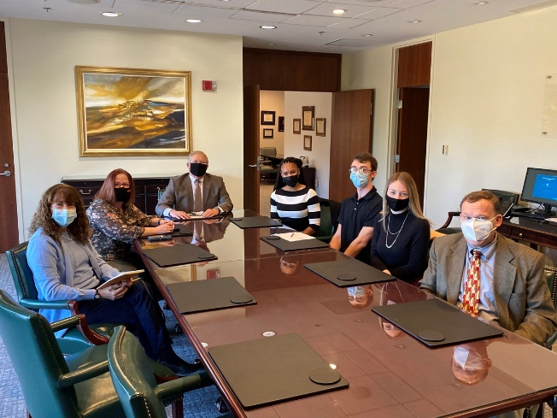

Spring 2022 Marlin Business Conference Planning Begins
I met with student leadership for the upcoming Marlin Business Conference: (from left) Doris White, Chief of Staff; Davon Young, Chief of Technology; and MacKenzie Osborne, Chief Executive Officer. This spring’s conference will focus on commerce and innovation. We were joined by faculty leadership Frank Futyma, Lecturer in Management, Business, and Economics; Michelle Vachris, Professor and Chair of Management, Business and Economics and MBA Program Director; and Sue Larkin, Vice President for Academic Affairs. President’s Blog
The spring Marlin Business Conference took place from April 11-14. 2022.

Marlin Business Conference: November 15-18, 2021
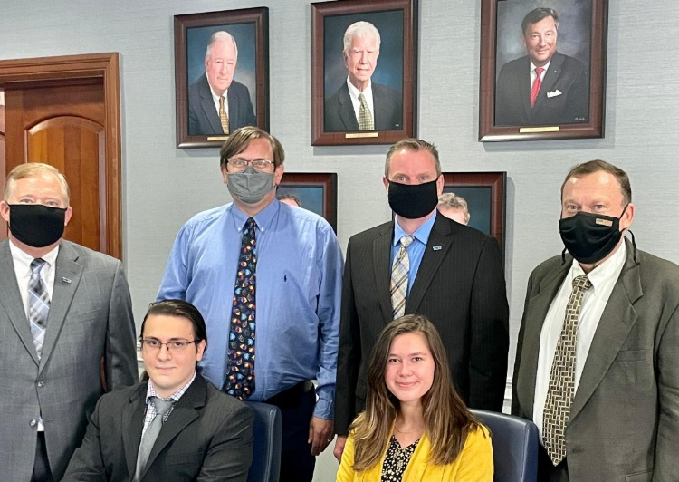
The Fall 2021 Marlin Business Conference, “Commerce in the New Normal,” begins this week with its opening session at The Hive in Virginia Beach Town Center. Taylor Adams, Deputy City Manager for Virginia Beach, will be the keynote speaker. Our partnership with The Hive is thanks to the Virginia Beach Department of Economic Development, which partnered with VWU to offer over 70 workforce development courses at no cost to over 3,000 Virginia Beach residents. These courses have been offered online, at The Hive, and in our newly renovated Clarke Hall. We thank VBED and Taylor Adams for their friendship and support. President’s Blog

VWU/TCC/VBED Partnership Center, The Hive, Hosts Grand Opening 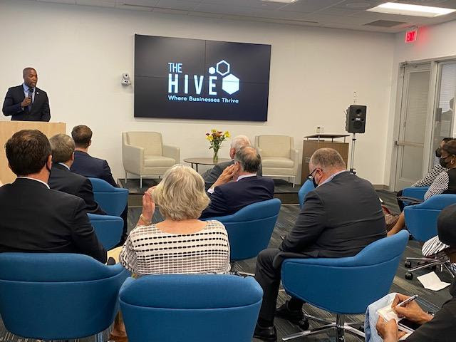 September 27, 2021
After a year of planning, space designing and construction, and program implementation the long-awaited grand opening of The Hive in Virginia Beach Town Center was held Wednesday night.
Dignitaries from throughout the City joined partners—Virginia Beach Economic Development, Tidewater Community College, and Virginia Wesleyan University—to showcase the new facility to the business community. Mayor Bobby Dyer and several City Council members provided comments as well as Taylor Adams, Deputy City Manager and Director of Economic Development for the City of Virginia Beach.
The VWU/VB Economic Development partnership has been significant this year. Over 1,500 learners have enrolled in VWU non-credit programs for Virginia Beach residents displaced by the pandemic. Additionally, infrastructure upgrades to Clarke Hall have come from private support facilitated through this partnership.
Deirdre Gonsalves-Jackson, Dean of VWU Global Campus; Marion Hibbler, Director of Lifelong Learning, VWU Global Campus; and Larry Belcher, Director of Enrollment, VWU Global Campus, joined me for the Grand Opening celebration.
The compliments that we received were tremendous and the pledges of financial support to this program and our main campus will continue. I thank Deirdre, Marion, and Larry for their leadership on this partnership. President’s Blog

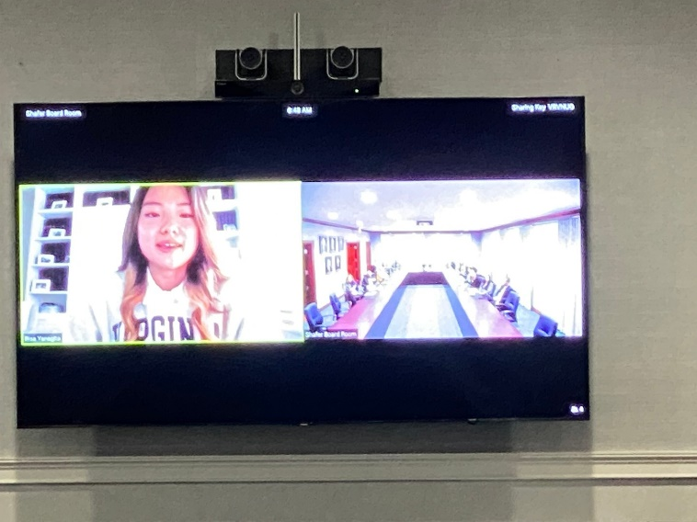

Spring 2022 President's Council Meeting
Junior Business Major Risa Yanagita presented to members of the President's Council this morning about her transition from VWU Global in Tokyo, Japan, to campus life in Virginia Beach. We thank the President's Council for their engagement and continued support of student internships and job placement upon graduation.

Principle 4: Research

Academic Symposium
The Academic Symposium is a signature Virginia Wesleyan event that celebrates the academic achievement of students completing a variety of academic experiences, including research, internships, performance, and global engagement.
The Academic Symposium is a conference-style event held on the Virginia Wesleyan campus. Students share their work with a professional oral, poster, or panel presentation. As part of the discussions following these presentations, students are encouraged to reflect upon their experiences and offer advice to other students who are preparing to undertake their own experiences.

Excelsis: A Publication of the Batten Honors College
Fall 2022 edition includes features written by program scholars
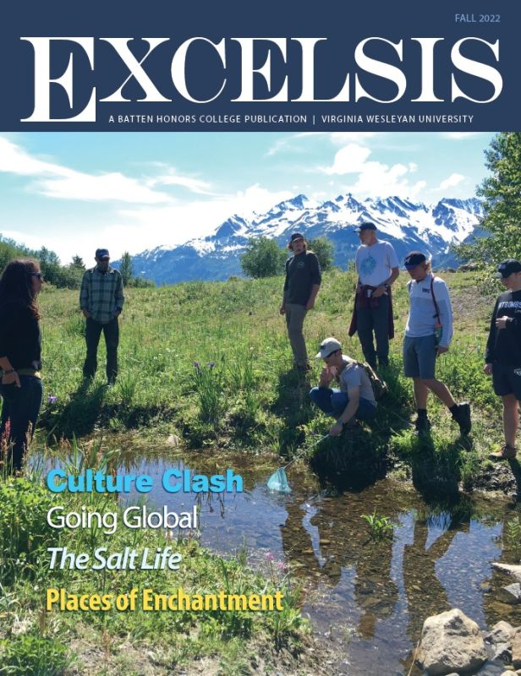University News | November 17, 2022
The fall 2022 edition of Excelsis, a publication of the Batten Honors College of Virginia Wesleyan University, is now available online. The latest issue includes student achievements, BHC events, an interview with international scholars and an alumni spotlight.
Fall 2022 features include:
- “Going Global,” by Dean of the Batten Honors College Travis Malone, Ph.D.;
- “Lessons Learned,” by Garrett Page and Madelyn Yale;
- “Places of Enchantment,” by Ryan Abraham and Kirkland Butler;
- “Tradition and Modernism,” by Katelyn Baines;
- “Sweet Treat,” by Alyssa Lane;
- “Culture Clash,” by Katie Baker and Jessica Wilson;
- “Pushing the Envelope,” by Breanna Wimbush;
- “The Salt Life,” by Abby Mahoney;
- “Summer Internships,” by Brian Hostetter and Breana Mahoney;
- “International Insight,” by Abby Peterson;
- A Global Outlook,” by Melina Cabral; and
- “A New Perspective,” by Devin Calpo.
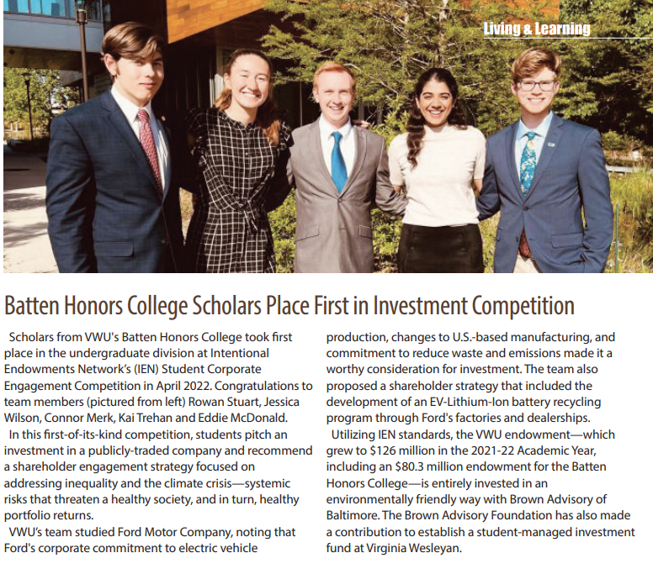
Principles 5 & 6: Partnership and Dialogue
Business is the largest undergraduate major at VWU in terms of active students and completions. The department relies heavily across the institution to provide curricular and co-curricular programs for our majors. As a small, private, liberal arts university, this is as it should be. The entire institution bears the responsibility for educating all of our students.
Wesleyan Engaged: Civic Engagement and Service Learning
In 2017, Virginia Wesleyan University established Wesleyan Engaged: Center for Civic Engagement and Service Learning (formerly the office of Community Service). The office's responsibility is to establish and maintain both in-class and out-of-class engagement for students, faculty, and staff. In the 2019-2020 academic year, VWU registered 32500 hours of engagement (among faculty, staff, and students) of 487 unique individuals at 53 local and state organizations/non-profits and 11 organizations/non-profits outside of the Commonwealth of Virginia.
In 2020, VWU received the Carnegie Classification for Civic Engagement based on their 2019 application. VWU offers over 1060 four-credit courses. Of those courses, 18.93% of these courses have a service-learning component contained within the course. The percent of courses with service-learning components represents 77.3% of all departments on the campus. Of the 163 full-time or part-time faculty teaching at VWU, 33.13% of them teach a course with a service-learning component built into their course. Finally, over 950 unique students were found to have taken a course that had a service-learning component built into the curriculum, which represents 66.36% of the undergraduate students on the VWU campus.

Of the graduating seniors, 47% took a capstone course within their major and 39% of the graduating seniors completed an internship.

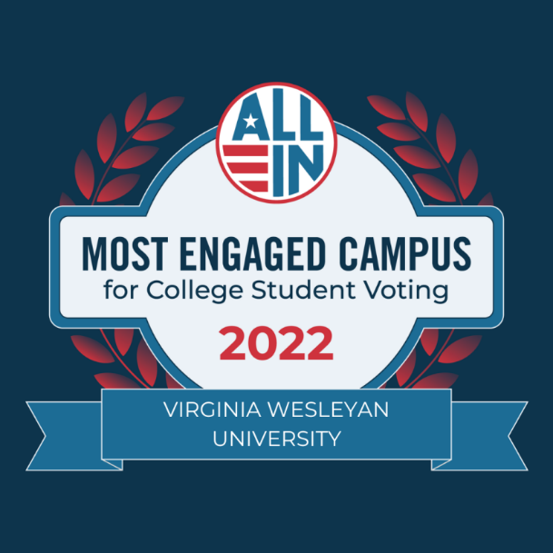

VWU Recognized Among Most Engaged Campuses for Student Voting
University celebrated by ALL IN for efforts to increase student voter participation
University News | November 16, 2022
Virginia Wesleyan University has been recognized by the ALL IN Campus Democracy Challenge (ALL IN) as one of this year's Most Engaged Campuses for College Student Voting.
The accolade recognizes colleges and universities for making intentional efforts to increase student voter participation. Virginia Wesleyan is among a group of 394 colleges and universities recognized by ALL IN for completing these four actions: participating in the ALL IN Campus Democracy Challenge; sharing 2020 NSLVE Reports with campus voting data with ALL IN; developing and submitting a 2022 democratic engagement action plan with ALL IN; and having a current signatory to ALL IN’s Higher Education Presidents’ Commitment to Full Student Voter Participation.
“College student voter turnout has increased since 2016 and this increase has been driven by students,” said Jennifer Domagal-Goldman, Executive Director of the ALL IN Campus Democracy Challenge. “The ALL IN Campus Democracy Challenge is excited to expand our ALL IN Student Voting Honor Roll to recognize these student voting champions across the country. These student registered voters served on their campus voting coalitions, spearheaded voter education efforts, advocated for campus polling locations and organized other voter engagement efforts to ensure their peers were confident and informed voters. We are excited to see what they continue to accomplish.”
The ALL IN Campus Democracy Challenge is a national nonpartisan initiative of Civic Nation, a 501(c)(3) organization that strives to change civic culture and institutionalize democratic engagement activities and programs on college campuses, making voter participation a defining feature of campus life.
The initiative empowers colleges and universities to achieve excellence in nonpartisan student democratic engagement. Campuses that join the ALL IN Campus Democracy Challenge complete a set of action items, with the support of ALL IN Challenge staff, to institutionalize nonpartisan civic learning, political engagement, and voter participation on their campus. The initiative currently engages over nine million students from more than 950 institutions in all 50 states and the District of Columbia.
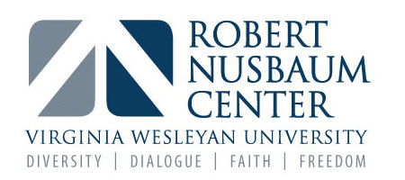
Robert Nusbaum Center
Frequently the most contentious and polarizing moments in American civic life are related to issues in religion, politics, race, gender, and sexuality. In responding to those issues, the Robert Nusbaum Center (NC) is grounded in Virginia Wesleyan’s commitment to a rigorous liberal arts education and its United Methodist heritage, both of which have long recognized religious freedom as a basic human right, and diversity as the bedrock of a strong foundation.
The Robert Nusbaum Center aims to create a civil society through education, respectful dialogue, and mutual understanding. The NC equips and empowers students and community members to be leaders and citizens who value diversity and who understand how the reconciliation of our religious, racial, and ideological differences create meaningful opportunities for civil solutions to difficult and urgent problems.

OUTCOMES ASSSESSMENT AND KEY OBJECTIVES
Excerpt from SLAR: Student Learning Assessment Report for MBA Graduate AY 2021-2022

MBA students are expected to read and engage in scholarly research and
appropriate professional practice and training in each course, either in discussion
board postings or in more formal writing assignments.
Examples:
MBE520: Requires a major research paper dealing with a business ethics topic.

MBE540: Students complete a Harvard Business School simulation assignment
in which they manage a rental car company in Florida.

MBE550: For discussion boards, students read scholarly articles and reflect on
their personal experiences. They also use the information in these articles and
their text reading to analyze a publicly listed company and provide
recommendations to improve financial performance.

MBE590: Requires students to engage in a very comprehensive case
assignment whereby they must integrate all of the functional areas of business in
making strategic recommendations for organizational improvement.

Excerpt from SLAR: Student Learning Assessment Report for Sustainability Management Undergraduate AY 2021-2022

iii. Give a brief summary of student achievement of outcomes, comparing to past years if applicable and noting any areas of concern.
Graduate #1 is working locally for Zlm Logistics. Graduate #2 is working for the Norfolk Botanical Gardens and Wesleyan as a Horticulturist. Graduate #3, the subject of this report, for with the Elizabeth River Project as a River Star Businesses Program Assistant.
All of these graduates have been outstanding examples fulfilling the hopes of the committee who created this major. The fact they have been in these jobs in this major field since their respective graduations, especially during these challenging times for organizations as a whole, is testimony to the effectiveness of their preparation.
The concern that this is such an interdisciplinary major with such low enrollment and a revolving door of coordinators is a weakness soon to be corrected. The Management, Business, and Economics department should more overtly identify Sustainability Management majors/minors and join forces with the other faculty teaching major courses and proceed as a hybrid faculty in caring for these students’ progress. A little more coordination will go a long way in assessing the progress of our shared students.

Additional MBE Departmental Intentions
2020 SIP Report: This report presented examples of expansion beyond the Business Conference and Lighthouse programming participation to include the Nusbaum Center, Wesleyan Engaged, the President’s Council for Inclusive Communities as well as the Environmental Sustainability Council.

2022 Response: This report presents myriad examples of the collaborative efforts across the University in service of broader priorities spanning the pandemic, economic contraction, and uncertainty.

Next Steps:

The Management, Business, and Economics department added a very talented Associate Professor in Fall 2021. He is a management generalist with a wealth of international business experience. He is already serving the online undergraduate and graduate programs as well as Global Campus offerings for Leadership Development certificate programs on-site and on-campus serving such clients as the Port of Virginia. The MBE department will be a continuing contributor to the success of the Global Campus.

In Spring of 2023 we plan to continue our course review similar to that done for the MBA last summer. This review will focus on our undergraduate online offerings and perhaps extend to the F2F, day program as well.

We have been very fortunate to welcome a member of our Philosophy faculty to routinely teach our required MBE 400: Managerial Ethics. This is further evidence of the cross-pollination of departments as well as Schools for the benefit of our students. We hope to recruit faculty for collaborative teaching assignments from other schools within the University.

Alumni continue to play an important role in returning to campus to interact with our students in many ways from serving as Shark Tank judges to classroom speakers and internship mentors. As newer faculty members join our department it is the job of our University’s Office of Alumni Relations, fortunately led by a Business graduate, to continue strengthening these ties.
As the Sustainability Management major continues to grow we will find more students in our classes with greater interest in pursuing PRME principles beyond graduation. We must be sure to share the department’s ongoing support as new MBE faculty join our ranks.

Following models of other programs who intentionally build a community for their majors, we plan to use the redesigned and redesignated spaces in the MBE Innovation Hub as a physical space our students can call their departmental headquarters.

As our department continues to transition with three potential new hires in the next two years, we will be able to expand such initiatives as our Economics Guest Lecture Series, Faculty Research workshops, and Undergraduate Discussion Seminars.

Following the examples of Dr. Vachris, Senior Research Fellow at the College of Charleston’s Center for Public Choice and Market Process, and Professor Jackson, J. Robert Beyster Fellow at the Institute for the Study of Employee Ownership and Proit Sharing at the Rutgers University School of Management and Labor Relations new and current colleagues will have the opportunity to form alliances with other institutions to broaden our reach into the greater academic community.

Appendix A: Quick Facts About VWU
- A 300-acre park-like campus just minutes from the Atlantic Ocean and Chesapeake Bay
- Over 1,500 undergraduate students and 100 graduate students
- An additional 4,000 continuing studies and lifelong learning students, and 400 students at LUJ/VWU Global collaborative in Tokyo, Japan
- 59 percent female and 41 percent male students
- 13:1 student-faculty ratio
- An average class size of 15
- 67 percent of classes with fewer than 20 students
- 0 classes led by teaching assistants
- 42 undergraduate degree programs, 31 minors, 19 pre-professional tracks, and three master's degree programs
- Most popular majors by degree awarded:
  - Traditional and Non-Traditional: Business, Biology, Psychology, Criminal Justice, Sport and Recreation Professions
  - Traditional Only: Biology, Business, Psychology, Criminal Justice, Sport and Recreation Professions
- Accredited by the Southern Association of Colleges and Schools Commission on Colleges
- 146 faculty members within the Batten Honors College, Birdsong School of Social Science, Joan P. Brock School of Mathematics and Natural Sciences, Susan S. Goode School of Arts and Humanities, D. Henry Watts School of Professional Studies, and VWU Global Campus
- 115 faculty members possess a doctorate or other terminal degree
- Hundreds of internship opportunities in Hampton Roads metropolitan market
- 99 percent of students receive scholarships/grants from all sources.
- 70 percent of students receive awards based on financial need with an average award package of $33,000
- 50+ student organizations and clubs
- 22 intercollegiate sports (Division III) with membership in the Old Dominion Athletic Conference, and an esports team
- 96% of first-time, first-year students and 85% of all undergraduates live in college-owned, -operated, or -affiliated housing
- 20 residence halls in four campus-based villages and an additional eight mixed-use apartment buildings in Oxford Village on the north side of the campus
- 4 national fraternities and 5 national sororities, with membership in the Interfraternity Council, National Panhellenic Conference, and National Pan-Hellenic Council
- More than 32,000 volunteer and community service hours a year

Appendix B: Elizabeth River Project
The University has achieved Sustained Distinguished Performance at the Model Level as a River Star

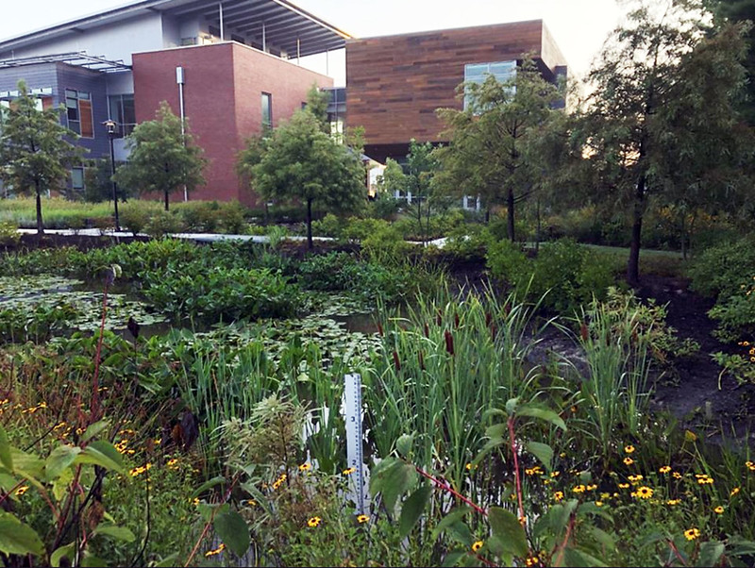
Virginia Wesleyan's wildlife habitat enhancement efforts include the teaching gardens surrounding the Greer Environmental Sciences Center with more than two acres of vegetated open space and 23,787 native plants, including a pollinator garden and three wetland gardens.
University News | December 6, 2022
Virginia Wesleyan University has received recognition from the Elizabeth River Project for “Sustained Distinguished Performance at Model Level.” Sustained Distinguished Performance represents completion of significant new initiatives by a River Star Business. The Elizabeth River Project and Inside Business, the project’s media partner, have initiated a special award to be presented at their annual luncheon in January. Virginia Wesleyan University was chosen as the Inside Business River Star Hall of Fame winner and will be inducted into the Inside Business Hall of Fame for River Stars in the new year.
“It is so appropriate that VWU is recognized as a leader on this topic,” said President Scott D. Miller. “Our commitment goes beyond our beautiful 300-acre park-like campus in Virginia Beach. We are distinctively unique in two very important ways: the mission and vision of our honors college and the investment of our full endowment in an environmentally friendly way.”
In 2021, Virginia Wesleyan received a series of private gifts increasing its endowment to $123.5 million. Of those funds, $80.2 million are designated for the endowment of the Batten Honors College, a highly selective residential program of the University with a focus on environmental stewardship, global engagement, and leadership. The entire endowment for the Batten Honors College and the University has been invested following environmental, social, and governance criteria with Brown Advisory of Baltimore, Maryland.
Sustainability efforts at Virginia Wesleyan reflect a larger commitment to ethical conduct and social responsibility through environmental stewardship and education. In 2020, the Board of Trustees adopted Environmental Guiding Principles to be embedded in the permanent institutional mindset for future planning.
Virginia Wesleyan’s wildlife habitat enhancement efforts include the teaching gardens surrounding the Greer Environmental Sciences Center with more than two acres of vegetated open space and 23,787 native plants, including a pollinator garden and three wetland gardens. Marlin Meadows, a 3,950 square foot, student-initiated rain and pollinator garden funded by the Earth & Environmental Sciences Endowed grant, was created by VWU’s Marlins Go Green student club with support from Norfolk Botanical Gardens and Elizabeth River Project staff. Marlins Go Green challenges students to become engaged in environmental sustainability on campus and in the community. This student club raises awareness of sustainability through education, activism, and volunteer opportunities. They host campus clean-ups, invasive species removal events, environmental documentaries, used clothing drives, and Earth week activities.
VWU oceanography students, in partnership with the City of Norfolk, Norfolk Master Gardeners and the Elizabeth River Project have planted wetland plants and grasses over 11,800 square feet of shoreline at Poplar Hall Park. Students in the Batten Honors College partnered with ERP, the City of Chesapeake and the Living River Trust to plant 55 trees and shrubs over 7,500 square feet at the new park, as part of a pilot demonstration for FEMA purchased property transformed into green space to allow for sea level rise.
In addition, the University participated in a statewide urban heat island research project organized by the Virginia Foundation for Independent Colleges. Professor of Ocean and Atmospheric Sciences and Director of Sustainability Dr. Elizabeth Malcolm and her research students organized the citizen science measurement campaign which involved more than 20 volunteers driving with heat sensors on a hot day in August 2021 to create an urban heat island map for the city to determine what neighborhoods are most at risk from extreme heat. The research group is currently working with Lynnhaven River Now and the Virginia Department of Forestry to plan a tree planting project informed by the heat maps.
VWU Professor of Biology and Environmental Science and Coordinator of Sustainability Management Dr. Maynard Schaus received a grant from the Second Nature Acceleration fund to financially support student internships with the Elizabeth River Project that support environmental justice and climate equity in local neighborhoods. The student interns work on projects including shoreline and oyster reef restoration in an urban watershed and community environmental education.
VWU’s pollution prevention efforts include joining the American College & University Presidents' Climate Commitment with a pledge to be carbon neutral by 2040. VWU reduced greenhouse gas emissions from 2008 to 2018 by 56.8%. In 2017, VWU constructed the 44,000-square-foot state-of-the-art Greer Environmental Sciences Center, which is LEED Gold certified for solar, green roof, cool roof, geothermal, LED, extra insulation, and low-flow fixtures. President Miller’s, new home on campus, Deford Manor, is designated as a River Star Home.
The University will be formally recognized for these accomplishments at the Annual River Star Businesses Recognition Luncheon scheduled for January 19 at Founders Inn in Virginia Beach.

APPENDIX C:
Update from the DEIC (Dec. 2, 2022)
Dear Campus Community,

The Diversity Equity Inclusion Council (DEIC) is committed to creating a more equitable and inclusive environment for every member of our campus community. Our mission is to make informed recommendations on policies, practices, and programming that support diversity, equity and inclusion, and to continuously assess the campus climate.

Our objective is to maintain an educational and work environment in which every member of the campus community is valued and has a sense of belonging, and where discrimination and harassment are not tolerated. By ensuring such an environment, individuals will be better equipped to reach their full potential in their respective roles within the university, and thus, in return, the university will benefit from every individual’s increased function and greater commitment to the institution.

As the DEIC works towards the development of a comprehensive strategic plan, our current efforts include the following projects that support our mission.

- Student Focus Groups to assess the racial climate on campus.
Virginia Wesleyan University is a member of the Liberal Arts Colleges Racial Equity Leadership Alliance (LACRELA) (please see the attached sheet for more information). One important aspect of our partnership includes the administration of the National Assessment of Collegiate Campus Climate (NACCC), a quantitative national survey that assesses the campus racial climate and provides data-driven guidance for improving the climate.

Virginia Wesleyan University students completed the web-based NACCC survey in the spring of 2021 and the results highlighted areas of concern with respect to the racial climate. In response, we have organized focus group discussions amongst students that will help us to better understand the campus climate. Virginia Wesleyan University is committed to hiring an external facilitator who will ensure the confidential reporting of the atmosphere students experience on campus. These discussions will take place in the Spring of 2023 and the conclusions of these discussions will be shared amongst the campus community in the Fall of 2023.

Virginia Wesleyan University Staff completed the NACCC survey in the Spring of 2022 and Faculty are scheduled to complete the survey in the Spring of 2023. The DEIC is recommending a similar process of holding focus groups for staff after receiving the results of the NACCC staff survey and for faculty once those results are received.
For more information on LACRELA, please see this website https://race.usc.edu/.

- DEI events
The DEIC will work to centralize the information of events organized by faculty, staff, and students into a central clearing house in order to amplify them across campus. In addition, the DEIC is sharing the 2022-2023 Virginia Center for Inclusive Communities (VCIC) calendar of Holidays and Festivals. Our hope is that this will bring more awareness to the traditions recognized in the attached calendar.

We would like to hear from you if you plan on hosting an event on campus that celebrates these important dates, which we can help you publicize. To this end, at the beginning of each semester and as needed throughout the year, the DEIC will contact faculty, staff, and student leaders to request information about DEI programming that is being planned for the semester. Please use this form to let us know about any speakers and/or events you plan to hold, and we will work with the University Marketing and Communications Department to help develop and distribute marketing materials.

- Assessing DEI initiatives that support areas impacting Student Life
The DEIC is currently working with Academic Affairs and Campus Life in order to make recommendations that support and improve the existing avenues of communication and engagement between students and the broader campus community.

This list of initiatives reflects a significant cross-section of our wider community, but it is not exhaustive nor exclusive. We hope that such initiatives come to fruition in a way that inclusion, equity, and diversity are promoted. Please understand that many of these initiatives take time to complete because of their nature or simply because we need to first assess what is already in place, discuss how to make improvements, and recommend changes and/or adjustments as we move forward.

Sincerely,
The Diversity, Equity, and Inclusion Council (DEIC)

Cameia Alexander, Director of Men's and Women's Cross Country and Track and Field
Audwin Harris, Enrollment Counselor
Dr. Felipe Hugueño, Assistant Professor of Hispanic Studies
Kelly Jackson, Associate Director of the Robert Nusbaum Center
Dr. Susan Larkin, Provost and Vice President for Academic Affairs
Dr. Keith Moore, Senior Vice President
Dr. Modupe Oshikoya, Assistant Professor of Political Science
Maria Peña-Pinedo, Human Resources Assistant and Wellness Program Coordinator
Bethany Tsiaras, Director of Wesleyan Engaged
CeeCee Tucker, Senior Advisor to the President on Diversity, Equity, and Inclusion Initiatives

Appendix D: Accolades

Chosen as one of the nation's best by The Princeton Review, selected for inclusion in the 2023 edition of The Best 388 Colleges and featured in the Southeastern category of 2023 Best Colleges: Region by Region.
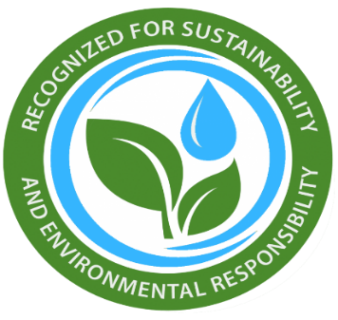
Selected by The Princeton Review as one of the most environmentally responsible colleges; profiled in its Guide to Green Colleges: 2022 Edition.

Recognized by U.S. News & World Report in three categories of its 2023 Best Colleges guide, ranked among the top institutions in "Ethnic Diversity" among liberal arts institutions, featured as a Best National Liberal Arts College, and also named a Top Performer on Social Mobility in that category.
Selected for inclusion among U.S. News & World Report's 2022 Best Online Bachelor's Programs, with the undergraduate online business degree highlighted in the discipline-specific category.
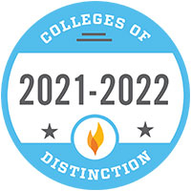
Honored among the 2021-2022 Colleges of Distinction, chosen for excellence in student-focused higher education and exemplary commitment to engaged students, great teaching, vibrant community and successful outcomes.
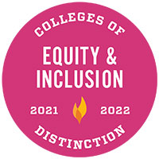
Recognized as a 2021-2022 Equity & Inclusion College of Distinction, distinguished as a community dedicated to equal opportunity for all students, faculty, and staff.
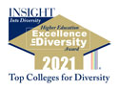
Received the 2021 Higher Education Excellence in Diversity (HEED) Award from INSIGHT Into Diversity magazine, the oldest and largest diversity-focused publication in higher education. The national award recognizes U.S. colleges and universities that demonstrate an outstanding commitment to diversity and inclusion.
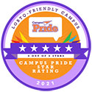
One of just 40 institutions selected by Campus Pride among the Best of the Best Colleges and Universities for LGBTQ+ Students for 2022. Also named the #1 College in Virginia for LGBTQ+ students by BestColleges.com in partnership with Campus Pride.
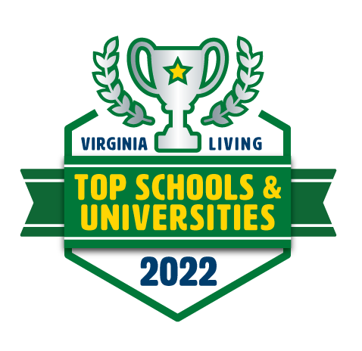
Named to Virginia Living's Top Schools & Colleges 2022, which features approximately 160 schools across the state leading the way in innovation.

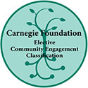
One of 119 U.S. colleges and universities selected in 2020 to earn the Carnegie Foundation's prestigious Community Engagement Classification, indicating institutional commitment to community engagement.
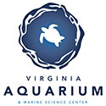
Partnerships with numerous community organizations, including the Virginia Aquarium & Marine Science Center, Chrysler Museum of Art, Chesapeake Bay Foundation, Elizabeth River Project, Lynnhaven River Now, Virginia Zoo, and Norfolk Botanical Garden.
Recognized as one of the top eight liberal arts colleges in the country for veterans by U.S. News & World Report in a recent ranking of the Best Colleges for Veterans.

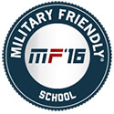
Repeatedly receives the Military Friendly School designation by G.I. Jobs, the premier magazine for military personnel transitioning to civilian life.

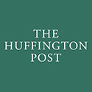
Virginia Wesleyan University President Scott D. Miller has been recognized as one of the most active and visible communicators in the country among college and university presidents. He was named in a national study (by Roland H. King of PhairAdvantage Communications) as one of the "Top 14 Presidents Publishing Op-eds" in 2014. Dr. Miller is a regular columnist for HuffPost, The Virginian-Pilot, College Planning and Management, and Enrollment Manager. He served as co-executive editor of Presidential Perspectives, an online presidential thought series that resulted in 10 books, and he has co-published several volumes of President to President.
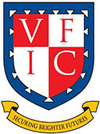
One of 16 residential liberal arts colleges in the selective Virginia Foundation for Independent Colleges, an organization dedicated to advancing the distinctive values and strengths of Virginia's leading liberal arts and sciences institutions.

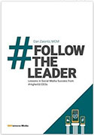
President Scott D. Miller was chosen as one of 22 leaders from U.S. and Canadian colleges and universities to be featured in the book "#FollowTheLeader: Lessons in Social Media Success from #HigherEd CEOs" (EDUniverse Media, January 2015). In the book, the author, Dan Zaiontz, shares the collective wisdom of Dr. Miller and his counterparts, providing tips and best practices to higher education leaders interested in adopting social media or learning to use it more effectively.
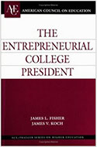
President Scott D. Miller has been recognized by numerous books and publications nationally for his transformative leadership style. He was identified in "The Entrepreneurial College President" as one of 17 most entrepreneurial presidents in American higher education.

A member of a select group of 440 institutions nationwide in the Climate Leadership Network, comprised of colleges and universities taking action on climate and preparing students through research and education to solve the challenges of the 21st century.
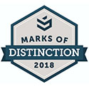
Earned "Marks of Distinction" from climate action-based Second Nature in the "On Track" category and as a "We are Still In" participant. Signatory higher education institutions are recognized based on performance, participation, and goal setting.
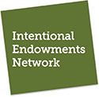
Virginia Wesleyan University is one of 58 select colleges and universities nationwide, along with 102 other endowed institutions, that are members of the Intentional Endowments Network, the leading network for endowment fiduciaries investing for a thriving, sustainable economy.
Scholars from the Batten Honors College of Virginia Wesleyan University took first place in the undergraduate division in the Intentional Endowments Network's Student Corporate Engagement Competition. In this student investment competition, participants pitch an investment in a publicly-traded company, and include in that recommendation a shareholder engagement strategy focused on addressing inequality and the climate crisis, as they are systemic risks that threaten a healthy society, and in turn, healthy portfolio returns.
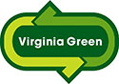
Virginia Wesleyan University Dining Services is one of a handful of original Virginia colleges and universities to be designated as a Virginia Green Restaurant by the Virginia Department of Environmental Quality. To qualify, restaurants (or dining halls) must minimize the use of disposable food service products, recycle grease, recycle and reduce waste, use water efficiently and conserve energy.
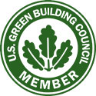
Virginia Wesleyan University is a member of the U.S. Green Building Council, the nation's foremost coalition of leaders from every sector of the building industry working to promote buildings that are environmentally responsible, profitable and healthy places to live and work. More than 12,000 member organizations and a network of 76 regional chapters are united to advance the USGBC's core purpose of transforming the way buildings and communities are designed, built and operated, enabling an environmentally and socially responsible, healthy, and prosperous environment that improves the quality of life.
Virginia Wesleyan's beautiful 300-acre campus is home to an old-growth beech forest that is listed on the Council of Independent Colleges' site for the Historic Campus Architecture Project. It is several acres of mature hardwoods, with a very tall canopy and an undisturbed understory, making it a sustainable ecological system.

Continuously recognized by the Professional Grounds Management Society (PGMS) as part of its Green Star Awards competition. Saluted for exceptional maintenance of the University's 300-acre campus in the University and College Grounds category.
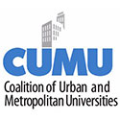
A member of a select group of 104 institutions nationwide in the Coalition of Urban and Metropolitan Universities, the longest-running and largest organization committed to serving and connecting the world's urban and metropolitan universities and their partners.
President Scott D. Miller stands with over 400 U.S. College and University leaders as part of the President's Alliance on Higher Education and Immigration. The non-partisan alliance is dedicated to increasing public understanding of how immigration policies and practices impact students, campuses, communities, and country, and supports policies creating a welcoming environment for undocumented, immigrant, and international students.

Appendix E:
Wesleyan Engaged-Community Partners

Animals and the Environment
- Chesapeake Bay Foundation
- Hoffler Creek Wildlife Preserve
- Keep Norfolk Beautiful
- Nauticus
- Norfolk Animal Care Center
- Norfolk Botanical Gardens
- Norfolk Environmental Commission/Keep America Beautiful
- Norfolk SPCA
- Portsmouth Humane Society
- Untamed Spirit Therapeutic Riding
- Virginia Beach Aquarium
- Virginia Beach SPCA
- Western Bayside Churches United Community Garden

Health and the Elderly
- AARP
- Affinity Hospice
- ACCESS AIDS Care and the LGBT Center of Hampton Roads
- American Red Cross, Eastern Virginia Region
- Chesapeake Care Clinic
- Heartland Hospice
- I Need a Lighthouse Suicide Awareness Out of the Darkness Walk
- Kindred Hospice
- MASS
- Montero Medical Missions
- Seniors Unlimited Lifestyles Inc.
- Special Olympics
- The Gardens Assisted Living
- Tranquility at the Lakes
- Virginia Beach Department of Human Services – Behavioral Health Division

Hunger and Homelessness
- Catholic Worker
- Ceramic Designers Association (Empty Bowls)
- Empty Bowls Charity Dinner
- Foodbank of Southeastern Virginia and the Eastern Shore
- Habitat for Humanity of South Hampton Roads
- H.E.R. Shelter
- JCOC
- LIFT Fitness Foundation
- Oasis Social Ministry
- Portsmouth Volunteers for the Homeless
- Samaritan House
- The Focus Center/Park Place United Methodist Church
- Union Mission Ministries
- Virginia Beach Department of Housing and Neighborhood
- Virginia Supportive Housing

Youth
- AVID Tutoring
- Bayside Elementary School
- Bayside High School
- Bayside Middle School
- Bayside 6th Grade Campus
- BF Williams Elementary School
- Big Brothers Big Sisters Military Mentoring
- Chesapeake Bay Academy
- Diamond Springs Elementary School
- ForKids
- Girls on the Run Hampton Roads
- Horizons Hampton Roads
- Newtown Elementary School
- Shelton Park Elementary School
- Teens With a Purpose
- Tidewater Collegiate Academy
- Tidewater Youth Services

Other
- Coast Guard Chief Petty Officers Association
- Compassion Cards
- Ebenezer Baptist
- Enoch Baptist
- Good Samaritan Episcopal Church
- Hampton Roads Chamber of Commerce
- Haygood United Methodist Church
- Heritage United Methodist Church
- Lake Edward Area Civic League
- One Love Festival
- Planned Parenthood
- The Gloucester Institute
- United Way of South Hampton Roads
- Virginia Beach Parks and Recreation
- Virginia Beach Public Library
- Virginia Beach Voter Registrar
- Volunteer Hampton Roads
- Westminster Canterbury on Chesapeake Bay
- YWCA

