

Department of Management

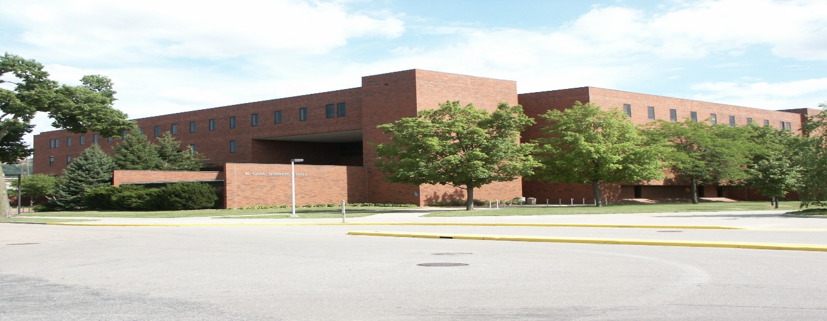

Principles for Responsible Management Education

Sharing Information on Progress (SIP) Report

December 2014



**Table of Contents**

**1. Letter of Renewed Commitment 3**

**2. Department of Management 4**

**3. Principles in Action 6**

**4. Future Objectives / Key Perspectives 9**

**1. Letter of Renewed Commitment**

**2. Department of Management**



The following report is about the Department of Management, College of Business Administration, University of Wisconsin-La Crosse.

The University of Wisconsin-La Crosse was founded in 1909 as the La Crosse Normal School. Today it is one of the 13 four-year campuses in the University of Wisconsin System. Originally known for its nationally recognized physical education program, UW-La Crosse now offers 85 undergraduate programs in 30 disciplines, and 21 graduates programs and emphases in eight disciplines.

The compact 119-acre campus located in a residential section of La Crosse provides a vibrant place to live and learn. Enrollment has grown from 176 when the doors opened to over 10,300 undergraduate students. Statewide, freshman credentials are second only to UW-Madison, and showed the most improvement in ACT scores and class rank during the past decade. The campus embraces diversity, a commitment that has increased minority and international students, faculty and staff. Students take part in an array of organizations and community service. Intercollegiate teams compete in 19 sports and have produced 63 national championships since.

The university offers much to the region—cultural events, regional and national conferences, prominent speakers, applied research, professionals with varying expertise, a large workforce, and numerous faculty, staff and student community volunteers. UW-La Crosse works cooperatively with the city’s other higher education institutions and area elementary and secondary schools. Also, the university led development of a consortium among the city’s higher education institutions and major health care organizations to bring cutting-edge health care to the region, along with a state-of-the-art health research and education facility.

The College of Business Administration (CBA) is one of the three colleges at the University of Wisconsin-La Crosse. The CBA consists of six academic departments and one non-academic department, which is the Small Business Development Center. The college has seven academic programs including an International Business major. All programs are housed in an academic department except for the International Business program, which is managed by the CBA International Business Advisory Committee. In the spring of 1982 the College’s undergraduate program earned its initial accreditation from AACSB International. In 1987, both the graduate and undergraduate programs became fully accredited by AACSB International. As of 2011, the college has approximately 1600 undergraduate students and approximately 60 graduate students. It has a highly qualified instructional staff of 55. The college maintains active collaborations with the region and community and with numerous education institutions in Europe, Asia, and elsewhere.

The Department of Management is one of six majors in the College of Business Administration and serves approximately 300 students within the major. The department also provides core program courses at both the undergraduate and graduate levels. Composed of ten tenured or tenure track Faculty and three Instructional Academic Staff, the management department delivers roughly 70 classes and connects with every student within the College of Business Administration. Since its inception to PRME in 2008, the Department has undergone some considerable changes. Currently 70% of the Faculty are new with an influx of diversity, thought, and research. In both social responsibility and sustainability, the Faculty of the Department of Management are engaged in cutting-edge research and this has a direct influence on the curriculum that is being delivered.

The Department of Management is committed to the College of Business Administration’s mission and vision which is:

Mission

“To provide students and exceptional business education that empowers them to serve organizations and communities as socially responsible citizens in a global environment.”

Vision

“To be recognized for quality as the leading business school among regional and state comprehensive universities.”

Values

* Teaching: Highly effective and innovative teaching employing relevant curriculum.
* Scholarship: scholarship that advances discipline-based knowledge, best practices, and teaching pedagogy, each equally enriching student learning.
* Faculty: quality faculty who are accessible, responsive, and dedicated to student learning.
* Students: quality students who are actively engaged in their professional and personal development.
* Learning: a highly interactive learning environment that fosters strong relationships and student success.
* Global Engagement: global engagement and collaboration to increase international awareness and opportunities.
* High Standards: high standards that reflect best practices and ethical behavior, stimulate intellectual growth, and promote continuous improvement.
* Diversity: acceptance and respect for human and ideological differences.
* Sustainability: promotion of sustainable practices in the use of economic, ecological, and social resources.
* Service: service to the university, discipline, and community that promotes strong partnerships and advances professional and economic development.

**3. Principles in Action**

Since its inception into PRME, UWL, the CBA and the Department of Management has embarked upon a number of initiatives. An update of these initiatives, since December of 2012, is reflected in the following:

**Principle 1 – Purpose: We will develop the capabilities of students to be future generators of sustainable value for business and society at large and to work for an inclusive and sustainable global economy.**

**Principle 2 – Values: We will incorporate into our academic activities and curricula the values of global social responsibility as portrayed in international initiatives such as the United Nations Global Compact.**

**Principle 3 – Method: We will create educational frameworks, materials, processes and environments that enable effective learning experiences for responsible leadership.**

Since 2008, members of the management department have been involved in College and University wide committees for the development of both responsible and sustainable practices. One immediate outcome of this activity was the formation of a Joint Committee on Environmental Sustainability (JCES). In turn, one of this committee’s primary objectives is to create ways of infusing issues of sustainability across the whole university curriculum.

Another outcome from this commitment is UWL having joined STARS (Sustainability Tracking, Assessment & Rating System). STARS is an assessment tool used by colleges and universities to measure their sustainability efforts and accomplishments.  A STARS Coordinator position was created and in part was funded by the Provost and in part by the Dean of the CBA. The STARS Coordinator position is currently housed in the Management Department. UWL’s STARS rating is at Reporter status with plans to submit data in May of 2015.

In the College of Business Administration, the Assurance of Learning Task Force (AOLTF) was created in 2009 to develop systematic and on-going processes to develop, monitor, and evaluate the substance and delivery of the curricula of the undergraduate degree program and to assess the impact of the curricula on learning. The six learning outcomes are outlined below with the two which are directly related to PRME principles highlighted:

* Communication Goal: Our students will be able to convey information and ideas effectively.
* Decision Making and Critical Thinking Goal: Our students will be able to think critically when evaluating decisions.
* **Global Context of Business Goal: Our students will be prepared to serve others in a global environment.**
* Major Competency Goal: Our students will be proficient in the primary functional area of study.
* **Social Responsibility Goal: Our students will be prepared to be socially responsible citizens.**

The Business Sustainability minor, which falls under the umbrella of the Management Department within the CBA, began taking students in the Fall of 2013. The initial course in this minor, BUS 310, has been offered as a free standing elective within the College of Business Administration since the Fall 2011. The BusinessS**ustainability minor**  provides students with the opportunity to explore the relation between business and creation, maximizing good stewardship of natural resources, while pursuing business objectives.  The goal is to achieve the "Triple Bottom Line":  Pursuing Profits, Protecting People, and Preserving the Planet. As of December 2014, there are 25 declared Sustainability Minors.

**Coursework:**

There are courses campus-wide which reflect UW-La Crosse’s commitment to PRME principles. Listed is a sampling of the courses offered at UWL that have either sustainability as their main focus OR as a theme within the course. The highlighted courses are specific to the CBA and/or support the Sustainability Minor and have included corporate social responsibility and global social responsibility. The courses are below:

* **Green Operations (MGT 400)**
* **Management Forum - Systems Thinking and Change Management (MGT 400)**
* **Environmental and Ecological Economics (ECO 346)**
* **Sustainability in Marketing (MKT 351)**
* Contemporary Media in Life (CST 271)
* Pastoralism: Past and Present (ANT/ARC 330)
* Comparative Animal Physiology (BIO 125/558)
* **Principles of Sustainable Business (BUS310)**
* **Business Form (BUS 700)**
* Communication Leadership (CST 380)
* **Economic Forum (ECO 474/574**)
* **Environmental Sustainability (ENV 301)**
* **Issues in Environmental Studies (ENV303)**
* **Finance Forum (FIN 400)**
* Human Ecology and Environmental Health (HED 335)
* **Principles of Labor Management Relations (MGT 303)**
* **Organizational Behavior (MGT 308)**
* **Principles of Management Thought (MGT 328)**
* **Human Resources: Current Issues and Policies (MGT 486)**
* **Global Perspective on Business (MGT 360)**
* **Production and Operations Management (MGT 393)**
* **The Global Responsibility of Business (MGT 408)**
* **Policy Administration and Determination Strategy (MGT 449)**
* Principles of and Practices of Tourism (REC 320)

**Principle 4 – Research: We will engage in conceptual and empirical research that advances our understanding about the role, dynamics, and impact of corporations in the creation of sustainable social, environmental and economic value.**

All tenured or tenured track members of the department are research active and for many of them their research touches upon ethical, responsible and competence issues reflected in sustainable management.

Some specific sustainability research, which has occurred or is in process within the Management Department follows:

* Published article (Lemke and Petersen, 2013) on teaching corporate social responsibility in the supply chain
* Article under review (Petersen and Lemke) on supply chain risks and its management via social responsibility
* Research on sustainability in food supply chains (Petersen, Lemke, and Luca)
* Research on identifying sustainability factors in purchasing decisions
* Writing a textbook for Palgrave Macmillan on Sustainability Marketing

**Principle 5 – Partnership: We will interact with managers of business corporations to extend our knowledge of their challenges in meeting social and environmental responsibilities and to explore jointly effective approaches to meeting these challenges.**

Since the summer of 2011, the Department has been organizing the Global Consulting Program, a short-term study abroad program in which students work to solve problems for businesses in Slovakia.

As a principle the Management Faculty engage with practitioners on an ongoing basis. As professionals within their respective fields, interactions with business and business practitioners are a common occurrence. Guest speakers, classroom projects in collaboration with local businesses/organizations and other types of collaboration are common within the CBA and Management Department.

**Principle 6 – Dialogue: We will facilitate and support dialog and debate among educators, business, government, consumers, media, civil society organizations and other interested groups and stakeholders on critical issues related to global social responsibility and sustainability.**

In the Fall of 2012 the Department of Management started a research/development colloquium for the sharing and dissemination of information. The forum provides a venue for Faculty to share research, ideas, best practices or host discussions on relevant topics.

**4. Future Objectives / Key Perspectives**

Looking forward, the Department of Management and other departments within the CBA will continue to develop elective courses that support the Business Sustainability Minor. In addition to course development, collaboration in the form of projects, internships and research are all potential future goals.

The Department is also in the process of developing a Health Care Management program to better serve the surrounding community. Two new faculty members have been hired into the Management Department to create partnerships across campus and within the health care community in the greater La Crosse area. Healthcare and sustainability are related closely in the La Crosse Community and we look to work with Gundersen Health Systems, who is a leader in energy independence in healthcare.

Finally, in the Spring of 2014 the CBA started The Center or Sustainability, Entrepreneurship and International Trade. This Center is housed within the one non-academic department of the College of Business Administration, the Small Business Development Center.